计算环境部署文档

Ubuntu

基础环境准备

系统优化
锁内核：
apt-mark hold linux-generic linux-image-generic linux-headers-generic
关闭自动更新：
sudo sed -i.bak 's/1/0/' /etc/apt/apt.conf.d/10periodic &> /dev/null
sudo sed -i.bak 's/1/0/' /etc/apt/apt.conf.d/20auto-upgrades &> /dev/null

依赖安装
apt install gcc make -y

驱动下载

Nvidia drive 下载
官方链接：https://www.nvidia.cn/drivers/lookup/
根据个人的版本需求进行下载，下载后会获得一个run包，直接上传到服务器即可



Cuda 下载（根据实际版本）
官方链接：https://developer.nvidia.com/cuda-downloads
根据个人的版本需求进行下载，下载后会获得一个run包，直接上传到服务器即可
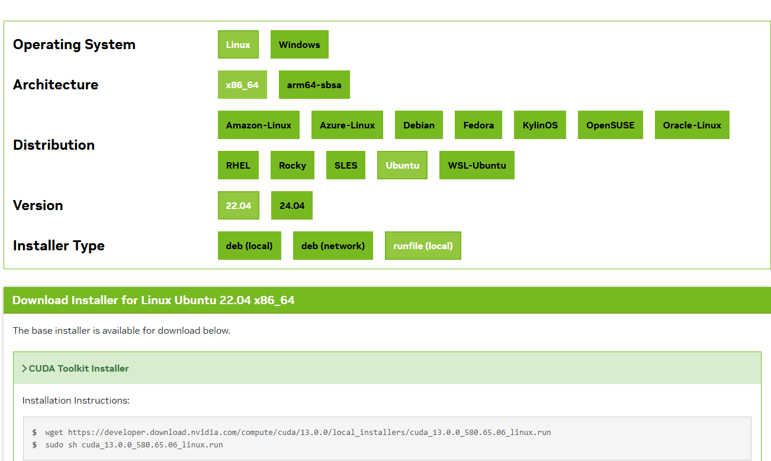

Nvidia fabricmanager 下载（根据实际操作系统修改/SXM需要，PCIE不需要）
wget https://developer.download.nvidia.cn/compute/cuda/repos/ubuntu2004/x86_64/nvidia-fabricmanager-535_535.154.05-1_amd64.deb

驱动安装

Nvidia Drvie(根据实际版本修改)
./NVIDIA-Linux-x86_64-535.154.05.run \
--ui=none \ # 禁用图形界面（纯命令行模式）
--no-questions \ # 跳过所有交互式提问（自动确认）
--accept-license \ # 自动接受许可协议
--disable-nouveau \ # 禁用开源驱动 Nouveau
--install-libglvnd # 安装 libglvnd 兼容层

Cuda(根据实际版本修改)
./cuda_12.2.0_535.154.05_linux.ru \
--silent \ # 静默模式
--toolkit \ # 仅安装CUDA Toolkit
--override \ # 覆盖某些默认设置
--no-drm \ # 安装DRM库，这样可以避免安装GPU驱动程序
--no-opengl-libs # 不安装OpenGL库

Nvidia fabricmanager
dpkg -i nvidia-fabricmanager-535_535.154.05-1_amd64.deb

服务设置

Nvidia fabricmanager(NVLINK)
systemctl daemon-reload
systemctl start nvidia-fabricmanager
systemctl enable nvidia-fabricmanager

Nvidia-persistenced
cat << EOF > /lib/systemd/system/nvidia-persistenced.service
[Unit]
Description=NVIDIA Persistence Daemon
After=syslog.target
[Service]
Type=forking
PIDFile=/var/run/nvidia-persistenced/nvidia-persistenced.pid
Restart=always
ExecStart=/usr/bin/nvidia-persistenced --verbose
ExecStopPost=/bin/rm -rf /var/run/nvidia-persistenced/*
TimeoutSec=300
[Install]
WantedBy=multi-user.target
EOF
systemctl daemon-reload
systemctl enable nvidia-persistenced
systemctl start nvidia-persistenced

Cuda 环境设置(根据实际情况)
cat << EOF >> /etc/profile
export PATH=/usr/local/cuda/bin:$PATH
export CUDA_HOME=/usr/local/cuda/

export LD_LIBRARY_PATH=/usr/local/cuda/lib64:$LD_LIBRARY_PATH
export LD_LIBRARY_PATH=/usr/local/cuda/targets/x86_64-linux/lib:$LD_LIBRARY_PATH
export LD_LIBRARY_PATH=/usr/local/cuda/targets/x86_64-linux/lib/stubs:$LD_LIBRARY_PATH
EOF
环境加载
source /etc/profile

环境验证

nvidia-smi
+---------------------------------------------------------------------------------------+
| NVIDIA-SMI 535.154.05 Driver Version: 535.154.05 CUDA Version: 12.2 |
|-----------------------------------------+----------------------+----------------------+
| GPU Name Persistence-M | Bus-Id Disp.A | Volatile Uncorr. ECC |
| Fan Temp Perf Pwr:Usage/Cap | Memory-Usage | GPU-Util Compute M. |
| | | MIG M. |
|=========================================+======================+======================|
| 0 NVIDIA A800-SXM4-80GB On | 00000000:10:00.0 Off | 0 |
| N/A 41C P0 62W / 400W | 0MiB / 81920MiB | 0% Default |
| | | Disabled |
+-----------------------------------------+----------------------+----------------------+
| 1 NVIDIA A800-SXM4-80GB On | 00000000:16:00.0 Off | 0 |
| N/A 39C P0 63W / 400W | 0MiB / 81920MiB | 0% Default |
| | | Disabled |
+-----------------------------------------+----------------------+----------------------+
| 2 NVIDIA A800-SXM4-80GB On | 00000000:49:00.0 Off | 0 |
| N/A 37C P0 59W / 400W | 0MiB / 81920MiB | 0% Default |
| | | Disabled |
+-----------------------------------------+----------------------+----------------------+
| 3 NVIDIA A800-SXM4-80GB On | 00000000:4D:00.0 Off | 0 |
| N/A 39C P0 61W / 400W | 0MiB / 81920MiB | 0% Default |
| | | Disabled |
+-----------------------------------------+----------------------+----------------------+
| 4 NVIDIA A800-SXM4-80GB On | 00000000:C5:00.0 Off | 0 |
| N/A 38C P0 64W / 400W | 0MiB / 81920MiB | 0% Default |
| | | Disabled |
+-----------------------------------------+----------------------+----------------------+
| 5 NVIDIA A800-SXM4-80GB On | 00000000:CA:00.0 Off | 0 |
| N/A 40C P0 63W / 400W | 0MiB / 81920MiB | 0% Default |
| | | Disabled |
+-----------------------------------------+----------------------+----------------------+
| 6 NVIDIA A800-SXM4-80GB On | 00000000:E3:00.0 Off | 0 |
| N/A 37C P0 64W / 400W | 0MiB / 81920MiB | 0% Default |
| | | Disabled |
+-----------------------------------------+----------------------+----------------------+
| 7 NVIDIA A800-SXM4-80GB On | 00000000:E7:00.0 Off | 0 |
| N/A 41C P0 63W / 400W | 0MiB / 81920MiB | 0% Default |
| | | Disabled |
+-----------------------------------------+----------------------+----------------------+

+---------------------------------------------------------------------------------------+
| Processes: |
| GPU GI CI PID Type Process name GPU Memory |
| ID ID Usage |
|=======================================================================================|
| No running processes found |
+---------------------------------------------------------------------------------------+

nv-fabricmanager
● nvidia-fabricmanager.service - NVIDIA fabric manager service
Loaded: loaded (/lib/systemd/system/nvidia-fabricmanager.service; enabled; vendor preset: enabled)
Active: active (running) since Mon 2023-05-07 08:33:50 CST; 3 months 20 days ago
Main PID: 2979 (nv-fabricmanage)
Tasks: 18 (limit: 629145)
Memory: 17.9M
CPU: 19min 27.766s
CGroup: /system.slice/nvidia-fabricmanager.service
└─2979 /usr/bin/nv-fabricmanager -c /usr/share/nvidia/nvswitch/fabricmanager.cfg

nvidia-persistenced
● nvidia-persistenced.service - NVIDIA Persistence Daemon
Loaded: loaded (/lib/systemd/system/nvidia-persistenced.service; enabled; vendor preset: enabled)
Active: active (running) since Fri 2023-05-07 15:13:59 CST; 3 months 16 days ago
Main PID: 304182 (nvidia-persiste)
Tasks: 1 (limit: 629145)
Memory: 360.0K
CPU: 214ms
CGroup: /system.slice/nvidia-persistenced.service
└─304182 /usr/bin/nvidia-persistenced --verbose

