**Koduru Pushpalatha**

**1: Draw your Home Network Topology and explain how you are accessing the RPS Lab environment**

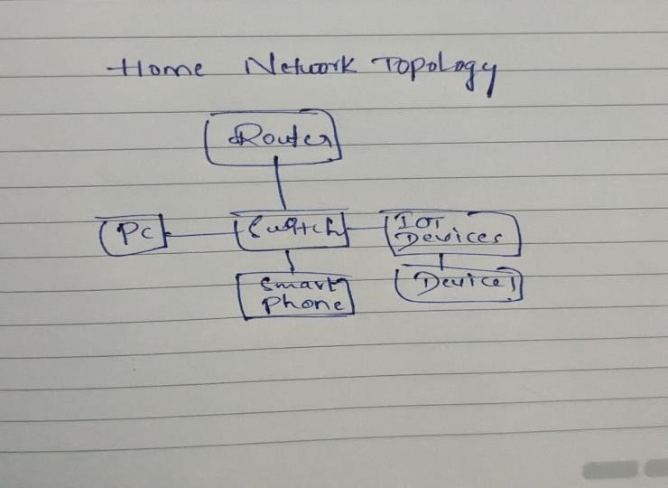

In above diagram:

The devices in the network which are connected to router, which acts as the central hub of the network.

The Pc and smart phone which are connected to the switch.

**2. Identify a real-world application for both parallel computing and networked systems. Explain how these technologies are used and why they are important in that context.**

Parallel computing is a computing architecture that divides a problem into smaller tasks and runs them concurrently. It has the ability to process multiple tasks simultaneously, making it significantly faster than a sequential computer. Parallel computing helps to solve large, complex problems in a much shorter time.

Example: Weather Forecasting

**Parallel Computing**:Weather forecasting invloves running complex numerical models that simulate atmospheric conditions. These models require massive computational power to process vast amounts of data quickly. Parallel computing allows weather forecasters to divide these complex simulations into smaller tasks and distribute them across multiple processors or computing nodes, thereby speeding up the computation process. Each processor works simultaneously on its assigned task, and once all tasks are completed, the results are combined to produce the final forecast. Without parallel computing, performing these simulations would be extremely time-consuming, potentially ddelaying the forecast and reducing its accuracy.

**Networked Systems**: Weather forecasting also heavily relies on data from various sources such as weather stations, satellites, and ocean buoys, which are geographically dispersed. Networked systems enable the seamless transmission of this data to central forecasting centers. Through networks, meteorologists can access real-time observations and integrate them into their models to improve the accuracy of predictions. Additionally, networked systems facilitate collaboration among meteorological agencies worldwide, allowing them to share data, models, and expertise. This collaboration enhances the quality and coverage of weather forecasts, benefiting not only local communities but also global efforts to understand and mitigate the impacts of ectreme weather events.

In summary, parallel computing and networked systems are indispensable in weather forecasting for their abilities to process large-scale simulations efficiently and integrate real-time data from diverse sources. These technologies enable meteorologists to provide timely and accurate forecasts, thereby helping communities prepare for and respond to weather-related challenges effectively.