**Assignment 1: Implement a navigation bar using an unordered list with links to different sections of your HTML page. Use CSS to style the list as a horizontal menu and highlight the current page or section.**

<!DOCTYPE html>

<html lang="en">

<head>

<meta charset="UTF-8">

<meta name="viewport" content="width=device-width, initial-scale=1.0">

<title>Navigation Bar Example</title>

<link rel="stylesheet" href="styles.css">

<style>

body {

font-family: Arial, sans-serif;

}

header {

background-color: #333;

padding: 10px 0;

}

.navbar {

list-style: none;

margin: 0;

padding: 0;

display: flex;

justify-content: center;

}

.navbar li {

margin: 0 15px;

}

.navbar a {

text-decoration: none;

color: white;

padding: 10px 20px;

display: block;

transition: background-color 0.3s;

}

.navbar a:hover {

background-color: #575757;

}

.navbar a.active {

background-color: #575757;

border-radius: 4px;

}

section {

padding: 50px;

text-align: center;

}

section:nth-of-type(odd) {

background-color: #f4f4f4;

}

</style>

</head>

<body>

<header>

<nav>

<ul class="navbar">

<li><a href="#home" class="active">Home</a></li>

<li><a href="#about">About</a></li>

<li><a href="#services">Services</a></li>

<li><a href="#contact">Contact</a></li>

</ul>

</nav>

</header>

<section id="home">

<h1>Home Section</h1>

<p>Welcome to the home section.</p>

</section>

<section id="about">

<h1>About Section</h1>

<p>Welcome to the about section.</p>

</section>

<section id="services">

<h1>Services Section</h1>

<p>Welcome to the services section.</p>

</section>

<section id="contact">

<h1>Contact Section</h1>

<p>Welcome to the contact section.</p>

</section>

</body>

</html>

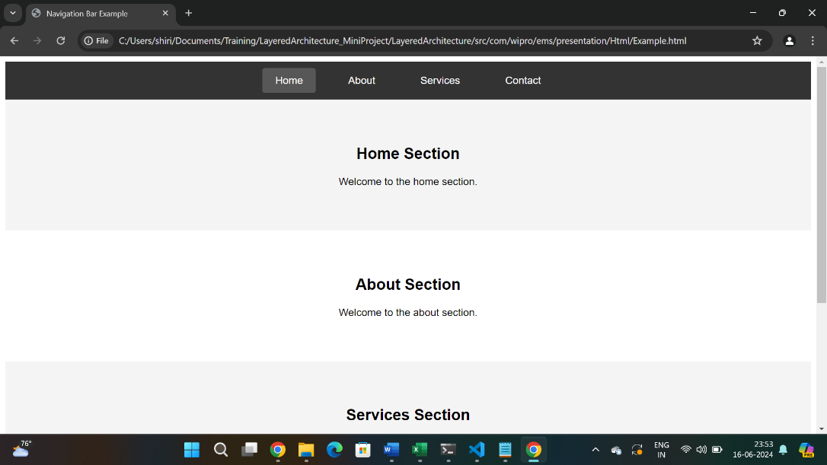

Assignment 2: Create a simple HTML page that includes the use of headings, paragraphs, and at least two semantic tags like <article> or <section>. Add a table with data of your choice and a form with fields for a user's name, email, and a submit button.

<!DOCTYPE html>

<html lang="en">

<head>

<meta charset="UTF-8">

<meta name="viewport" content="width=device-width, initial-scale=1.0">

<title>Simple HTML Page</title>

<style>

body {

font-family: Arial, sans-serif;

line-height: 1.6;

margin: 20px;

}

header, footer {

background-color: #333;

color: white;

text-align: center;

padding: 10px 0;

}

article, section {

margin-bottom: 20px;

}

table {

width: 100%;

border-collapse: collapse;

margin: 20px 0;

}

table, th, td {

border: 1px solid black;

}

th, td {

padding: 10px;

text-align: left;

}

form {

max-width: 400px;

margin: 0 auto;

padding: 10px;

border: 1px solid #ccc;

border-radius: 5px;

}

form div {

margin-bottom: 10px;

}

form label {

display: block;

margin-bottom: 5px;

}

form input[type="text"], form input[type="email"] {

width: 100%;

padding: 8px;

box-sizing: border-box;

}

form input[type="submit"] {

background-color: #333;

color: white;

border: none;

padding: 10px;

cursor: pointer;

}

form input[type="submit"]:hover {

background-color: #575757;

}

</style>

</head>

<body>

<header>

<h1>Welcome to My Simple HTML Page</h1>

</header>

<article>

<h2>Introduction</h2>

<p>This is a simple HTML page that demonstrates the use of various HTML elements, including headings, paragraphs, semantic tags, tables, and forms. The goal is to create a structured and organized web page.</p>

</article>

<section>

<h2>Table Example</h2>

<p>Below is a table that contains some sample data:</p>

<table>

<tr>

<th>Item</th>

<th>Quantity</th>

<th>Price</th>

</tr>

<tr>

<td>Apples</td>

<td>10</td>

<td>$1.00</td>

</tr>

<tr>

<td>Oranges</td>

<td>5</td>

<td>$0.80</td>

</tr>

<tr>

<td>Bananas</td>

<td>7</td>

<td>$0.50</td>

</tr>

</table>

</section>

<section>

<h2>Contact Form</h2>

<p>Please fill out the form below to contact us:</p>

<form action="#" method="post">

<div>

<label for="name">Name:</label>

<input type="text" id="name" name="name" required>

</div>

<div>

<label for="email">Email:</label>

<input type="email" id="email" name="email" required>

</div>

<div>

<input type="submit" value="Submit">

</div>

</form>

</section>

<footer>

<p>&copy; 2024 My Simple HTML Page</p>

</footer>

</body>

</html>

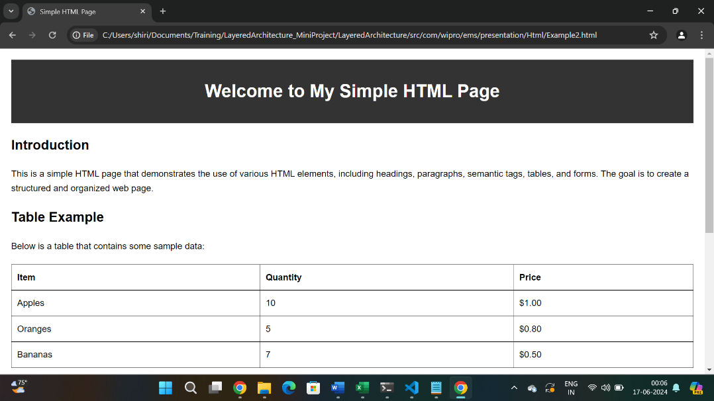

**Assignment 3:** Apply the CSS box model to ensure that your page content has appropriate margins and padding. Create a layout using div tags and style them to arrange content in a multi-column format using floats or flexbox.

<!DOCTYPE html>

<html lang="en">

<head>

<meta charset="UTF-8">

<meta name="viewport" content="width=device-width, initial-scale=1.0">

<title>Multi-Column Layout with Flexbox</title>

<link rel="stylesheet" href="styles.css">

<style>

body {

font-family: Arial, sans-serif;

line-height: 1.6;

margin: 0;

padding: 0;

}

header, footer {

background-color: #333;

color: white;

text-align: center;

padding: 10px 0;

}

.container {

display: flex;

flex-wrap: wrap;

margin: 20px;

}

.column {

background-color: #f4f4f4;

margin: 10px;

padding: 20px;

box-sizing: border-box;

flex: 1;

min-width: 200px;

}

.sidebar {

order: 1;

}

.main-content {

order: 2;

flex: 2;

}

.extra-content {

order: 3;

}

@media (max-width: 768px) {

.container {

flex-direction: column;

}

}

footer {

padding: 10px;

background-color: #333;

color: white;

text-align: center;

}

</style>

</head>

<body>

<header>

<h1>Multi-Column Layout Example</h1>

</header>

<div class="container">

<div class="column sidebar">

<h2>Sidebar</h2>

<p>This is the sidebar content. It could include links, additional information, or advertisements.</p>

</div>

<div class="column main-content">

<h2>Main Content</h2>

<p>Hey hi</p>

<p>Hello </p>

</div>

<div class="column extra-content">

<h2>Extra Content</h2>

<p>This is the extra content area.</p>

</div>

</div>

<footer>

<p>&copy; Layout Example</p>

</footer>

</body>

</html>

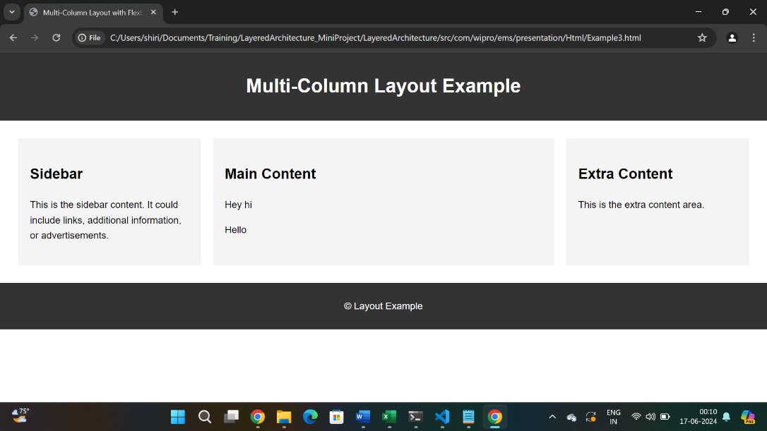

**Assignment 4:** Enhance the page by adding CSS3 animations to the menu and form elements. Also, use media queries to make the page responsive, ensuring it looks good on both desktop and mobile screen sizes.

<!DOCTYPE html>

<html lang="en">

<head>

<meta charset="UTF-8">

<meta name="viewport" content="width=device-width, initial-scale=1.0">

<title>Enhanced Page</title>

<style>

/* Basic CSS reset */

body, h1, h2, h3, p, ul, li {

margin: 0;

padding: 0;

list-style: none;

}

body {

font-family: Arial, sans-serif;

line-height: 1.6;

}

.container {

width: 90%;

max-width: 1200px;

margin: 0 auto;

}

/* CSS for menu animation */

.menu {

display: flex;

justify-content: space-between;

background-color: #333;

padding: 10px;

}

.menu-item {

display: inline-block;

margin-right: 15px;

padding: 10px;

color: #fff;

transition: transform 0.3s ease-in-out;

}

.menu-item:hover {

transform: scale(1.1);

}

/* CSS for form animation */

.form-container {

margin-top: 20px;

}

input, button {

display: block;

width: 100%;

padding: 10px;

margin-bottom: 10px;

transition: border-color 0.3s ease, background-color 0.3s ease;

}

input:focus, button:hover {

border-color: #3498db;

background-color: #eaf6ff;

}

/* Responsive CSS */

@media (max-width: 768px) {

.menu {

display: flex;

flex-direction: column;

align-items: center;

}

.menu-item {

margin-bottom: 10px;

}

.form-container {

width: 100%;

padding: 20px;

}

}

@media (min-width: 769px) {

.menu {

display: flex;

justify-content: space-between;

}

.form-container {

width: 50%;

margin: 0 auto;

}

}

</style>

</head>

<body>

<div class="container">

<nav class="menu">

<div class="menu-item">Home</div>

<div class="menu-item">About</div>

<div class="menu-item">Services</div>

<div class="menu-item">Contact</div>

</nav>

<div class="form-container">

<form>

<input type="text" placeholder="Name">

<input type="email" placeholder="Email">

<button type="submit">Submit</button>

</form>

</div>

</div>

</body>

</html>