***การบ้าน 3 Code***

***Form1.cs (CC1)***

using System;

using System.Collections.Generic;

using System.ComponentModel;

using System.Data;

using System.Drawing;

using System.Linq;

using System.Text;

using System.Windows.Forms;

namespace CC

{

public partial class Form1 : Form

{

public Form1()

{

InitializeComponent();

Mlist.Text = "Sample";

}

private void label2_Click(object sender, EventArgs e)

{

}

private void calButt_Click(object sender, EventArgs e)

{

double a, b;

a = double.Parse(FirstBox.Text);

b = double.Parse(secondBox.Text);

resultLab.Text = calculate(a,b);

}

public string calculate(double x, double y)

{

double z = 0;

if (Mlist.Text == "+")

{

z = x + y;

}

else if (Mlist.Text == "-")

{

z = x - y;

}

else if (Mlist.Text == "*")

{

z = x * y;

}

else if (Mlist.Text == "/")

{

z = x / y;

}

else if (Mlist.Text == "^X")

{

z = Math.Pow(x, y);

}

else if (Mlist.Text == "Root")

{

z = Math.Pow(x, (1 / y));

}

return z.ToString();

}

private void ClearButt_Click(object sender, EventArgs e)

{

FirstBox.Text = "0";

secondBox.Text = "0";

resultLab.Text = "0";

}

private void GTCST_Click(object sender, EventArgs e)

{

this.Hide();

Form2 form = new Form2();

form.Show();

}

private void SquareF_Click(object sender, EventArgs e)

{

this.Hide();

Form3 form = new Form3();

form.Show();

}

private void Close_Click(object sender, EventArgs e)

{

MessageBox.Show("Bye");

Close();

}

}

}

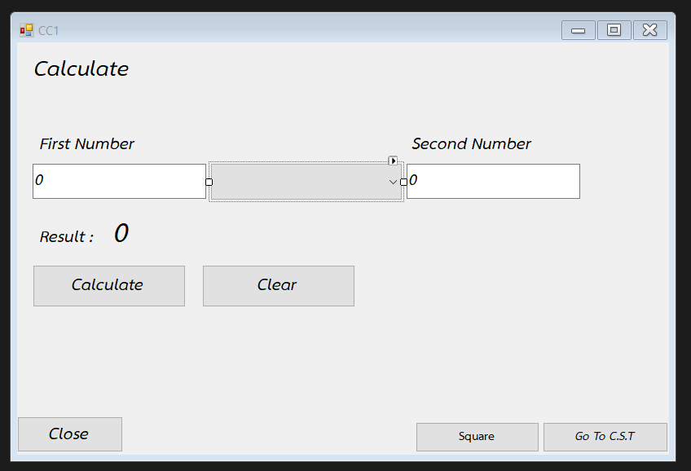

***Form2.cs (C.S.T.)***

using System;

using System.Collections.Generic;

using System.ComponentModel;

using System.Data;

using System.Drawing;

using System.Linq;

using System.Text;

using System.Windows.Forms;

namespace CC

{

public partial class Form2 : Form

{

public Form2()

{

InitializeComponent();

}

private void label2_Click(object sender, EventArgs e)

{

}

private void CirRB_CheckedChanged(object sender, EventArgs e)

{

if (CirRB.Checked == true)

{

RadiusBox.Enabled = true;

HeightBox.Enabled = false;

WidthBox.Enabled = false;

RadiusBox.Focus();

}

}

private void hSqRB_CheckedChanged(object sender, EventArgs e)

{

if (hSqRB.Checked == true)

{

RadiusBox.Enabled = false;

HeightBox.Enabled = true;

WidthBox.Enabled = true;

RadiusBox.Focus();

}

}

private void Tri_CheckedChanged(object sender, EventArgs e)

{

if (TriRB.Checked == true)

{

RadiusBox.Enabled = false;

HeightBox.Enabled = true;

WidthBox.Enabled = true;

RadiusBox.Focus();

}

}

private void EnterBT_Click(object sender, EventArgs e)

{

float radius, height, width, resultL;

double Z;

//Cir

if (CirRB.Checked == true)

{

if (RadiusBox.Text == "")

{

MessageBox.Show("Please Insert Radius");

}

else

{

radius = float.Parse(RadiusBox.Text);

resultL = (22 / 7) * radius * radius;

resultLab.Text = resultL.ToString();

}

}

//Square

else if (hSqRB.Checked == true)

{

if (HeightBox.Text == "")

{

MessageBox.Show("Please Insert Number height");

}

else if (WidthBox.Text == "")

{

MessageBox.Show("Please Insert Number width");

}

else

{

height = float.Parse(HeightBox.Text);

width = float.Parse(WidthBox.Text);

resultL = height * width;

resultLab.Text = resultL.ToString();

}

}

//Triangle

else if (TriRB.Checked == true)

{

if (HeightBox.Text == "")

{

MessageBox.Show("Please Insert Number height");

}

else if (WidthBox.Text == "")

{

MessageBox.Show("Please Insert Number width");

}

else

{

height = float.Parse(HeightBox.Text);

width = float.Parse(WidthBox.Text);

Z = (0.5) * height * width;

resultLab.Text = Z.ToString("#.00");

}

}

else

{

MessageBox.Show("Please input value", "Error", MessageBoxButtons.OKCancel, MessageBoxIcon.Error);

}

}

private void GTCalculate_Click(object sender, EventArgs e)

{

this.Hide();

Form1 form = new Form1();

form.Show();

}

private void ClearBT_Click(object sender, EventArgs e)

{

RadiusBox.Clear();

HeightBox.Clear();

WidthBox.Clear();

resultLab.Clear();

}

private void GTS_Click(object sender, EventArgs e)

{

this.Hide();

Form3 form = new Form3();

form.Show();

}

private void Close_Click(object sender, EventArgs e)

{

MessageBox.Show("Bye");

Close();

}

}

}

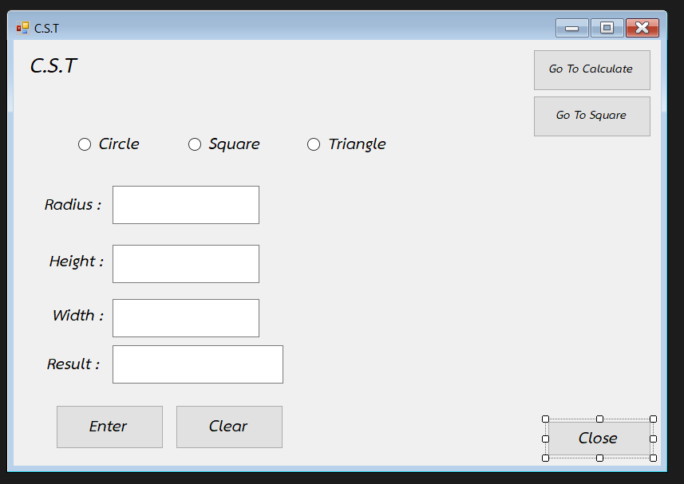

***Form3.cs (Square)***

using System;

using System.Collections.Generic;

using System.ComponentModel;

using System.Data;

using System.Drawing;

using System.Linq;

using System.Text;

using System.Windows.Forms;

namespace CC

{

public partial class Form3 : Form

{

public Form3()

{

InitializeComponent();

}

private void hSq2_Click(object sender, EventArgs e)

{

double a, b;

a = double.Parse(FirstBox.Text);

b = double.Parse(SecBox.Text);

resultLab.Text = Square(a, b);

}

public string Square(double x, double y)

{

double z = 0;

if (MlistBox.Text == "Square(จัตุรัต)")

{

if (FirstBox.Text == "")

{

MessageBox.Show("Please insert NUM Side1");

}

else if (SecBox.Text == "")

{

MessageBox.Show("Please insert NUM Side2");

}

else

{

z = x * y;

}

}

else if (MlistBox.Text == "Rectangle(ผืนผ้า)")

{

if (FirstBox.Text == "")

{

MessageBox.Show("Please insert NUM Width");

}

else if (SecBox.Text == "")

{

MessageBox.Show("Please insert NUM Long");

}

else

{

z = x * y;

}

}

else if (MlistBox.Text == "Diamond(ขนมเปียกปูน)")

{

if (FirstBox.Text == "")

{

MessageBox.Show("Please insert NUM Base");

}

else if (SecBox.Text == "")

{

MessageBox.Show("Please insert NUM Height");

}

else

{

z = x * y;

}

}

else if (MlistBox.Text == "Parallelogram(ด้านขนาน)")

{

if (FirstBox.Text == "")

{

MessageBox.Show("Please insert NUM Base");

}

else if (SecBox.Text == "")

{

MessageBox.Show("Please insert NUM Height");

}

else

{

z = x * y;

}

}

return z.ToString();

}

private void MlistBox_SelectedIndexChanged(object sender, EventArgs e)

{

if (MlistBox.Text == "Square(จัตุรัต)")

{

text1.Text = "ด้าน";

text2.Text = "ด้าน";

}

else if (MlistBox.Text == "Rectangle(ผืนผ้า)")

{

text1.Text = "กว้าง";

text2.Text = "ยาว";

}

else if (MlistBox.Text == "Diamond(ขนมเปียกปูน)")

{

text1.Text = "ฐาน";

text2.Text = "สูง";

}

else if (MlistBox.Text == "Parallelogram(ด้านขนาน)")

{

text1.Text = "ฐาน";

text2.Text = "สูง";

}

}

private void GTCST_Click(object sender, EventArgs e)

{

this.Hide();

Form2 form = new Form2();

form.Show();

}

private void GTCalculate_Click(object sender, EventArgs e)

{

this.Hide();

Form1 form = new Form1();

form.Show();

}

private void Close_Click(object sender, EventArgs e)

{

MessageBox.Show("Bye");

Close();

}

private void ClearBT_Click(object sender, EventArgs e)

{

FirstBox.Text = "0";

SecBox.Text = "0";

resultLab.Text = "0";

}

}

}

