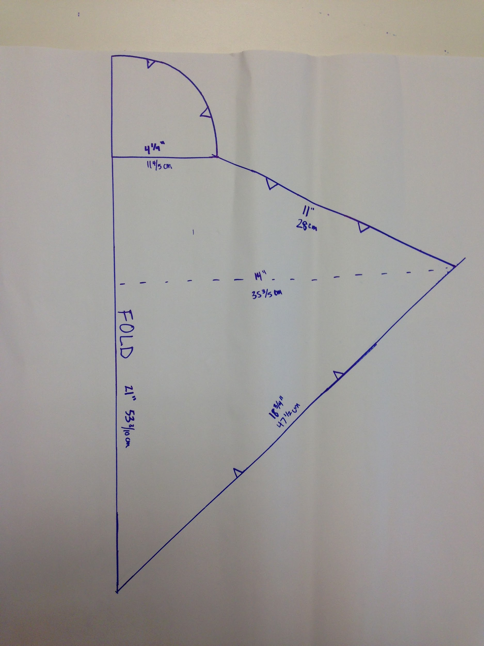
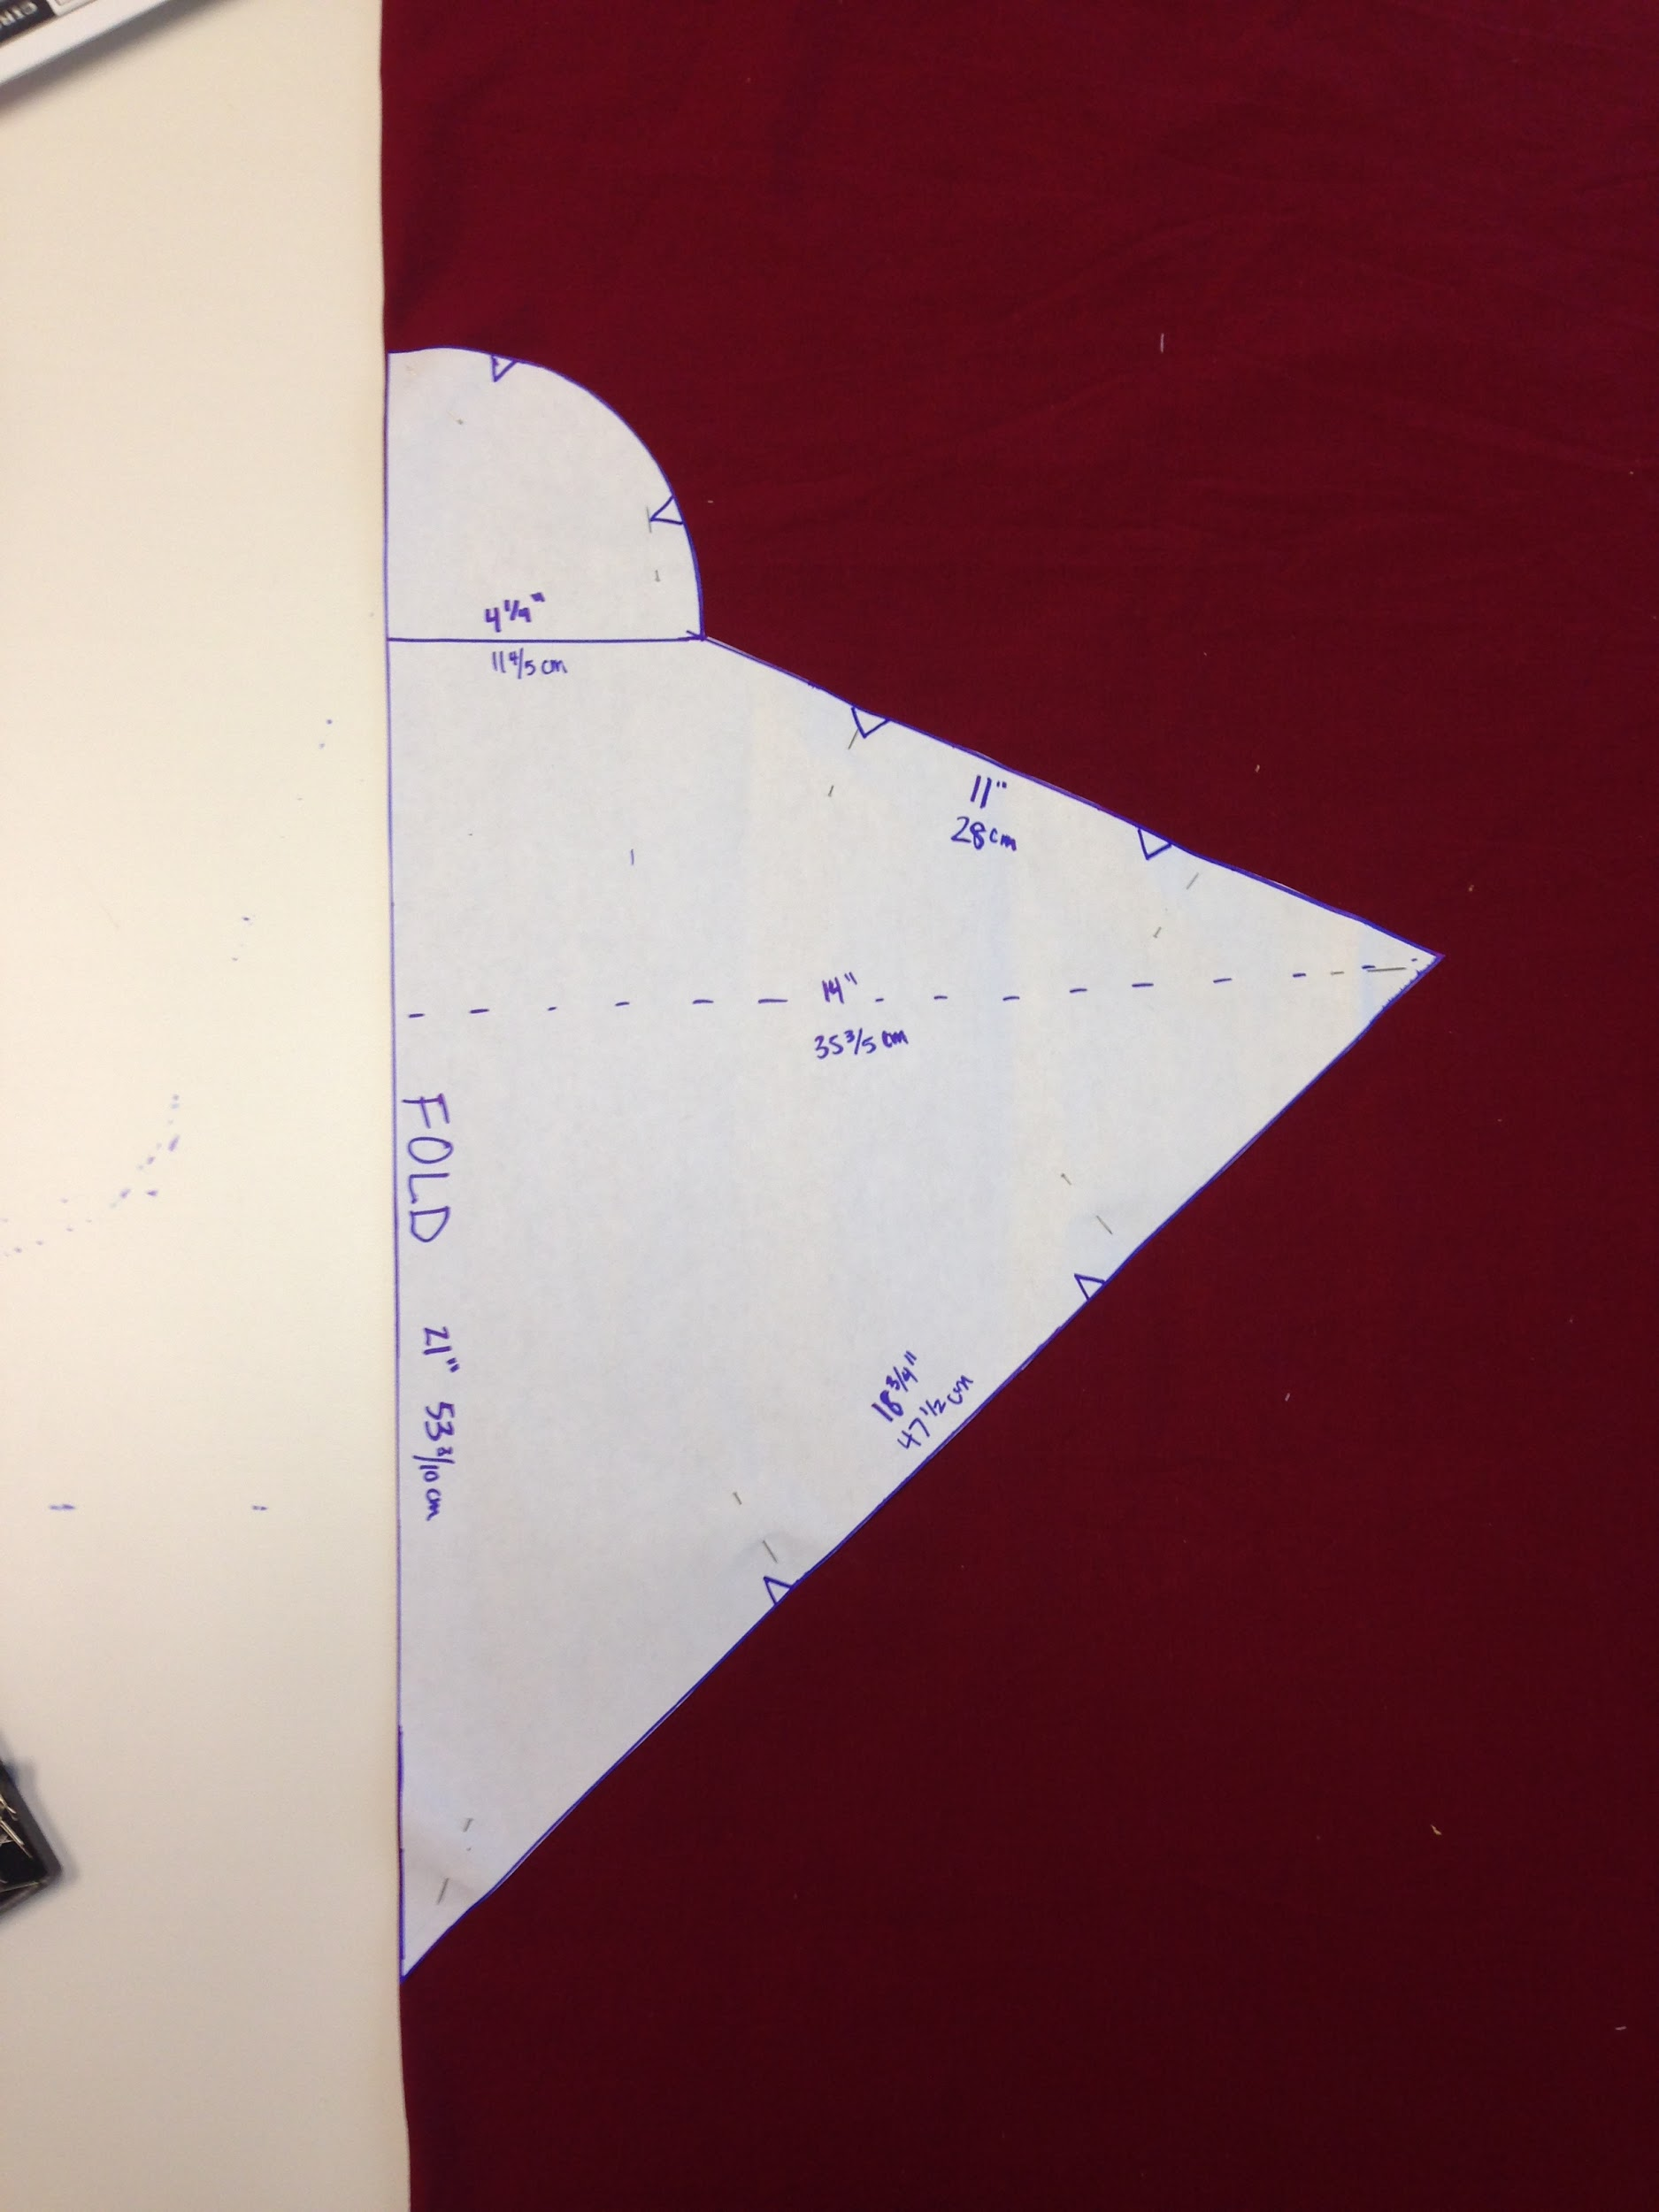
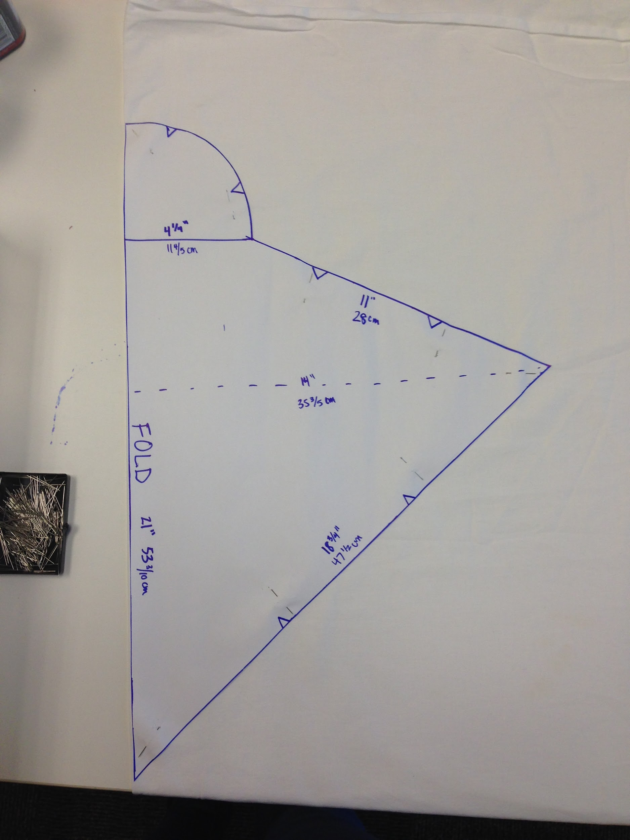
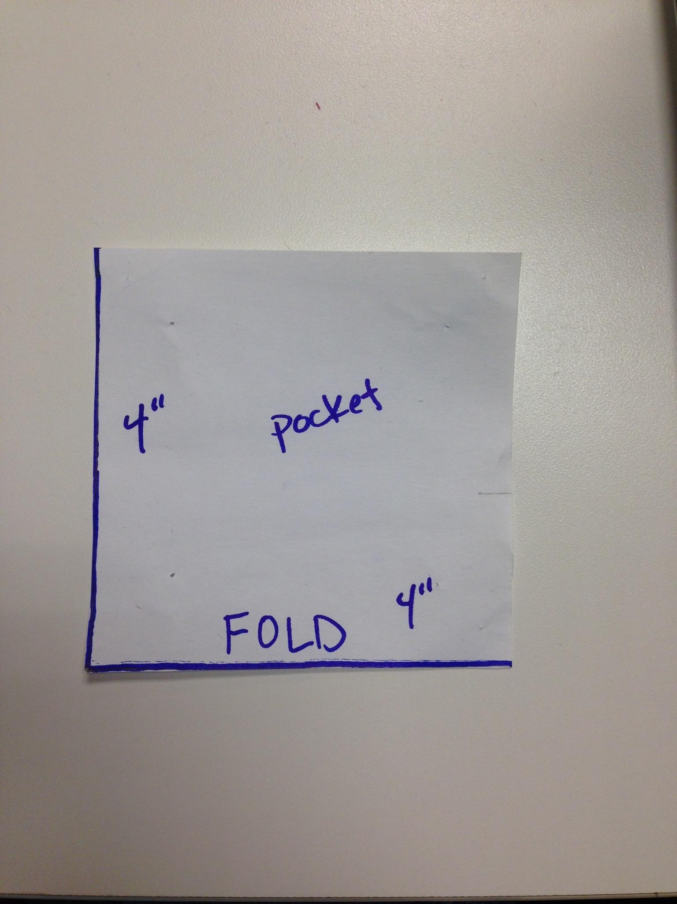
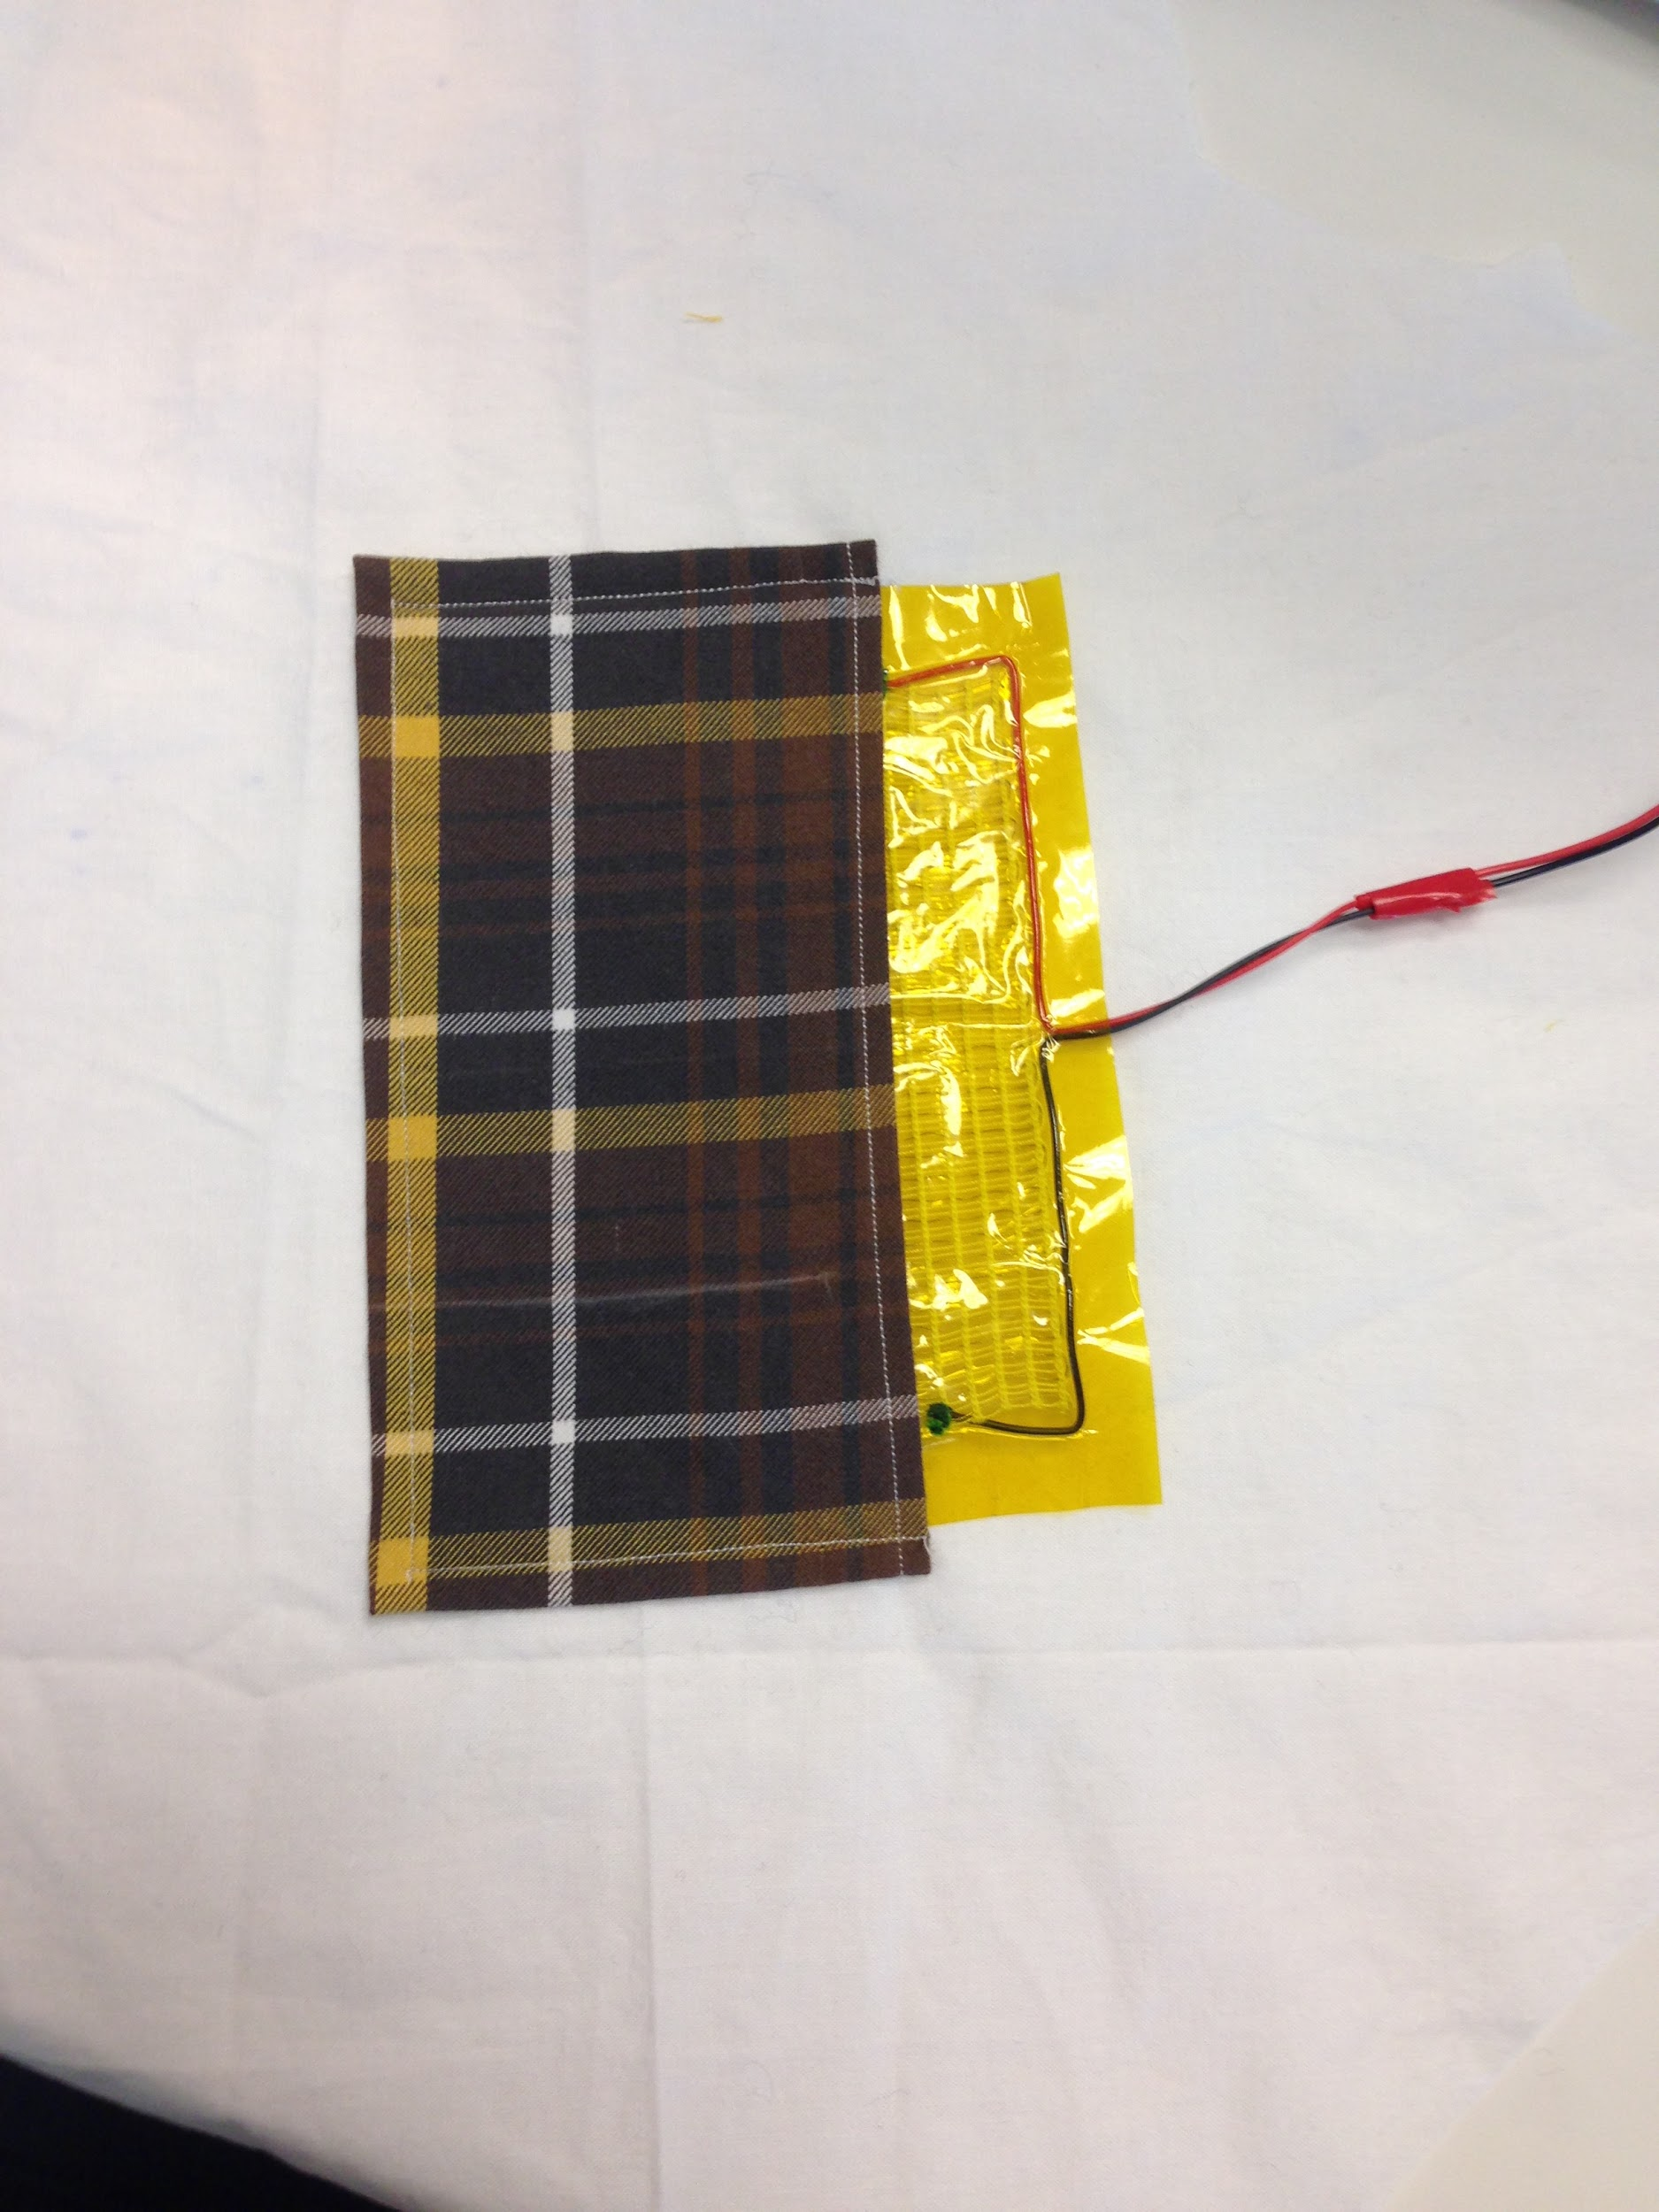
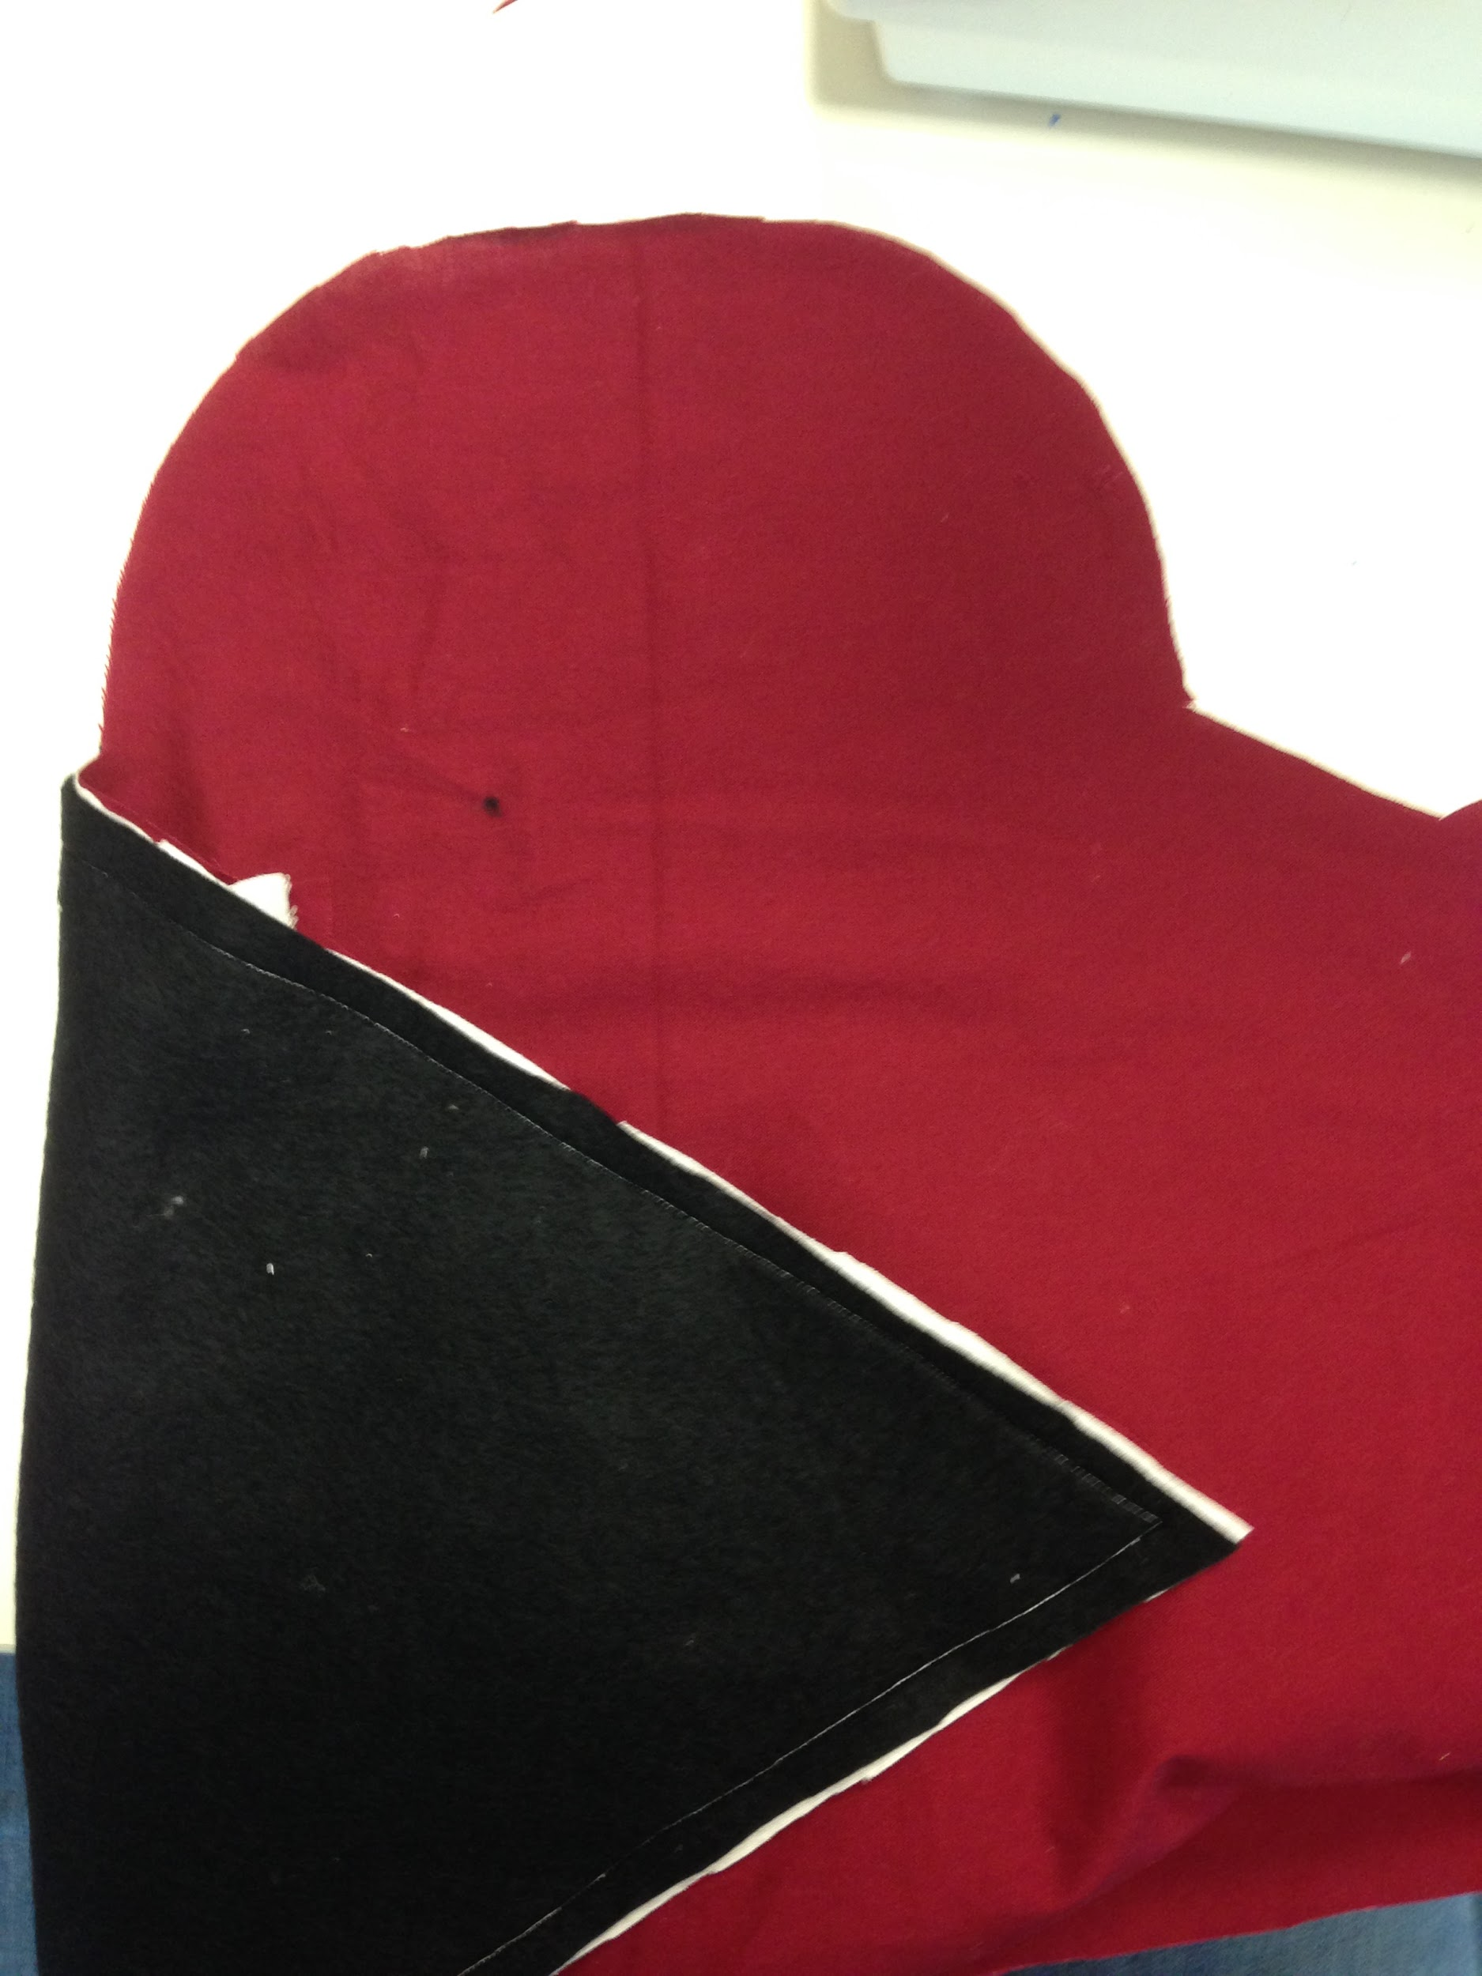
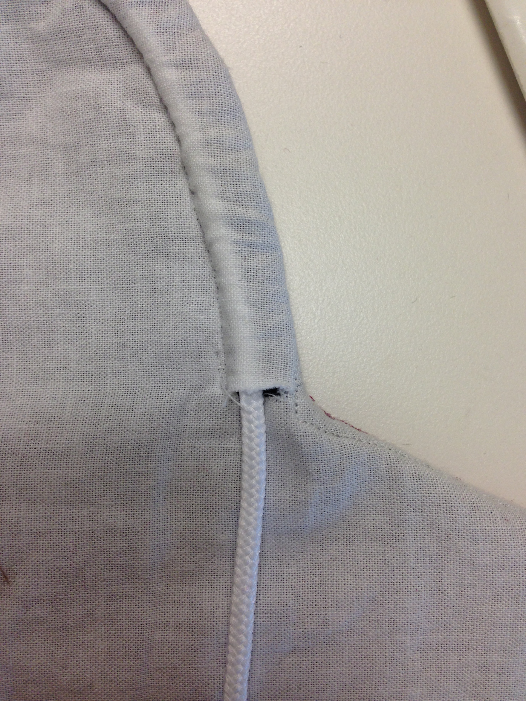
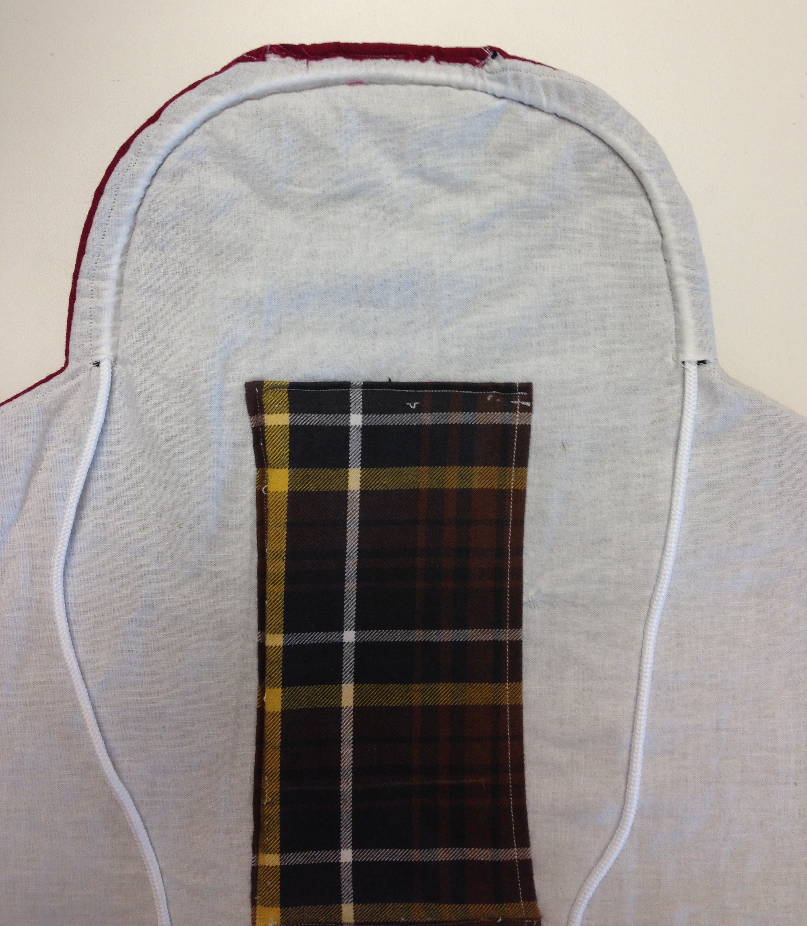
Step 1: Cut out pattern. See measurements on picture below.

Step 2: Fold outside fabric in half with. Pin pattern to fabric with long edge on the fold. Cut out pattern, making notches at designated arrows if desired.

Repeat step with other layers of fabric.

Step 3: Use pocket pattern to cut out pocket from fabric. Pin pattern to folding fabric with the FOLD along fold of fabric. Cut out pocket.
Step 4: Fold under and iron ¼” of fabric around edges of pocket fabric.

Step 5: Sew on right side long edge from top to bottom on pocket.

Step 6: Place pocket fold side down on the inner lining of the blanket fabric, and sew along all three remaining edges (top, left side and bottom side). Leave right long side open. This creates a pocket into which to slide the heating element.

Step 7: Sew blanket fabrics together. Make sure to place inner lining/insulation on the outside. Place inside of inner fabric against the outside of the outer fabric. Sew from top of “hoodie” around edges back to the top of the “hoodie” leaving 2 or 3 inch opening. Turn blanket inside out and finish opening with a hidden stitch.

Step 8: Cut small ¼ in. slots on the bottom of the hood. Sew a ¼ inch wide channel around outside of hood edge and thread a shoe lace or other thick string through channel to create a drawstring.

