PubMatic MCP Server Setup Guide for Claude Desktop
Version 1.0 | © PubMatic Inc. | Confidential

Overview
Use this guide to install and configure the PubMatic MCP Server extension in Claude Desktop. Follow the steps in order and use your provided credentials (Bearer Token, Resource ID, Resource Type).

Prerequisites
• Claude Desktop (latest release).
• Download and store provided PubMatic .MCPB file.
• Your PubMatic Bearer Token, Resource ID, and Resource Type (PUBLISHER/BUYER/DSP).

Install & Configure

Step 1: Locate the downloaded Pubmatic_MCP_Server.mcpb file on your computer. This file will be used to install the PubMatic MCP Server extension in Claude Desktop.

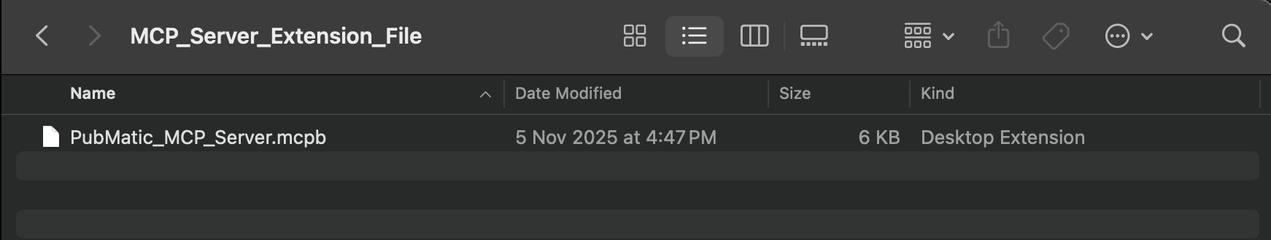

Step 2: Launch Claude Desktop. In the bottom-left corner, click on your username and then select Settings from the menu.
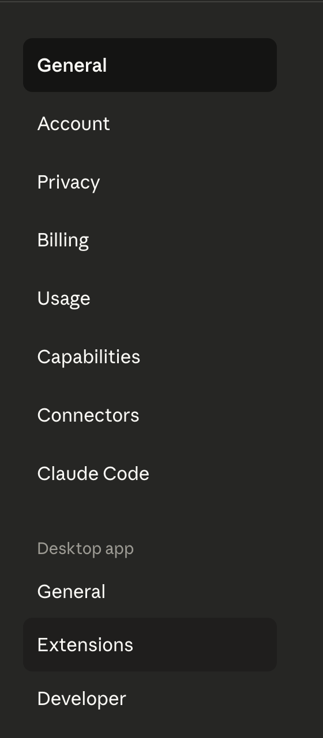

Step 3: Within the Settings panel, click on the Extensions option to open the list of available extensions
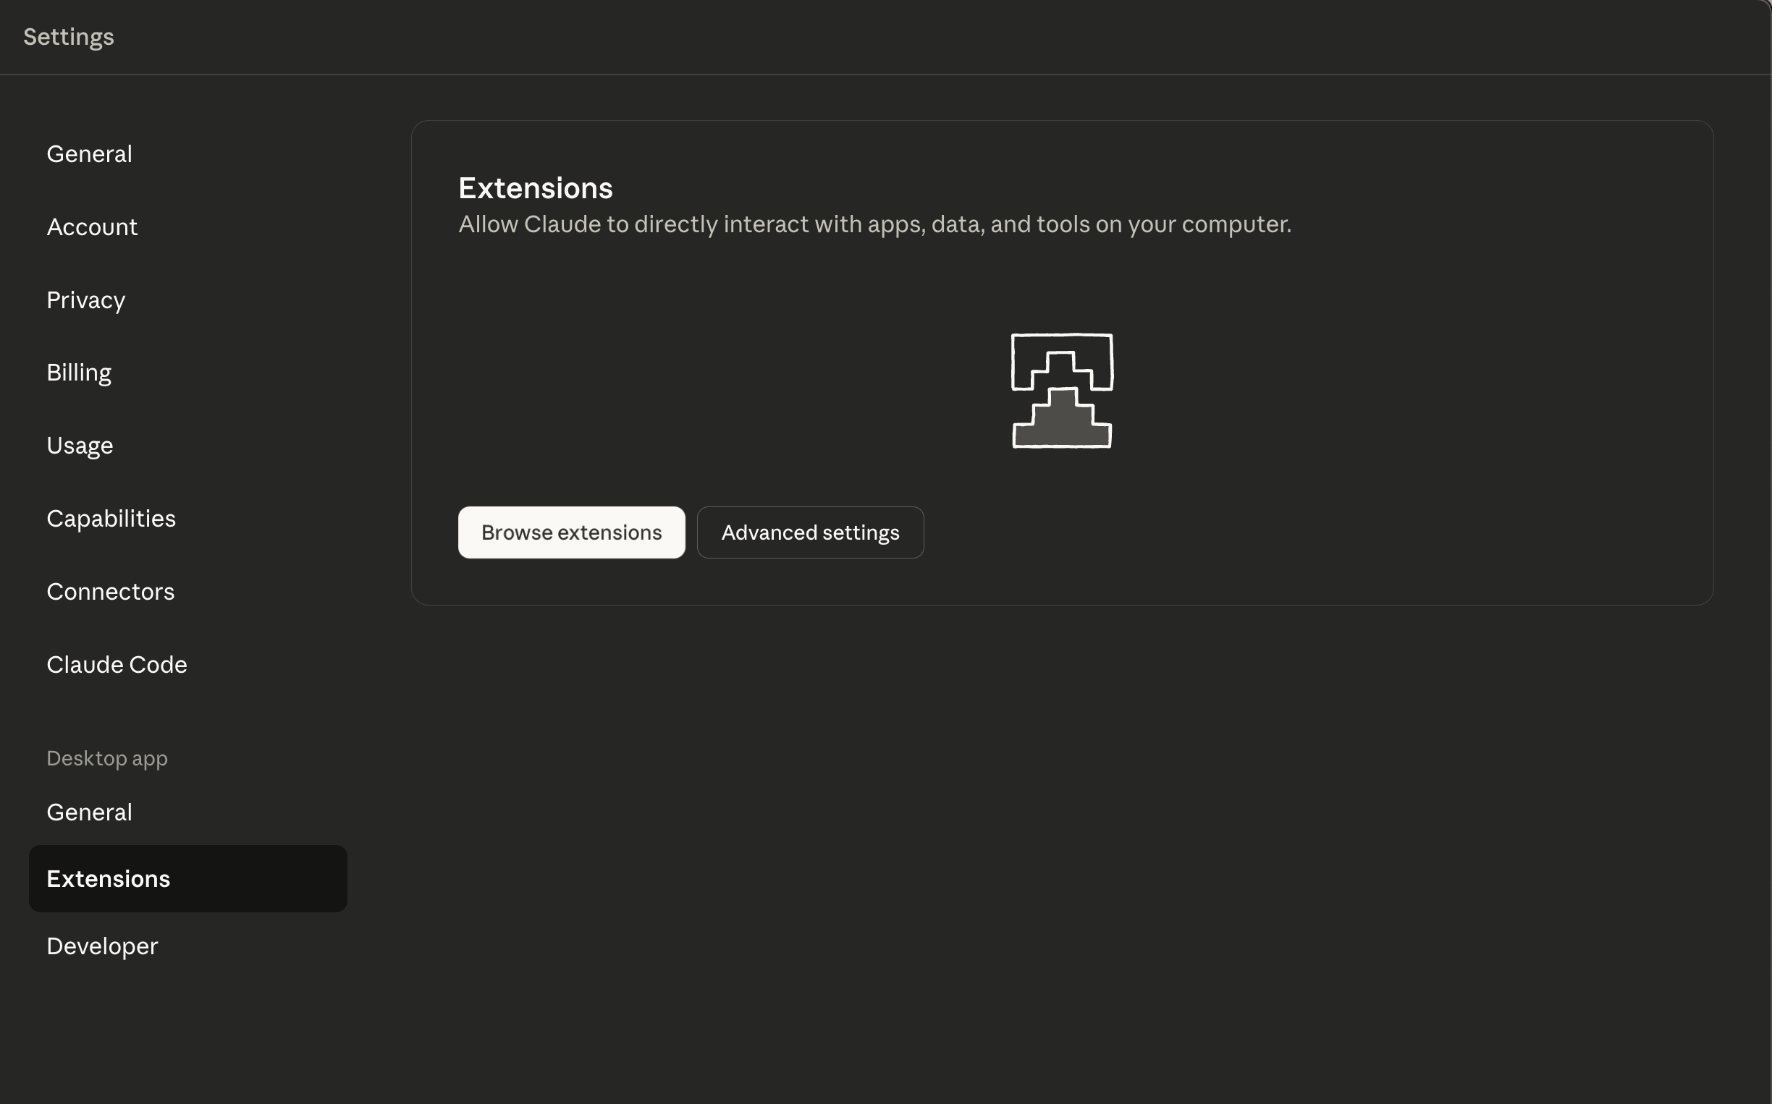

Step 4: Scroll to the bottom of the Extensions page and click Advanced settings to view developer and import options.
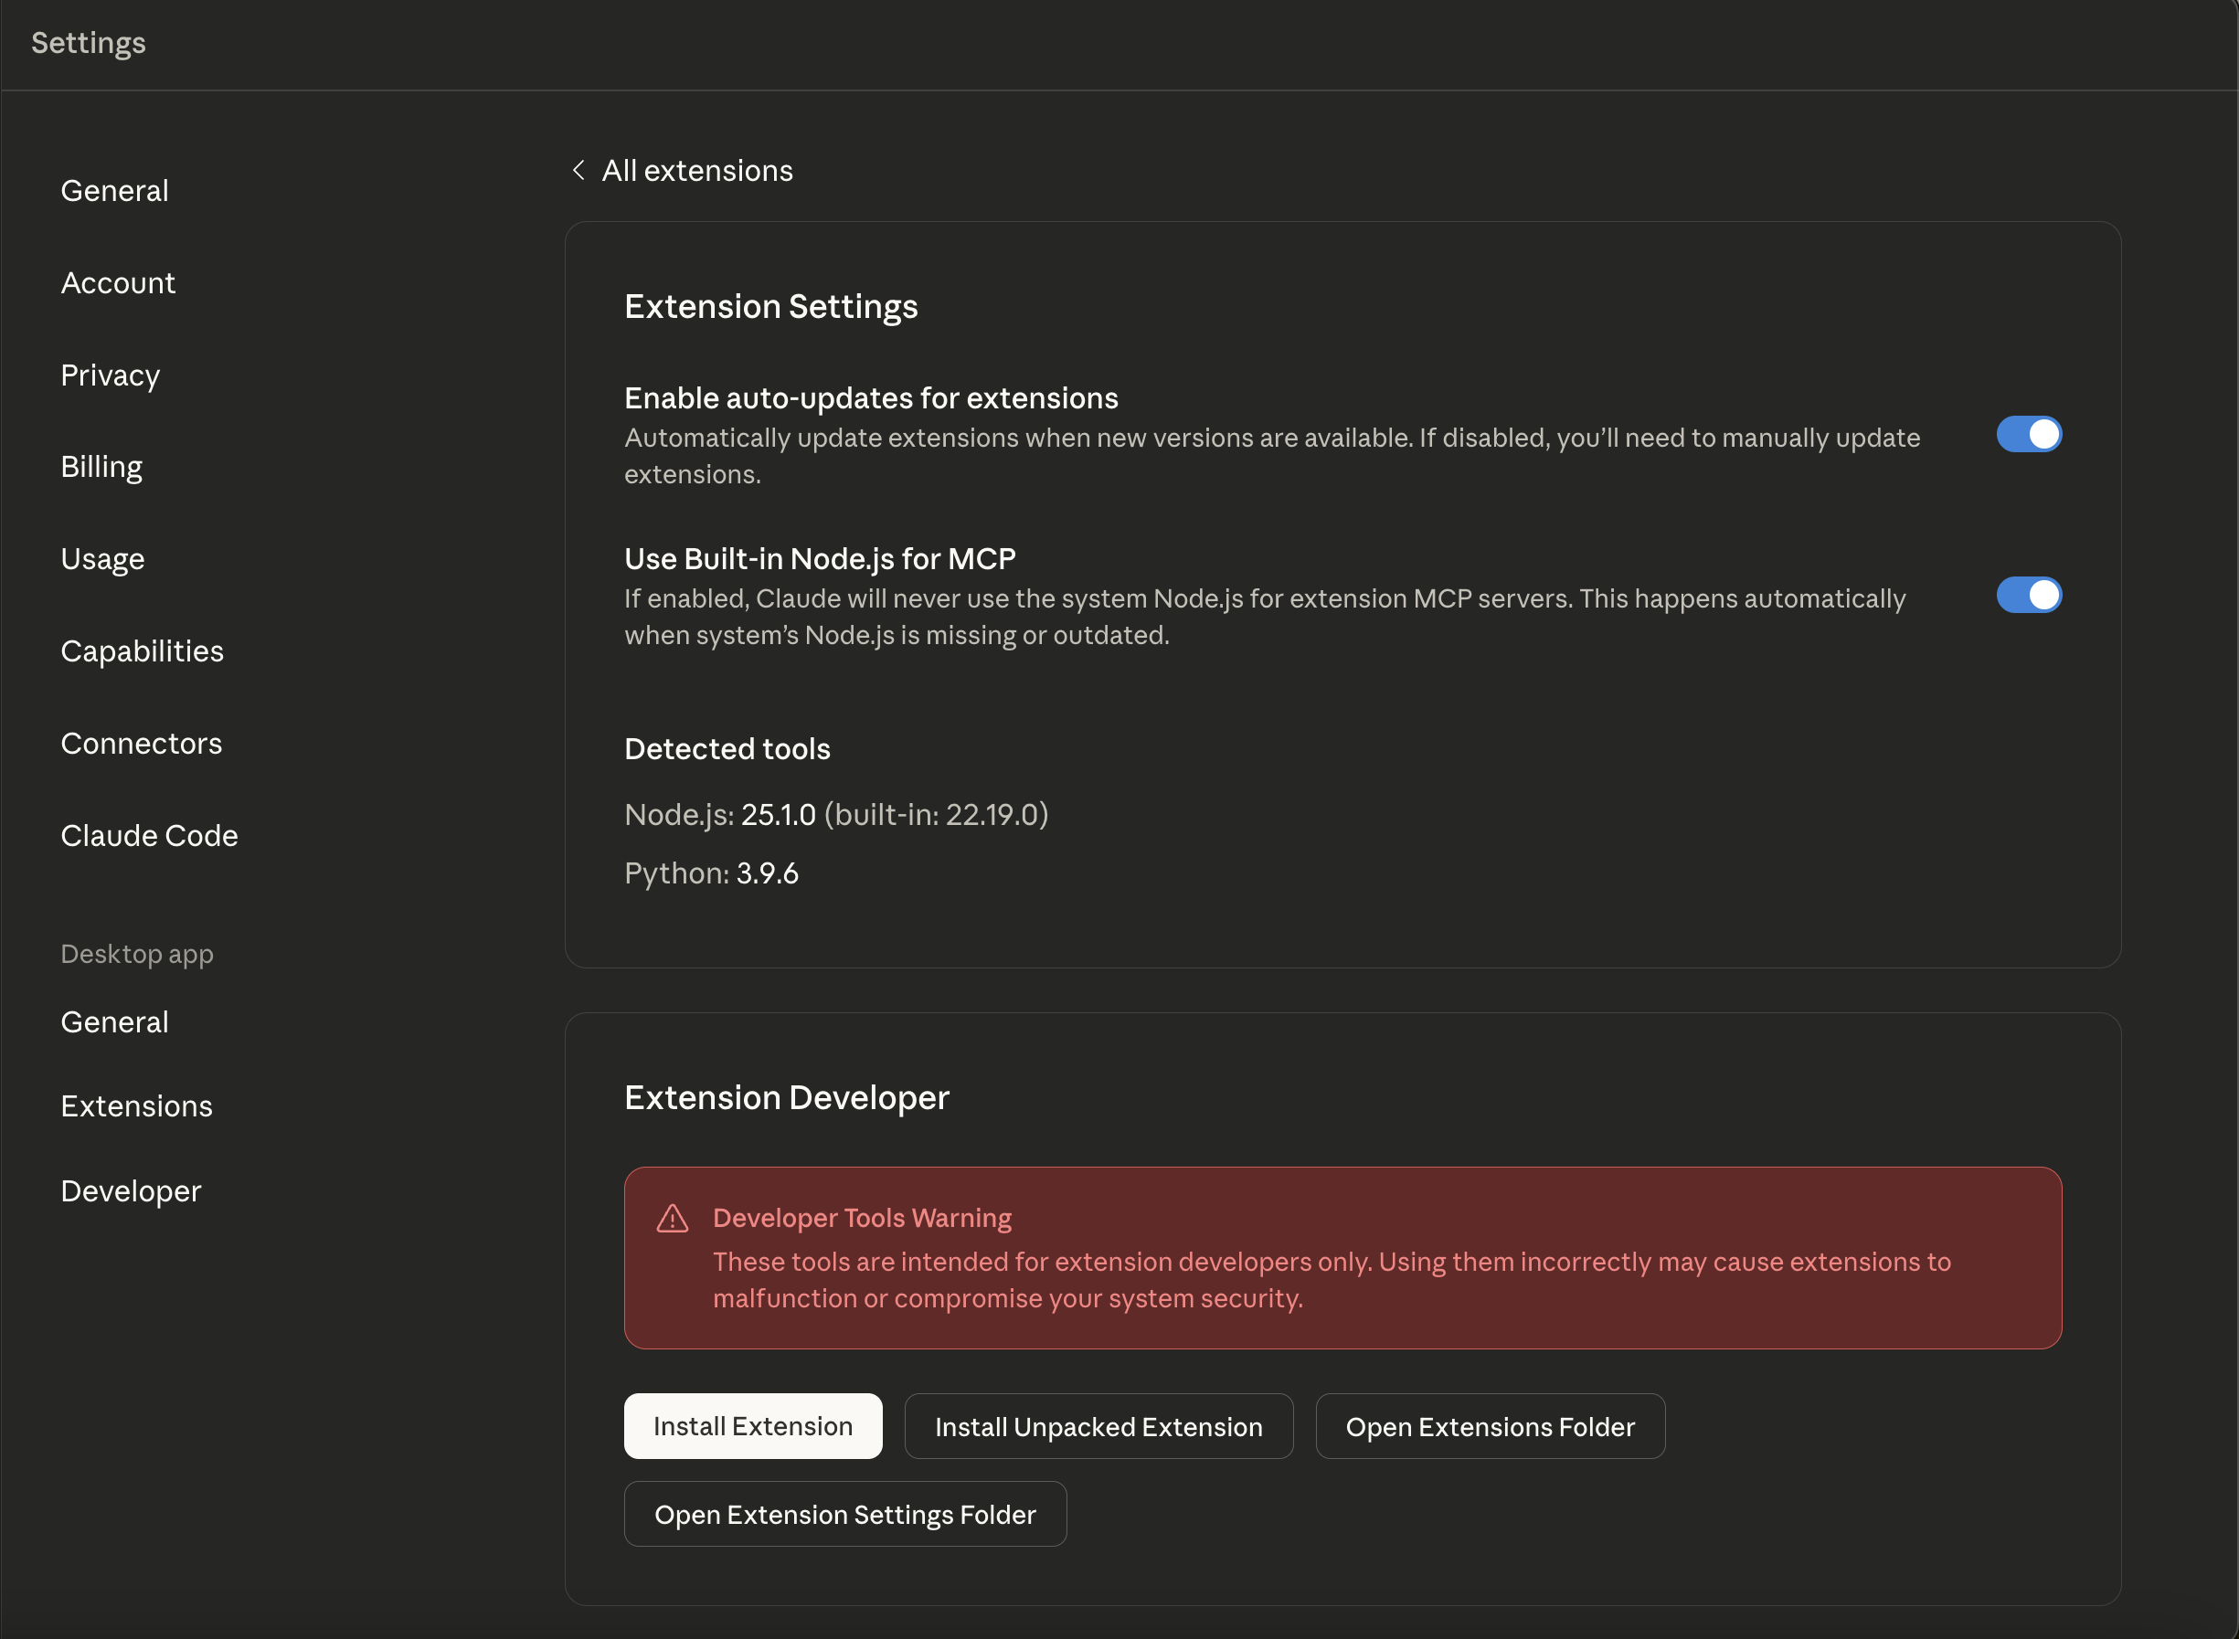

Step 5: Click Install Extension. A file browser window will appear — navigate to the folder where your .mcpb file is saved, select it, and proceed. The selected file will be displayed on screen.
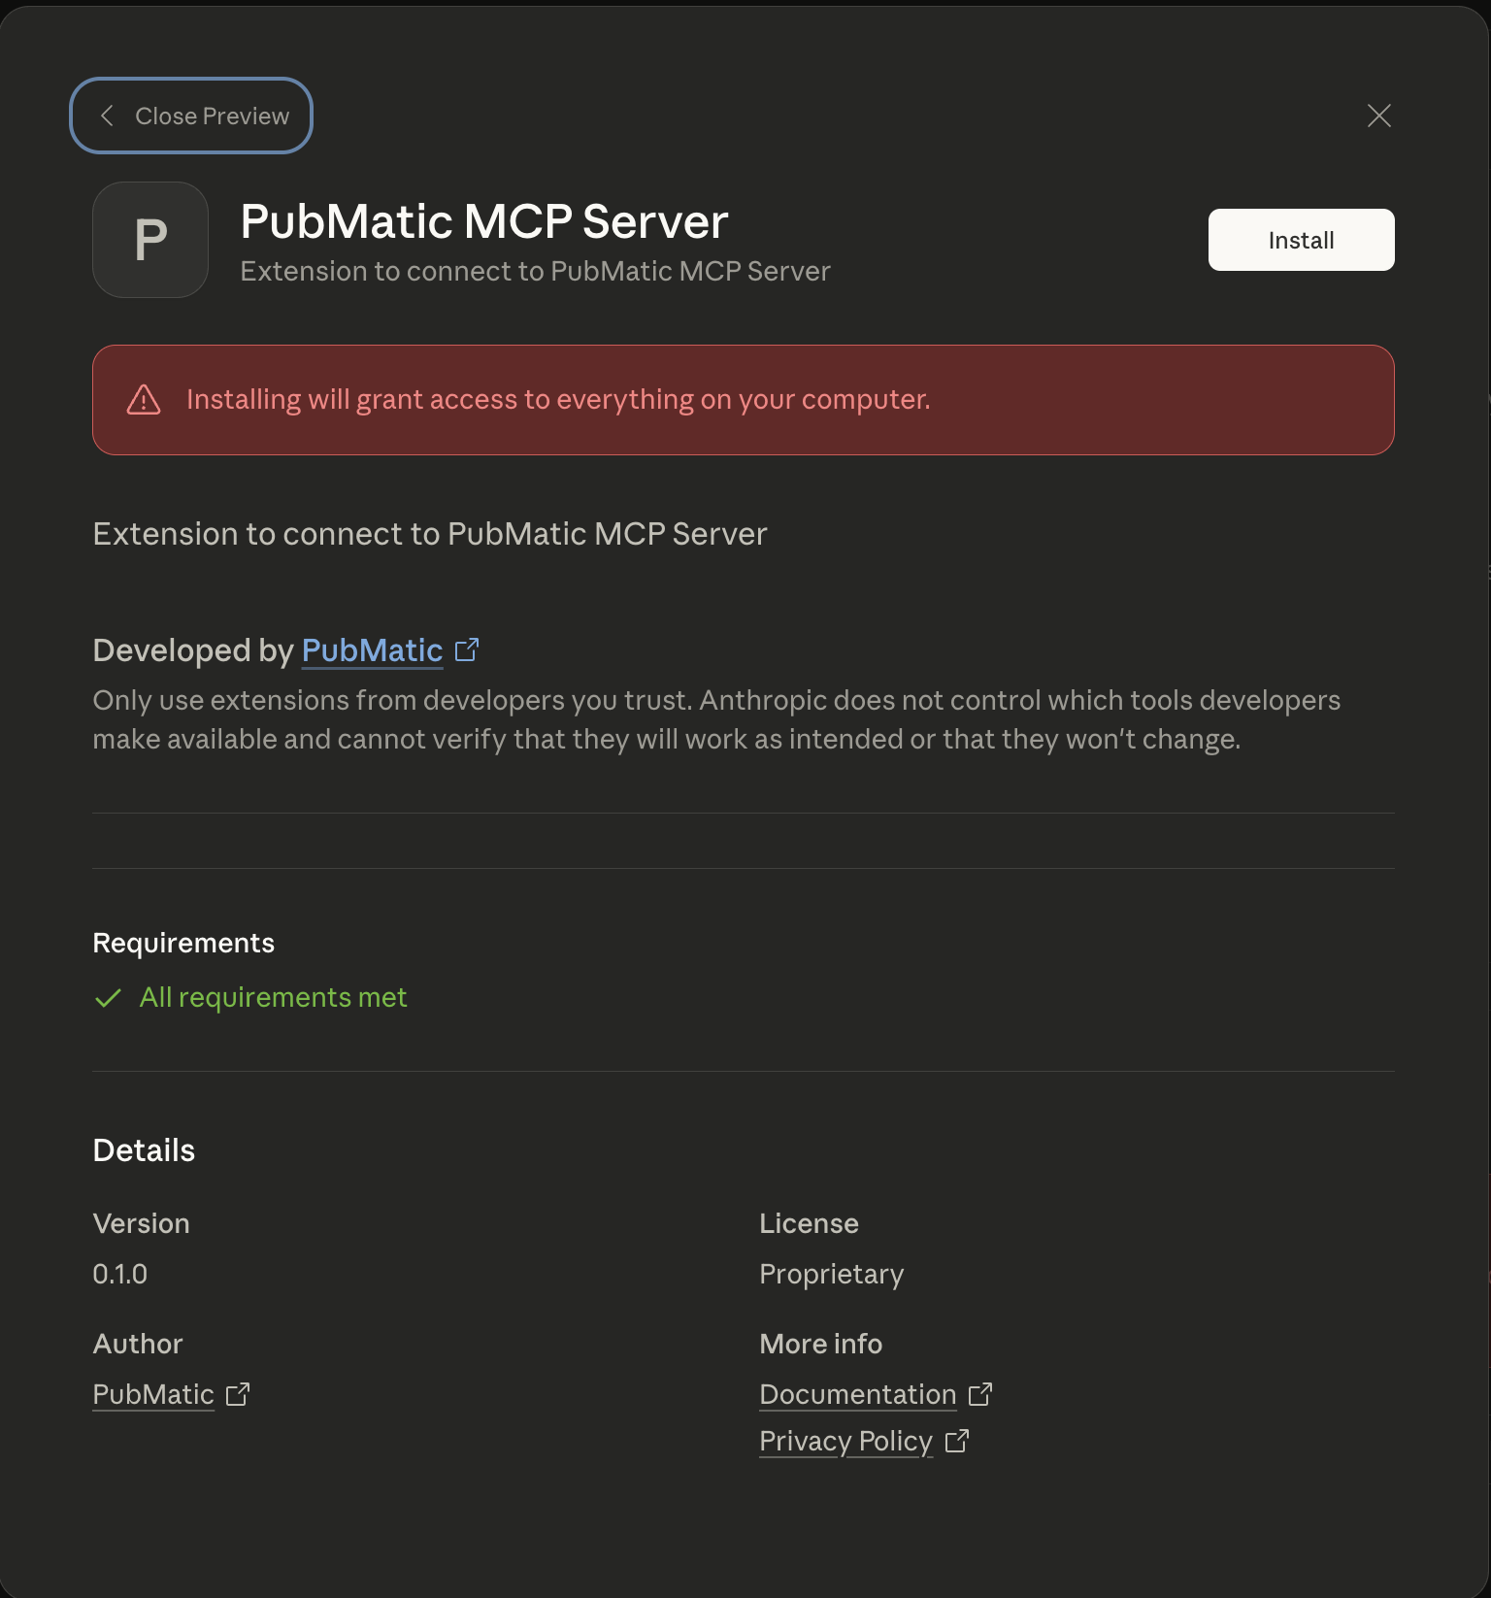

Step 6: Click Install next to the MCP Server extension name. A confirmation dialog will appear — click Install again to complete the installation
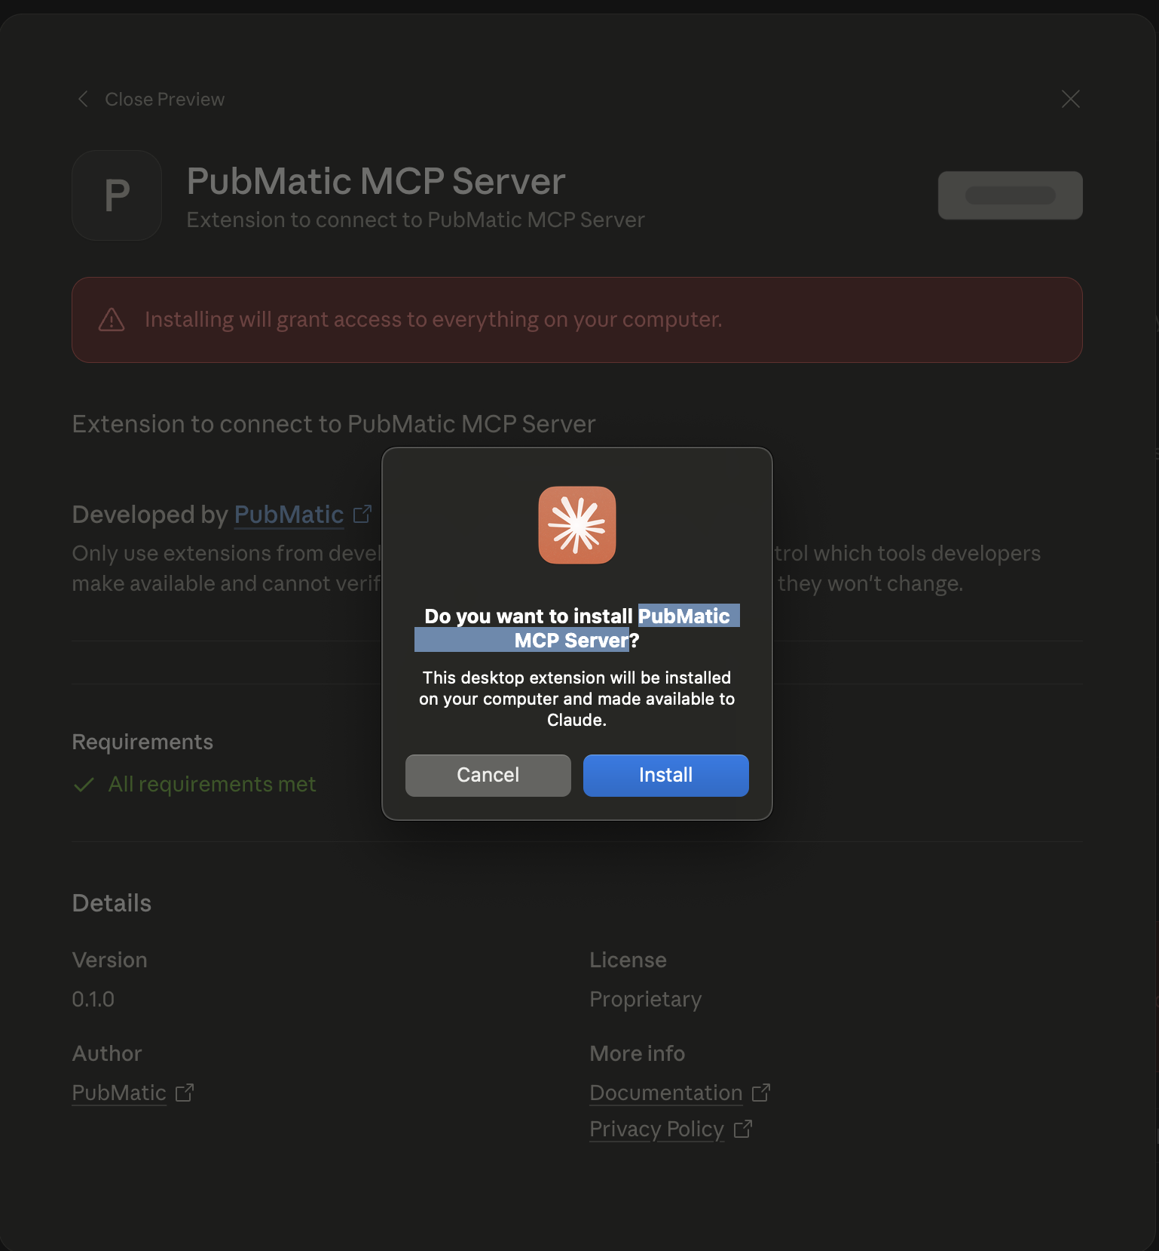

Step 7: A configuration screen will open requesting authentication details.
- Bearer Token – your PubMatic access token
- Resource ID – your PubMatic Publisher or DSP ID
- Resource Type – set to PUBLISHER or DSP as applicable
Click Save after filling in all fields.
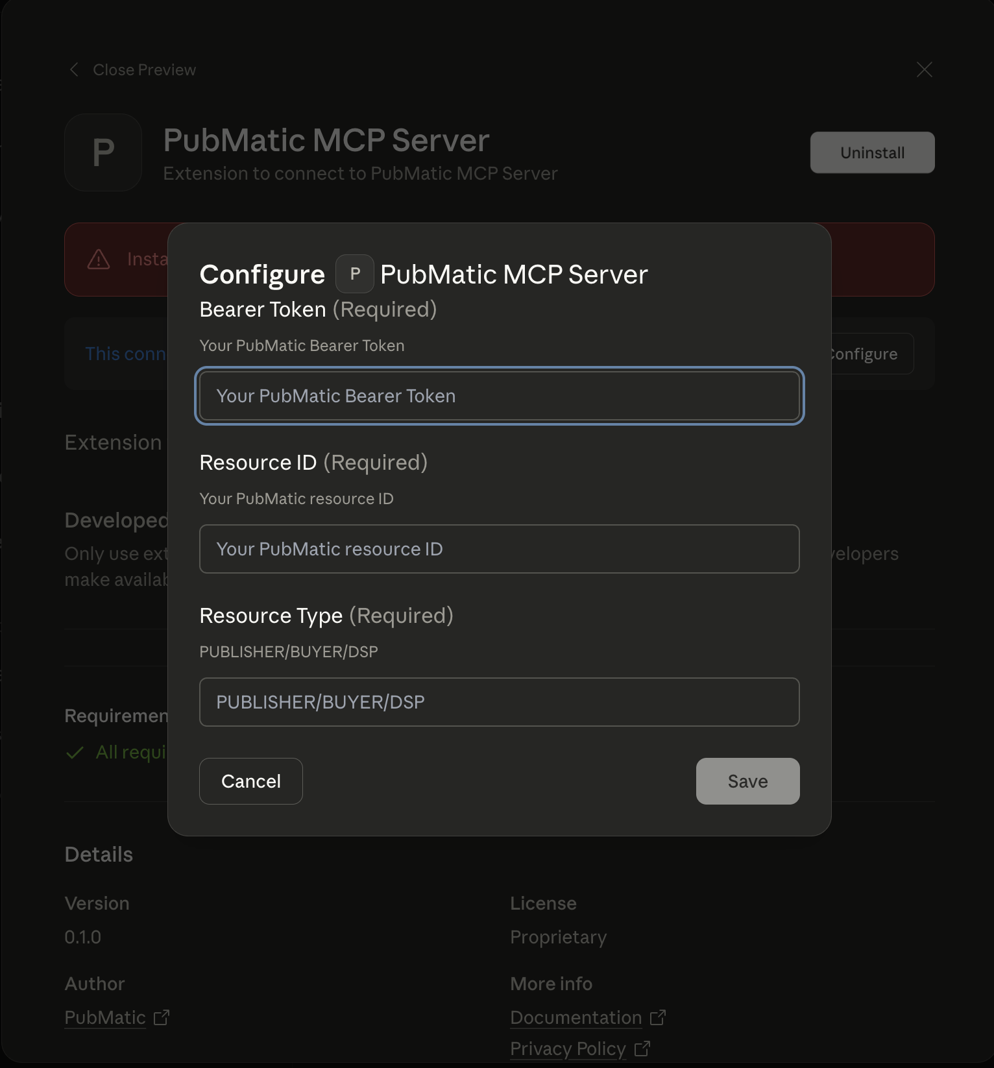
Step 8: The next screen shows the installed extension. If the toggle is off, switch it on to enable the extension, then close the screen by clicking the “×” icon.
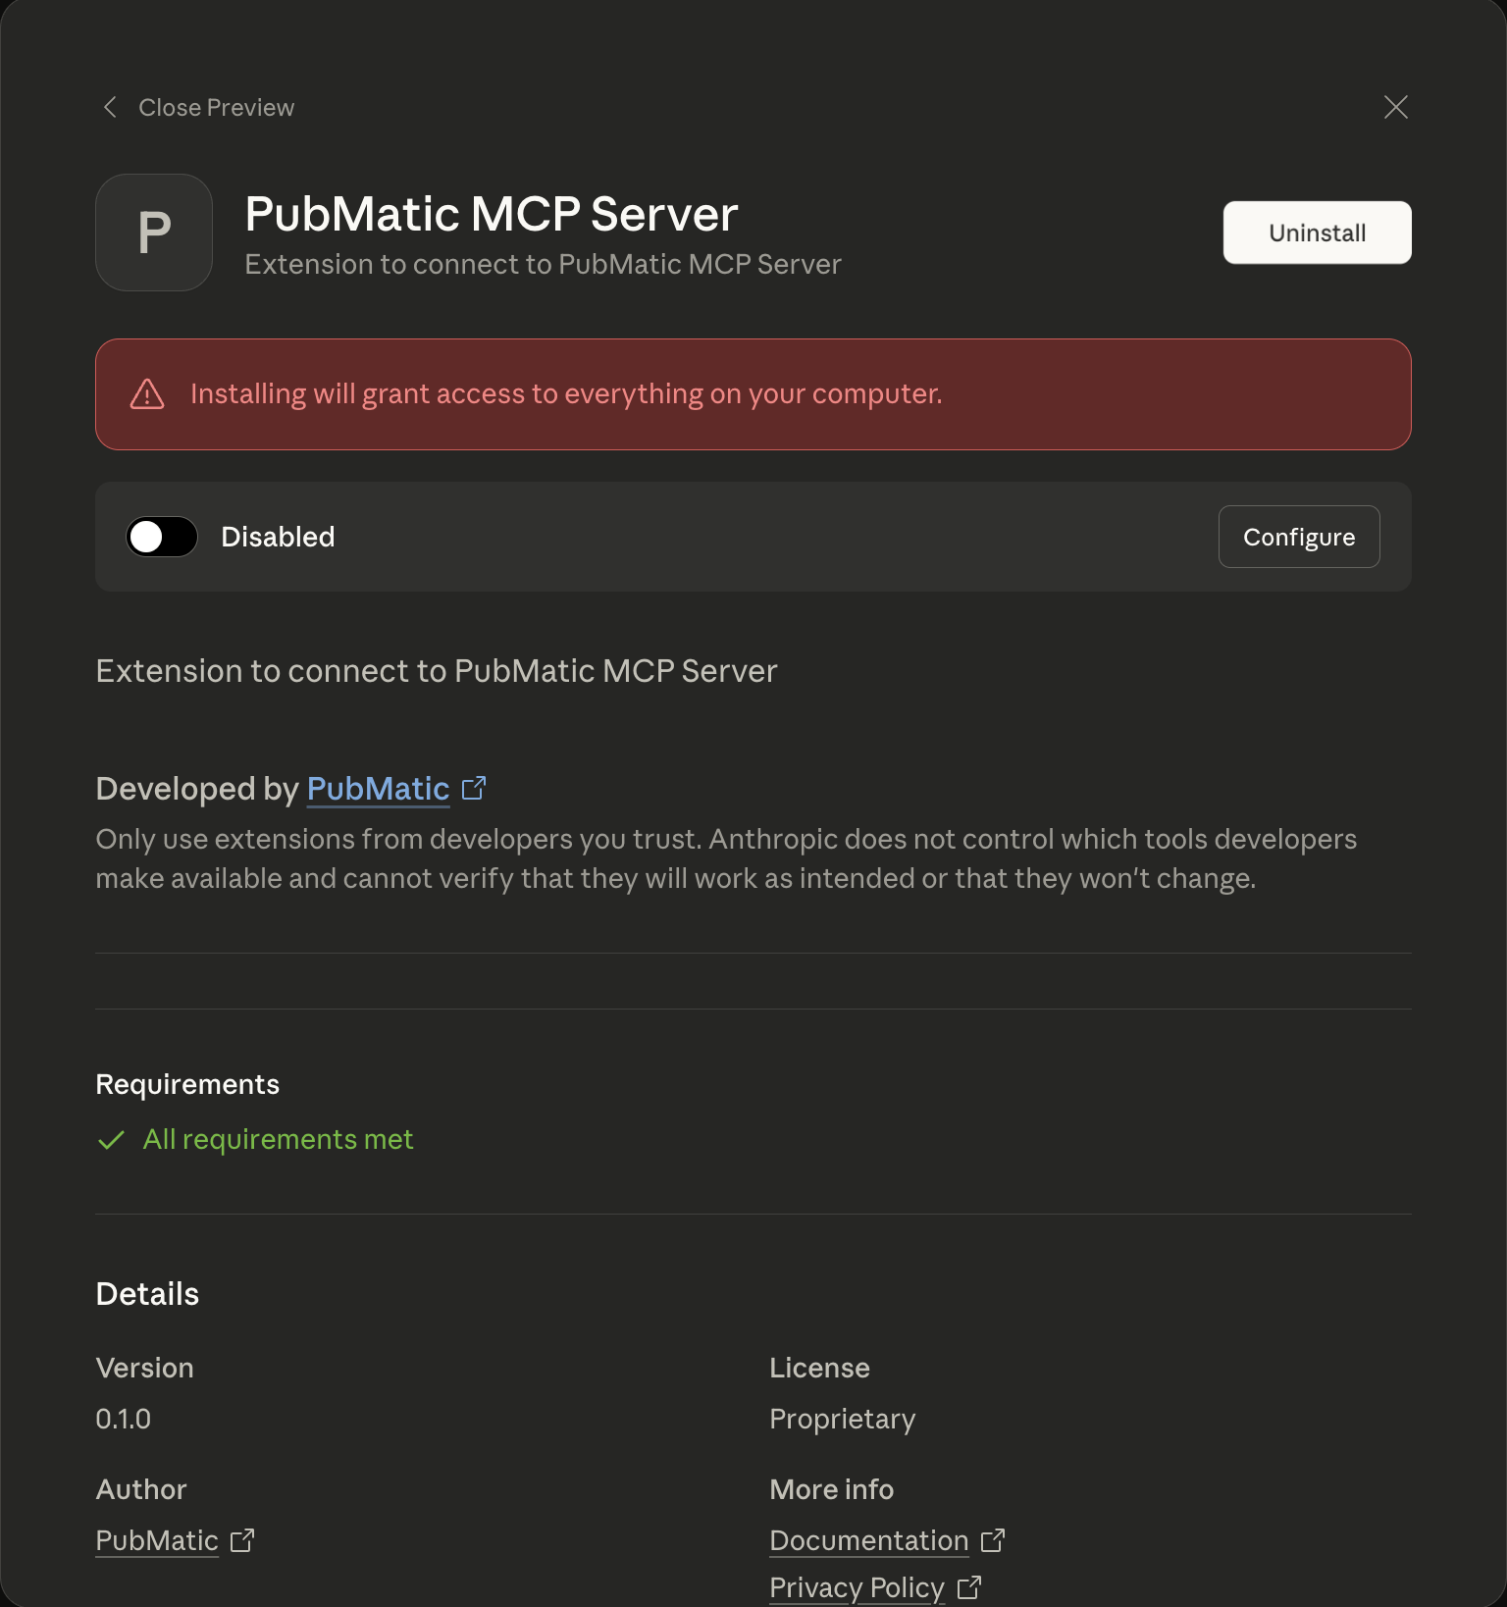
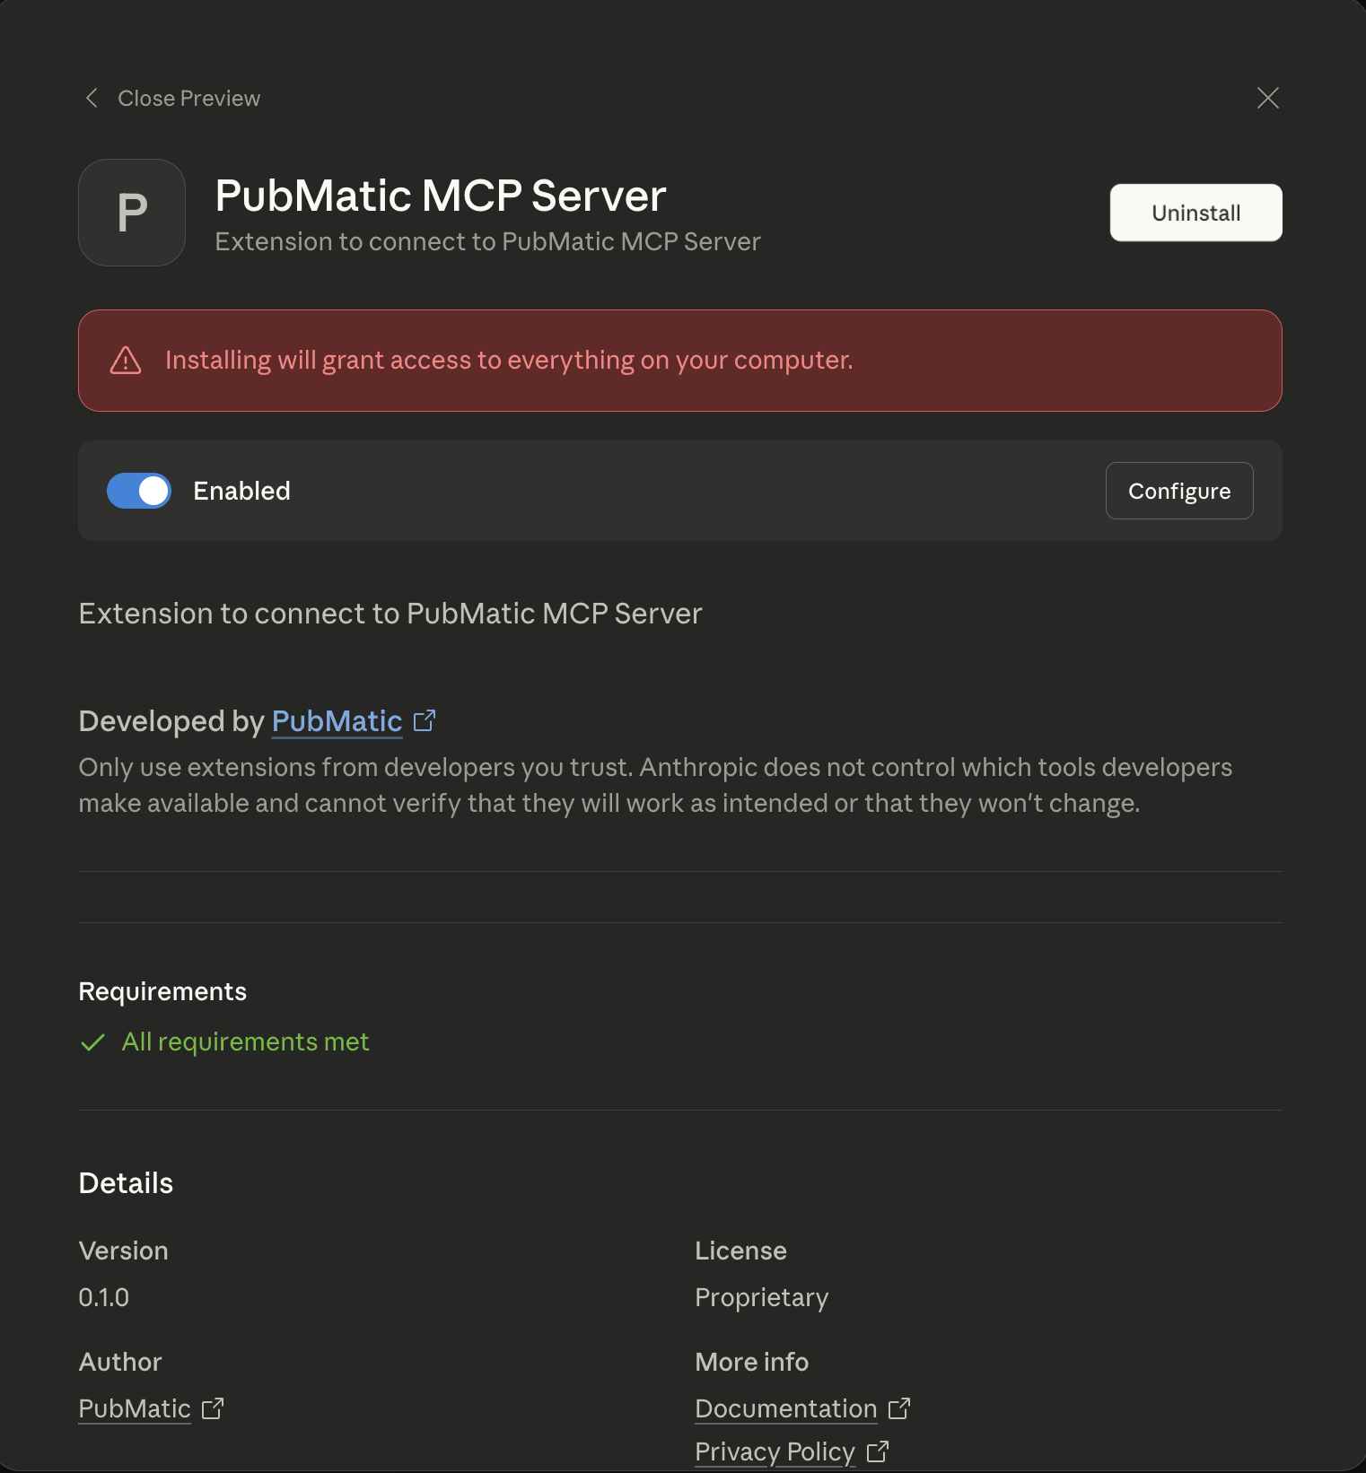

Step 9: Return to the Extensions section. You should now see the PubMatic MCP Server listed under installed extensions.
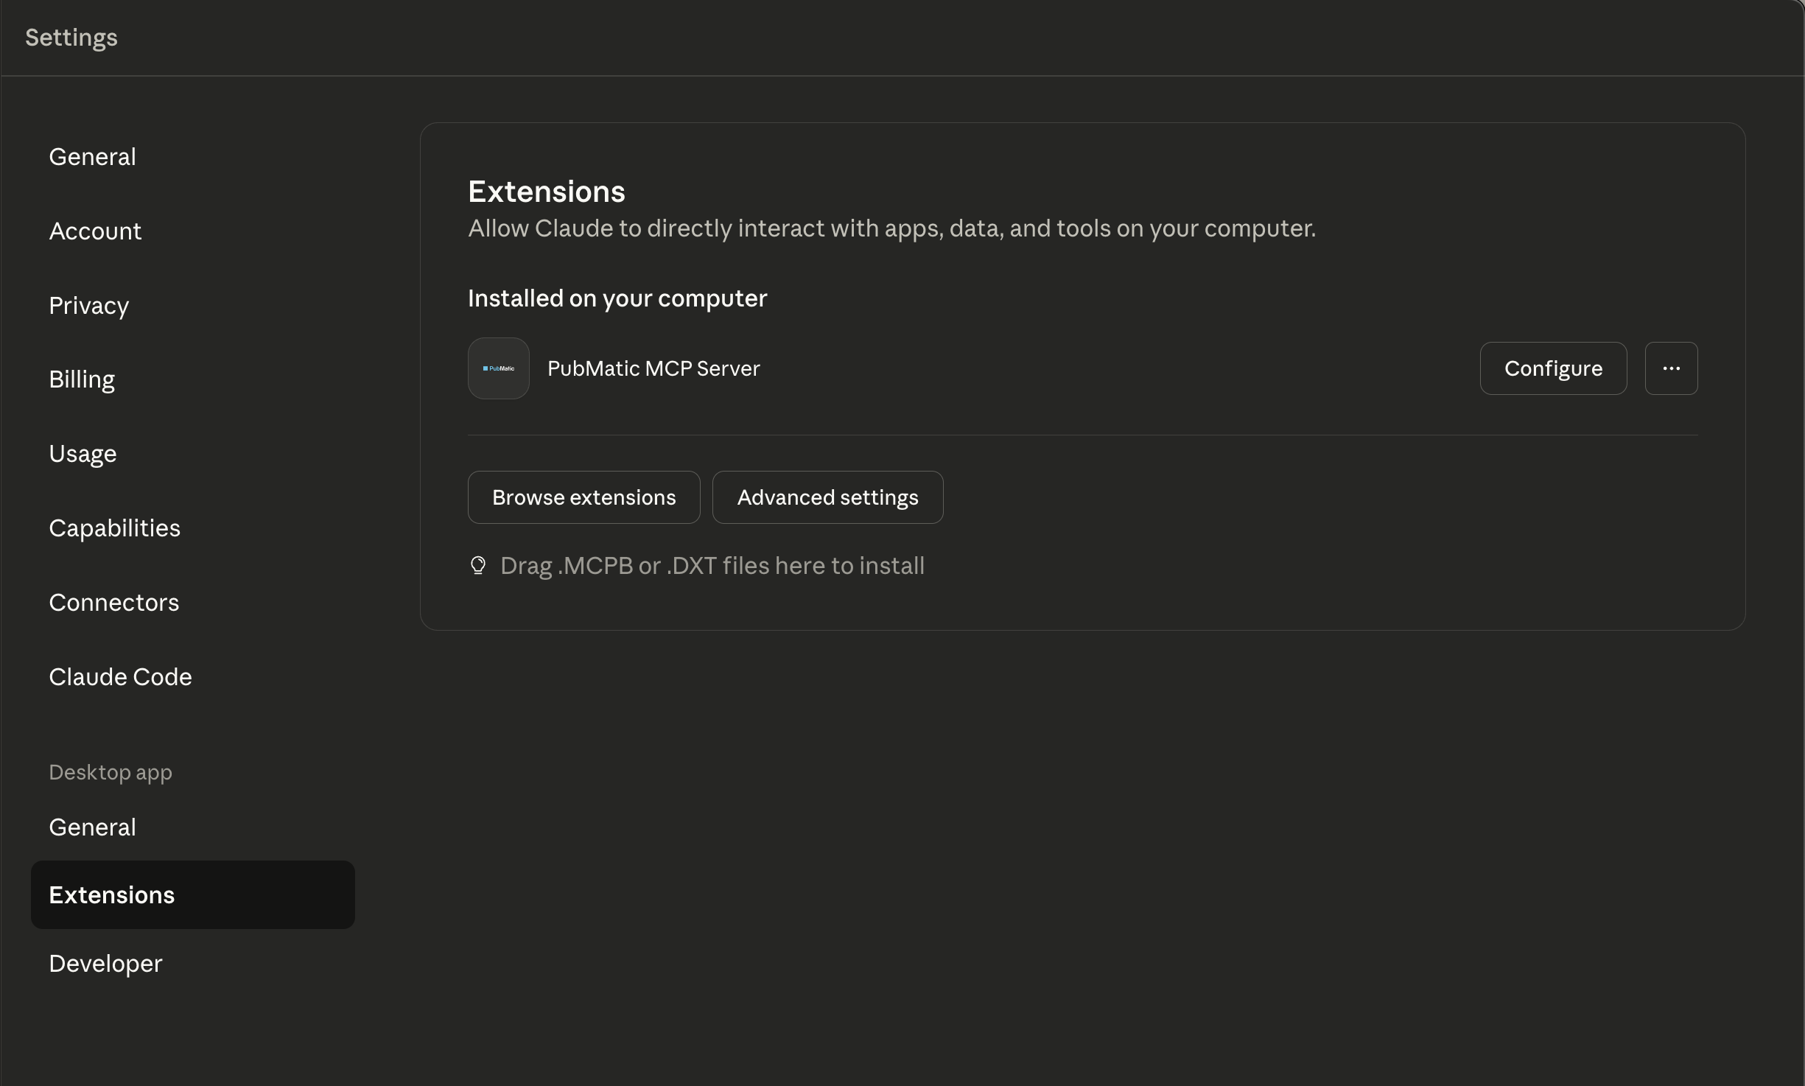

Step 10: Click Configure to verify installation. This screen will display the credentials you entered earlier and list the available tools or agents accessible through the extension.
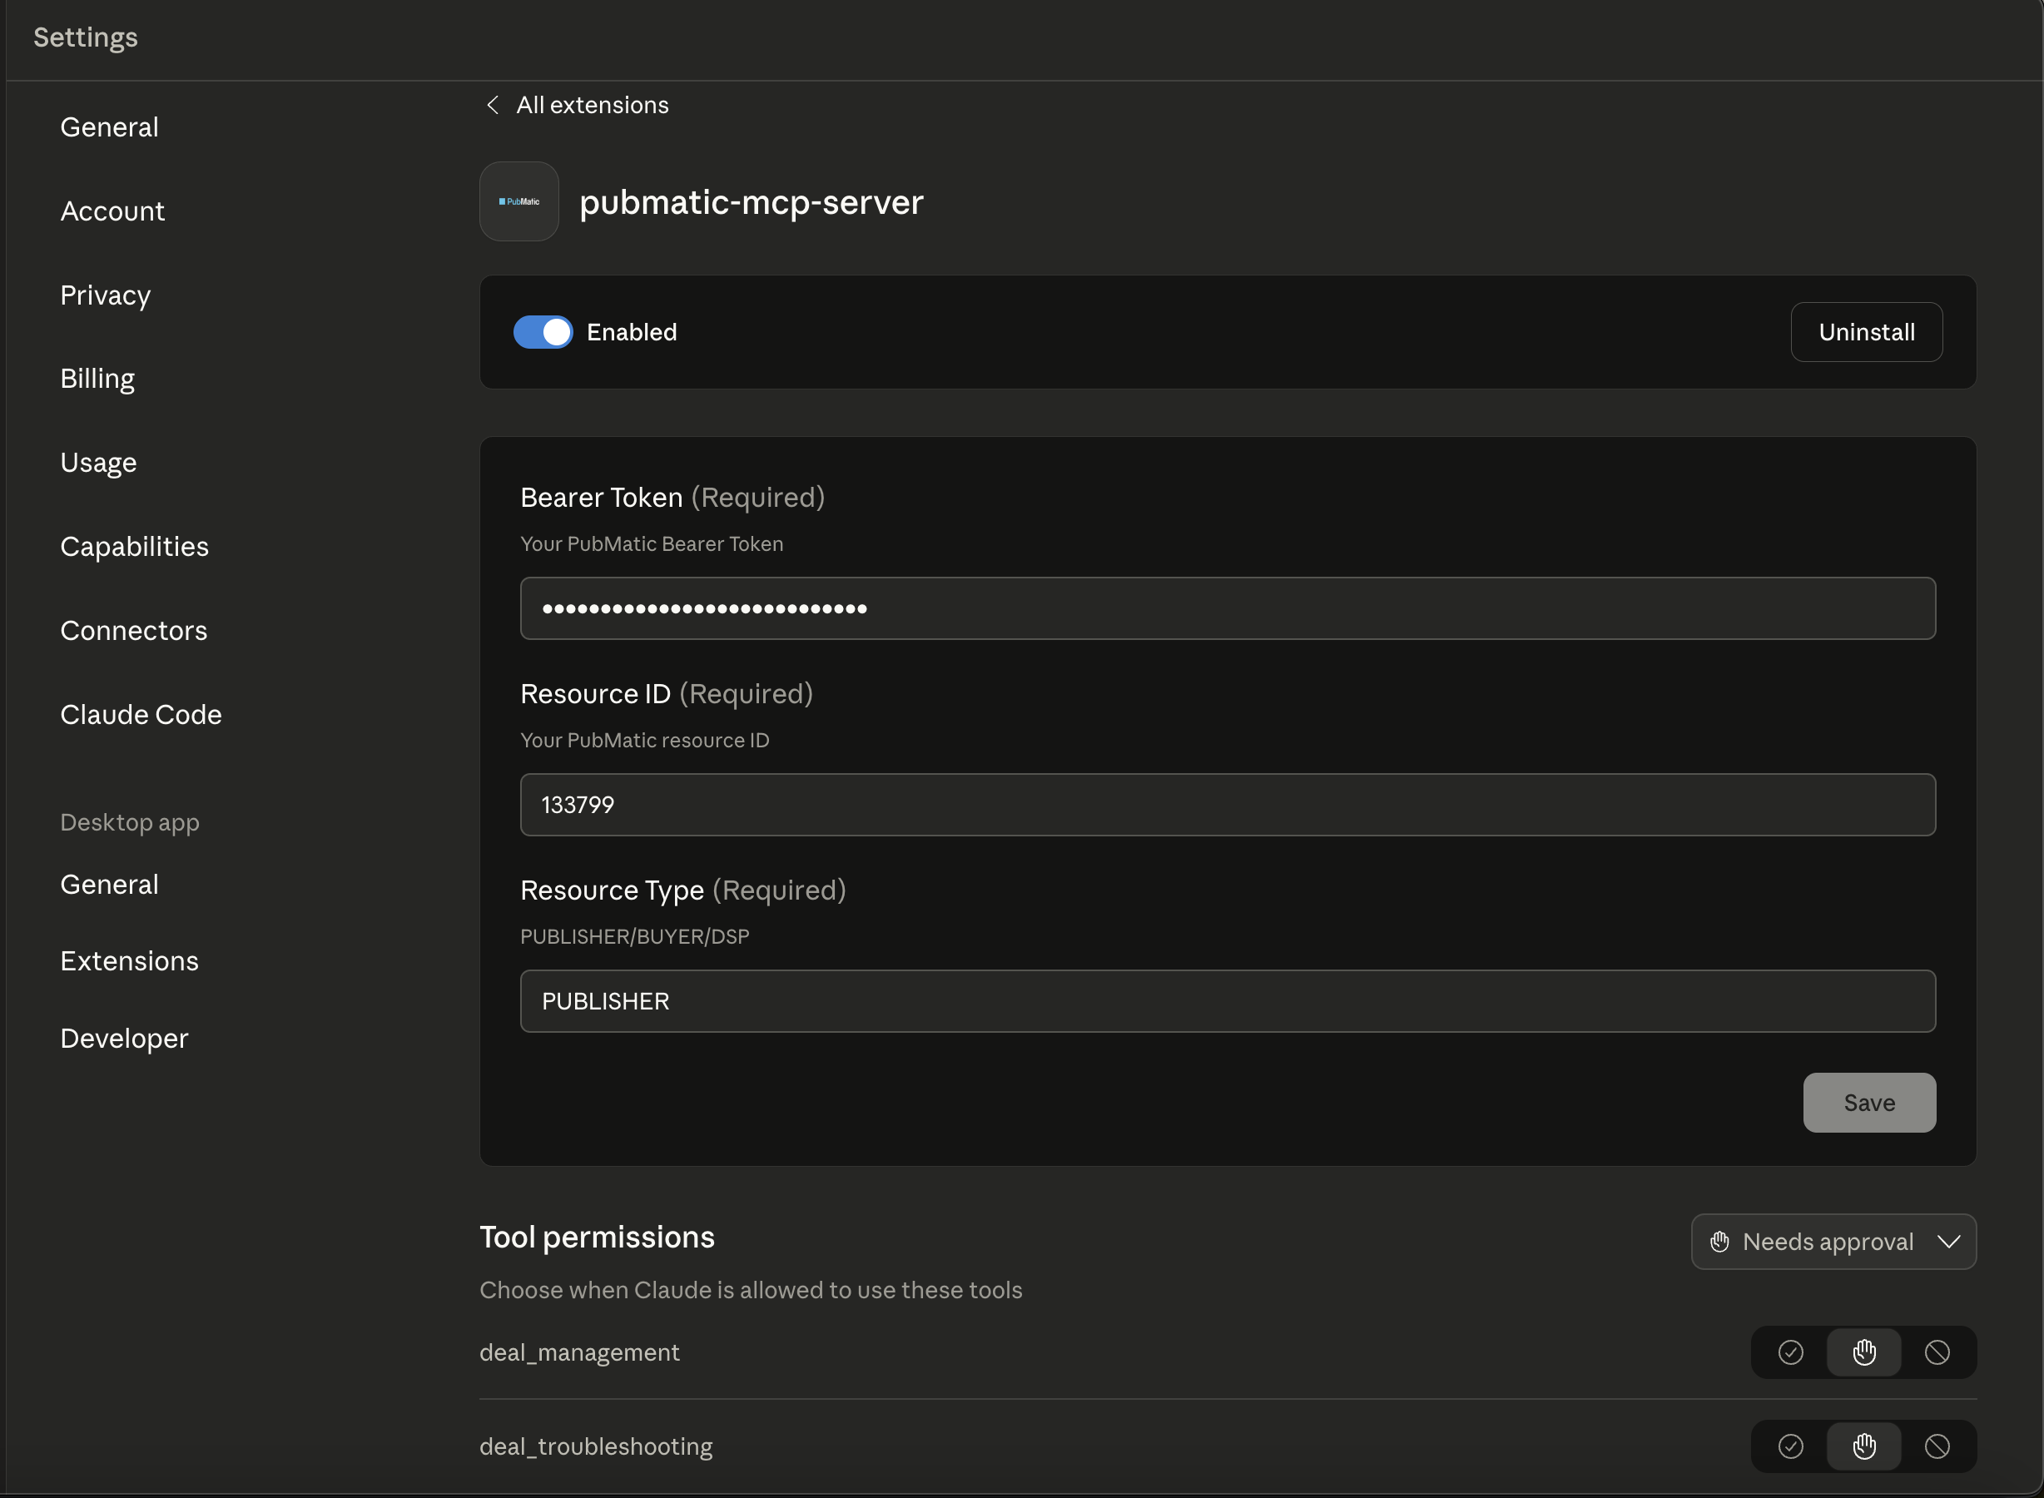

Step 11: After verifying the configuration, start a new chat from the left sidebar. The available MCP servers and their tool lists will be visible here as well
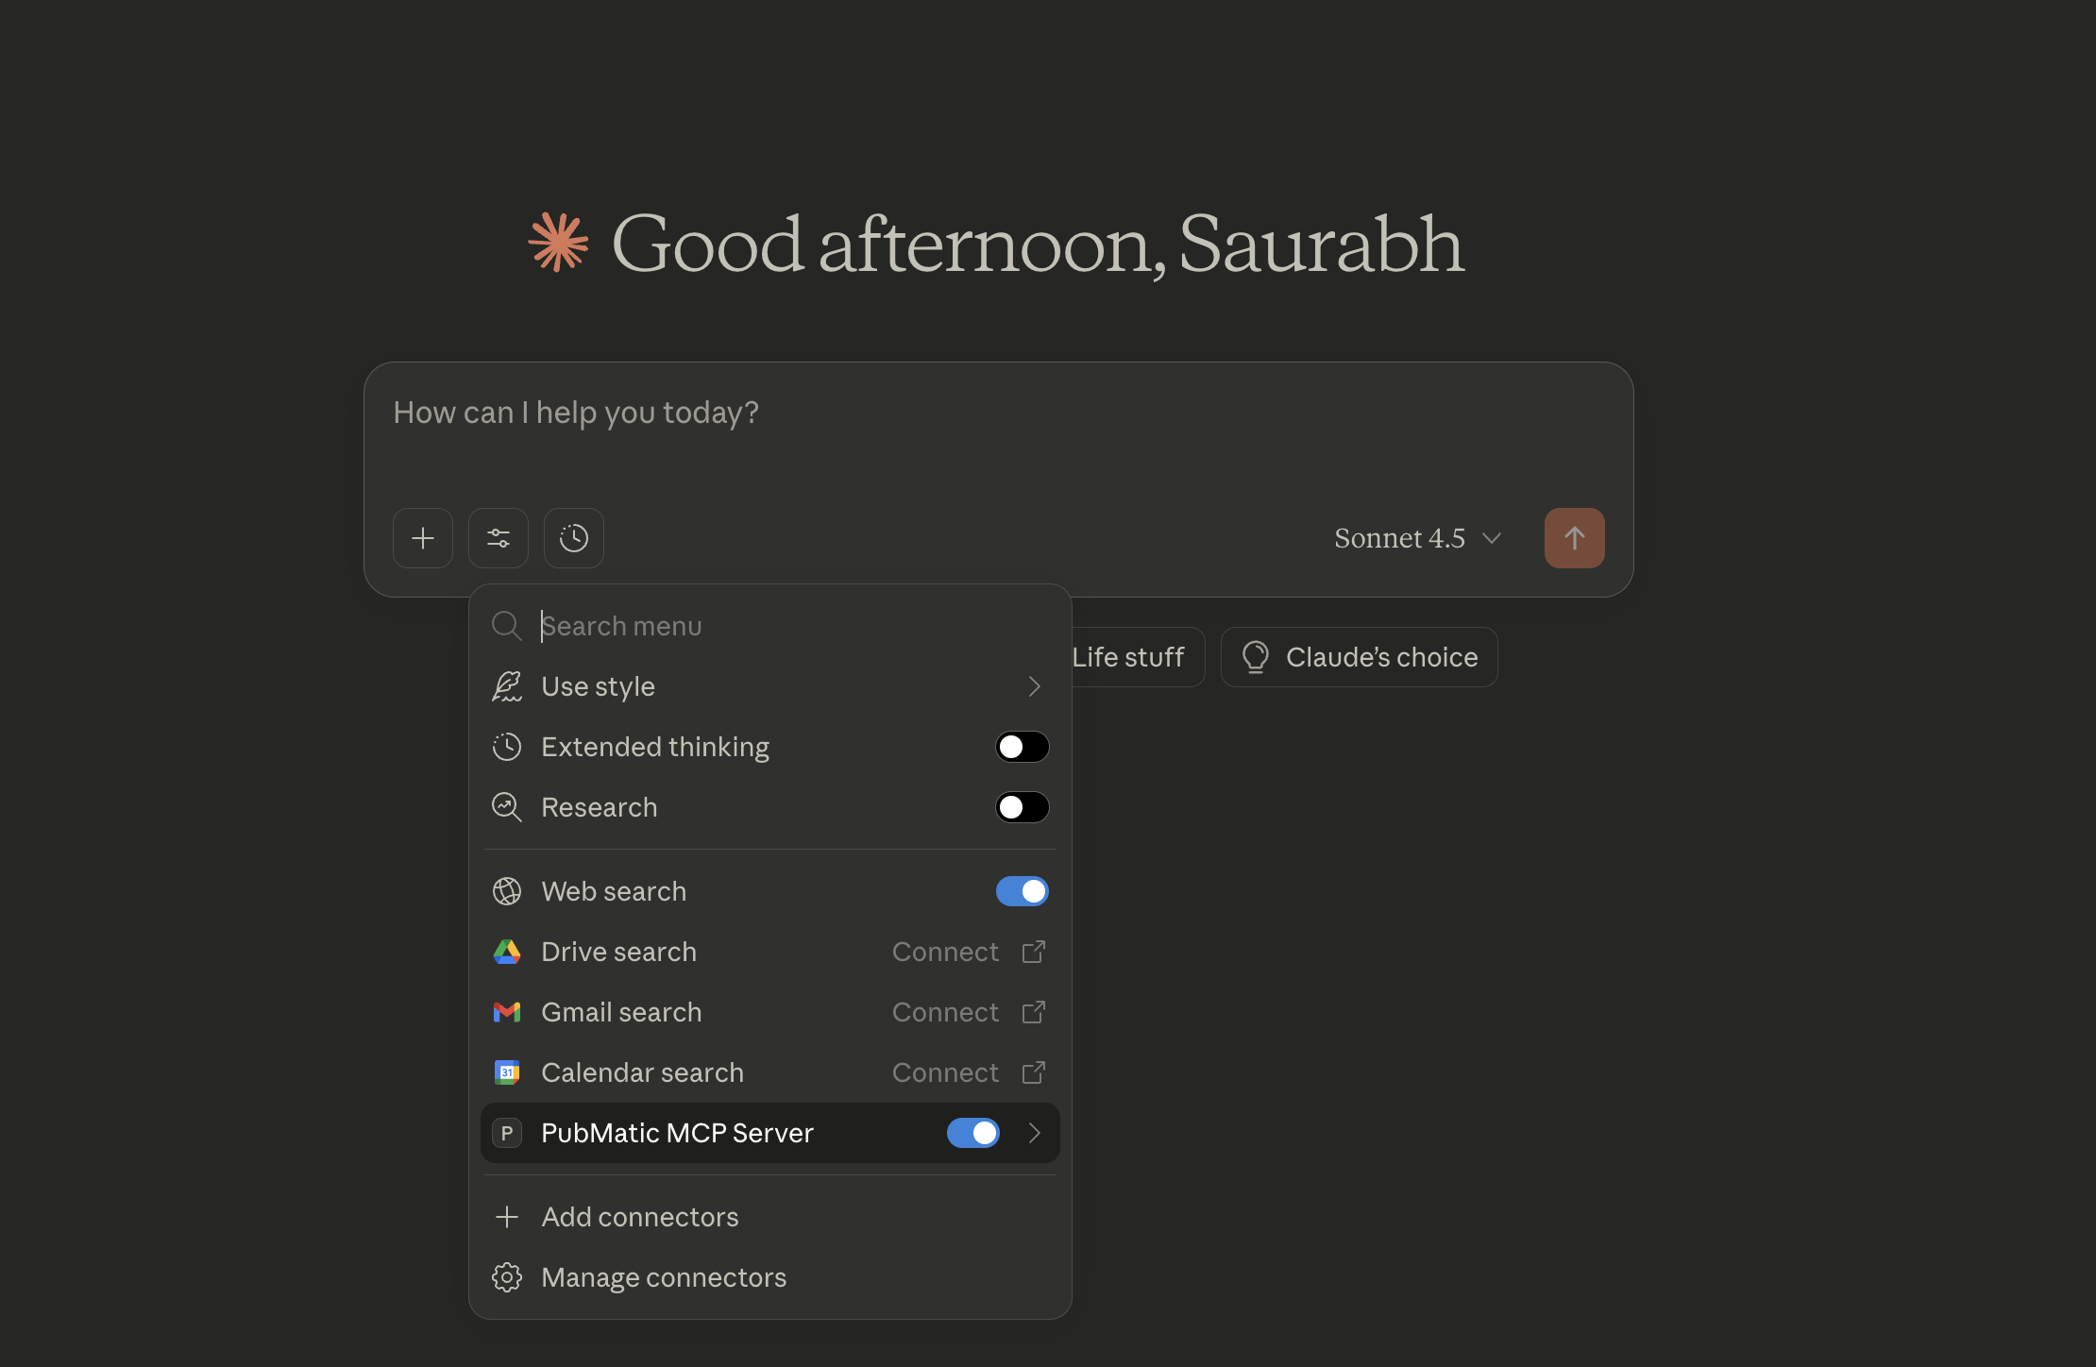

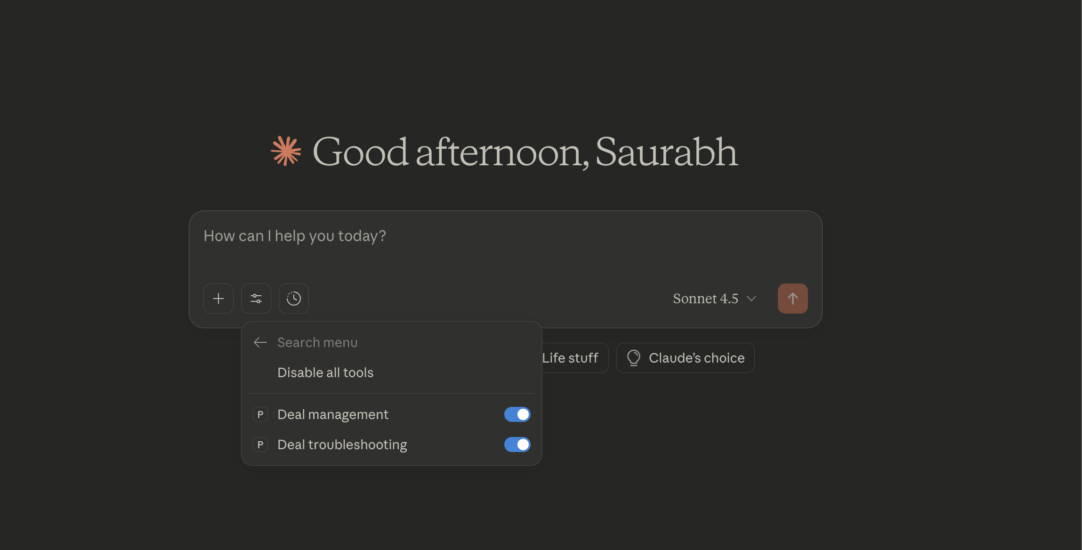
Step 12: You can now begin interacting with Claude using the installed PubMatic MCP Server.
When you enter a query, Claude will automatically route it through PubMatic’s MCP Server to the appropriate tool or agent, and display the returned response. The visible list shows available tools and their respective capabilities.
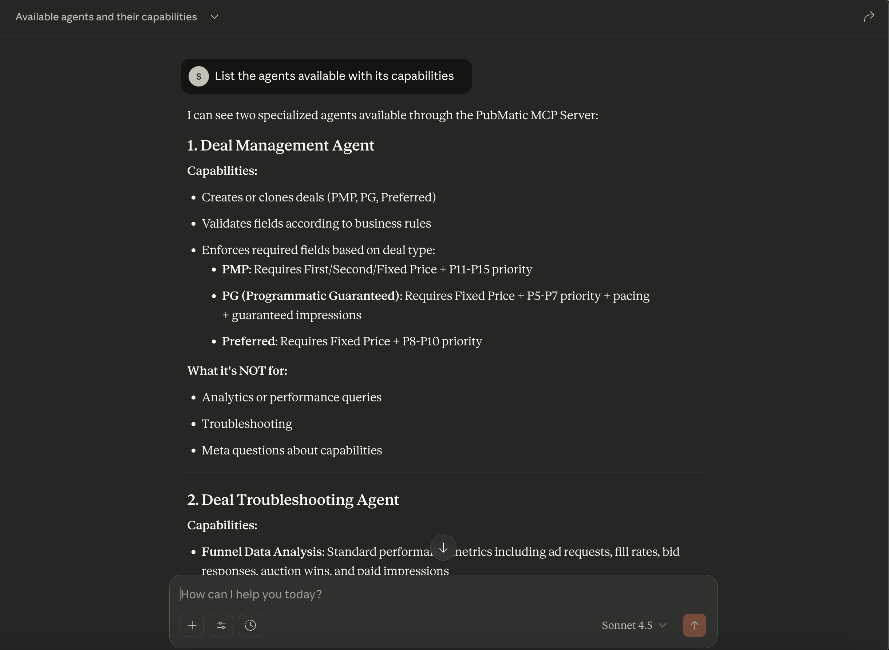

Troubleshooting
• If the toggle shows Disabled, re-enable and re‑enter credentials.
• Ensure token is current; expired tokens will fail to authenticate.
• If tools don’t appear in chat, re-open Claude or re-install the extension.

