**IoT Competition using Raspberry Pi**

Intel IoT Club, Amrita Vishwa Vidyapeetham

Date: August 19, 2023 (Saturday) – 10 AM to 4 PM

Event: Online

**SensEnv control system**

***Group No – 01***

***Team Member:***

1. PRANJALI YADAV – CB.EN.U4CCE21047
2. PUBESH KUMAAR K S– CB.EN.U4CCE21048
3. K SATHWIK – CB.EN.U4ECE21226
4. ABHIJAY – CB.EN.U4ECE21001

***Abstract:***

This is a sensor environmental control system for residential automation which will perform functions by using raspberry pi and grove pi module using IoT concepts. This application has multiple sensors like temperature, humidity, ultrasonic sensor, rotary, buzzer and LED. They are intelligently connected inside the homes and will be sensing the temperature and humidity outside the house and alter the house temperature accordingly. When there is a change in the temperature and humidity, the system accordingly checks the value and balances the temperature inside the house to prevent unnecessary damage. For eg if temperature is high outside, temperature sensor senses and the air conditioner is switched on automatically after checking threshold values. If the temperature is low, temperature sensor senses and the thermostat is switched on automatically after checking threshold values. Using ultra-sonic sensor, it calculates no of occupancy and changes light intensity automatically. There is rotary sensor to change the temperature of the house manually if dire case asks it.

***Introduction:***

This project aims to introduce an innovative and efficient solution tailored to the demands of modern living environments. In today's fast-paced world, the need for seamless control, energy efficiency, and enhanced security in residential spaces has grown substantially. The project capitalizes on state-of-the-art Internet of Things (IoT) technologies to elevate ordinary homes into intelligent, interconnected, and adaptable spaces.

At its core, this system comprises a central hub (Raspberry Pi), and grove pi and intricate network of sensors. These integral components operate in unison, furnishing homeowners with unparalleled control and automation capabilities. Furthermore, the system doesn't stop at convenience alone, it also serves as a safeguard in times of hazardous calamities, such as climate change and extreme weather events.

For instance, consider the recent darkening of the New York sky due to wildfires—a stark example of environmental challenges. In such scenarios, the system promptly alerts residents and enables them to take preventive measures. For instance, the system can detect smoke from wildfires in the vicinity and facilitate the implementation of appropriate safety measures.

***Hardware Required:***

1. Raspberry Pi 3
2. Grove Pi Sensors
   1. Temperature
   2. Humidity
   3. Ultrasonic
   4. Led
   5. Buzzer

***Flow chart:***

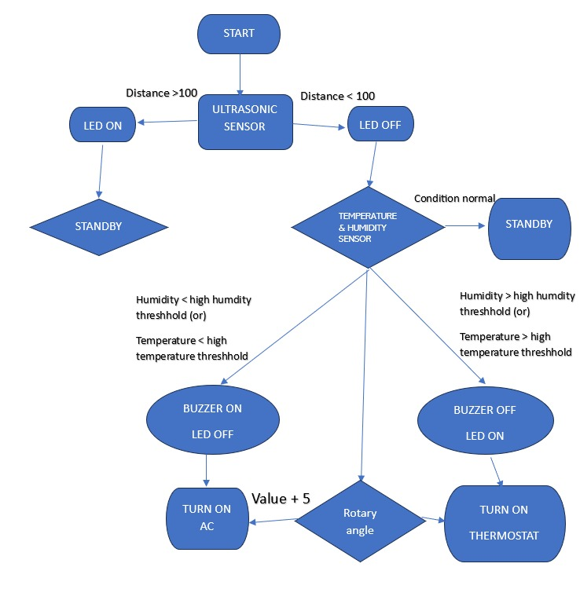

***Purpose of each sensor:***

Temperature: senses temperature of the surrounding,

Humidity: senses humidity of the surrounding

Buzzer: alerts when the condition of the sensor values is satisfied

Led: glows when the condition of the sensor values is satisfied

Ultrasonic: using distance it counts the occupancy of the area

Rotarary: To manually alter the intensity of the connected sensor

***Schematic diagram:***

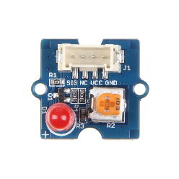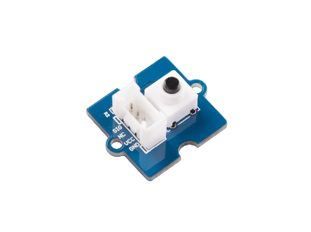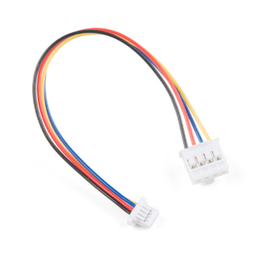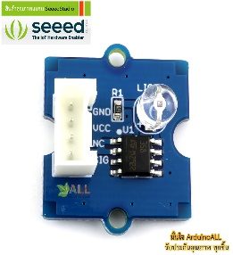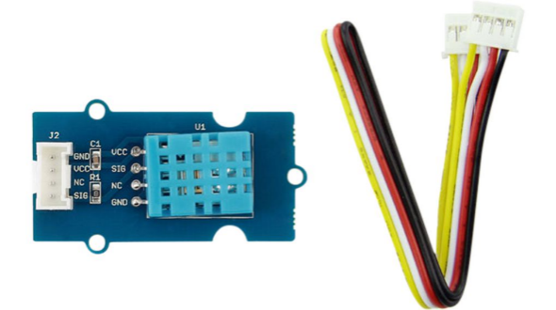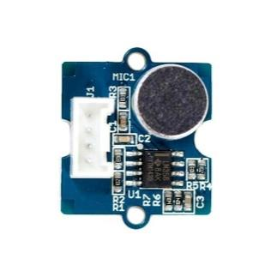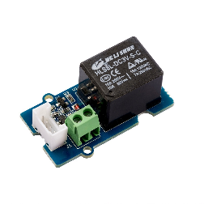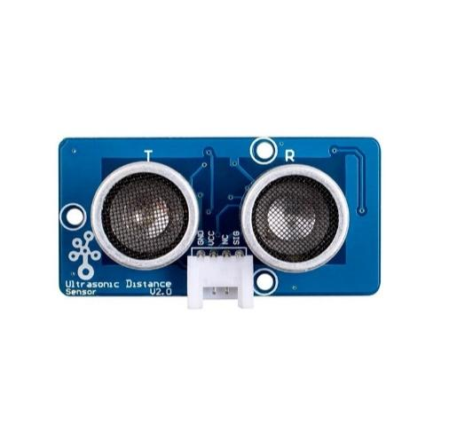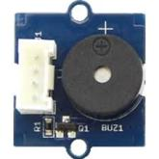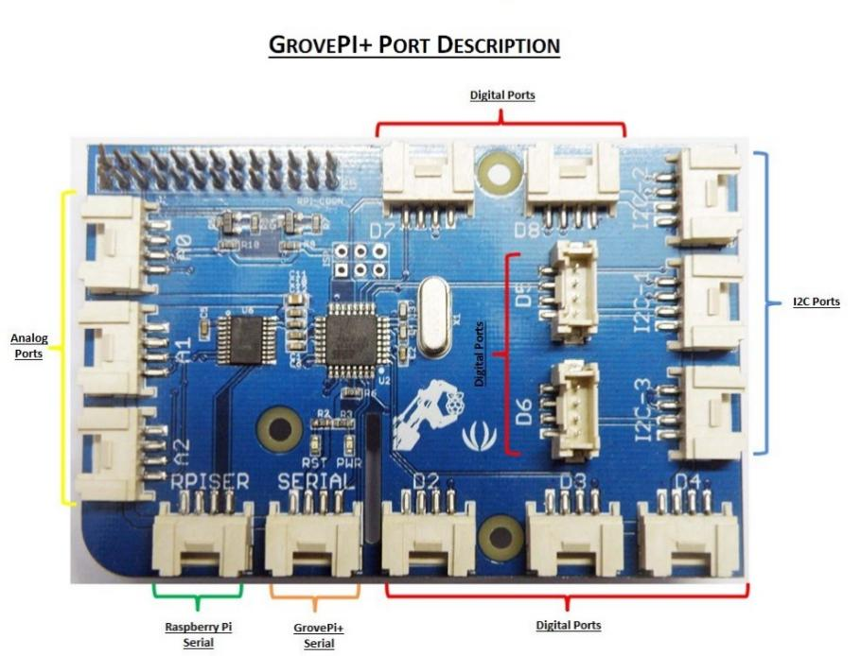

***Conclusion:***

In conclusion, the Smart Home System represents a significant leap forward in the realm of modern living environments. It addresses the pressing needs of our fast-paced world, where control, energy efficiency, and security in residential spaces have become paramount. Leveraging cutting-edge Internet of Things (IoT) technologies, this project transforms conventional homes into intelligent, interconnected, and adaptable spaces.

The project's central components, including a Raspberry Pi-based central hub, a network of sensors and actuators, and a user-friendly interface, work in tandem to grant homeowners unprecedented control and automation capabilities. Beyond convenience, the system also serves as a vital safety net during calamities like climate change and severe weather events.