Assignment-3
Enter the command cd / and then ls and then hit Enter key
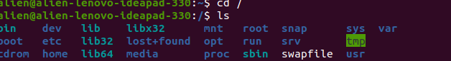
cd / and ls , command gave list of file that is used system

- Enter the command now cd /home and then hit Enter key


Gave list of files from hosme dir

- Enter cd .. and hit Enter key [ Note: here we have space after cd then use double dot]

go to previous dir . Back buttom

- Now enter cd /var/www/html and then type cd and hit Enter key
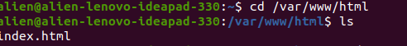
cd change dir to exact mentioned path

- Now type cd /root and then hit Enter key
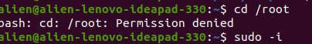

As u can yes in SS permission is denied , because i did login as root user , so used sudo su / -i to login as root user

Assignment-4
Working with File Listing
- Go to cd /etc and type ls
Take screenshot and explain what
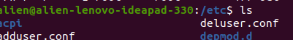

this command lsited directies and files
- Take screenshot and explain what different output you found compare to previous command you used?-- (not cleaar which previous command )

- Then type ls -al and hit Enter key

List of all file incuding hidden files
- Then use ls -i and hit Enter key

file with index number

