Assignment Part-3

1. Create a file like nano file1.txt 2. Now we will copy date from file1 to new file2
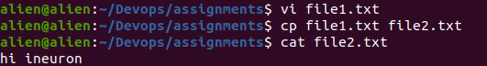
3. Now we will move the file2.txt to new folder /home
o mv file2.txt /home
o Then go to home directory and check ls, file exits or not?
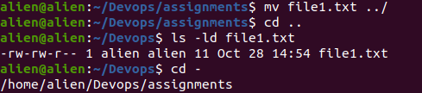

4. Then we create a new file3.txt and file4.txt in home directory and add
content in it.
o Now do echo “Hello I am newline” > file3.txt and provide the
output of file3.txt
o Now do echo “Hello I am newline” >> file4.txt and provide the
output of file4.txt
o Tell the different between both step you follow and the reason
behind it

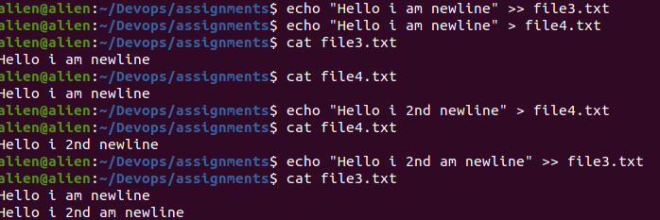
> will rewrite the content of file
>> will append the content to file

5. For remove a file or directory you can use the below two commands
o To delete a file – rm <any_filename>

