Heading 2 with break

Heading 2 less spacing
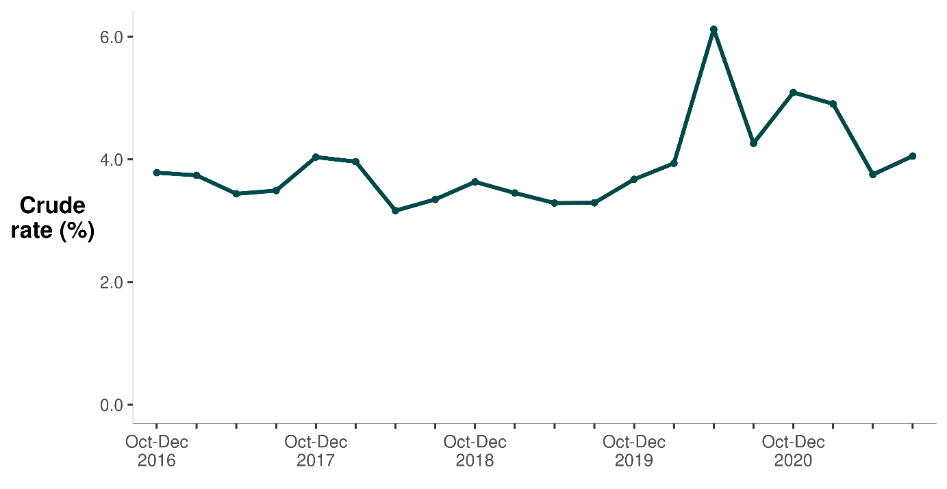

Heading 1 alt
This is renamed because compile_report() messes up heading 1

