#####Page break

## Demographics

### Summary:

**For the most recent time periods available, Moray HSCP had:**

* A total population of **96,410** people, where **49.5%** were male, and **22.3%** were aged over 65.
* **11.7%** of people lived in the least deprived SIMD quintile, and **2.7%** lived in the most deprived quintile.

### Population

In 2021, the total population of Moray HSCP was 96,410. The graph below shows the population distribution of the HSCP. Overall, **49.5%** of the population are male, and **50.5%** are female.

####Figure 1: Population by age and sex.

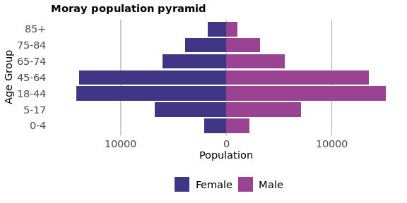

Figure 2 shows the historical population of Moray, along with the NRS population projections. The population has been rising. The population in Moray is estimated to decrease by 0.2% from 2021 to 2026. *Please see the footnotes for more information on how the population projections were calculated1.*

#####Page break

####Figure 2: Population time trend and projection.

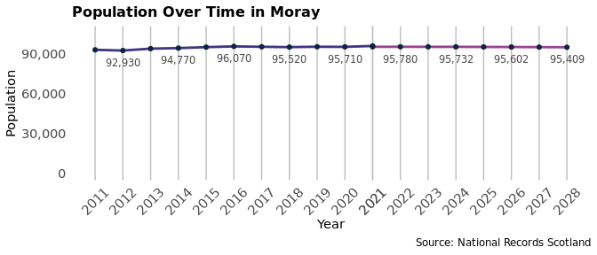

Figure 3 shows how population structure has changed between 2016 and 2021.

####Figure 3: Change in population structure over the last five years.

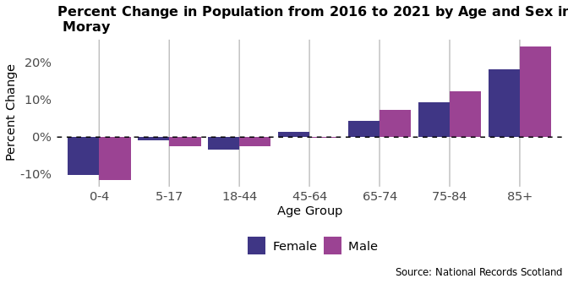

##### Page break

### Deprivation

The following section explores the deprivation structure of Moray through the Scottish Index of Multiple Deprivation (SIMD). The SIMD ranks all datazones in Scotland by a number of factors; Access, Crime, Education, Employment, Health, Housing and Income. Based on these ranks, each datazone is then given an overall deprivation rank, which is used to split datazones into Deprivation Quintiles (Quintile 1 being the most deprived, and Quintile 5 the least). The most recent SIMD ranking was carried out in 2020. This section mainly focuses on the SIMD 2020 classifications, however the 2016 classifications are used to assess how deprivation has changed in Moray when compared to the rest of Scotland.

Of the 2021 population in Moray, **2.7%** live in the most deprived Quintile (SIMD 1), and **11.7%** live in the least deprived Quintile (SIMD 5).

####Figure 4: Map of Data Zones within Moray coloured by SIMD quintiles.

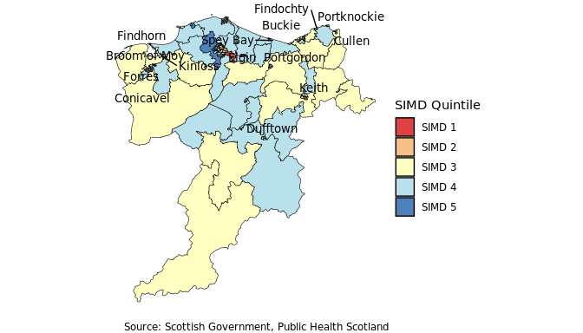

##### Page break

The following table details the percentage of the 2016 population living in the 2016 SIMD Quintiles, the percentage of the 2021 population living in the 2020 SIMD Quintiles, and their difference for comparison. Figure 5 then breaks down SIMD by domain in Moray.

####Table 1: Percentage population living in the 2016 and 2020 SIMD Datazone Quintiles in 2016 and 2021 respectively.

| **Quintile** | **Percent of 2016 Population (SIMD 2016 Ranking)** | **Percent of 2021 Population (SIMD 2020 Ranking)** | **Difference** |
| --- | --- | --- | --- |
| SIMD 1 | 0.9% | 2.7% | 1.8% |
| SIMD 2 | 15.5% | 15.2% | -0.3% |
| SIMD 3 | 27.9% | 33.4% | 5.5% |
| SIMD 4 | 38.0% | 37.1% | -0.9% |
| SIMD 5 | 17.8% | 11.7% | -6.0% |

####Figure 5: Proportion of the population that reside in each 2020 SIMD quintile by domain in 2021.

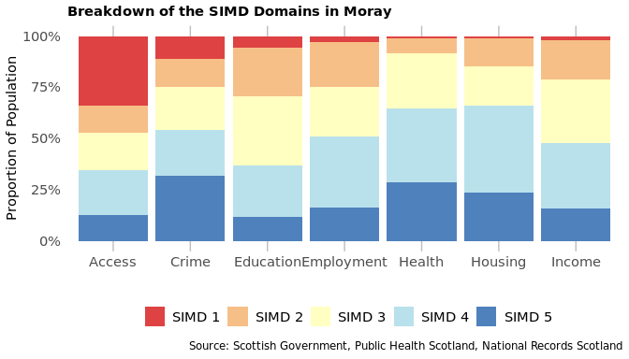

##### Page Break

Figure 6 presents a comparison between the 2016 SIMD ranking applied to 2016 population estimates, and the more recent 2020 SIMD ranking applied to 2021 population estimates. The percentages of the population living within each SIMD quintile by domain were calculated using the 2016 and 2020 SIMD datazone classifications respectively. The differences in these percentages are plotted in Figure 6. Negative values on the y-axis indicate a decrease in percent of the population living within a quintile, while positive values indicate an increase in percent of the population living within a quintile. **Please note that quintiles have been weighted by the Scottish population so, any local changes in SIMD quintile do not necessarily indicate a difference in deprivation, but rather a difference in deprivation in comparison to the rest of Scotland.**

####Figure 6: Percentage population in 2016 and 2021 living in the 2016 and the 2020 SIMD quintiles by domain.

