##### Page break

## Households

###Summary:

**For the most recent time periods available, Moray HSCP had:**

* **46,606** dwellings, of which: **94.6%** were occupied and **1.7%** were second homes.
* **35.9%** of dwellers received a single occupant council tax discount, and **3.7%** were exempt from council tax entirely.
* **64%** of houses were within council tax bands A to C, and **7.2%** were in bands F to H.

The graph below shows the number of dwellings in Moray from 2014 to 2022.

####Figure 1: Number of dwellings time trend.

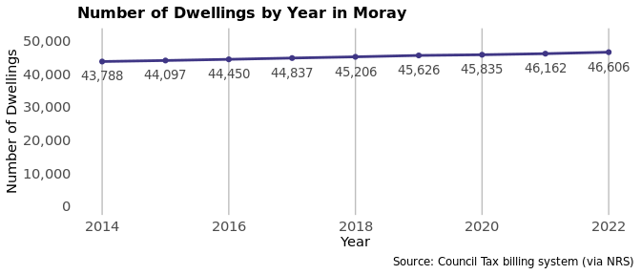

Of the total number of dwellings in 2022, 35.9% (16,737 households) were occupied by an individual receiving a single occupant council tax discount. Furthermore, 3.7% (1,722 households) were occupied and exempt from council tax.

There were 795 dwellings classed as a second home in 2022, these dwellings made up 1.7% of the households in Moray.

#####Page break

####Table 1: Breakdown of dwelling types by year for Moray HSCP.

| **Year** | **Total Dwellings** | **Occupied Dwellings** | **Vacant Dwellings** | **Single Occupant Tax Discount** | **Council Tax Exempt Dwellings** | **Second Homes** |
| --- | --- | --- | --- | --- | --- | --- |
| 2014 | 43,788 | 41,355 | 1,758 | 14,808 | 1,539 | 659 |
| 2015 | 44,097 | 41,675 | 1,713 | 15,016 | 1,592 | 714 |
| 2016 | 44,450 | 41,993 | 1,696 | 15,200 | 1,618 | 757 |
| 2017 | 44,837 | 42,300 | 1,751 | 15,350 | 1,637 | 785 |
| 2018 | 45,206 | 42,584 | 1,849 | 15,601 | 1,670 | 776 |
| 2019 | 45,626 | 42,980 | 1,836 | 15,783 | 1,702 | 810 |
| 2020 | 45,835 | 43,184 | 1,864 | 15,485 | 1,718 | 787 |
| 2021 | 46,162 | 43,651 | 1,744 | 16,383 | 1,780 | 767 |
| 2022 | 46,606 | 44,068 | 1,737 | 16,737 | 1,722 | 795 |

The proportion of households within each council tax band are displayed in the chart below, figures are shown in Table 2.

####Figure 2: Breakdown of households by council tax band for Moray in 2022.

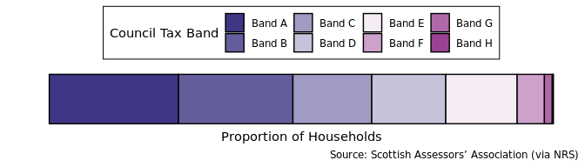

####Table 2: Percentage of households by council tax band for Moray in 2022.

| **Tax Band** | **A** | **B** | **C** | **D** | **E** | **F** | **G** | **H** |
| --- | --- | --- | --- | --- | --- | --- | --- | --- |
| Percent of households | 25.60% | 22.70% | 15.60% | 14.70% | 14.10% | 5.40% | 1.60% | 0.23% |