##Services

####Figure 1: Map of GP practices by locality in Moray HSCP2.

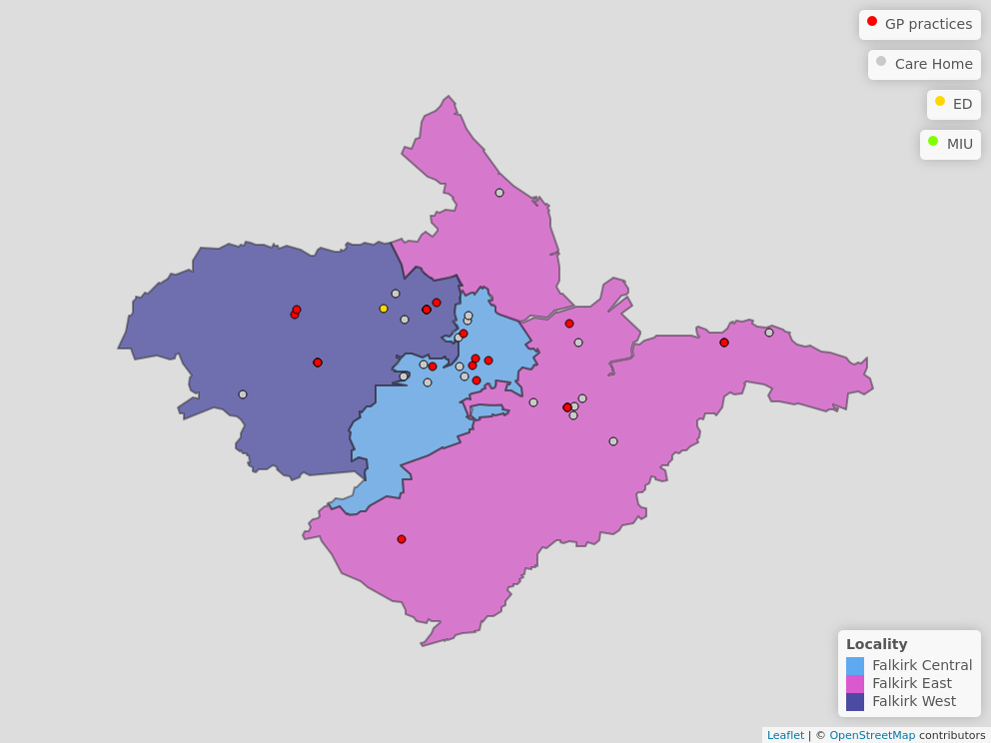

######ED = Emergency Department, MIU = Minor Injuries Unit (or other)

####Table 1: Number of each type of service in Moray HSCP2.

| **Service Type** | **Service** | **Number** |
| --- | --- | --- |
| **Primary Care** | GP Practice | 12 |
| **A&E** | Emergency Department | 1 |
|  | Minor Injuries Unit | 4 |
| **Care Home** | Elderly Care | 13 |
|  | Other | 8 |

In 2017, 27.5% of the population of Moray lived in the 15% most ‘access deprived’ areas.