Title

Subtitle

A National Statistics release for Scotland

Publication date: DD Month YYYY

RESTRICTED STATISTICS: embargoed to 09:30 dd/mm/yyyy

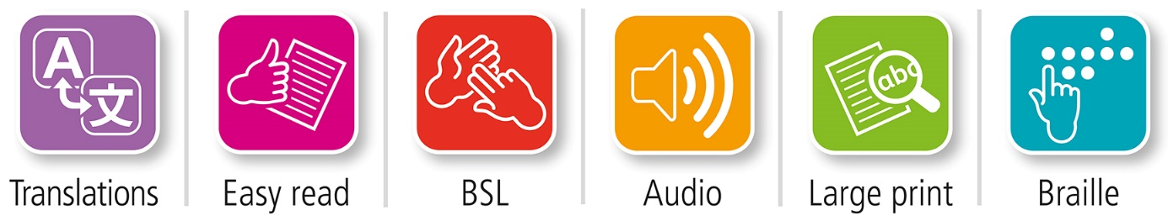

Translations and other formats are available on request at:

 [phs.otherformats@phs.scot](mailto:phs.otherformats@phs.scot) **0131 314 5300**

Public Health Scotland is Scotland's   
national agency for improving and   
protecting the health and wellbeing   
of Scotland's people.

© Public Health Scotland 2022

  
This publication is licensed for re-use   
under the [Open Government Licence v3.0](http://www.nationalarchives.gov.uk/doc/open-government-licence/).

For more information, visit   
[www.publichealthscotland.scot/ogl](http://www.publichealthscotland.scot/ogl)

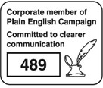

[**www.publichealthscotland.scot**](http://www.publichealthscotland.scot)

This is a National Statistics publication

[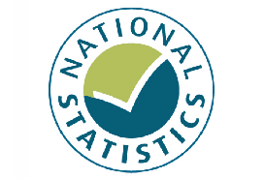](https://www.statisticsauthority.gov.uk/wp-content/uploads/2015/12/kitemark_tcm97-17949.jpg)

National Statistics status means that the official statistics meet the highest standards of trustworthiness, quality and public value. They are identified by the quality mark shown above.

The UK Statistics Authority has designated these statistics as National Statistics signifying compliance with the Code of Practice for Statistics.

Once statistics have been designated as National Statistics, it is a statutory requirement that the Code of Practice shall continue to be observed.

Find out more about the Code of Practice by visiting the [UK Statistics Authority website](https://code.statisticsauthority.gov.uk/).

Find out more about National Statistics on the [UK Statistics Authority website](https://code.statisticsauthority.gov.uk/glossary/#national-statistics).