SEAWAT-2000 Programming Notes

This document contains programming notes for changes made to SEAWAT-2000.

General Coding Issues for Combining MODFLOW and MT3DMS

MT3DMS FORTRAN variables in the main program with names that conflict with
MODFLOW-2000 variables:

IOBS IMOBS
ISUM ISUMY
ISUM2 ISUMIY
LCDELR LTDELR
LCDELC LTDELC
LCBUFF LTBUFF
LCIRCH LTIRCH
LCRECH LTRECH
LCCRCH LTCRCH
LCIEVT LTIEVT
LCEVTR LTEVTR
LCCEVT LTCEVT
IERR IMT3DERR
LCSS LCSSM
ICNVG ICNVGMT
MXITER MXITERGC
ITER1 ITER1GC
LCA LCAGC
LCLRCH LCLRCHGC
LCRHS LCRHSGC
ACCL ACCLGC
All references to X(...) are changed to Y(...)
All references to IX(...) are changed to IY(...)
Change COMMMON /FC/ to COMMON /FCMT3D/
Add IMT1 to beginning of all primary subroutine names

The variable ILMTFMT is used by LMT subroutines to determine format of output.
For SEAWAT, ILMTFMT should be 0 whenever writing to $file.umt.
However, when saving fluxes for subsequent run, ILMTFMT can be any value.

Conversely, the variable IFTLFMT should always be zero. This value is only used by FMI subroutines to read information from $file.umt.

common statements for both:
COMMON /LINKMT3D/ILMTFMT
COMMON /FTL/IFTLFMT

Note that the common state /LINKMT3D/ILMTFMT had to be added to the main program to store and then reset value of ILMTFMT.

SEAWAT-2000 Version 3.11.00
Date: 3/3/05
Update purpose: update swt2k with mf2k version 1.15.00

The following are the results from a search for 'seawat' in the imt_*.f files:

----------------------------------------
Find 'seawat' in 'D:\Users\langevin\seawat2k\swt2000\source\v3_11_20050303_public\imt1utl4.for' :
D:\Users\langevin\seawat2k\swt2000\source\v3_11_20050303_public\imt1utl4.for(1): C--SEAWAT: REMOVED SUBROUTINES UCOLNO AND URWORD. CONTAINED IN MODFLOW-2000 SOURCE
D:\Users\langevin\seawat2k\swt2000\source\v3_11_20050303_public\imt1utl4.for(2): C--SEAWAT: MODIFED RARRAY TO READ SINGLE PRECISION BINARY ARRAYS
D:\Users\langevin\seawat2k\swt2000\source\v3_11_20050303_public\imt1utl4.for(476): C--SEAWAT: NEED REAL*4 VARIABLE TO READ SINGLE PRECISION FROM BINARY FILE
D:\Users\langevin\seawat2k\swt2000\source\v3_11_20050303_public\imt1utl4.for(615): C--SEAWAT: MODIFIED THIS SECTION TO READ SINGLE PRECISION BINARY ARRAY
D:\Users\langevin\seawat2k\swt2000\source\v3_11_20050303_public\imt1utl4.for(616): C--SEAWAT: READ(-IREAD) NTRANS,KSTP,KPER,TOTIM,TEXT,NC,NR,ILAY
D:\Users\langevin\seawat2k\swt2000\source\v3_11_20050303_public\imt1utl4.for(617): C--SEAWAT: READ(-IREAD) A
D:\Users\langevin\seawat2k\swt2000\source\v3_11_20050303_public\imt1utl4.for(618): C--SEAWAT: THIS SECTION MAY NEED TO BE CHANGED IF FORM='UNFORMATTED'

According to this search, there are seawat modifications in the imt1utl4.for subroutine. In addition to these modifications, there are some minor differences
between utl4 and utl5:
1. utl5 does not have the subroutine namefile. this is now contained in subroutine btn5open
2. All STOP commands are now CALL USTOP(' ')
3. Dates on subroutines are changed to 02-15-2005

To implement these changes, I will rename imt1utl4.for to imt1utl5.for and make the 3 changes shown above.

Found 'seawat' 7 time(s).
----------------------------------------
Find 'seawat' in 'D:\Users\langevin\seawat2k\swt2000\source\v3_11_20050303_public\imt1btn4.for' :
D:\Users\langevin\seawat2k\swt2000\source\v3_11_20050303_public\imt1btn4.for(643): C--SEAWAT: INTEGER FIRSTDT
D:\Users\langevin\seawat2k\swt2000\source\v3_11_20050303_public\imt1btn4.for(703): C--SEAWAT: IF DTRANS IS ZERO, SET TO FIRSTDT
D:\Users\langevin\seawat2k\swt2000\source\v3_11_20050303_public\imt1btn4.for(740): C--SEAWAT: FOR NOW, COMMENT FOLLOWING LINES SO RHS IS ALWAYS UPDATED
D:\Users\langevin\seawat2k\swt2000\source\v3_11_20050303_public\imt1btn4.for(741): C--SEAWAT: IF(ABS(DTRANS-DTOLD).LT.ABS(DTRANS+DTOLD)*EPSILON
D:\Users\langevin\seawat2k\swt2000\source\v3_11_20050303_public\imt1btn4.for(742): C--SEAWAT: & .AND. NTRANS.GT.1) UPDLHS=.FALSE.
D:\Users\langevin\seawat2k\swt2000\source\v3_11_20050303_public\imt1btn4.for(1040): C--SEAWAT: CHANGED COMMON NAME FC TO FCMT3D TO AVOID CONFLICT WITH SUBROUTINE
D:\Users\langevin\seawat2k\swt2000\source\v3_11_20050303_public\imt1btn4.for(1085): C--SEAWAT CHANGED FOLLOWING TWO STATEMENTS TO WRITE SINGLE PRECISION

Steps for converting btn file that contains btn subroutines
1. I replaced all subroutine names with BTN5 to IMT1BTN5
2. I made all of the changes shown above in the search for SEAWAT in imt1btn4.for (and found 1 more that converted sorbed concentrations to single precision)

Found 'seawat' 7 time(s).
----------------------------------------
Find 'seawat' in 'D:\Users\langevin\seawat2k\swt2000\source\v3_11_20050303_public\imt1fmi4.for' :
D:\Users\langevin\seawat2k\swt2000\source\v3_11_20050303_public\imt1fmi4.for(17): C--SEAWAT: CHANGED COMMON NAME FC TO FCMT3D TO AVOID CONFLICT WITH SUBROUTINE
D:\Users\langevin\seawat2k\swt2000\source\v3_11_20050303_public\imt1fmi4.for(515): C--SEAWAT: CHANGED COMMON NAME FC TO FCMT3D TO AVOID CONFLICT WITH SUBROUTINE

Steps for converting fmi file that contains fmi subroutines
1. Replaced all FMI5 with IMT1FMI5 in subroutine calls
2. Changed all common /fc/ to common /fcmt3d/

Found 'seawat' 2 time(s).
----------------------------------------
Find 'seawat' in 'D:\Users\langevin\seawat2k\swt2000\source\v3_11_20050303_public\imt1ssm4.for' :
D:\Users\langevin\seawat2k\swt2000\source\v3_11_20050303_public\imt1ssm4.for(17): C--SEAWAT: CHANGED COMMON NAME FC TO FCMT3D TO AVOID CONFLICT WITH SUBROUTINE
D:\Users\langevin\seawat2k\swt2000\source\v3_11_20050303_public\imt1ssm4.for(135): C--SEAWAT: CHANGED COMMON NAME FC TO FCMT3D TO AVOID CONFLICT WITH SUBROUTINE
D:\Users\langevin\seawat2k\swt2000\source\v3_11_20050303_public\imt1ssm4.for(322): C--SEAWAT: CHANGED COMMON NAME FC TO FCMT3D TO AVOID CONFLICT WITH SUBROUTINE
D:\Users\langevin\seawat2k\swt2000\source\v3_11_20050303_public\imt1ssm4.for(479): C--SEAWAT: CHANGED COMMON NAME FC TO FCMT3D TO AVOID CONFLICT WITH SUBROUTINE
D:\Users\langevin\seawat2k\swt2000\source\v3_11_20050303_public\imt1ssm4.for(601): C--SEAWAT: CHANGED COMMON NAME FC TO FCMT3D TO AVOID CONFLICT WITH SUBROUTINE
D:\Users\langevin\seawat2k\swt2000\source\v3_11_20050303_public\imt1ssm4.for(760): C--SEAWAT: CHANGED COMMON NAME FC TO FCMT3D TO AVOID CONFLICT WITH SUBROUTINE

STeps for converting SSM file that contains ssm subroutines
1. rename all ssm5 to imt1ssm5
2. change all common /fc/ to common /fcmt3d/

Found 'seawat' 6 time(s).
Search complete, found 'seawat' 22 time(s). (4 files.)

The MT3DMS namefile is read in swt2k using the SGLO1BAS6OPEN subroutine, instead of the subroutine that comes with MT3DMS.

SEAWAT-2000 Version 3.11.00
Date: 4/7/2005
Update purpose: Add compatibility between MNW and VDF

2 limitations with MNW--heads used in conductance are equivalent freshwater values and all concentrations are
assumed to be zero (is only highly accurate for wells pumping water of low concentration)

IN swt2k.f
1. Add a call to vdf1mnw1fm
2. Add a call to lmt6mnw1fm both in swt2k.f and in lmt6vd.inc !!
3. Add a call to vdf1mnw1bd

In VDF1MNW1.F
1. in FM routine, multiplied HCOF and RHS additions by denseref
2. in BD routine, multiplied terms added to ratin and ratout by denseref

SEAWAT-2000 Version 3.12.00
Date: 3/14/2006
Update purpose: Update with MT3DMS version 5.1

Main program--no differences
BTN
BTN5OT--slight changes
ADV--no differences
DSP--no differences
SSM
SSM5FM--changed
SSM5BD--changed
GCG--no differences
RCT
RCT5AL
RCT5RP
SRCT5R
RCT5FM
RCT5BD
TOB--no difference
UTL--no difference
FMI--no difference

*Be careful to change common FC to common FCMT3D (in SEAWAT) for any subroutines that were updated.

SEAWAT-2000 Version 3.13.00
Date: 4/13/2006
Update purpose: Update with mf2k 1.16.00 and get ETS package working for VDF

Increased size of MXPRS, MXPER, MXOBS to 10,000

The table below shows the files that have been updated since mf2k version 1.15.00, which is in the present version of SEAWAT. The modifications to these files need to be incorporated into SEAWAT.

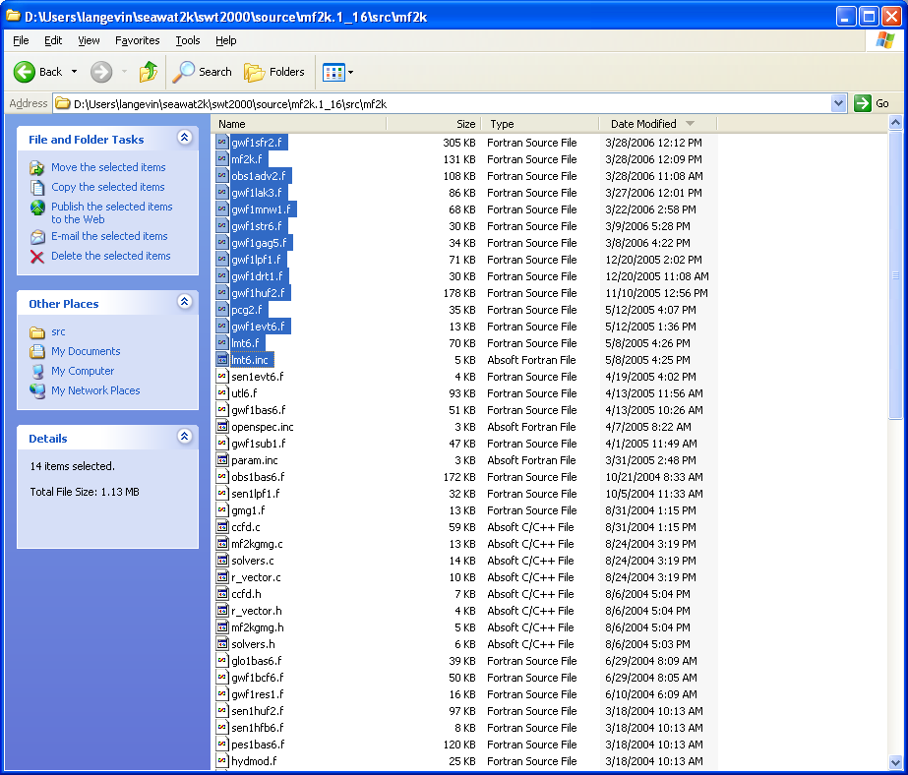

gwf1sfr2.f—copied and pasted into SEAWAT directory; deleted gwf1sfr1.f

note that in mf2k version 1.16.00, “unc” has been assigned to IUNIT(60), which is presently used for the DSP (dispersion) package. This change was not incorporated—assuming that unc is something related to GWT process.

MNW arguments are different—changed for both GWF and VDF

swt2k.f was updated with all the changes that were made to mf2k.f between 1.15.00 and 1.16.00. Most of these changes were related to (1) SFR2 package, (2) double precision changes to MNW, and (3) minor changes to ADV package.

Copied obs1adv2.f and gwf1lak3.f from MF version 1.16.00 into the SEAWAT subdir

Updated VDF1MNW1FM
INCLUDE vdf.inc

C--SEAWAT: MULTIPLY BY DENSITY TO CONSERVE MASS (ASSUME CONCENTRATION OF ZERO FOR ALL PUMPING)
DENSE=DENSEREF
c Modify HCOF and RHS arrays
if( iqslv.ne.0 .and. kiter.gt.1 .and. kiter.lt.NoMoIter ) then
qact = ( hlim - hnew(n) ) * cond
hcof(n) = hcof(n) - DENSE*cond
rhs(n) = rhs(n) - DENSE*cond * hlim
else
c Specify Q and solve for head; add Q to RHS accumulator.
rhs(n) = rhs(n) - DENSE*qact
endif
well2(3,m) = qact
endif
enddo ! End of DO WHILE loop
c
return
end

Updated VDF1MNW1BD
INCLUDE vdf.inc
Move NLAY calc to top of subroutine
Multiply by dense for ratin and ratout
Comment out nlay calculation

Copied gwf1str6.f and gwf1gag5.f into SEAWAT subdir

Copied gwf1lpf1.f into SEAWAT subdir; no changes required for vdf1lpf1.f

Copied gwf1drt1.f into SEAWAT subdir

Copied gwf1huf2.f into SEAWAT subdir
Made change to SVDF1HUF2B

Copied pcg2.f into SEAWAT subdir

lmt6.f
Changes to lmt6huf2 subroutine
changes to lmt6mnw1 subroutine
note: in the latest version of the lmt6 package, changes were made to the lmt6huf2 subroutine so that the LVDA option would work with MT3D. Since LVDA does not work with the VDF process, these changes were not incorporated into the lmt6huf2vd subroutine. Thus, the lmt6huf2vd subroutine is from the previous lmt version.

Programming compatibility between ETS and VDF
Procedure:
Created VDF1ETS1FM
Created VDF1ETS1BD
Created LMT6ETS1VD
Put calls for VDF1ETS1FM and VDF1ETS1BD into swt2k.f
Put call for LMT6ETS1VD into lmt6vd.inc
Put call for LMT6ETS1VD into swt2k.f

In constant density EVT package:

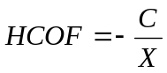

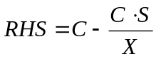

In variable density EVT package (eqns. 125 and 126, Guo and Langevin, 2002)

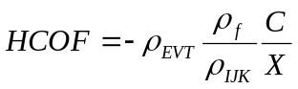

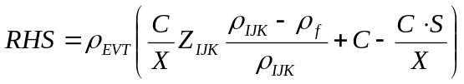

In constant density ETS package (Banta, 2000):

To simplify equations, set variable RATIO:

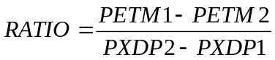

then,

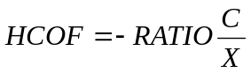

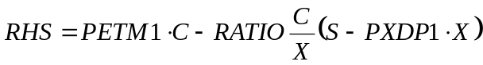

Which can be rewritten as:

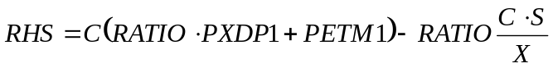

It follows that the variable-density equations for the ETS package are:

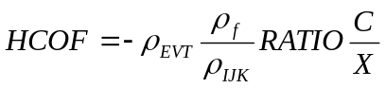

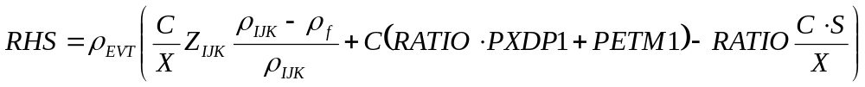

Programming compatibility between DRT and VDF
Procedure:
Created VDF1DRT1FM
Created VDF1DRT1BD
Created LMT6DRT1VD
Put calls for VDF1DRT1FM and VDF1DRT1BD into swt2k.f
Put call for LMT6DRT1VD into lmt6vd.inc
Put call for LMT6DRT1VD into swt2k.f

Bug Fix:
Fixed a bug that would have caused problems if the VDF process was used without the IMT process and the user tried to save a Flow-Transport Link (FTL) file.

