Methods

R version 4.0.5 was used for data importation and analysis (R Core Team, 2021).

Datasets and importation
We accessed the CID data via the TFL cycling open data portal (TFL, 2019). The function read_sf was used to import the json file into R as a simple features (sf) tibble and convert the longitude and latitude into geometry (Pebesma, 2018). To simplify this process, we created an R package named CycleInfLnd (Tait and Lovelace, 2019).

We utilised open data to obtain population estimates (mid-2019) (ONS, 2020a), geographical areas (km^2), geographical boundaries (ONS, 2020b) and the 2019 Index of Multiple Deprivation (MHCLG, 2019) for each of the 33 Local Authorities (‘Boroughs’) in London. The Index of Multiple Deprivation data utilised summarises the rank of each Local Authority in England and Wales based on the ranked average level of deprivation of smaller geographical areas within that Local Authority. St_read was used to import Boundary data into R.

We extracted the London cycle route network and commuter cyclist data from the Propensity to Cycle Tool (Lovelace et al., 2017) using the pct R package (Lovelace and Hama, 2021). This provided spatial cycle route data and estimates of the numbers of cyclists using that route based on Census 2011 data.

We downloaded historical OpenStreetMap data from January 2019 (Geofabrik, 2019; OpenStreetMap contributors, 2017) and imported it using osmextract (Gilardi and Lovelace, 2021). Road speed limit data was xxxx this way.

We accessed the following datasets to facilitate visualisation of data. The London Squared dataset enables Boroughs to be represented as squares in a simplified spatial arrangement that supports visual data comparison (After the flood, 2019a, 2019b). Geographical Borough boundaries that are clipped to the mean high water mark support visualisation with the River Thames landmark to aid data interpretation (ONS, 2020d).

THE ABOVE MAY NEED CHANGING DEPENDING ON HOW INTRO IS PHRASED - eg do I define boroughs, OSM etc

Spatial data cleansing and manipulation
We transformed all spatial data into the British National Grid (ONS, 2020c). The outermost boundary of London was used with the function st_intersection to spatial limit data from the CID, Propensity to Cycle Tool and OpenStreetMap to within London. As the majority of analysis was to be performed at a Borough level, the subsequent paragraphs describe the approaches taken to assign data to the correct Borough.

Although the majority of CID observations were assigned a Borough in the CID, we spatially cross-referenced all observations with ONS Borough boundaries to ensure they were correctly labelled. Infrastructure that crossed Rivers was spatially divided using the full extent of the realm Borough boundaries (ONS, 2020b).

Where an observation did not have a Borough coded or there was a mismatch between the pre-coded and cross-referenced Borough, these were corrected as follows. Two ASL were assigned to the Borough location where the Traffic signal for that ASL was located (one was NA, one reassigned). The 28 Crossings that had no Borough assigned were visually inspected and their length measured. In 26 cases, the visual inspection and greatest length resulted in congruency in Borough allocation. In the further two cases where visual inspection and greatest length were not congruent, these were split in two and allocated to the appropriate Borough. A further two Crossings that had a coded Borough required intervention with one being reassigned and the other being split into two observations Cycle lanes and tracks and Restricted routes in the CID can cross multiple Borough boundaries as well as cross into Local Authorities outside London. Of the 24622 Cycle lane and tracks observations that had a coded Borough, 72 were segmented by Borough boundaries creating an additional 72 observations. Segmentation of the 354 observations with no Borough assigned resulted in an additional 267 observations. Segmentation of coded Restricted routes created an additional 3 observations whilst segmentation of those without a Borough created a further 18 observations. The number of observations that were incorrectly labelled and we reassigned in the other datasets were Traffic calming (138), Cycle parking (37), Restricted points (2) and Cycle signals (2). 8 Signage observations were removed as they were outside London Boundaries and 398 were reassigned to correct Boroughs.

We spatially split the cycling route network to the Borough boundaries. Where a network crossed a Borough boundary, this resulted in two segments. The length of each segment was calculated in metres using st_length. We calculated the total distance cycled by commuters per working day on each segment by multiplying the segment length by the number of commuter cyclists using that segment per working day. Finally, we calculated an estimate of the annual total distance (in kilometres) cycled by commuters by multiplying the previous figure by 400 (one outbound and one inbound trip for the 200 working days of the year) and then dividing by 1000 (to obtain kilometres) (Sheehan and Lovelace, 2021).

Other data cleansing and manipulation
All datasets with Borough names were recoded to ensure that the names matched for when the datasets were joined together

CID
We examined all CID datasets for completeness. Minor spelling errors were corrected e.g. “TRE” to “TRUE”. In the Cycle Lanes and Tracks dataset where 5 observations had neither True or False for a variable and in the Cycle Parking dataset where two observations had missing data for number of stands and parking spaces, these observations were examined using googlemaps and the asset images and the correct value was inserted. The length of each Cycle Lane and Track was calculated using st_length. ??? ANY MORE FOR CID

For the 5 CID datasets that are relevant for safety: ASL, Crossings, Signals, Traffic Calming and Cycle Lanes and Tracks, more detailed analysis of the unique variables was performed using cross-tabulations (???). Subsequently observations and counts (lengths) were aggregated to a Borough level. We joined this data to the Borough geographical boundaries and areas, estimated population and estimated total annual km commuting cycling. We then calculated counts or length of each observation by area (square kilometre), per 100,000 head of population and per 100,000 total annual km commuter cycled.

Index of Multiple Deprivation
We divided all IMD ranks (1-317) into deciles and each London Local authority was assigned the appropriate decile based on their ranking.

Speed limit data
We utilised the following approach to obtain the maximum road speeds for highways that cyclists may be using. Using the OpenStreetMap variable “highway”, observations that had the following values were kept: primary, residential, trunk, trunk_link, service, unclassified, tertiary, secondary, tertiary_link, secondary_link, primary_link, and living_street. Other values such as motorway, escalator, proposed, bridleway and footway were dropped.
We examined the ‘maxspeed’ variable. All observations coded “NA” for maxspeed were dropped as were those labelled as national, signal and variable leaving 71660 observations. The resulting values for maxspeed were wrangled to obtain the speed limit in numeric miles per hour that was grouped into 10mph increments.

On road cycle lane degree of separation
To examine the degree of separation from motor vehicles on road cycle lanes were examined. We assigned each observation to the ‘highest level of segregation’ according to the UK Design guidance (DfT, 2020). This was achieved by creating multiple columns each representing a numeric value for degree of segregation (10000 for full segregation, 1000 for stepped etc down to 1 for advisory). These columns were summed. If the sum was greater than 10000 then the asset was assigned to full segregation, if between 1000 and 10000 then assigned to stepped etc. We categorised the cycle lanes by whether they were shared with buses or contraflow lanes as opposed to general cycle lanes.

Visualisation and statistical analysis (??)
We used the following R packages for visualisation. tmap was used to generate chloropleths (Tennekes, 2018). ggplot2 was used for bar charts and ???(Wickham, 2016).

Results

Description of the CID
The CID consists of 9 datasets each containing a different type of linear or point cycling infrastructure (known as assets). These and the common variables that they share are shown in Figure X whilst Table X describes each asset type . In addition, each dataset contains unique, relevant variables that describe the infrastructure in more detail.

Figure X: An overview of the CID datasets by type with the number of observations, dataset name (italics) and common variables
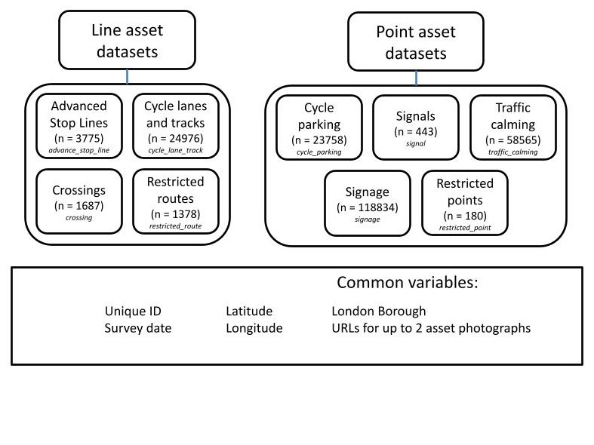

Table X: Description of 9 datasets

Dataset
Description

Source (TFL, n.d. a) Number The assets were surveyed between 6 January 2017 and 2 September 2019 although 75.9% were surveyed in 2017, 24.1% in 2018 and 0.01% in 2019. Less than 2% of observations were missing photographs of the infrastructure with the exception of Restricted points (6.7%), Restricted routes (4.5%) and Cycle lanes and tracks (2.4%). Line assets can be on or off-carriageway. When on-carriageway, the spatial data is aligned to the kerb except for Crossings, which run perpendicular to the kerb, and Cycle Lanes that continue through a junction. It represents where the infrastructure starts and ends according to road markings. Off-carriageway assets are aligned to their actual position where possible and represent their central location on the footway or path. Point assets are spatially located as close as possible to their physical location. Co-located assets e.g. multiple signs on a single signpost are recorded as separate assets. (REFERENCE TFL documentation) Other information to include on CID: - How collected? Or does that go in introduction - The CID is updated regularly - ?how often Analysis of assets related to safety The majority of unique variables are coded True or False. ASL and Cycle lanes and tracks have a ‘Colour’ variable that gives categorical data as to the colour that the infrastructure is painted. The Cycle lanes and tracks has an ‘Access Times’ variable that gives the times that this infrastructure is accessible either as a time or description in text format ??? Table X provides a description of the unique variables in each safety-related asset dataset and the number/length and percentage of observations that have those characteristics. Tables X: Unique variable description of the safety related infrastructure with the number (and proportion) of observations that have that characteristic present Dataset Unique variable descriptions Number (%) Length (%) ASL Feeder Lane present 1783 (47.2) Feeder Lane on Left 1695 (44.9) Feeder Lane in Centre 78 (2.1) Feeder Lane on Right 27 (0.7) Shared Nearside Lane (e.g with buses) 7 (0.2) Table X shows that for 47.2% of ASL a feeder lane is present and for 28.1% the ASL has coloured tarmac. However 1568 ASL (41.5%) have no characteristics recorded (Appendix: table A1). Only 7 ASL have more than one feeder lane (Appendix: table A2). 657 (61.9%) of Coloured ASL involved feeder or shared lanes (Appendix: table A1). The majority of crossings for cyclist are signal controlled (74.3%) and nearly a fifth segregate cyclists from other users (18.8%). 42 (2.5%) required cyclists to dismount to use the crossing. More detailed characterisation of the observations revealed that 200 crossings (11.8%) did not have any of the characteristics identified by the unique variables (Appendix: table A3). Other crossings had multiple characteristics, for example, 41 crossings (2.4%) were signal-controlled, had cyclist segregation and a gap in the island or kerb. The majority of crossings that required cyclists to dismount were signal-controlled (21) or over rail/tram tracks (5). The majority of crossings that were signal-controlled had no other characteristics (1100, 87.6%). However, crossings with cyclist segregation, gaps that allowed cyclists through or required pedestrians to dismount were more likely to have other characteristics (63.5%, 88.7%, 61.9%). Whilst on road cycle lanes account for the majority of cycle lanes and tracks (55.2%) they only account for 32.5% of the total length. Examination of characteristics by whether the cycle lane or track is on or off road show that NOW TALK ABOUT TABLE A4 and figure X - ?is figure X just same as table A4? Figure X - Comparison of characteristics of cycle lanes and tracks by on or off-road status 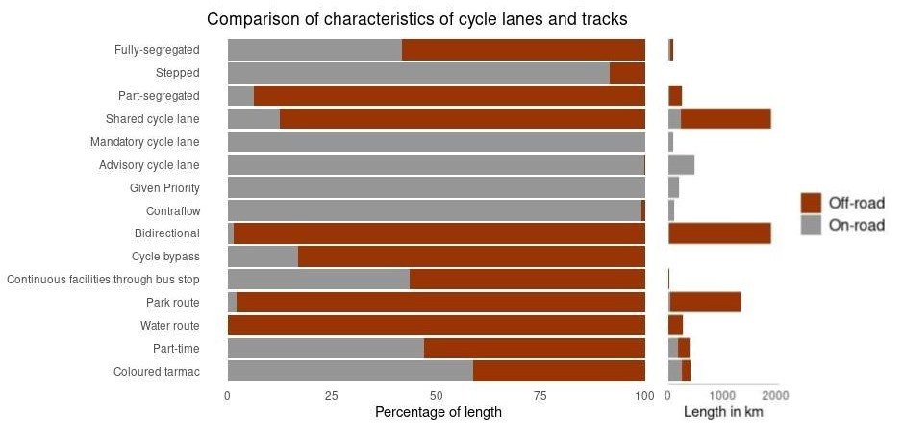 NOW TALK ABOUT TABLE A5 likely combination of characteristics on V off road including NO CHARACTERISTICS Borough analysis of assets related to safety Summary statistics - ? Present in box plot Can I do a simple model that explains the relationship bet number/length of assets(by type) and population, area and cycling Maps Discussion – include stuff on messiness of data and what it is possible to deduce easily from this dataset Licenses/acknowledgements TFL OSM: Data/Maps Copyright 2018 Geofabrik GmbH and OpenStreetMap Contributors | Map tiles: Creative Commons BY-SA 2.0 Data: ODbL 1.0 | Contact | Legal Notice/Privacy Policy If OpenStreetMap data is used in your analysis, the following should be included in your acknowledgements section: "Map data copyrighted OpenStreetMap contributors and available from https://www.openstreetmap.org". In addition, when OpenStreetMap data is introduced in the paper, a citation should be included to "OpenStreetMap contributors. (2015) Planet dump [Data file from $date of database dump$]. Retrieved from https://planet.openstreetmap.org.". This is formatted in APA style and should be adapted to whatever style is needed. London squared Copyright 2019 After the Flood Ltd. Permission notice: https://github.com/aftertheflood/londonsquared/blob/master/LICENSE.txt ONS/UK gov Contains public sector information licensed under the Open Government Licence v3.0. CT Masters dissertation: Appendix /supplementary data Table A1 - Detailed characterisation of ASL Total number Characteristic Number (%) Additional characteristics 1568 No characteristics 1568 (100) 1783 Feeder lane present 1 (0.06) None 1067 (59.8) Feeder lane on left 45 (2.5) Feeder lane in centre 15 (0.8) Feeder lane on right 1 (0.06) Feeder lane on left and in Centre 3 (0.2) Feeder lane on left and Right 609 (34.2) Feeder lane on left and Coloured 30 (1.7) Feeder lane in centre and Coloured 8 (0.4) Feeder lane on right and Coloured 2 (0.1) Feeder lane on left, in Centre and Coloured 1 (0.06) Feeder lane on left, Right and Coloured 1 (0.06) Coloured 1695 Feeder Lane on Left 11 (0.6) None 1067 (62.9) Feeder lane present 609 (35.9) Feeder lane present and Coloured 1 (0.06) Feeder lane present and Feeder lane in Centre 3 (0.2) Feeder lane present and Feeder lane on Right 2 (0.1) Feeder lane present, Feeder lane in Centre and Coloured 1 (0.06) Feeder lane present, Feeder lane on Right and Coloured 1 (0.06) Coloured 78 Feeder Lane in Centre 45 (64.3) Feeder lane present 30 (38.5) Feeder lane present and Coloured 1 (1.3) Feeder lane present, Feeder lane on Left and in Centre 2 (2.6) Feeder lane present, Feeder lane on Left, in Centre and Coloured 27 Feeder Lane on Right 15 (55.6) Feeder lane present 8 (29.6) Feeder lane present and Coloured 3 (11.1) Feeder lane present and Feeder lane on Left 1 (3.7) Feeder lane present, Feeder lane on Left and Coloured 7 Shared Nearside Lane (e.g with buses) 2 (28.6) None 5 (71.4) Coloured 1062 Table A2: Number of ASL feeder lanes TAble A3: Detailed characterisation of Crossings Table A4: THESE % ARE COLUMN% - probably more interested in row percents - these are available in on_off_clt_comparison_counts object Table A5: Comparison of the top 10 characteristics with longest length for on and off-road cycle lanes and tracks References After the flood, 2019a. London Squared - design and code for communicating with data [WWW Document]. URL https://tools.aftertheflood.com/londonsquared/design-process (accessed 5.10.21). After the flood, 2019b. London Squared - data grid [WWW Document]. URL https://github.com/aftertheflood/londonsquared/blob/master/site/data/grid.csv (accessed 5.10.21). DfT, 2020. Local Transport Note 1/20: Cycle infrastructure design. TSO, London. Geofabrik, 2019. OpenStreetMap Data Extracts: Greater London January 2019 (greater-london-190101.os.pbf). Gilardi, A., Lovelace, R., 2021. osmextract: Download and Read OpenStreetMap Data Extracts. Lovelace, R., Goodman, A., Aldred, R., Berkoff, N., Abbas, A., Woodcock, J., 2017. The Propensity to Cycle Tool: An open source online system for sustainable transport planning. J. Transp. Land Use 10. https://doi.org/10.5198/jtlu.2016.862 Lovelace, R., Hama, L., 2021. pct: Propensity to Cycle Tool. MHCLG, 2019. English indices of deprivation 2019, File 10: local authority district summaries. ONS, 2020a. Estimates of the population for the UK, England and Wales, Scotland and Northern Ireland Mid-2019 (April 2020 local authority district codes) [WWW Document]. URL https://www.ons.gov.uk/peoplepopulationandcommunity/populationandmigration/populationestimates/datasets/populationestimatesforukenglandandwalesscotlandandnorthernireland (accessed 1.29.21). ONS, 2020b. Local Authority Districts (May 2020) Boundaries UK BFE [WWW Document]. URL https://geoportal.statistics.gov.uk/datasets/local-authority-districts-may-2020-boundaries-uk-bfe (accessed 1.29.21). ONS, 2020c. A Guide to Coordinate Systems in Great Britain. Ordnance Survey. ONS, 2020d. Local Authority Districts (May 2020) Boundaries UK BFC [WWW Document]. URL https://geoportal.statistics.gov.uk/datasets/local-authority-districts-may-2020-boundaries-uk-bfc (accessed 1.29.21). OpenStreetMap contributors, 2017. Planet dump retrieved from https://planet.osm.org. Pebesma, E., 2018. Simple Features for R: Standardized Support for Spatial Vector Data. R J. 10, 439. https://doi.org/10.32614/RJ-2018-009 R Core Team, 2021. R: A language and environment for statistical computing. R Foundation for Statistical Computing, Vienna, Austria. Sheehan, N., Lovelace, R., 2021. Estimating million km’s cycled per zone in England and Wales regions [WWW Document]. URL https://itsleeds.github.io/pct/articles/km-cycled.html (accessed 5.10.21). Tait, C., Lovelace, R., 2019. CycleInfLnd: Accesses and downloads data from the Transport for London Cycling Infrastructure Database into R as spatial data (Simple features). Tennekes, M., 2018. tmap: Thematic Maps in R. J. Stat. Softw. 84, 1–39. https://doi.org/10.18637/jss.v084.i06 TFL, 2019. Cycling Infrastructure Database [WWW Document]. URL https://cycling.data.tfl.gov.uk/ (accessed 3.6.20). TFL, n.d. a. Cycle Infrastructure Database Asset Information Guide [WWW Document]. URL https://cycling.data.tfl.gov.uk/CyclingInfrastructure/documentation/asset_information_guide.pdf (accessed 3.6.20). Wickham, H., 2016. ggplot2: Elegant Graphics for Data Analysis, Second. ed. Springer, New York, NY.

