
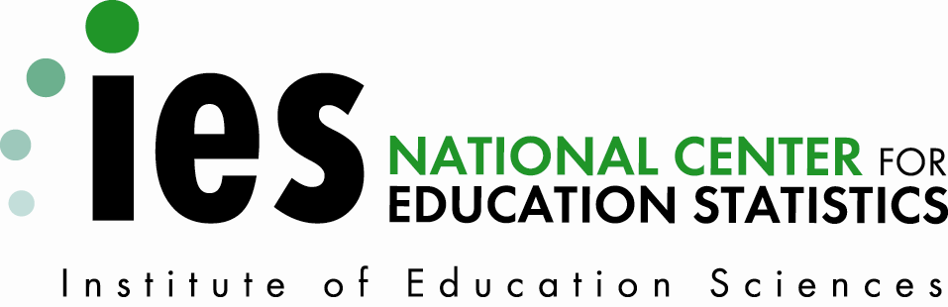
NCES 2015-174 U.S. DEPARTMENT OF EDUCATION
Documentation to the NCES Common Core of Data Public Elementary/ Secondary School Universe Survey Preliminary Directory File: School Year 2014-15

Documentation to the NCES
Common Core of Data Public Elementary/Secondary School Universe Survey Preliminary Directory File: School Year 2014-15

October 2015

Mark Glander
National Center for
Education Statistics

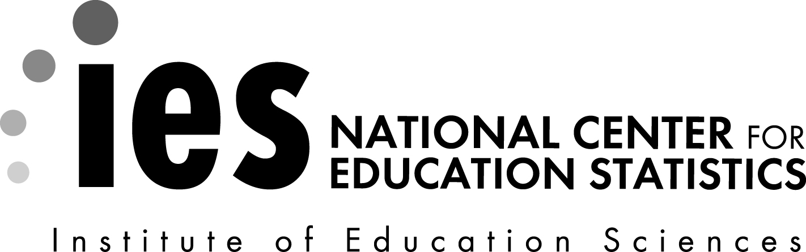
NCES 2010-304
U.S. DEPARTMENT OF EDUCATION


NCES 2015-174
U.S. DEPARTMENT OF EDUCATION
U.S. Department of Education
Arne Duncan
Secretary

Institute of Education Sciences
Ruth Neild
Deputy Director for Policy and Research
Delegated Duties of the Director

National Center for Education Statistics
Peggy G. Carr

Acting Commissioner
Administrative Data Division
Ross Santy
Associate Commissioner

The National Center for Education Statistics (NCES) is the primary federal entity for collecting, analyzing, and reporting data related to education in the United States and other nations. It fulfills a congressional mandate to collect, collate, analyze, and report full and complete statistics on the condition of education in the United States; conduct and publish reports and specialized analyses of the meaning and significance of such statistics; assist state and local education agencies in improving their statistical systems; and review and report on education activities in foreign countries.

NCES activities are designed to address high-priority education data needs; provide consistent, reliable, complete, and accurate indicators of education status and trends; and report timely, useful, and high-quality data to the U.S. Department of Education, the Congress, the states, other education policymakers, practitioners, data users, and the general public. Unless specifically noted, all information contained herein is in the public domain.

We strive to make our products available in a variety of formats and in language that is appropriate to a variety of audiences. You, as our customer, are the best judge of our success in communicating information effectively. If you have any comments or suggestions about this or any other NCES product or report, we would like to hear from you. Please direct your comments to
NCES, IES, U.S. Department of Education
1990 K Street NW
Washington, DC 20006-5651
October 2015
This publication is only available online. To download, view, and print the report as a PDF file, go to the NCES Publications and Products website shown below.
Suggested Citation
Glander, M. (2015). Documentation to the NCES Common Core of Data Public Elementary/Secondary School Universe Survey Preliminary Directory File: School Year 2014-15 (NCES 2015-174). U.S. Department of Education. Washington, DC: National Center for Education Statistics. Retrieved [date] from http://nces.ed.gov/pubsearch.
Content Contact
Mark Glander
(202) 502-7323
Mark.Glander@ed.gov
Contents
Page
List of Tables iii
I. Introduction to the NCES Common Core of Data Public Elementary/Secondary School Universe Survey Preliminary Directory File: School Year 2014-15 1
II. Methodology and Technical Notes 2
A. Data Collection and Editing Procedures 2
B. Sources of Error and Technical Details about the SY 2014-15 File 5
C. Limitations of the Public Elementary/Secondary School Universe Data Preliminary Directory File 13
Appendix A—Record Layout for the Common Core of Data Public Elementary/Secondary School Universe Survey Preliminary Directory File: School Year 2014-15 A-1
Appendix B—Value Distribution and Field Frequencies for the Common Core of Data Public Elementary/Secondary School Universe Survey Preliminary Directory File: School Year 2014-15 B-1

List of Tables

Table Page
1. File Extraction Dates for Directory Files: School Year 2014-15 4
2. American National Standards Institute (ANSI) State Codes and Abbreviations Used in CCD Datasets 11
3. List of Schools with Mailing Address in Another State: School Year 2014-15 12
B-1. Number of records with missing, not applicable, and reported values for variables: School Year 2014-15 B-3
B-2. Frequencies of categorical variables: School Year 2014-15 B-4

Page intentionally left blank.
- Introduction to the NCES Common Core of Data Public Elementary/Secondary School Universe Survey Preliminary Directory File: School Year 2014-15
This documentation is for the preliminary directory file of the National Center for Education Statistics’ (NCES) Common Core of Data (CCD) Public Elementary/Secondary School Universe Survey. It contains a brief description of the data collection, along with information required to understand and access the data file.
The CCD is a national statistical program that collects and compiles administrative data from state education agencies (SEAs) covering the universe of all free, public elementary and secondary schools and school districts in the United States. There are five annual surveys that comprise the CCD: the Public Elementary/Secondary School Universe Survey, Local Education Agency Universe Survey, the State Nonfiscal Survey of Public Elementary/Secondary Education, the National Public Education Finance Survey, and the School District Finance Survey. The Education Sciences Reform Act of 2002 (20 U.S.C. § 9543) requires NCES to collect, compile and disseminate information about elementary/secondary education, and the CCD provides essential components about public education in the United States through use of administrative data.
The scope of the CCD public school universe covers the 50 states, the District of Columbia, and five U.S. Island Areas (American Samoa, Guam, the Commonwealth of the Northern Mariana Islands, Puerto Rico, and the U.S. Virgin Islands). Schools that are supported by the Department of Defense Education Activity (DoDEA) and the Bureau of Indian Education (BIE) are also included in the universe. SEAs report school-, agency-, and state-level education data for each school year through the U.S. Department of Education’s EDFacts Submission System (ESS). While each SEA maintains its own public education data systems, NCES and SEAs work cooperatively to develop and accept common data items and definitions in the goal of producing consistent and comparable statistical data that are critical to NCES’ mission to report complete statistics on the condition of education in the United States.
The school universe serves as a basis for all other administrative data collections within EDFacts that collect data at the school level. These include data that are used by NCES to produce official statistics and data that are used by other offices within the Department of Education to administer federal education programs. Additionally, the school directory data are frequently used as sampling frames for surveys such as NCES’ National Assessment of Education Progress or the Schools and Staffing Survey. The school universe data are also useful to (1) chief officers of state education agencies, (2) policymakers in the executive and legislative branches of federal and state governments, (3) education policy and public policy researchers, (4) the press, and (5) citizens interested in information about public schools.
The preliminary school universe directory file includes basic identifying information for each public school including the NCES school ID numbers, location and mailing address information, and some limited attributes about the school, such as school type, operational status, charter status, the lowest grade offered, and the highest grade offered. The preliminary school universe directory does not include aggregated demographic information such as student enrollment or teacher and staff counts. For the preliminary directory, NCES has only conducted a limited review of the file. It is meant to provide data users with a more timely release of basic information with the understanding that the file may be incomplete or contain some inaccuracies or inconsistencies. Once NCES completes a thorough review of the school universe data, NCES will publish a complete, higher quality provisional universe file along with a First Look report.
The remainder of this document contains a methodology and technical notes section and two appendixes.
- Appendix A—Record Layout lists each variable on the data file, the position of the variable on the data file, a description of each variable and the permitted values for that variable, where applicable.
- Appendix B—Value Distribution and Field Frequencies indicates the number of missing, not applicable, and reported values for each variable, as well as the frequency, percentage, cumulative frequency, and cumulative percent of all categorical variables.

II. Methodology and Technical Notes
A. Data Collection and Editing Procedures
The ESS is the primary collection system for the CCD. Coordinators from SEAs submit the CCD data at the school, agency, and state levels. Prior to submitting CCD files into ESS, SEAs must collect and compile information from their respective local education agencies (LEAs) via administrative records systems within their state or jurisdiction. SEAs then assemble the data files per the reporting requirements and guidance available via file specifications provided by the Department of Education. For more information on the file specifications, visit www.ed.gov/edfacts. Once SEAs complete their submissions, CCD survey analysts review and verify the CCD for quality assurance. CCD survey analysts routinely verify data through edit and consistency checks, as well as checking SEA, LEA, or school public websites (if necessary), and then refer discrepancies to SEA coordinators for resolution. NCES does not contact LEAs or schools to verify data, except in unusual circumstances. Editing procedures are described in more detail later in this section.

For the purposes of data submissions to EDFacts/CCD, the definition of a school is an institution that:
- provides educational services;
- has one or more grade groups (prekindergarten through 12) or is ungraded;
- has one or more teachers;
- is located in one or more buildings;
- has assigned administrator(s);
- receives public funds as its primary support; and
- is operated by an education agency.
The CCD school definition recognizes that this organization may encompass several locations but must have a single contact point, which is the mailing address entered on the CCD school record. The directory also includes:
- schools that serve students on a part time basis, such as a vocational or technical school;
- schools that serve students remotely--that is, the school providing instruction is located in a different location than where the student is located, such as distance learning, cyber learning, or virtual learning;
- charter schools, including those that may be authorized by an entity other than an LEA; and
- schools run by SEAs or another state agency, such as a juvenile justice facility or school designed to meet a specialized need.
States report data to EDFacts on a reporting schedule throughout the year by submitting a series of data groups (or data files) through the ESS. The school year 2014-15 (SY 2014-15) EDFacts collection opened in December 2014, with the Directory file having a due date of January 31, 2015. NCES extracted the directory data from EDFacts between December 2014 and May 2015. Table 1 lists the exact dates when the files were last extracted from EDFacts. CCD survey staff processed each state’s submission on a flow basis, so the date of the extract for each state’s file depended on when the SEA completed their submission. Once a file was edited and verified for a particular state, CCD survey staff did not continue to incorporate late submissions or updates unless these late submissions or updates resulted in a major change of the reported data. Late submissions or updates from SEAs may be included in subsequent file releases.
Table 1. File Extraction Dates for Directory¹ Files: School Year 2014-15
State name | Date |  | State name | Date
Alabama | 4/29/2015 |  | New Jersey | 5/6/2015
Alaska | 4/9/2015 |  | New Mexico | 2/11/2015
Arizona | 5/8/2015 |  | New York | 3/30/2015
Arkansas | 5/13/2015 |  | North Carolina | 1/13/2015
California | 5/7/2015 |  | North Dakota | 4/29/2015
Colorado | 3/2/2015 |  | Ohio | 1/21/2015
Connecticut | 3/9/2015 |  | Oklahoma | 3/4/2015
Delaware | 4/21/2015 |  | Oregon | 5/7/2015
District of Columbia | 3/16/2015 |  | Pennsylvania | 1/27/2015
Florida | 3/6/2015 |  | Rhode Island | 4/17/2015
Georgia | 5/7/2015 |  | South Carolina | 1/29/2015
Hawaii | 3/6/2015 |  | South Dakota | 3/17/2015
Idaho | 5/11/2015 |  | Tennessee | 5/13/2015
Illinois | 3/31/2015 |  | Texas | 3/19/2015
Indiana | 1/22/2015 |  | Utah | 1/30/2015
Iowa | 4/22/2015 |  | Vermont | 12/19/2014
Kansas | 1/23/2015 |  | Virginia | 4/28/2015
Kentucky | 1/16/2015 |  | Washington | 5/11/2015
Louisiana | 5/13/2015 |  | West Virginia | 2/24/2015
Maine | 3/13/2015 |  | Wisconsin | 3/19/2015
Maryland | 1/12/2015 |  | Wyoming | 4/14/2015
Massachusetts | 5/7/2015 |  | American Samoa | --
Michigan | 1/26/2015 |  | Bureau of Indian
Minnesota | 3/27/2015 |  | Education | 3/23/2015
Mississippi | 5/6/2015 |  | DoDEA | --
Missouri | 5/14/2015 |  | Guam | --
Montana | 1/26/2015 |  | Northern
Nebraska | 1/28/2015 |  | Marianas | --
Nevada | 3/25/2015 |  | Puerto Rico | 3/27/2015
New Hampshire | 1/14/2015 |  | Virgin Islands | 1/21/2015
¹ See Appendix A for a complete list of variables in the directory file.

B. Sources of Error and Technical Details about the SY 2014-15 File
Nonsampling error. Nonsampling error is the error in an estimate arising at any stage in the survey from sources exclusive of sampling error. Nonsampling error includes nonresponse error, data processing or data entry errors, or reporting error because respondents misinterpret survey questions, do not follow survey instructions, or do not follow the item definitions correctly. State education policies may differ in such a way that does not allow them to map their data exactly to the CCD definitions. Another source of nonsampling error may be variations in the reference period for the reported data. For example, CCD requests data for October 1 of each school year, but a state may report their information for another date because they were not able to capture the data for October 1.

NCES attempts to minimize nonsampling error through the use of annual training of SEA coordinators, extensive quality reviews, and survey editing procedures. For example NCES performs an extensive matching procedure on the directory of schools to the directory from the prior year to ensure that the coverage of schools included in the directory is complete and accurate. NCES reviews the categorical variables for schools and changes in operating statuses to ensure that these meet with the business rules and data definitions established for reporting school data.

At multiple points throughout the collection, CCD survey staff contact SEA coordinators and provide targeted feedback about their data submissions. NCES asks state coordinators to address any data that appear to be in error or are anomalies in the data. Most often SEAs will submit corrected data or explain why the data are accurate. If an SEA provides no correction or adequate explanations for data anomalies, NCES may provide a logical correction to a data value or suppress the data.
Once CCD survey staff complete the collection and review of the CCD directory data, they clean and standardize the reported physical location addresses for schools and LEAs and then assign geographic elements (latitude, longitude, locale, congressional district, and county) based on the school location address. These geographic variables are not included in this preliminary 2014-15 directory file.
Coverage error. Coverage error is a source of nonsampling error that occurs when the measured universe of schools and agencies varies from the actual target universe; for example, the same agency or school could be reported twice (i.e., overcoverage) or an agency or school could be omitted (i.e., undercoverage). To minimize coverage error CCD survey analysts conduct an extensive review of the schools submitted by SEAs by matching to the universe reported in the prior year and ensuring that each school is only counted once and each school is accounted for with the appropriate operational status. Although longitudinal consistency is a key principle of the CCD, it is impossible for NCES to guarantee that state data coordinators follow CCD conventions regarding the deletion of closed schools or agencies and the addition of new ones. Errors may be more likely when there are cases of redistricting where the district boundaries change or if local education agencies merge or split or re-organize because these types of change make it more difficult to compare information for a given school or agency over time.
The CCD asks states to report all entities providing free, elementary/secondary public education in their state regardless of who administers the schools or districts. CCD coverage of traditional public schools and school districts is very complete (close to 100 percent). However, coverage of publicly funded education outside of traditional school districts has varying levels of coverage within different states and jurisdictions. Some states do not report schools that are administered by state organizations other than SEAs. Examples include charter schools authorized by an organization that is not a school district, schools sponsored by health and human services agencies within a state, and juvenile justice facilities. These schools may include schools for the deaf and blind, university lab schools, and other schools not covered by the authority of the SEA. In recent years EDFacts /CCD has increased efforts to work with other Department of Education offices as well as other federal agencies to use additional administrative data sources to identify schools that may be underreported by SEAs.
Response. The DoDEA, American Samoa, Guam and the Northern Marianas did not report data for school year 2014-15; however, NCES used historical CCD information and more current information from public websites for these education agencies to minimally include the schools from these entities in the school universe directory. Item response is described in appendix B: Value Distribution and Field Frequencies.
Handling of missing data. The file should contain no blank variables. All data elements are either completed by the state or have been edited to an “M” or “N.” The exception to this rule is the ZIP+4 code; this is left blank where not reported.
- M - Data are missing. A value was expected and none was reported
- N - Data are not applicable. A value was neither expected nor reported.

Comments about the Variables
Data users should also take note of certain conditions regarding each variable in the file. The code in parentheses before the variable description indicates the variable name, which is also referenced in Appendix A.
(FIPST) ANSI State Code. Each record contains an American National Standards Institute (ANSI) state code. This was formally known as the Federal Information Processing Standards (FIPS) state code and has retained the variable name of “FIPST” for longitudinal consistency with prior year files. A list of ANSI codes for each state and jurisdiction is presented in Table 2.
The FIPST should be used to determine which states are responsible for which schools. Some states operate schools in a neighboring state, and some schools have mailing addresses in a neighboring state. Consequently, LSTATE and MSTATE indicate the school location or mailing address and not necessarily the state that administers the school.
(LEAID) NCES Local Education Agency ID. Each record contains the NCES ID of the Local Education Agency that administers the school. The first two characters of this number are the ANSI state code.
(SCHNO) NCES School ID. Each record contains a unique NCES school identification number. Combining the NCES Local Education Agency ID with the NCES School ID allows the user to uniquely identify each school on the file.
(STID) State Local Education Agency ID. Each record contains a State Local Education Agency ID. State Local Education Agency ID numbers are assigned by SEAs and may not be unique across states.
(SEASCH) State School ID. Each record contains a State School ID. State School ID numbers are assigned by SEAs and may not be unique across states.
(LEANM) Name of Education Agency. Each record includes the name of the agency that operates the school. NCES reviewed any record filling the 60 characters assigned, and may have edited the agency name to improve readability (i.e., applied standard abbreviations).
(SCHNAM) Name of School. Each record has a school name. NCES reviewed any record filling the 50 characters assigned, and may have edited the school name to improve readability (i.e., applied standard abbreviations).
(PHONE) Area code + Telephone Number. If a valid phone number was not provided for the current school year, NCES researched prior year data files to determine if a valid phone number was reported for the school in a prior year. If a valid number was found in a prior year, this phone number was carried forward to the current data file.
(MSTREE) Mailing Street. This field may contain a street address or a P.O. Box number. Also, some mailing addresses consist solely of a city and state, indicated by an “N” in the street address field. If mailing street, city, state, and ZIP Code fields were left blank or missing, data from the corresponding location address fields were inserted.
(MCITY) Mailing City. There may be some valid cases in which a school may be located in one city and have a mailing address in another city.
(MSTATE) Mailing State (PO Abbreviation). Each record contains a mailing state. There are instances where a school that is part of one state’s education system reports a mailing address in another state; these situations have been confirmed by the reporting state. A list of the schools that have a mailing state code different from their ANSI state code is included at the end of this document (see Table 3).
(MZIP, MZIP4) Mailing ZIP Code +4. Each record displays a mailing ZIP Code in this field. The +4 may be left blank if it is unknown.
(LSTREE) Location Street. If the location street, city, state, and ZIP Code fields were left blank, data from the corresponding mailing address fields may have been inserted. In some instances, SEAs did not report physical locations for the location street field, but rather reported Post Office boxes and other addresses that did not represent the location of a school. In order to determine the physical location (and latitude and longitude coordinates) of these schools, NCES researched prior year’s data files to determine if a valid location street address had ever been reported. If a valid location was found in a prior year, this value was carried forward to the current year’s file. If no valid location was found in prior years, the SEA, LEA, or school websites were researched to find the physical location. If this search results in no identifiable address, LSTREE is set to ‘M’.
(LCITY) Location City. Each record displays a location city in this field.
(LSTATE) Location State (PO Abbreviation). Each record displays a location state in this field.
(LZIP, LZIP4) Location Zip Code +4. Each record displays a location Zip Code in this field. The +4 may be left blank if it is unknown.
(TYPE) School Type Code. Each record contains a school type code.
1 = Regular school

2 = Special education school

3 = Vocational education school

4 = Alternative/other school

5 = Reportable program

Beginning with the SY 2007–08, NCES began editing the reported school type if it did not agree with the CCD definition. For example, if a school name indicated that it focused primarily on the needs of students with disabilities or if the state reported that at least 80 percent of the students enrolled in the school had special education individual education programs (IEPs), NCES reclassified the school as a special education school. Similarly, if a school name suggested that it was a vocational or alternative school, NCES researched the school through different resources (e.g., school website or education association) to determine if the school should be reclassified as a vocational or alternative school. NCES asks SEA Coordinators to review these reclassifications, and if the SEA provides evidence that a school met the CCD criteria for the originally reported type, NCES publishes the value reported by the SEA.

Generally, CCD does not include reportable programs (TYPE=5). These programs are assigned NCES School ID to assist in data reporting to other Department of Education offices; they do not meet the CCD definition of a school. There are instances where entities reported as schools in the prior year have been reorganized as reportable programs. These are carried in CCD as a closed reportable program (STATUS=2, TYPE=5) for one year.

(STATUS) Operational Status Code. Each record contains a status code to reflect the school’s operational status for the referenced school year. Valid responses include the following:
1 = School was operational at the time of the last report and is currently operational.

2 = School has closed since the time of the last report.

3 = School has been opened since the time of the last report.

4 = School was in existence, but not reported in a previous year’s CCD school universe survey, and is now being added.

5 = School was listed in previous year’s CCD school universe as being affiliated with a different education agency.

6 = School is temporarily closed and may reopen within 3 years.

7 = School is scheduled to be operational within 2 years.

8 = School was closed on a previous year’s file but has reopened.

Schools with an operational status code of “2” remain on the file for one year for historical purposes.

Code “6” and “7” response options for the STATUS field were added to the CCD starting with the SY 2002–03 file. Code “8” response option for the STATUS field was added to the CCD starting with the SY 2005–06 file.

(UNION) Supervisory Union Identification Number. This field was added to the school file starting in SY 2011-12. For supervisory union administrative centers and component agencies, this is a number assigned by the state to the union. Additionally, if the agency is a county superintendent, this is the ANSI county number. If no number was reported, the field will contain "000.”

(GSLO, GSHI) Low/High Grade Span Offered. The lowest and highest grades offered in each school were calculated by NCES using two types of information reported by states: (1) binary ‘grade offered’ flags that indicate whether a given grade (e.g., prekindergarten, kindergarten, grade 1) was offered by the school; and (2) reports of enrollment by grade. The values for this variable have not been edited and are missing for schools in which enrollment is not finalized.

(CHARTR) Charter Status. This variable indicates whether a school is a charter school. The values for this variable have not been fully edited and are given in the preliminary directory file as reported by the state.
1 = Yes

2 = No
Table 2. American National Standards Institute (ANSI) State Codes and Abbreviations Used in CCD Datasets
State name/jurisdiction | ANSI¹ | Abbreviation² | State name/jurisdiction | ANSI | Abbreviation
Alabama | 01 | AL | New Mexico | 35 | NM
Alaska | 02 | AK | New York | 36 | NY
Arizona | 04 | AZ | North Carolina | 37 | NC
Arkansas | 05 | AR | North Dakota | 38 | ND
California | 06 | CA | Ohio | 39 | OH
Colorado | 08 | CO | Oklahoma | 40 | OK
Connecticut | 09 | CT | Oregon | 41 | OR
Delaware | 10 | DE | Pennsylvania | 42 | PA
District of Columbia | 11 | DC | Rhode Island | 44 | RI
Florida | 12 | FL | South Carolina | 45 | SC
Georgia | 13 | GA | South Dakota | 46 | SD
Hawaii | 15 | HI | Tennessee | 47 | TN
Idaho | 16 | ID | Texas | 48 | TX
Illinois | 17 | IL | Utah | 49 | UT
Indiana | 18 | IN | Vermont | 50 | VT
Iowa | 19 | IA | Virginia | 51 | VA
Kansas | 20 | KS | Washington | 53 | WA
Kentucky | 21 | KY | West Virginia | 54 | WV
Louisiana | 22 | LA | Wisconsin | 55 | WI
Maine | 23 | ME | Wyoming | 56 | WY
Maryland | 24 | MD | Department of Defense
Massachusetts | 25 | MA | Education Activity | 63³ | -
Michigan | 26 | MI | Bureau of Indian
Minnesota | 27 | MN | Education | 59³ | -
Mississippi | 28 | MS | American Samoa | 60 | AS
Missouri | 29 | MO | Guam | 66 | GU
Montana | 30 | MT | Commonwealth of the
Nebraska | 31 | NE | Northern Mariana | 69 | MP
Nevada | 32 | NV | Puerto Rico | 72 | PR
New Hampshire | 33 | NH | U.S. Virgin Islands | 78 | VI
New Jersey | 34 | NJ
¹ American National Standards Institute state codes (01–78).
² U.S. Postal Service state abbreviation codes.
³ Not an official U.S. ANSI state code. In the CCD files, the state abbreviations shown for DoDEA and BIE schools correspond to the mailing addresses and location addresses of the schools.
SOURCE: U.S. Geography Division, Geographic Standards and Criteria Branch. (2010). “Codes for the Identification of the States, the District of Columbia, Puerto Rico, and the Insular Areas of the United States (INCITS 38:2009).” Washington, DC: U.S. Census Bureau.

Table 3. List of Schools with Mailing Address in Another State: School Year 2014-15
Administration State | NCES ID | School Name | City | State
Arizona | 40081102855 | OMBUDSMAN - CHARTER EAST II | LIBERTYVILLE | IL
 | 40088003398 | SOUTHWEST LEADERSHIP ACADEMY | MINDEN | NV
District of Columbia | 110008700213 | MAYA ANGELOU ACADEMY AT NEW BEGINNINGS FORMERLY OA | LAUREL | MD
Idaho | 160261000459 | PLEASANT VALLEY ELEM-JR HIGH | JORDAN VALLEY | OR
Indiana | 181161001870 | COLLEGE CORNER UNION ELEM SCH | COLLEGE CORNER | OH
North Dakota | 380567000826 | SQUAW GAP SCHOOL | SIDNEY | MT
 | 382034000714 | EAST FAIRVIEW ELEMENTARY SCHOOL | FAIRVIEW | MT
Ohio | 390156105828 | CINCINNATI GENERATION ACADEMY | DENVER | CO
South Dakota | 467209000504 | LAKEVIEW ELEMENTARY - 09 | CROOKSTON | NE
 | 467209000506 | LITTLEBURG ELEMENTARY - 12 | VALENTINE | NE
Utah | 490090000491 | NAVAJO MOUNTAIN HIGH | TONALEA | AZ
Vermont | 500002400180 | RIVENDELL ACADEMY | ORFORD | NH
NOTE: This list includes only operational schools (status not = 2, 6, or 7).
SOURCE: U.S. Department of Education, National Center for Education Statistics, Common Core of Data, “Public Elementary/Secondary School Universe Survey,” SY 2014-15, Preliminary Directory.

C. Limitations of the Public Elementary/Secondary School Universe Data Preliminary Directory File
As mentioned in the Introduction Section, this preliminary directory file is created to provide users with a universe of schools for purposes that may have a greater need for timeliness than for verified accuracy. Although most of the variables in the file have been examined and edited, some variables are still being screened and checked. Two caveats should be noted. First, due to the incomplete data editing process, the file may contain errors that have not yet been resolved and thus may not be representative of the characteristics for a particular school. Second, because states may revise their reported data after the preliminary directory file is published, the preliminary directory file may not reflect the final data states submit.

Appendix A—Record Layout for the Common Core of Data

Public Elementary/Secondary School Universe Survey Preliminary Directory File:

School Year 2014-15

Page intentionally left blank.
(+) Fields represent subfields of the fields immediately preceding them.
The file contains data for the SY 2014-15 sorted by the NCES assigned school identification code (NCESSCH).
Character fields “M” for a value was expected but not reported, and “N” for not applicable. “AN” and “N” are alphanumeric and numeric data, respectively.
Variable Name | Order | Data Type |  | Description
SURVYEAR | 1 | AN |  | Year corresponding to survey record.
NCESSCH | 2 | AN |  | Unique NCES public school ID (7-digit NCES agency ID (LEAID) + 5-digit NCES school ID (SCHNO).
FIPST | 3+ | AN |  | American National Standards Institute (ANSI) state code.
LEAID | 4+ | AN |  | NCES local education agency (LEA) ID.  NOTE: The state to which the LEA belongs is identified by the first two digits (FIPS code) of the LEAID.
SCHNO | 5+ | AN |  | NCES school ID.  NOTE: SCHNO is a unique number within an LEA.  By combining LEAID with SCHNO, each school can be uniquely identified within the total file (see NCESSCH above).
STID | 6 | AN |  | State's own ID for the education agency.
SEASCH | 7 | AN |  | State's own ID for the school.
LEANM | 8 | AN |  | Name of the education agency that operates this school.
SCHNAM | 9 | AN |  | Name of the school.
PHONE | 10 | AN |  | Telephone number of school.
MSTREE | 11 | AN |  | The mailing address of the school— may be a street address, a P.O. Box number, or, if verified that there is no address beyond CITY, STATE, and ZIP, the character “N.”
MCITY | 12 | AN |  | School mailing address city.
MSTATE | 13 | AN |  | Two-letter U.S. Postal Service abbreviation of the state where the mailing address is located (see FIPS state codes and abbreviations used in CCD dataset).
MZIP | 14 | AN |  | Five-digit U.S. Postal Service ZIP code for the mailing address.
MZIP4 | 15 | AN |  | Four-digit (ZIP+4) code for the mailing address. If the mailing address has been assigned the additional four-digit +4 ZIP, this field contains that number; otherwise, this field is blank.
LSTREE | 16 | AN |  | School location street address.
LCITY | 17 | AN |  | School location city.
LSTATE | 18 | AN |  | Two-letter U.S. Postal Service abbreviation of the state where the school address is located (see FIPS state codes and abbreviations used in CCD dataset).
LZIP | 19 | AN |  | Five-digit U.S. Postal Service ZIP code for the location address.
LZIP4 | 20 | AN |  | Four-digit (ZIP+4) code for the location address. If the mailing address has been assigned the additional four-digit +4 ZIP, this field contains that number; otherwise, this field is blank.
TYPE | 21 | AN |  | NCES code for type of school:  1 = Regular school  2 = Special education school  3 = Vocational school  4 = Alternative / Other school  5 = Reportable program
STATUS | 22 | AN |  | NCES code for the school status:  1 = School was operational at the time of the last report and is currently operational.  2 = School has closed since the time of the last report.  3 = School has been opened since the time of the last report.  4 = School was in existence, but not reported in a previous year’s CCD school universe survey, and is now being added.  5 = School was listed in previous year’s CCD school universe as being affiliated with a different education agency.
6 = School is temporarily closed and may reopen within 3 years.

7 = School is scheduled to be operational within 2 years.

8 = School was closed on a previous year’s file but has reopened.

UNION | 23 | AN |  | Supervisory Union Identification Number for the school’s agency:  For supervisory union administrative centers and component agencies, this is a number assigned by the state to the union. Additionally, if the agency is a county superintendent, this is the ANSI county number. If no number was reported, the field will contain "000".
CHARTR | 24 | AN |  | Charter status. A school that provides free elementary and/or secondary education to eligible students under a specific charter granted by the state legislature or other appropriate authority.  1 = Yes  2 = No
GSLO | 25 | AN |  | School low grade offered. The following codes are used:  UG = Ungraded  PK = Prekindergarten  KG = Kindergarten  01–12 = 1st through 12th grade  N = School had no students reported  UG and N each occur only in isolation from other codes. When one of these does occur, it is both the lowest (GSLO) and the highest (GSHI) grade.
GSHI | 26 | AN |  | School high grade offered. The following codes are used:  UG = Ungraded  PK = Prekindergarten  KG = Kindergarten  01–12 = 1st through 12th grade  N = School had no students reported  UG and N each occur only in isolation from other codes. When one of these does occur, it is both the lowest (GSLO) and the highest (GSHI) grade.

Appendix B—Value Distribution and Field Frequencies for the Common Core of Data
Public Elementary/Secondary School Universe Survey Preliminary Directory File:
School Year 2014-15

Page intentionally left blank.

Table B-1. Number of records with missing, not applicable, and reported values for variables: School Year 2014-15
Variable | Label | M¹ | N¹ | Values Reported
NCESSCH | Unique School ID | 0 | 0 | 102,716
LEAID | Unique Agency ID (NCES Assigned) | 0 | 0 | 102,716
FIPST | ANSI State Number | 0 | 0 | 102,716
SCHNO | NCES School Identifier | 0 | 0 | 102,716
STID | State Local Education Number | 0 | 0 | 102,716
SEASCH | State School Identifier | 6 | 0 | 102,710
LEANM | LEA Name | 0 | 0 | 102,716
SCHNAM | School Name | 0 | 0 | 102,716
PHONE | School Phone Number | 136 | 9 | 102,571
MSTREE | School Mailing Address | 5 | 2 | 102,709
MCITY | School Mailing City | 0 | 0 | 102,716
MSTATE | School Mailing USPS State Abbreviation | 0 | 0 | 102,716
MZIP | School Mailing Zip | 0 | 0 | 102,716
MZIP4 | School Mailing Zip Plus 4 | 24,474 | 0 | 78,242
LSTREE | School Location Address | 144 | 0 | 102,572
LCITY | School Location City | 0 | 0 | 102,716
LSTATE | School Location USPS State Abbreviation | 0 | 0 | 102,716
LZIP | School Location Zip | 0 | 0 | 102,716
LZIP4 | School Location Zip Plus 4 | 24,741 | 0 | 77,975
UNION | Supervisory Union Identification Number | 3 | 322 | 102,391
¹ M indicates the data are missing; a value was expected, but no value was reported. N indicates the data are not applicable; a value was neither expected nor reported.
SOURCE: U.S. Department of Education, National Center for Education Statistics, Common Core of Data, “Public Elementary/Secondary School Universe Survey,” SY 2014-15, Preliminary Directory.

Table B-2. Frequencies of categorical variables: School Year 2014-15
Categorical variable and label | Frequency | Percent | Cumulative  Frequency | Cumulative  Percent
School type (TYPE)
1—Regular | 92,597 | 90.2 | 92,597 | 90.2
2—Special education | 2,212 | 2.2 | 94,809 | 92.3
3—Vocational | 1,482 | 1.4 | 96,291 | 93.7
4—Other/Alternative School | 6,415 | 6.3 | 102,706 | 100.0
5—Reportable program | 10 | # | 102,716 | 100.0
School operational status (STATUS)
1—Continuing | 98,499 | 95.9 | 98,499 | 95.9
2—Closed | 1,677 | 1.6 | 100,176 | 97.5
3—New | 1,476 | 1.4 | 101,652 | 99.0
4—Added | 70 | 0.1 | 101,722 | 99.0
5—Changed agency | 137 | 0.1 | 101,859 | 99.2
6—Inactive | 488 | 0.5 | 102,347 | 99.6
7—Future | 237 | 0.2 | 102,584 | 99.9
8—Reopened | 132 | 0.1 | 102,716 | 100.0
See notes at end of table.

Table B-2. Frequencies of categorical variables: School Year 2014-15—Continued
Categorical variable and label | Frequency | Percent | Cumulative  Frequency | Cumulative  Percent
School low grade offered (GSLO)
01—1st grade students | 1,004 | 1.0 | 1,004 | 1.0
02—2nd grade students | 578 | 0.6 | 1,582 | 1.5
03—3rd grade students | 1,507 | 1.5 | 3,089 | 3.0
04—4th grade students | 1,199 | 1.2 | 4,288 | 4.2
05—5th grade students | 2,563 | 2.5 | 6,851 | 6.7
06—6th grade students | 12,360 | 12.0 | 19,211 | 18.7
07—7th grade students | 5,951 | 5.8 | 25,162 | 24.5
08—8th grade students | 725 | 0.7 | 25,887 | 25.2
09—9th grade students | 15,706 | 15.3 | 41,593 | 40.5
10—10th grade students | 787 | 0.8 | 42,380 | 41.3
11—11th grade students | 224 | 0.2 | 42,604 | 41.5
12—12th grade students | 146 | 0.1 | 42,750 | 41.6
KG—Kindergarten students | 24,694 | 24.0 | 67,444 | 65.7
M - Missing | 2,330 | 2.3 | 69,774 | 67.9
N—Not applicable | 3,324 | 3.2 | 73,098 | 71.2
PK—Prekindergarten students | 29,545 | 28.8 | 102,643 | 99.9
UG—Students in ungraded classes | 73 | 0.1 | 102,716 | 100.0
See notes at end of table.

Table B-2. Frequencies of categorical variables: School Year 2014-15—Continued
Categorical variable and label | Frequency | Percent | Cumulative  Frequency | Cumulative  Percent

School high grade offered (GSHI)
01—1st grade students | 561 | 0.6 | 561 | 0.6
02—2nd grade students | 1,579 | 1.5 | 2,140 | 2.1
03—3rd grade students | 1,525 | 1.5 | 3,665 | 3.6
04—4th grade students | 3,984 | 3.9 | 7,649 | 7.5
05—5th grade students | 26,804 | 26.1 | 34,453 | 33.5
06—6th grade students | 12,001 | 11.7 | 46,454 | 45.2
07—7th grade students | 552 | 0.5 | 47,006 | 45.8
08—8th grade students | 20,537 | 20.0 | 67,543 | 65.8
09—9th grade students | 1,260 | 1.2 | 68,803 | 67.0
10—10th grade students | 305 | 0.3 | 69,108 | 67.3
11—11th grade students | 352 | 0.3 | 69,460 | 67.6
12—12th grade students | 25,777 | 25.1 | 95,237 | 92.7
M - Missing | 529 | 0.5 | 95,766 | 93.2
KG—Kindergarten students | 2,330 | 2.3 | 98,096 | 95.5
N—Not applicable | 3,324 | 3.2 | 101,420 | 98.7
PK—Prekindergarten students | 1,223 | 1.2 | 102,643 | 99.9
UG—Students in ungraded classes | 73 | 0.1 | 102,716 | 100.0
See notes at end of table.

Table B-2. Frequencies of categorical variables: School Year 2014-15—Continued
Categorical variable and label | Frequency | Percent | Cumulative  Frequency | Cumulative  Percent
Charter school indicator (CHARTR)
1—Yes | 7,148 | 7.0 | 7,148 | 7.0
2—No | 86,094 | 83.8 | 93,242 | 90.8
M—Missing | 259 | 0.3 | 93,501 | 91.0
N—Not applicable | 9,215 | 9.0 | 102,716 | 100.0
# Rounds to zero.
NOTE: Detail may not sum to totals because of rounding.
SOURCE: U.S. Department of Education, National Center for Education Statistics, Common Core of Data, “Public Elementary/Secondary School Universe Survey,” SY 2014-15, Preliminary Directory.
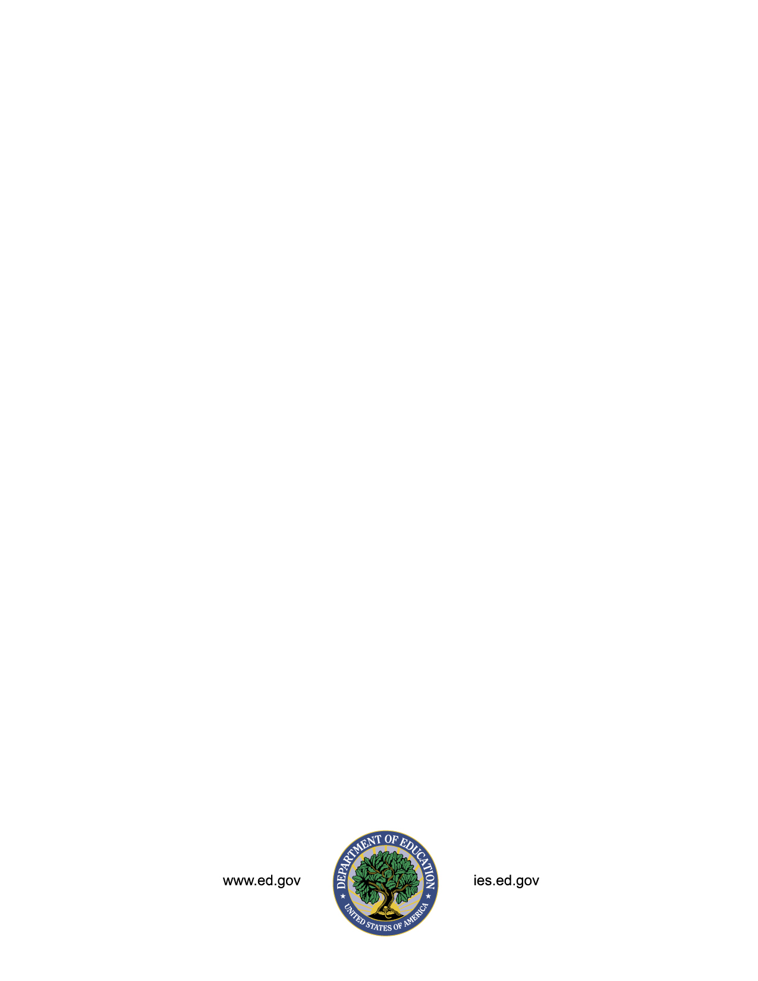

American National Standards Institute (ANSI) codes replace the Federal Information Processing Standards (FIPS) codes previously issued by the National Institute of Standards and Technology (NIST) for the 50 states, the District of Columbia, and the U.S. Island Areas. ANSI state code values map directly to the retired FIPS code values.
IEP counts are collected in the EDFacts file “Children with Disabilities (IDEA) School-Age” (C002) and reported on the CCD LEA Universe data file. CCD does not currently publish the number of special education students at the school level because of the risk of disclosure of individually identifiable information.

