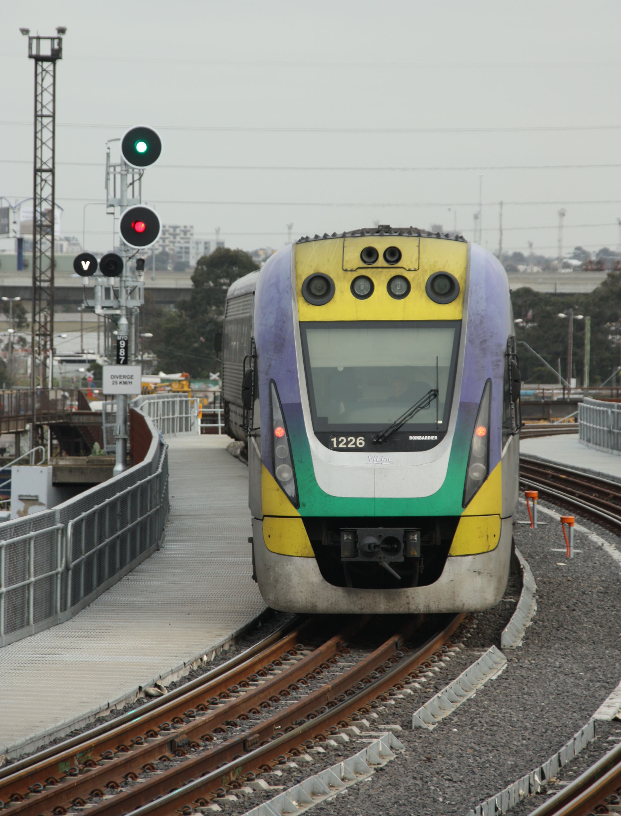SOMERSAULT

September 2014

Vol 37, No 5

Signalling Record Society of Victoria Inc