PRACTICAL NO. 1
A. Write a program for obtaining descriptive statistics of data. Step 1: Open your data in excel
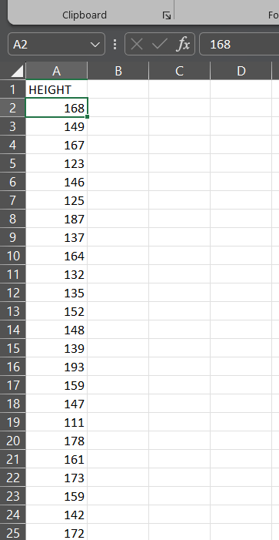

Step 2: From the Data Tool in the ribbon choose Data Analysis
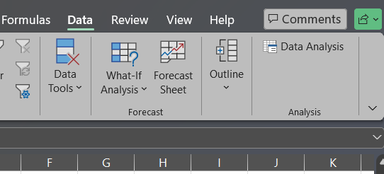

Step 3: Select the option of descriptive statistics

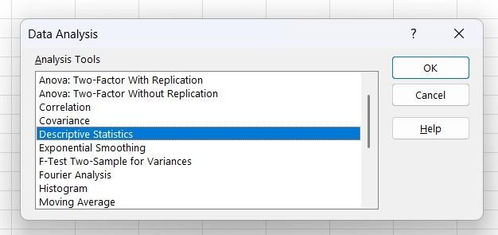

Step 4: Select and input range, output range, and check summary statistics and confidence level
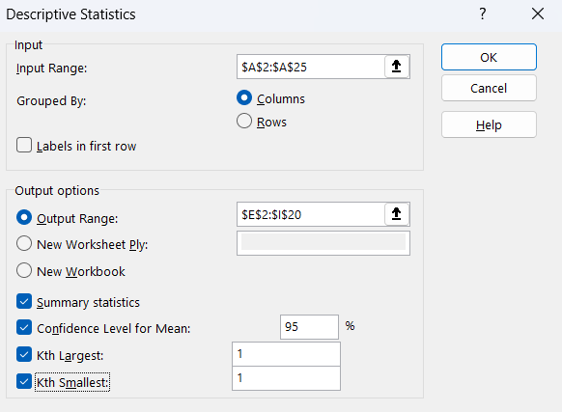

Step 5: The Output may appear as follows

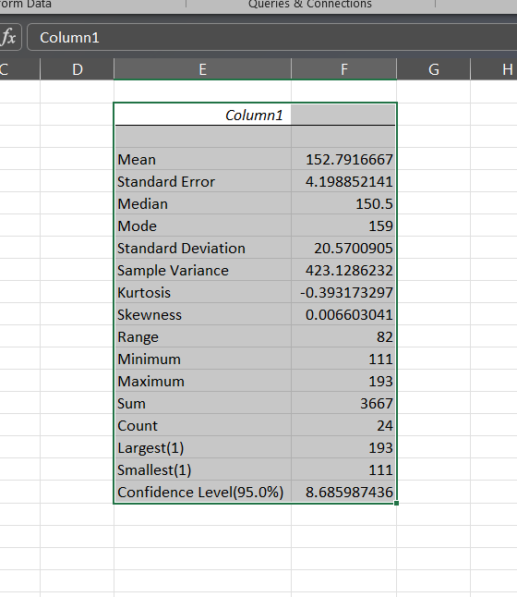

PRACTICAL NO. 2

A. Design a survey form for a given case study, collect the primary data and analyze it.
Step 1: To make a survey we used Google forms. Our case study’s aim was to find out which age group is most affected with health issues and practices healthcare
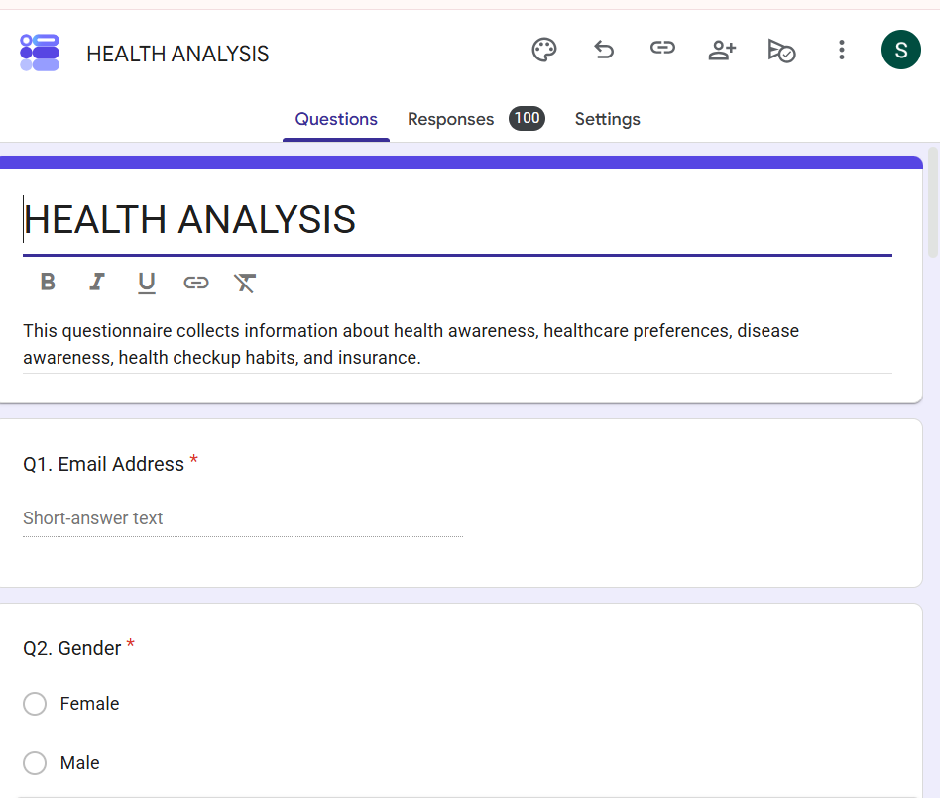

Step 2: The questions and options entered were as follows. Q1. Email Address:
Q2. Gender: (a). Female (b). Male (c). Prefer not to say Q3. Age Group: (a). 15-25 (b). 26-35 (c). 36-45 (d). above Q4. Do you suffer from any of these diseases?
(a). Diabetes (b). Blood Pressure (c). Asthma (d). Thyroid (e). Heart Disease. (f). NONE Q5. Which Lab do you prefer for test? (
a). Private Labs (b). Charitable Labs (c).
Government Labs (d). Hospital (e). Online lab checkup. Q6. Which is your preferred treatment?
(a). Allopathic (b). Ayurvedic
(c). Homeopathy (d). Unani(e). Naturopathy
Q7. Are you aware of the following disease? (a). Parkinson’s (b).
Alzheimer’s (c). Cancer(d). Leprosy (e). Schizophrenia
Q8. To your knowledge, check disease which are not contagious. (a). AIDS (b). Cold (c). Malaria (d). Typhoid (e). Pneumonia.
Q9. How Frequent do you have health checkups.
(a). Never (b). Twice a year (c).Once a year (d). Every 2/3 years (e). Every 5 years Q10. Do you have insurance in any of the following companies? (a). LIC (b).
Max Life (c). Reliance (d). Kotak (e). Other…

Step 3: Google forms tool was chosen because analysis becomes easier on Google forms
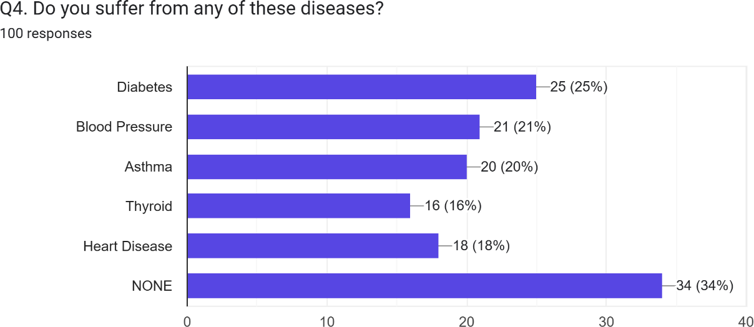

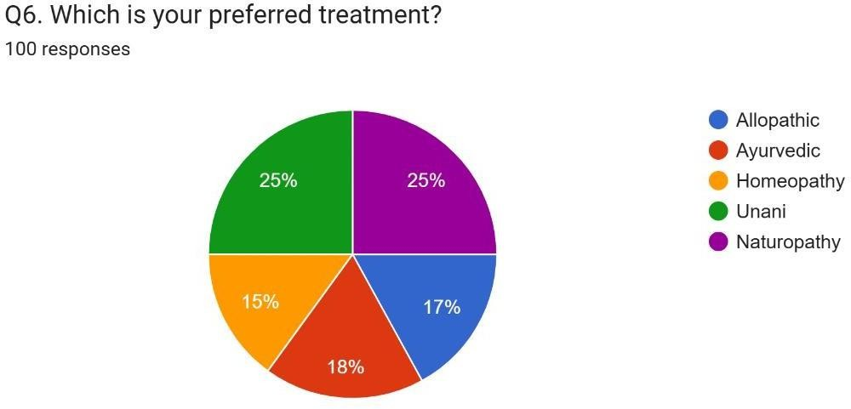

- B: Perform analysis of given secondary data Step 1: Open Data in excel
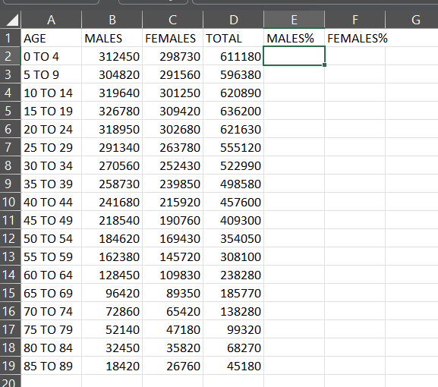

Step 2: Calculate the total sum of each column. Select the cell for Sum add formula SUM in formula bar select the range.

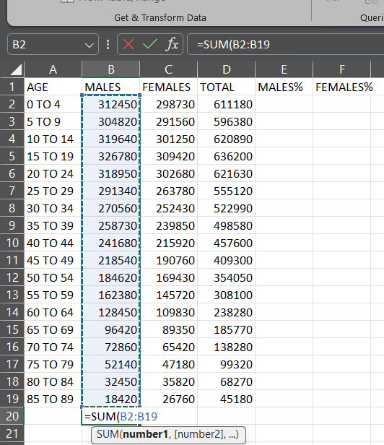
Step 3: Calculate the percentage of male in cell E. Use formula -1*100*B2/$D$21
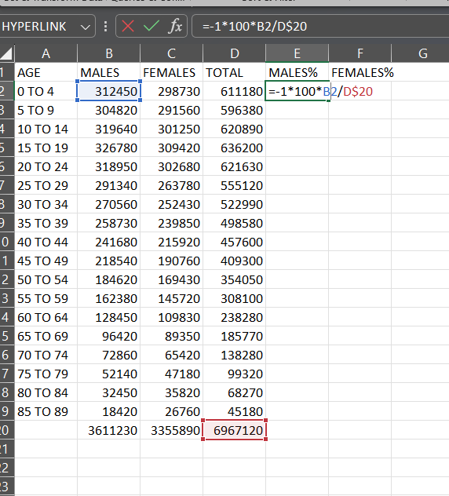

Step 4: Calculate the percentage female in cell F. Use formula 100*C2/$D$21
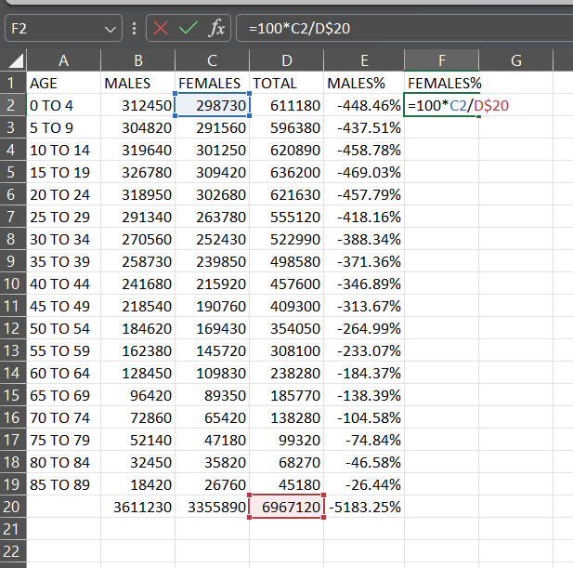
Step 5: The modified data may seem asfollows.
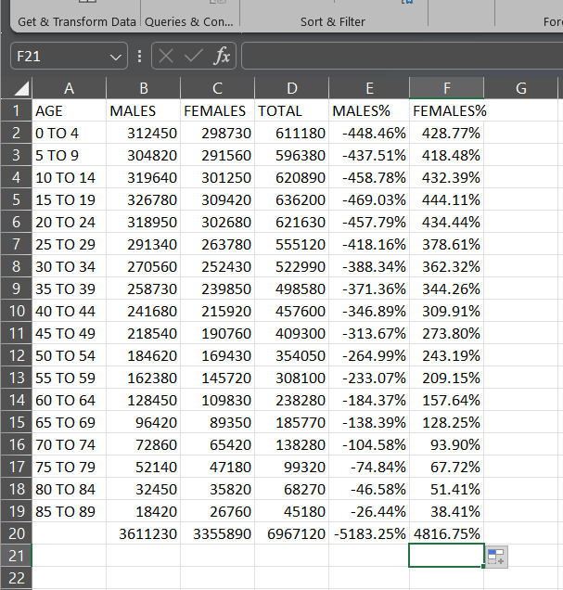

Step 6: For analysis go to Insert – Bar- 2D
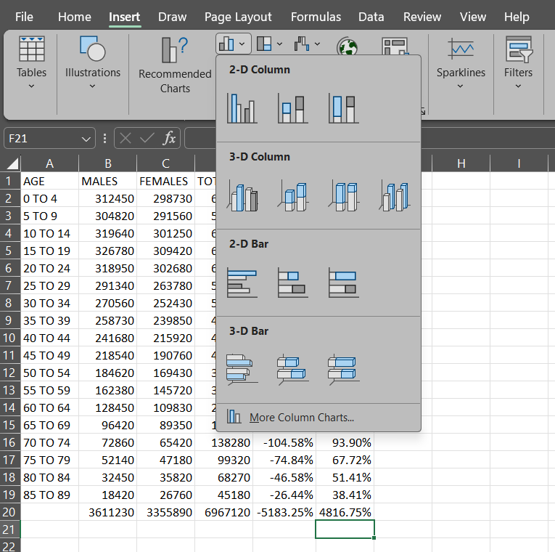

Step 7: Drag the data and set the graph for analysis
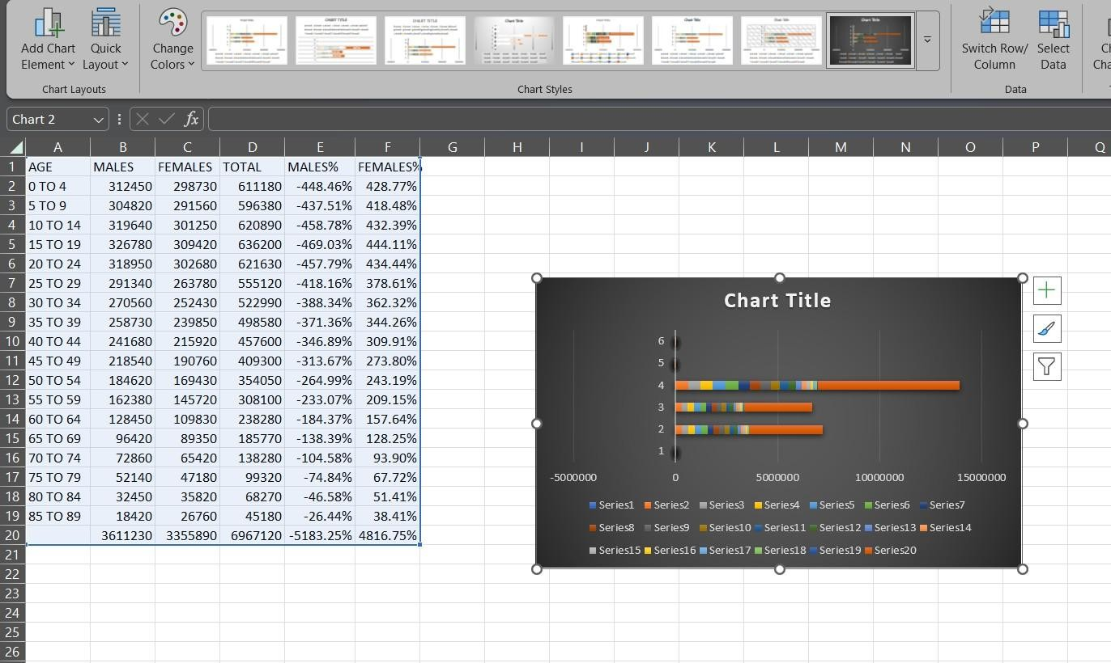

PRACTICAL NO. 3
A. Perform testing of hypothesis using one sample t-test. Step 1 : load the data and calculate mean
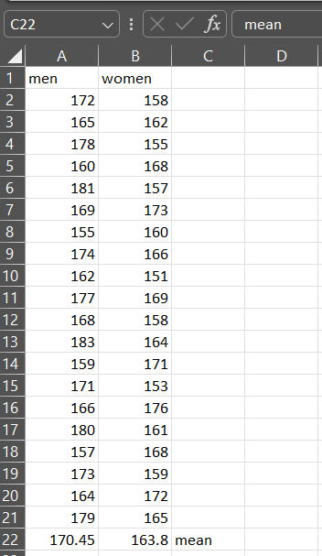
Step 2 : data – data analysis
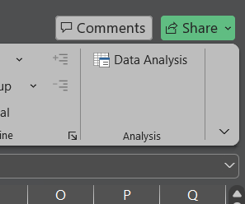

Step 3: Apply t-Test paired Two Sample for Means.
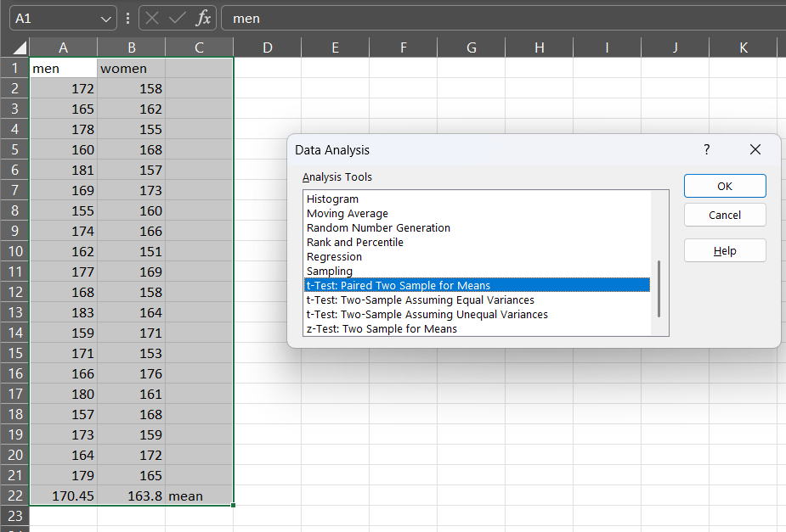

Step 4: Apply input Range and Output range
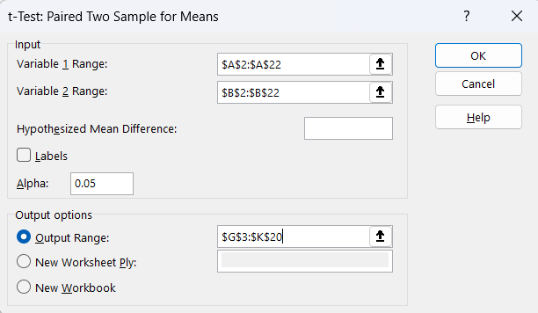

Step 5: output
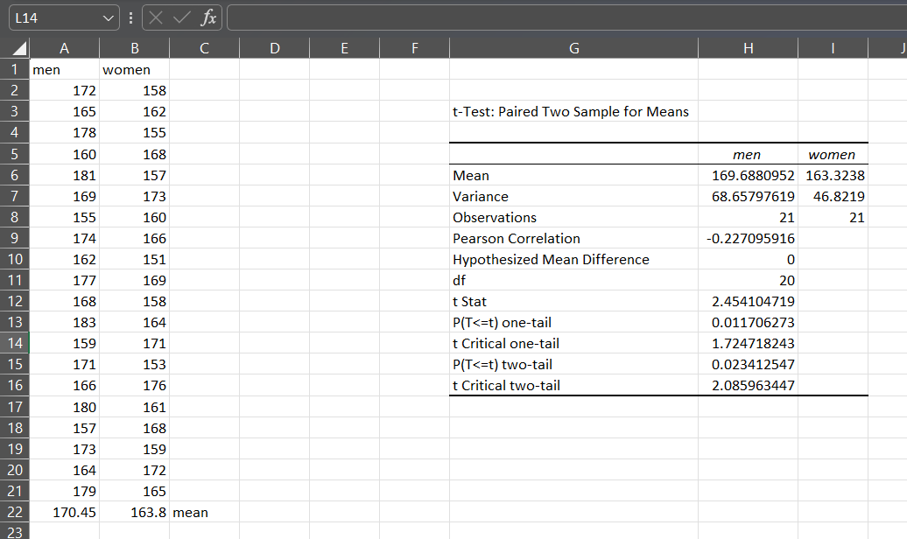

B. Write a program for t-test comparing two means for independent samples.

Step 1: Load the data and calculate mean
Step 2: data – data analysis

Step 3: Apply t-Test: Two– Sample Assuming Equal Variances
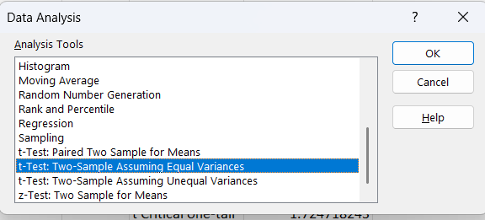
Step 4 : Apply input Range and Output rang
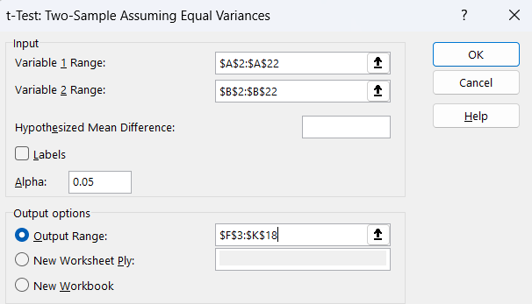

Step 5 : OUTPUT
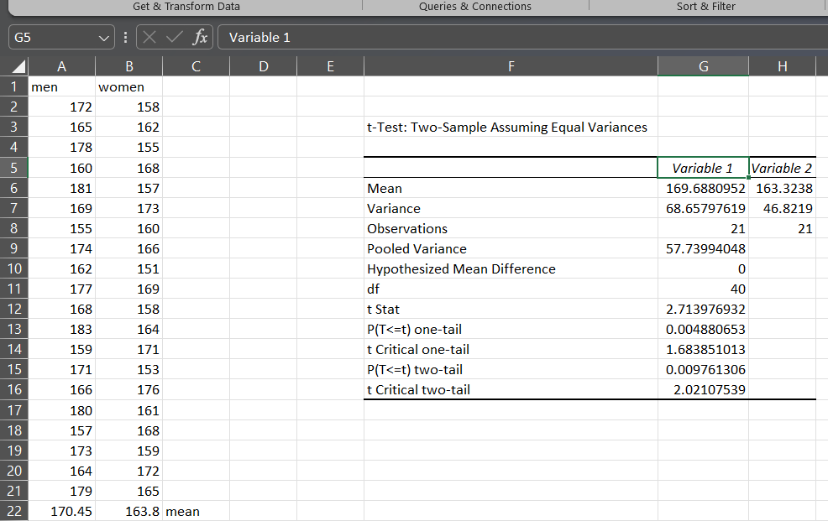

C. Perform testing of hypothesis using paired t-test. Step 1: load the data and calculate mean
Step2:Data–Data Analysis

Step 3: Apply T-Test: Two– Sample Assuming Unequal Variances

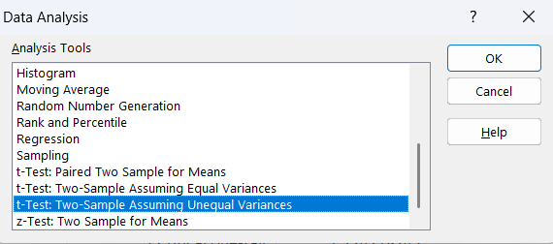
Step 4 : Apply input Range and Output range
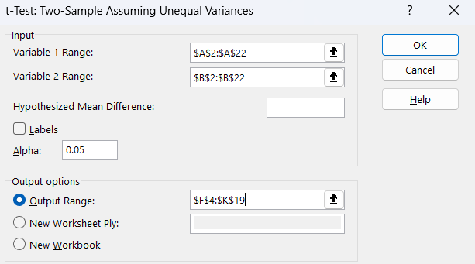
STEP 5 : OUTPUT
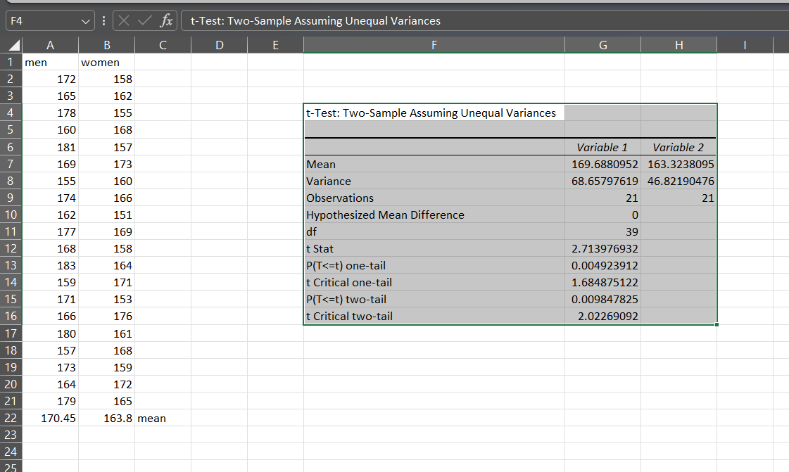

PRACTICAL NO. 4

A. Perform testing of hypothesis using chi-squared goodness of-fit test. Step 1: Load data.
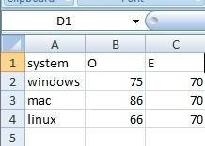

Step 2: Calculate the value of (O-E)^2 /E
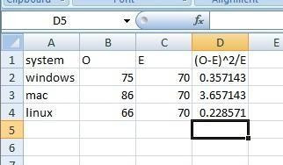
Step 3: Calculate Chisquare at 5% confidence and degree of freedom n-1=2(in our case)..
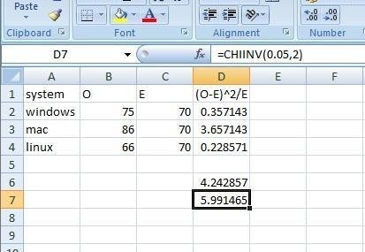

4.B. Perform testing of hypothesis using chi-squared test of independence Step 1: Load the data
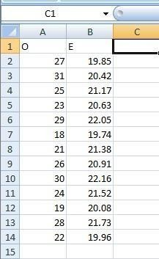
Step 2 : Type CHITEST and select Actual (observed value range) and Expected value range
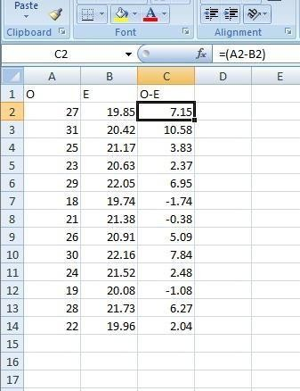

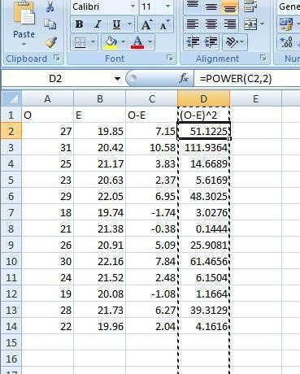
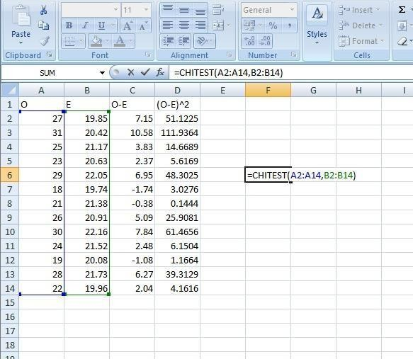

This calculated value is less than table value which is 19.68. Hence , we accept null hypothesis. i.e 0123581
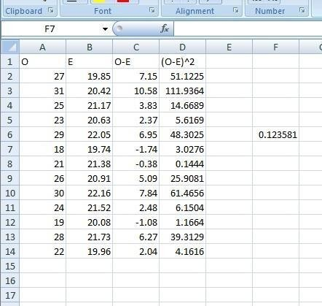

PRACTICAL NO. 5

A. Perform testing of hypothesis using Z-test.
Step 1: Load the data
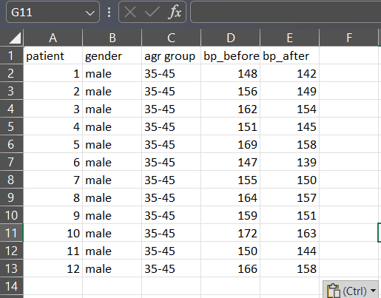
Step 2: To apply the Z-test, we need a sample size greater than 30. Since our sample size is only 12 data points, the Z-test cannot be applied. Therefore, we cannot proceed with the Z-test using this dataset.
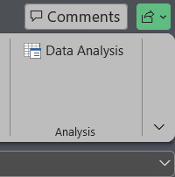
Step 3: Select-Test: Two Sample for Means.
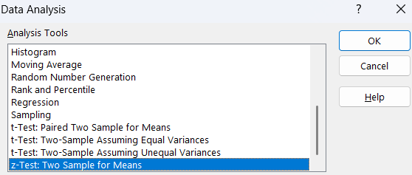

Step 4: Variance can be calculated using VAR.S(range)
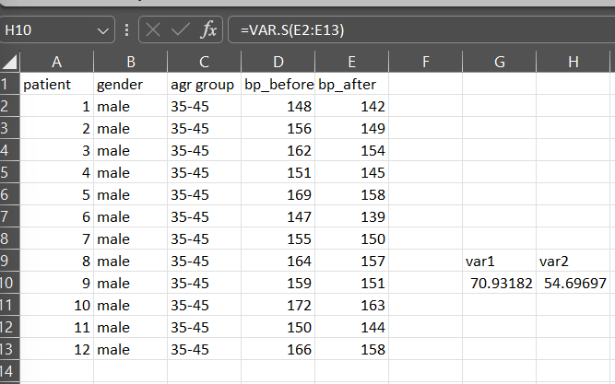
Step 5: Set the Variable 1 and 2 range
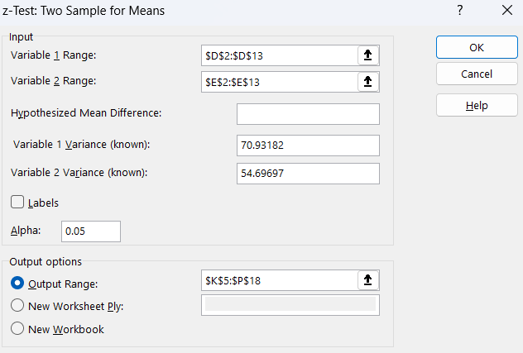

Step 6 : Output
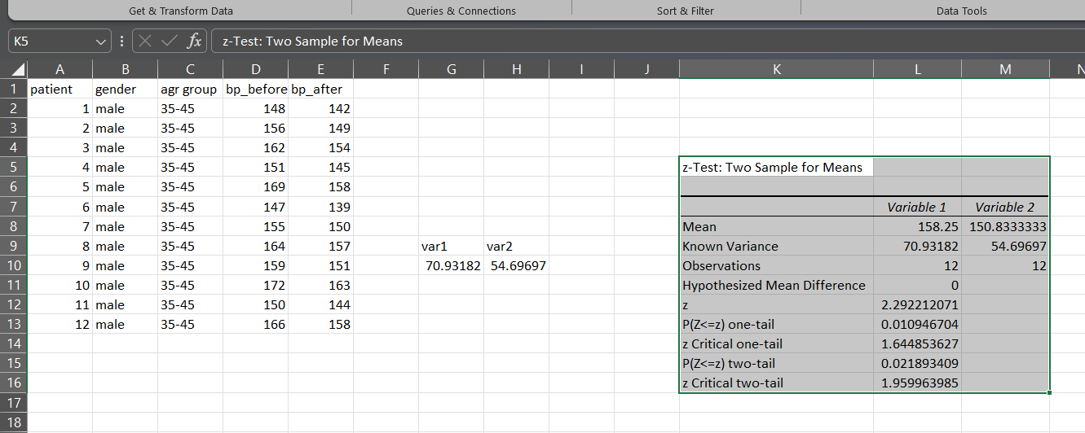

PRACTICAL NO. 6

6.A. Perform testing of hypothesis using One-way ANOVA Step 1: Load The Data
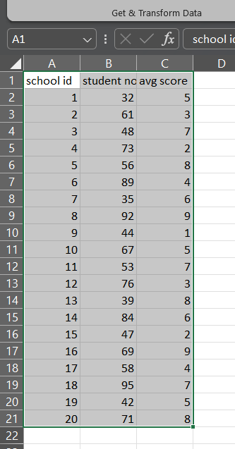
Step 2 : data - data analysis.

Step 3: Select Anova : Single Factor
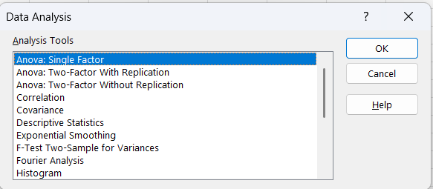

Step 4: select input and new worksheet ply:
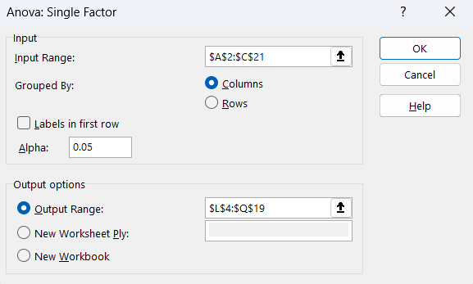

Step 5: OUTPUT

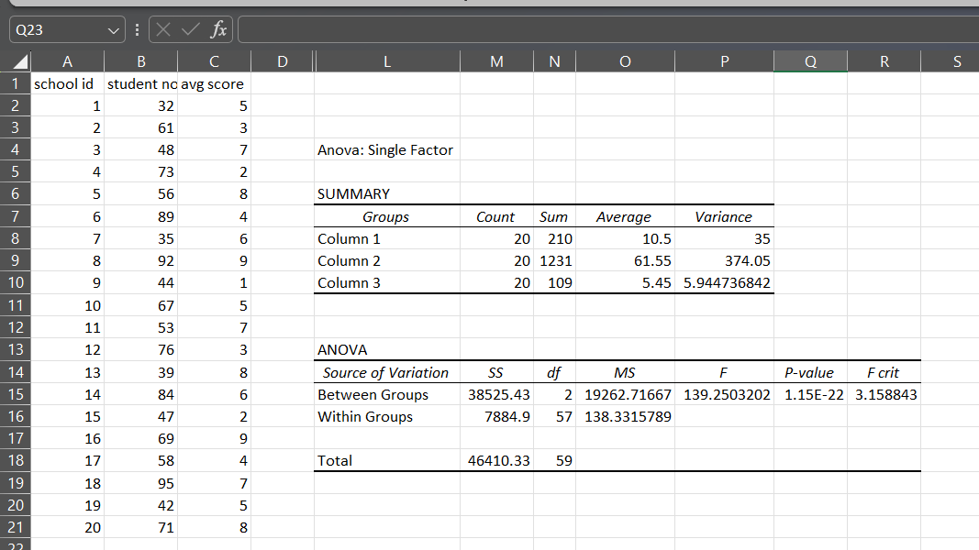

B: Perform testing of hypothesis using Two-way ANOVA. Step 1: load the data
Step 2: Data - Data Analysis

Step 3: Select Anova : Two- Factor With Replication.

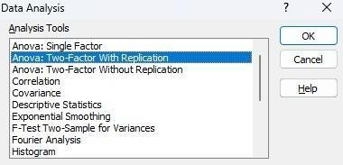
Step 4: Select Input and output range
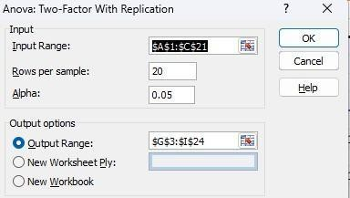

Step 5: OUTPUT
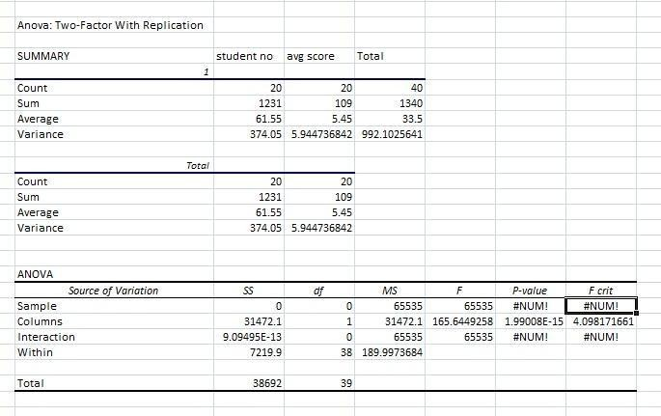

PRACTICAL NO. 7

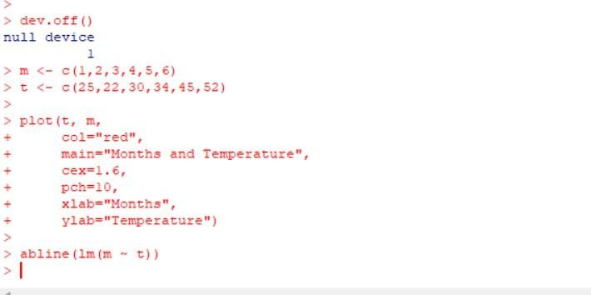
Write a program to perform linear regression for prediction. Code:
Output:
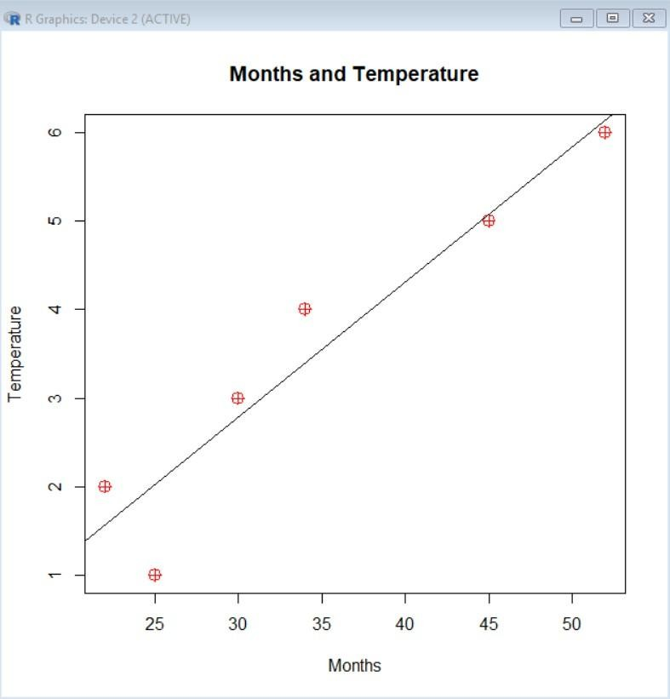

Polynomial Regression
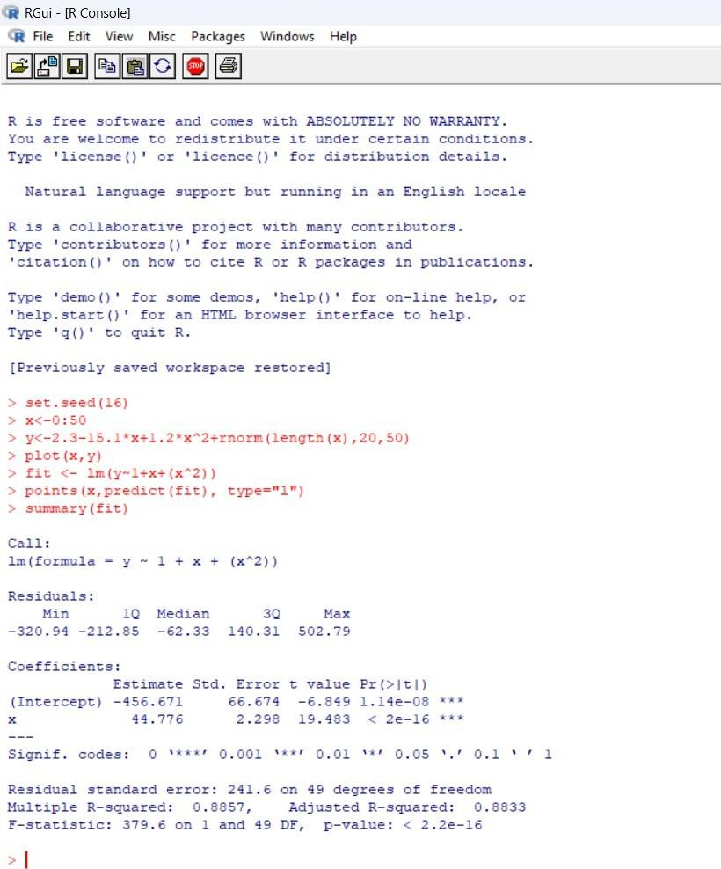

Output:
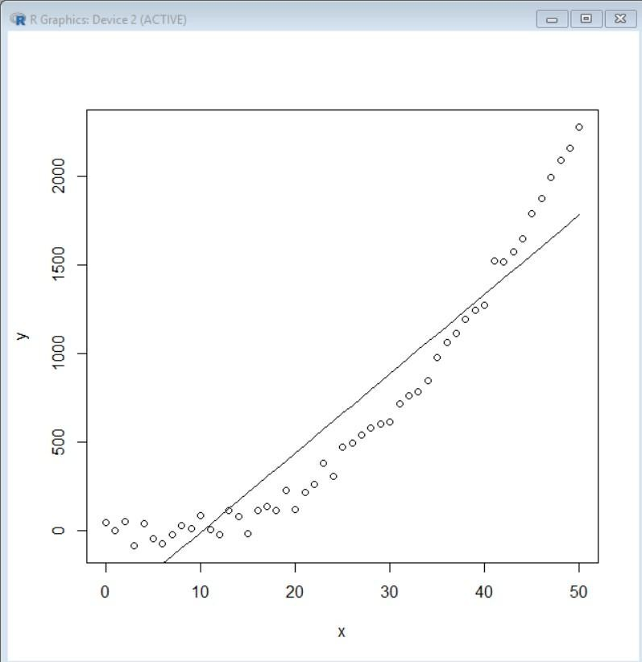

PRACTICAL NO. 8

A: Multiple linear regression Code:

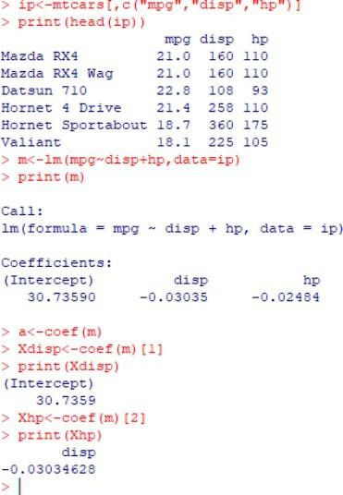

B: LOGISTIC REGRESSION CODE:
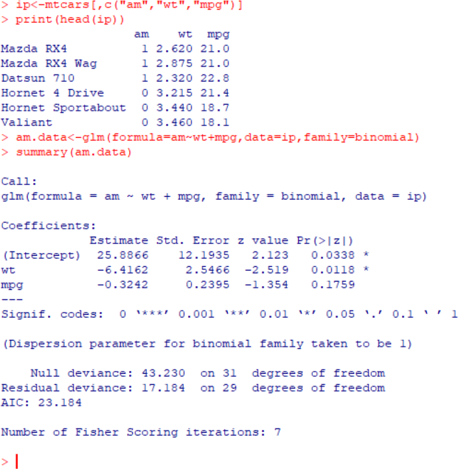

# Linear Regression:

dev.off()

m <- c(1,2,3,4,5,6)
t <- c(25,22,30,34,45,52)

plot(t, m,
col="red",
main="Months and Temperature",
cex=1.6,
pch=10,
xlab="Months",
ylab="Temperature")

abline(lm(m ~ t))

# Polynomial regression

set.seed(16)

x <- 0:50
y <- 2.3 - 15.1*x + 1.2*x^2 + rnorm(length(x), 20, 50)

plot(x, y)

fit <- lm(y ~ 1 + x + (x^2))

points(x, predict(fit), type="l")

summary(fit)

# Multiple Linear Regression

ip <- mtcars[,c("mpg","disp","hp")]
print(head(ip))

m <- lm(mpg~disp+hp,data=ip)
print(m)

a <- coef(m)

Xdisp <- coef(m)[1]
print(Xdisp)

Xhp <- coef(m)[2]
print(Xhp)

# Logistic Regression

ip <- mtcars[,c("am","wt","mpg")]
print(head(ip))

am.data <- glm(formula=am~wt+mpg, data=ip, family=binomial)
summary(am.data)

