**Testing the Get/Post/Put/Delete Requests using Postman**

Test 1:

Testing on the POST mapping through sending POST request to add a country name.

Request Body: Sending “Africa” as variable value

Status: 200 OK

Result: Country record added with an autogenerated Id value and assigning the passed variable value as the country name

Test 2:

Testing on the GET mapping through sending GET request to get all available list of country names.

Status: 200 OK

Result: Retrieving records of all the added countries

Test Case 3:

Testing on the PUT mapping through sending PUT request to update an existing country name

Request Body: Sending new country name

Path Variable: Sending existing Id of a country record

Status: 200 OK

Result: Country name updated at the record of the provided Id as the variable

After Updating: When retrieving the country list again after updating the country name shown updated

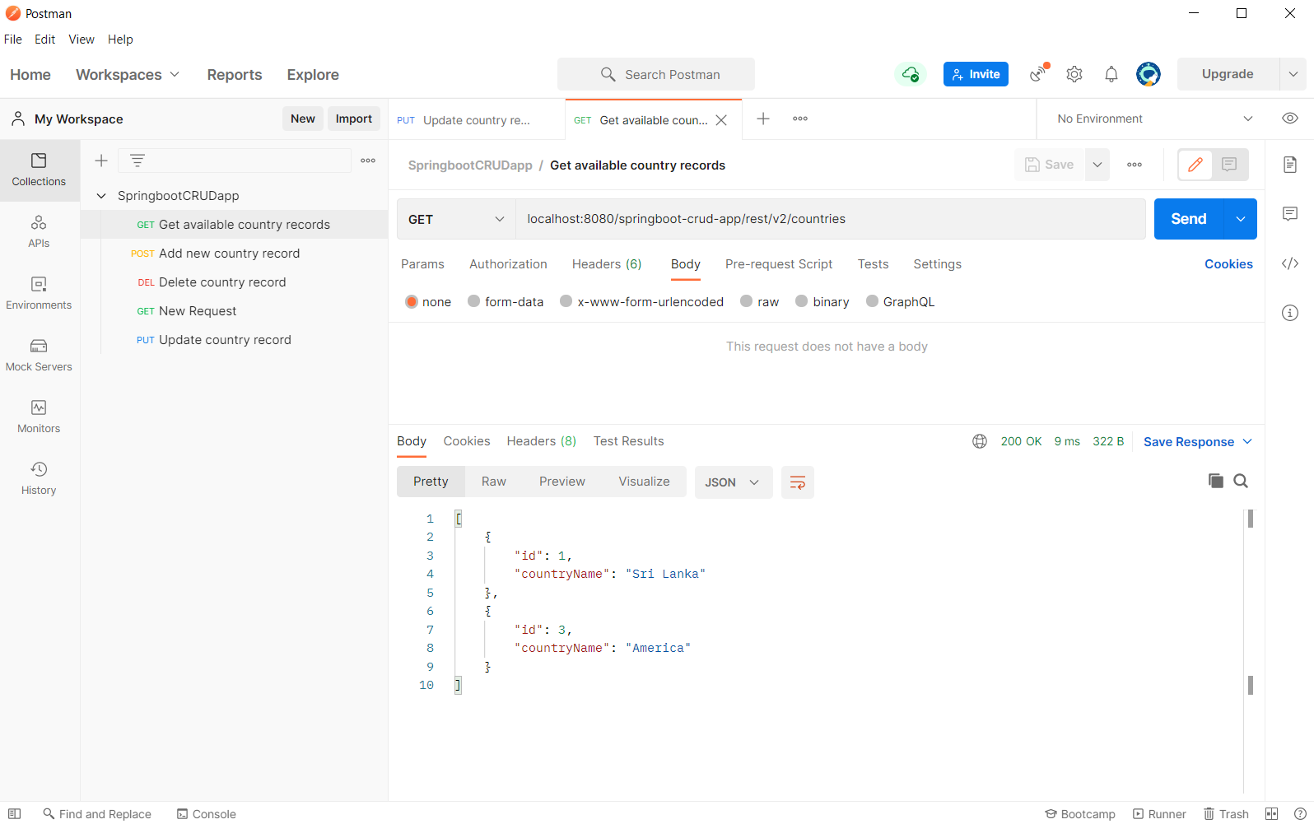

Test Case 4:

Testing on the DELETE mapping through sending DELETE request to delete an existing country record.

Status: 200 OK

Path Variable: Sending existing Id of a country record

Result: The record with the provided Id being removed

After Deletion: When retrieving the country list again after deleting the country record is removed and not shown

Test Case 5:

Testing on the GET mapping through sending GET request to get a particular existing country record.

Status: 200 OK

Path Variable: Sending existing Id of a country record

Result: The particular record retrieved and shown

Test Case 6:

Testing on the GET mapping through sending GET request to a dummy URL (not existing redirection)

Status: 404 NOT FOUND

Result: HTTP not found page displayed

Test Case 7:

Testing on the GET mapping through sending GET request to retrieve a country record by passing an invalid Path variable (name instead of id)

Status: 400 BAD REQUEST

Path Variable: Sending existing name of a country record

Result: HTTP Bad request page displayed

Test Case 8:

Testing on the GET mapping through sending GET request for an endpoint which does not accept a path variable

Status: 405 NOT METHOD NOT ALLOWED

Path Variable: Sending existing name of a country record

Result: HTTP method not allowed page displayed

Collection Test Runner:

