
Workshop project

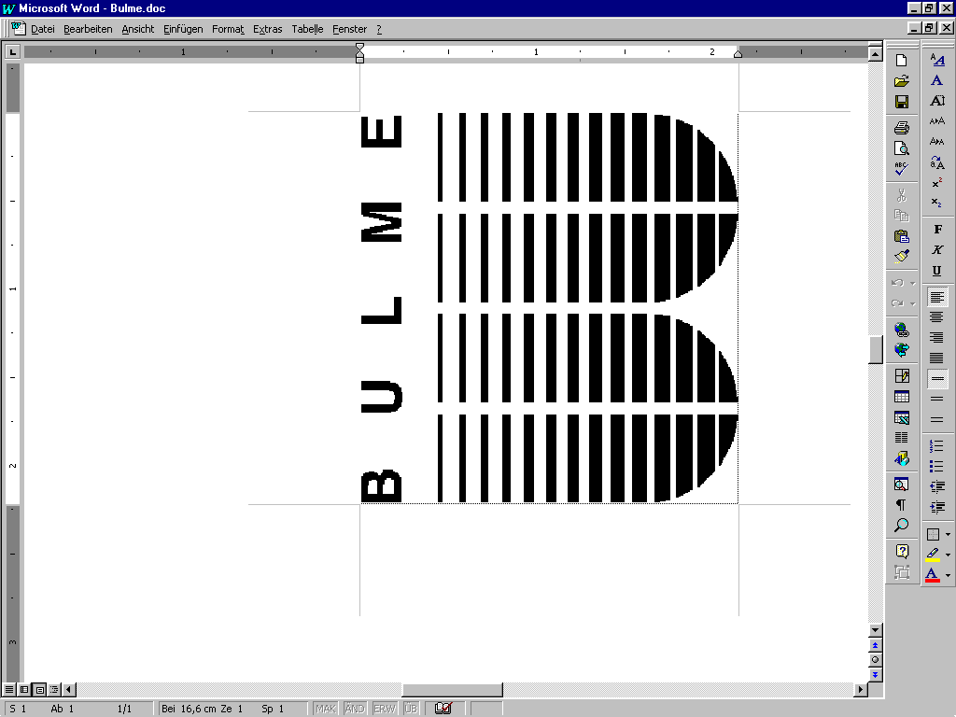
RGB-LED-Matrix-Console
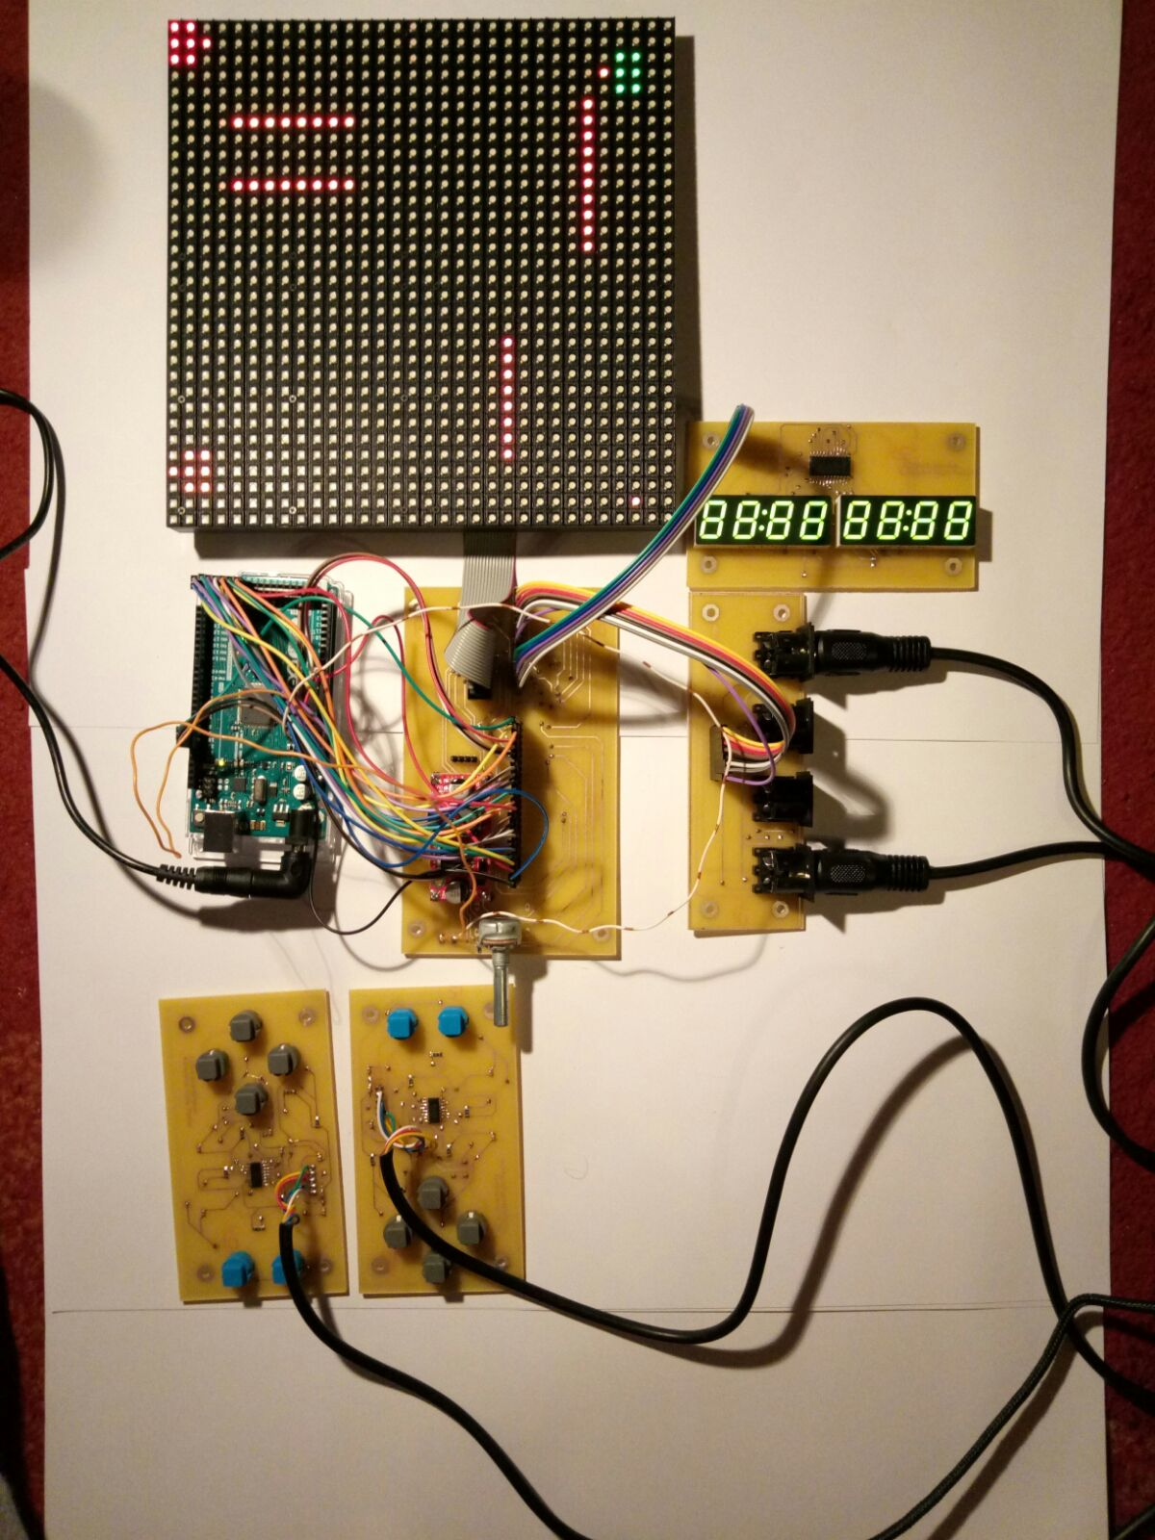

contents

1) project team 3
2) project description, idea 4
2.1) basic concept 4
2.2) final product 4
2.3) feedback 4
3) daily construction records 4
4) instruction manual 5
5) circuit, layout 5
5.1) circuit 5
5.2) layout 8
6) plans, calculations, parts list 10
7) check list 12

1) project team


Mujic Haris, builder of boards,



Karayanov Vitaliy, programmer and support,

Pucher Jonas, drawer of diagrams and layouts,


2) project description, idea

2.1) basic concept
We want to construct a game-console using a 32x32 RGB-LED-Matrix for
graphics and four controllers with four controlbuttons and two actionbuttons
each. We also want to add a 7-segments-display for scores, health etc.

2.2) final product
It's like the basic concept said, but the 7-segments-display doesn't work while
controling the matrix. There is no package.

2.3) feedback
// TODO

3) daily construction records

03.03.2017, creating the concept, searching for parts
03.10.2017, splitting the 6-man-group into two 3-man-groups, starting to
create the circuit diagram
03.31.2017, completed partslist and controller-layout
04.21.2017, completed boards and soldering of contacts between top and
bottom
05.05.2017, programming and mounting of the parts

4) instruction manual

- You just have to connect the power supply with a 230V 50Hz supply.
- You will land in the game-selection-menu
  - There you can navigate through the different games with the left and right control-buttons (gray).
  - To choose a game you simply push the lower blue button.
- Now you are in a game
  - Tanks
    - It's a four player game. You control a tank with the gray buttons and you can shoot with the lower blue button.
    - To win a game you have to hit the other tanks until you are the last
one.

5) circuit, layout

5.1) circuit
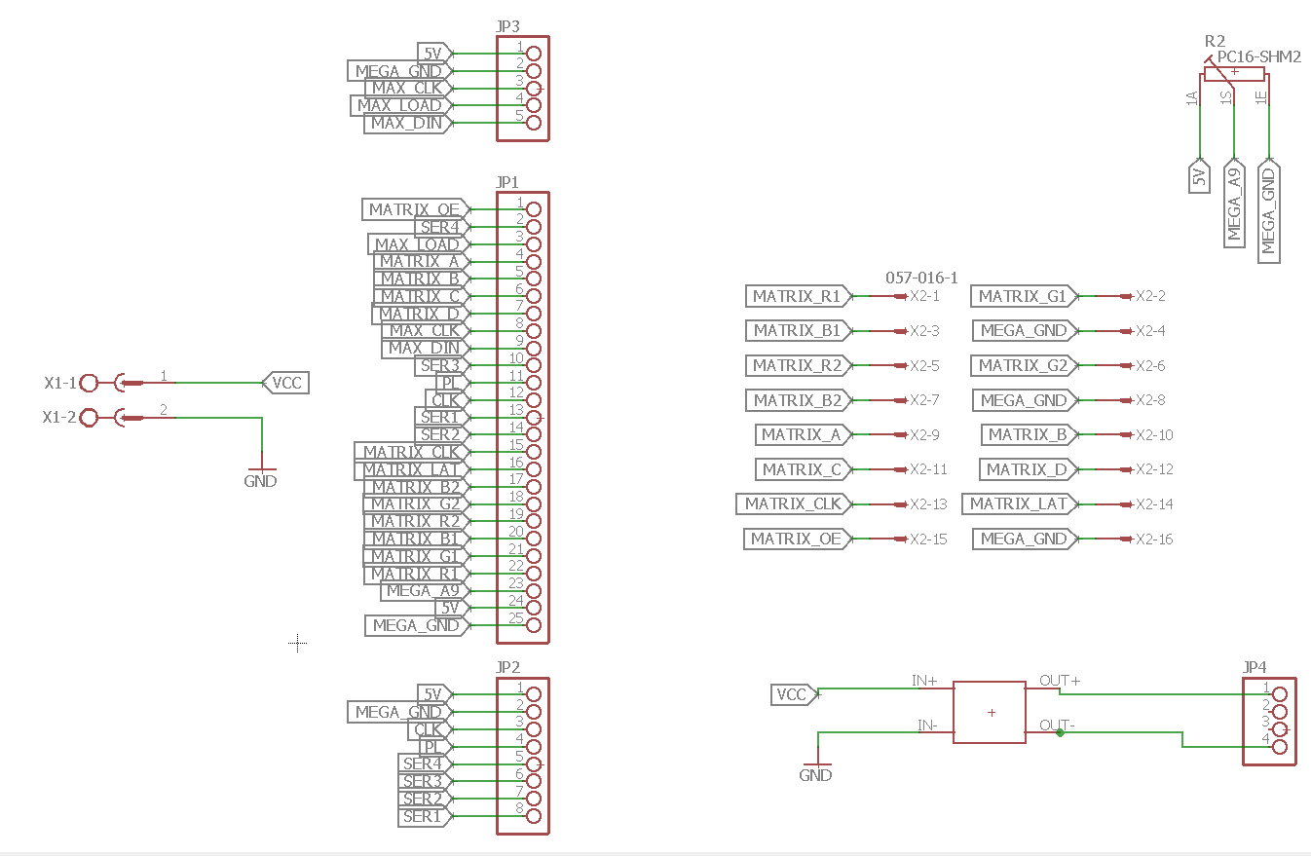
console.sch
This is the main board which consists of a power supply, a voltage stabilizer and
a few pin header to connect everything.
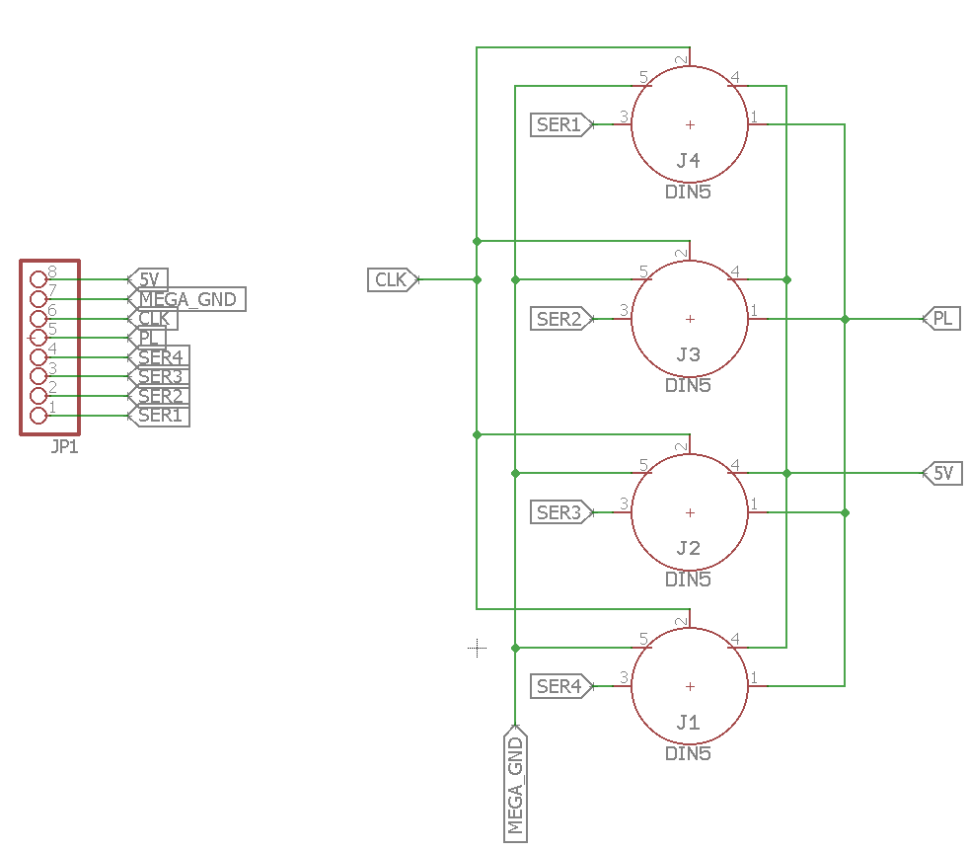
console1.sch
This board consists of the controller-jacks and a pin header to connect it with
the main board.

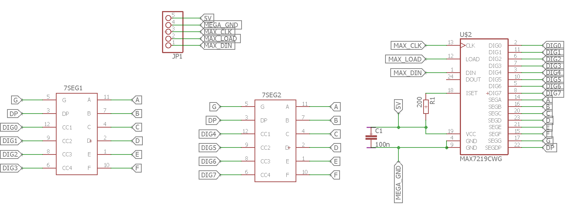
console2.sch
This board consists of two 4-digit-7-segments-displays, a MAX71219-IC to
control these and a pin header to connect it with the main board.
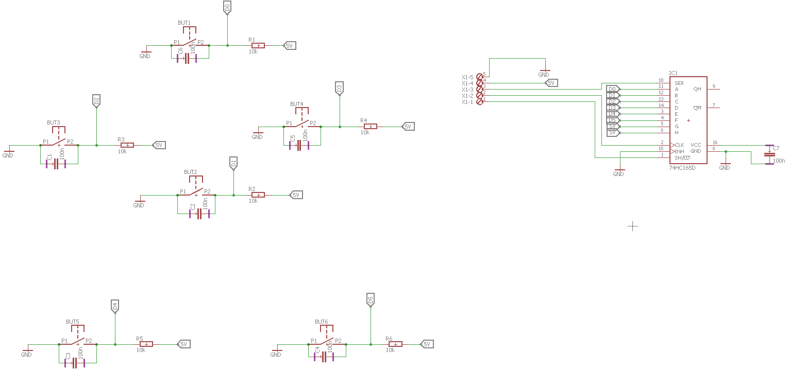
controller.sch
This is the board of the controller which consists of 6 buttons with the pull-up-
resistors and debouncing capacitors. There is also a 74HC165-shift register totransmit the button states to the arduino.

5.2) layout
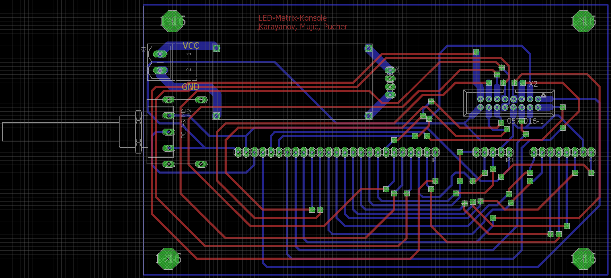
console.brd
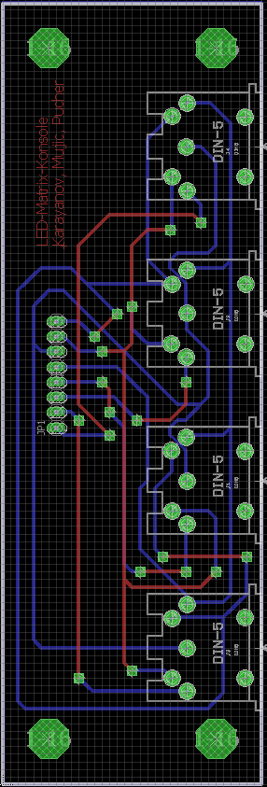
console1.brd

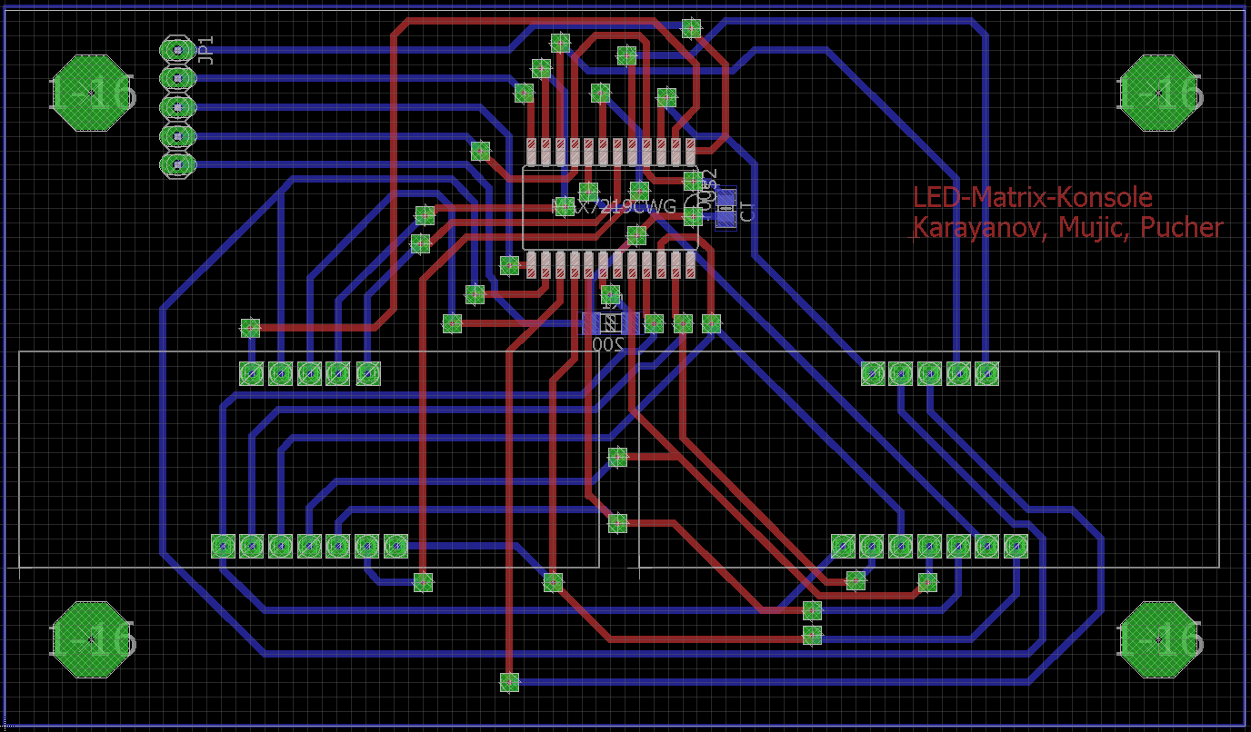
console2.brd
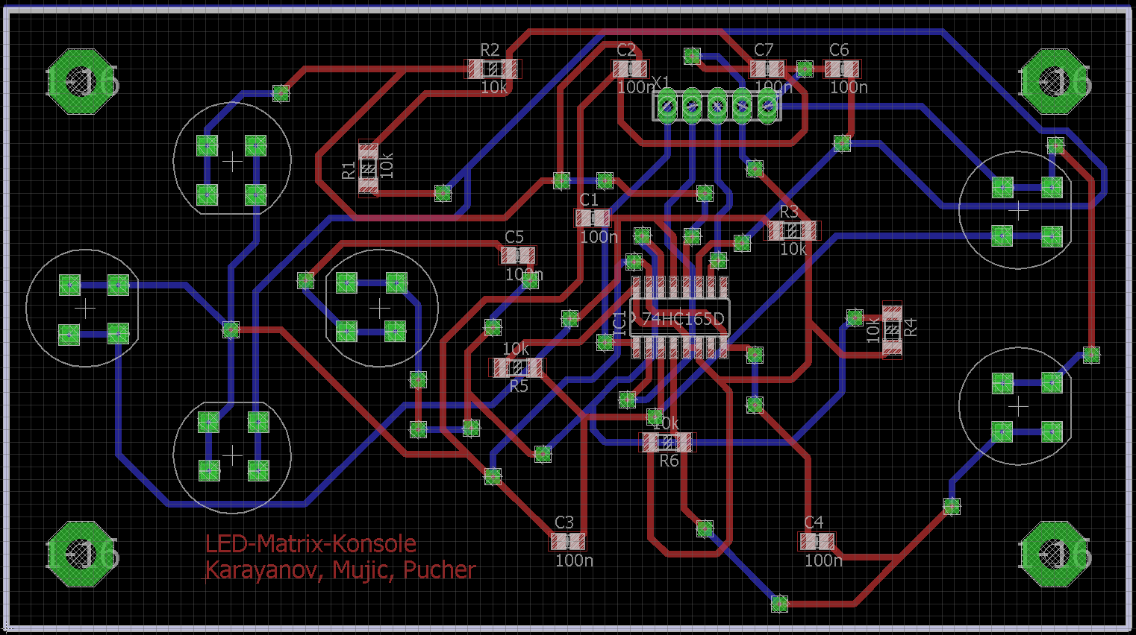
controller.brd

6) plans, calculations, parts list

6.1) parts list

name | amount | prize | website
32x32 Matrix | 1 | € 63,02 | www.adafruit.com
Arduino Mega | 1 | € 35,28 | www.arduino.cc
7-segments-display | 2 | € 5,94 | at.rs-online.com
controlbuttons | 16 | € 23,84 | at.rs-online.com
actionbuttons | 8 | € 11,44 | at.rs-online.com
potentiometer | 1 | € 1,92 | reichelt.at
74HC165 | 4 | € 1,28 | at.rs-online.com
MAX7219 | 1 | € 7,44 | at.rs-online.com
DIN-jack | 4 | € 2,40 | reichelt.at
DIN-cable | 4 | € 5,64 | reichelt.at
25x1 pinheader | 1 | € 3,71 | at.rs-online.at
8x1 pinheader | 2 | € 3,08 | at.rs-online.at
5x1 pinheader | 2 (5) | € 0,90 (2,26) | at.rs-online.at
8x2 pinstrip | 1 | € 0,49 | at.rs-online.at
voltage stabalizer | 1 | € 2,95 | neuhold-elektronik.at
100n capacitor | 29 | € 1,16 | reichelt.at
10k resistor | 24 | € 0,48 | reichelt.at
200 resistor | 1 | € 0,02 | reichelt.at
power supply | 1 | € 13,85 | amazon.de
 | Sum | € 186,20

6.2) plans
- Think out how we can do it
- Search for fitting parts
- Draw the circuit diagram
- Draw the circuit layout
- Print the boards
- Solder the connection from top to bottom
- Mount the parts
- Test the main board
- Design the package
- Print out the controller package with the 3D printer
- Build the main package in the KUV
- Connect everything and test it
- Finished!

6.3) calculations
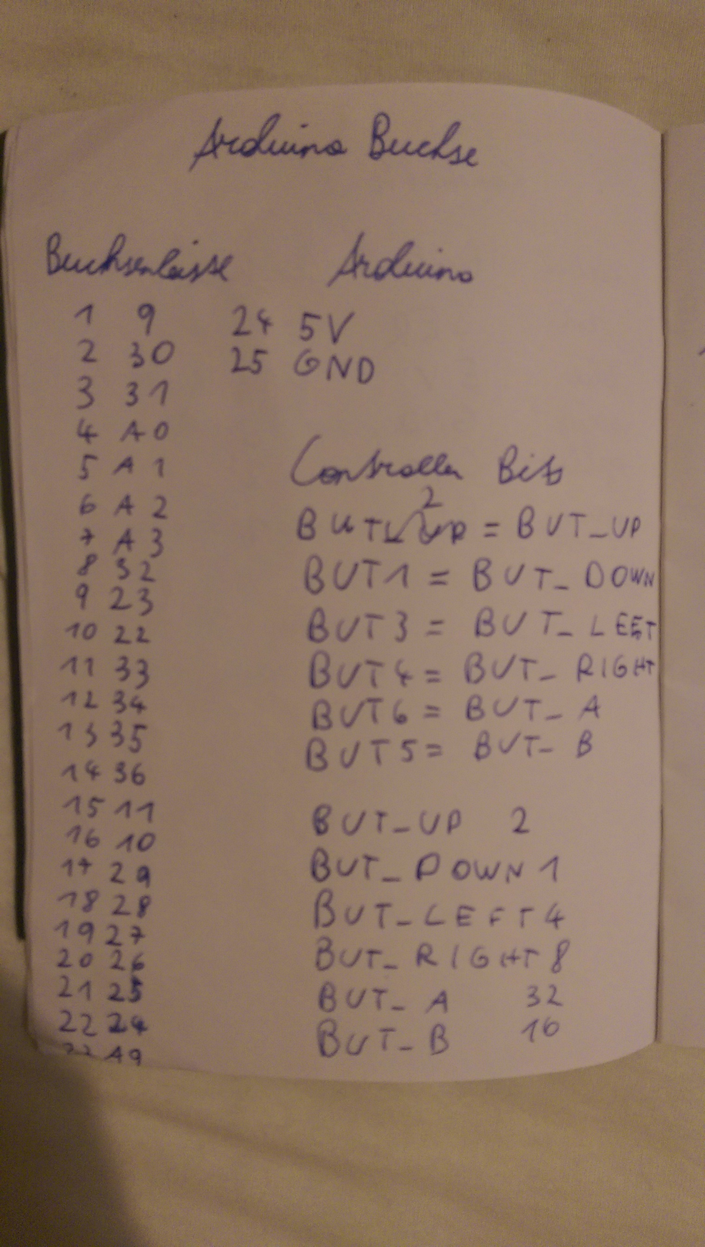

A photo of some notes. There are the pins of the 25x1 pinheader with their
corresponding arduino pin and the bits for the different buttons in the program.

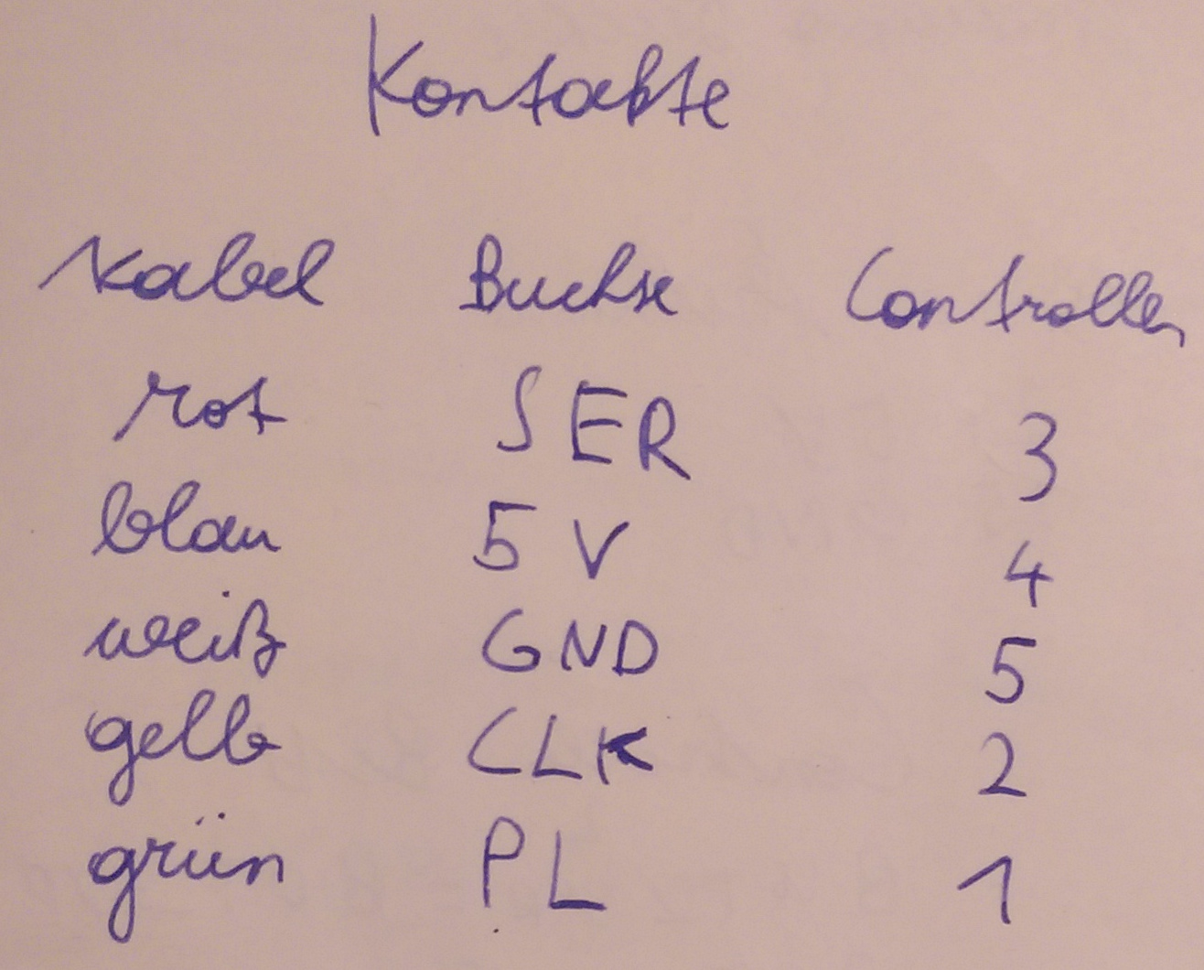

A picture of some notes about the contacts of the controller. There are the pins
of the controller and their corresponding cable-color and function in the program.

7) check list

Appointments: 03.03.2017 start
03.24.2017 ZT1, circuit finished, order components
04.28.2017 ZT2, control work progress
05.12.2017 test - presentation
06.09.2017 presentation

before presentation on 06.09.2017:
documentation ( 1x on paper, 1 x data medium) to teacher

every unit: upload work report to moodle

