|  |
| --- |
| Illuminati |
| SHOOT ALL THE ALIENS: THE MOVIE: THE GAME |
| **Based on a True Story** |
| Version #01  All work Copyright © 2018 by Illuminati Games.  All rights reserved. |
| **By Daniel Kerr-Cresswell, Aqhil Syed, Lakulish Patel, Oleksii Tomin, and Yehor Kalmykov** |
|  |



|  |
| --- |
| February 17th 2018 |

**Table of Contents**

[Your Table of Contents should go here. Make sure that your document’s sections are hyperlinked to their corresponding pages.]

1. Game Overview
2. Game Play Mechanics
3. Camera
4. Controls
5. Saving and Loading
6. Interface Sketch
7. Menu and Screen Descriptions
8. Levels
9. Characters
10. Non-player Characters
11. Enemies
12. Weapons
13. Items
14. Abilities
15. Script
16. Scoring
17. Puzzles/Mini-games
18. Bonuses
19. Sound Index
20. Story Index
21. Art / Multimedia Index
22. Design Notes
23. Future Features

**Version History**

Version 0.1: Started document!

* Version 0.1: The starting of document which included Team name, and Team Logo. The roles and the influences and game overview. The main MDA was decided and noted down in this file. And the initial panning was done.
* Version 0.2: The Updating was with inclusion of Placeholder Graphics, and main mechanics of basic working. The game basic player and gun and bullets firing was done and first level is included, and the live site link generation.
* Version 0.3: The graphics is being updated with three levels and there is energy bar and Gun type is updated. And the live site link generation.

[This is the body of your video game design document. You should add and delete sections as they pertain to your game’s design.]

1. **Game Overview**

*(ensure you mention the goal of the game and how to win if applicable)*

* The game is a 2D Side Scrolling Platformer, like Metal Slug/Contra
* In addition to a default pistol, there are four weapons the player can obtain (Shotgun, Machine Gun, Rocket Launcher, Laser Gun)
* There are four major power-up items for the player (Rapid Fire, Shield, Speed Up, Grenade)
* There are three enemy types and a boss in the game.
* There are three levels for the player to navigate, with increasing difficulty and complexity.

1. **Game Play Mechanics**

*PLAYER*

* *Has a life bar, can take 5 hits from enemies.*
* *Has 3 lives*

*CONTROLS*

* *Run*
* *Crouch*
* *Shoot*
* *Jump onto platforms*
* *Jump down from platforms*
* *Throw Grenade*
* *Roll (to evade)*

*WEAPONS and POWER UPS*

* *Weapons have limited ammo*
* *When they run out you switch back to the pistol*
* *Picking up a new weapon overwrites the old one*
* *Speed and Rapid-Fire power ups last 15 seconds.*
* *Shield lasts until hit*
* *Grenade adds 1 grenade to inventory*

1. **Camera**

*Side-view side scrolling platformer camera (see Interface Sketch section)*

1. **Controls**

*Basic WSAD/Arrow Key movement controls*

*S/down arrow crouches. While crouched, left or right arrow does evasive roll.*

*Spacebar to jump. Spacebar+Down to jump down through platforms.*

*CTRL to fire. While firing, movement stops and the movement controls instead direct your aim.*

*Stretch goal: mouse aiming and firing in all directions.*

1. **Saving and Loading**

*(Does your game include saving and loading? When? How?)*

*NO*

1. **Interface Sketch**

*(What does the game interface look like? Provide a screen shot or sketch)*

* + ***Initial Graphics***

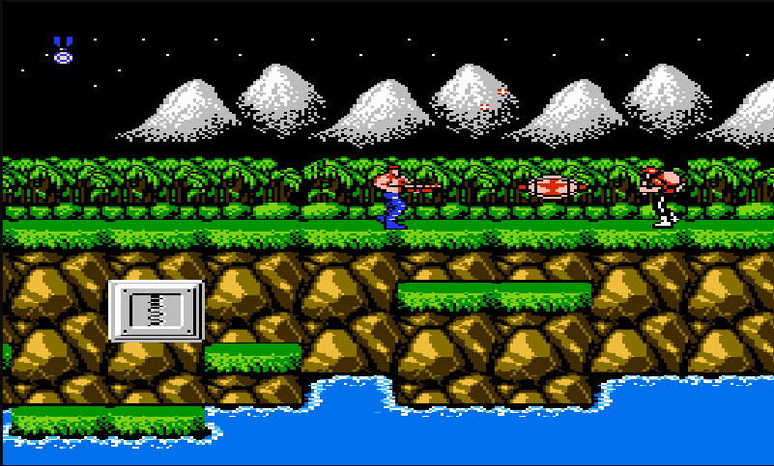

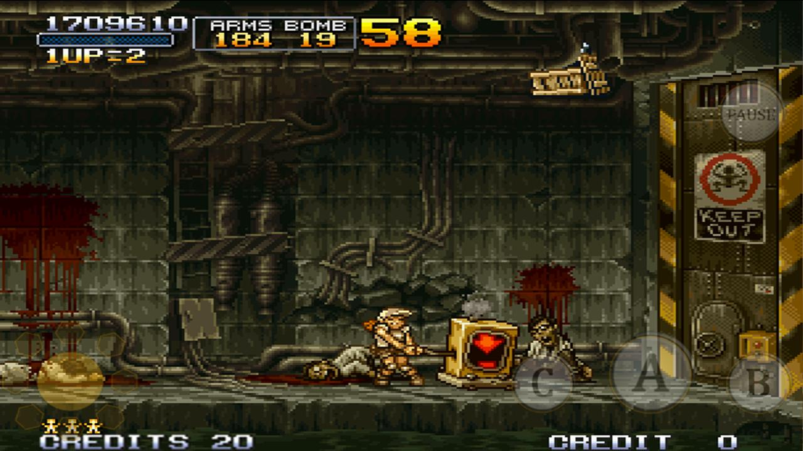

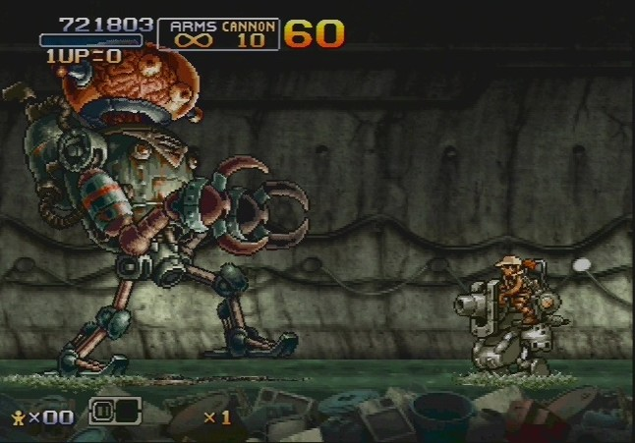

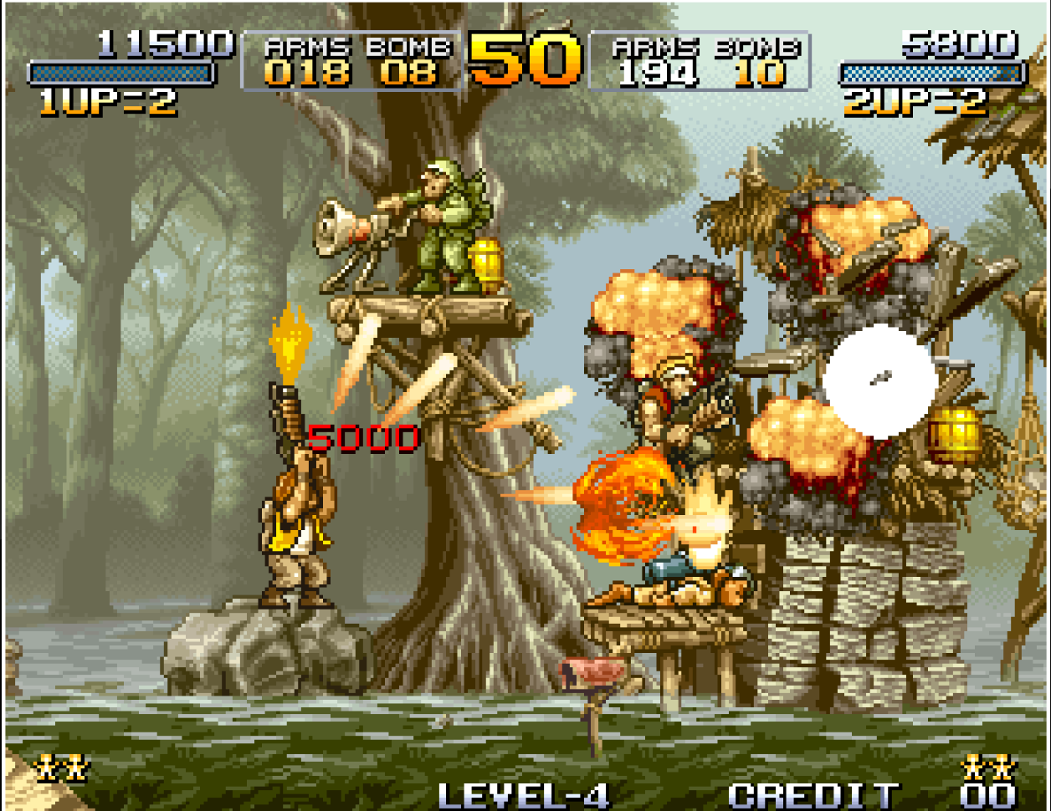

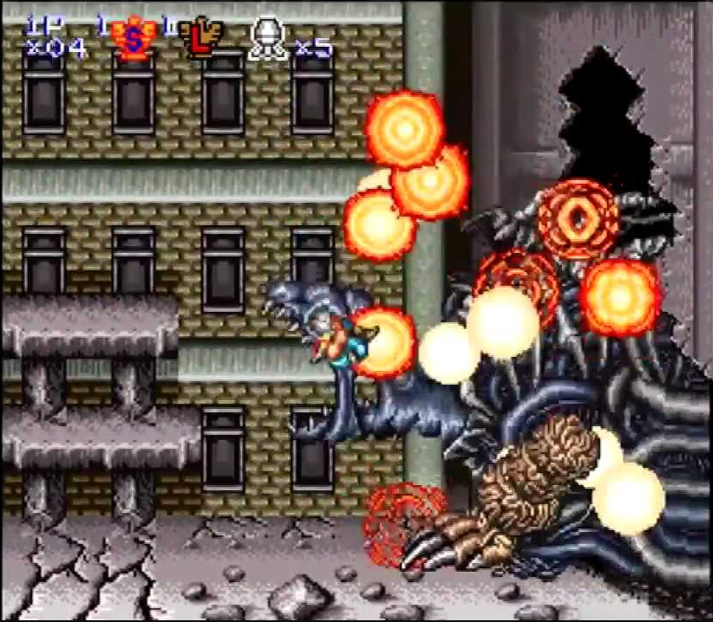

https://lh4.googleusercontent.com/e_1zffAYBk8QioGV-X4NLJEdOQlZDALljHRu1Q8NZuZZWbOMDCqFRTLL8tMtC2bnKMRO6Jzzwt92nZ3LP80fQrFgfqzMjv1rr8c3eqP7bmfReBrPIBA_Mzbxa5ZRYhDVOnzNIIRj7MA

***Actual Graphics****:*

* + *Level1 screen is having green background with some hurdles and has Handgun in it.*

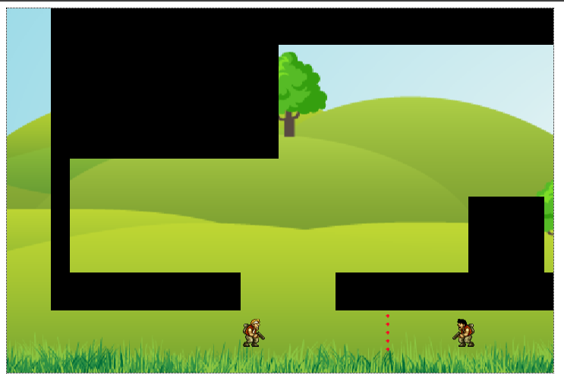

* + *Level2 is where the background changes and has some steps and we have addition weapon as Shotgun.*

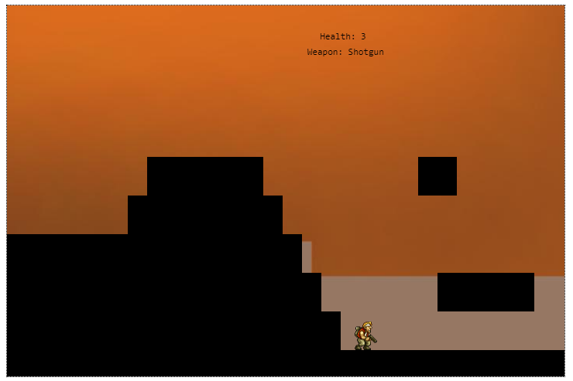

1. **Menu and Screen Descriptions**

*(Include additional screen shots and accompanying descriptions for any menus and additional screen)*

**

* + The name of the game and it has a button to start the game which is the initial screen.

1. **Levels**

*Three level types:*

* *Level 1: Basic side scrolling level. Jump a few platforms and get to the end.*
* *Level 2: More complex. Jump between moving platforms while defeating flying enemies.*
* *Level 3: Defeat waves of enemies jumping on to your platform and finally defeat the boss at the end.*

1. **Characters**

https://lh4.googleusercontent.com/e_1zffAYBk8QioGV-X4NLJEdOQlZDALljHRu1Q8NZuZZWbOMDCqFRTLL8tMtC2bnKMRO6Jzzwt92nZ3LP80fQrFgfqzMjv1rr8c3eqP7bmfReBrPIBA_Mzbxa5ZRYhDVOnzNIIRj7MA

This guy. He has a gun, he shoots the aliens and doesn’t afraid of anything.

He has a life bar, but can only take about five hits before dying and losing a life.

1. **Non-player Characters**

*No allies are currently planned. An allied character could be a stretch goal at the end of development.*

1. **Enemies**

*(Describe computer-generated enemies and boss monsters)*

* *Jumping Parasite*
  + *Scuttles along the floor. Player must crouch to hit them while on the floor. Reaching a set distance from the player, they leap, damaging on contact with the player.*
* *Parasite Soldier*
  + *These enemies shoot at you with the same weapons you can get. They will try and get on the same platform as you for a straight line of fire and then shoot.*
* *Flying Bug Enemy*
  + *Flies evasively when being shot at, launching a direct projectile and then sharply rising or diving away from return fire. Less often, can also launch a splash damage arcing projectile similar to player grenades.*

1. **Weapons**

* *Shotgun*
  + *20 shot capacity*
  + *Fires a tight 5 shot spread – one shot goes forward as normal, two spread out above and one spreads out below at 5 and 10 degree angles.*
* *Machine Gun*
  + *100 shot capacity*
  + *Fires automatically and rapidly in a straight line – hold down the button.*
* *Rocket Launcher (splash damage)*
  + *5 shot capacity*
  + *Fires a large slow moving projectile that explodes on the first thing it hits, damaging and knocking back everything in a small radius around the explosion.*
* *Pistol*
  + *Basic weapon*
  + *Infinite capacity*
  + *Fires in a straight line*
  + *2 shot/sec rate of fire*
  + *Semi-automatic – press the button every time you want to fire.*

1. **Items**

*There are six powerups in this game.*

* *Speed Up*
  + *Increases player speed and jump height by 1.5x*
* *Rapid Fire*
  + *Increases player rate of fire by 1.5x*
* *Shield*
  + *Encases the player in a protective shield that blocks all damage for 5 seconds, then stays on the player and disappears on the next hit.*
* *Grenade*
  + *Adds 1 grenade to grenade counter.*
  + *Grenade is an arching projectile which can bounce along the floor and explodes on impact with an enemy.*
* *Ammo Box*
  + *Replenishes all ammo in current special weapon.*
* *Medical Kit*
  + *Replenishes life bar by 2 hits.*

1. **Abilities**
2. **Script**
3. **Scoring**
4. **Puzzles/Mini-games**
5. **Bonuses**
6. **Sound Index**

*(Include an index of all your sound clips)*

1. **Story Index**

*(excerpt from the back of the box)*

In AD 20XX the aliens came and destroyed the world.

“Oh no” said the humans.

“I will fight the aliens” said Cool Gun Man, the GAME PROTAGANIST and BEST HERO

“ok” said the humans

Then Cool Gun Man picked up his gun and began to be fought with the aliens!

1. **Art / Multimedia Index**

*(Include an index of all your graphic and video assets here)*

1. **Design Notes**

*(Include additional design notes here)*

1. **Future Features**

*(Include any future features that are planned to be implemented)*