WEEK-2
Pudota Asritha Chowdary
Roll No: 2520030592
Step 1 — Create Database & Books Table
Created the librarybook database and the Books table with some constraints like PRIMARY KEY, NOT NULL, UNIQUE and CHECK. Then I inserted 3 books and checked using SELECT * FROM Books.
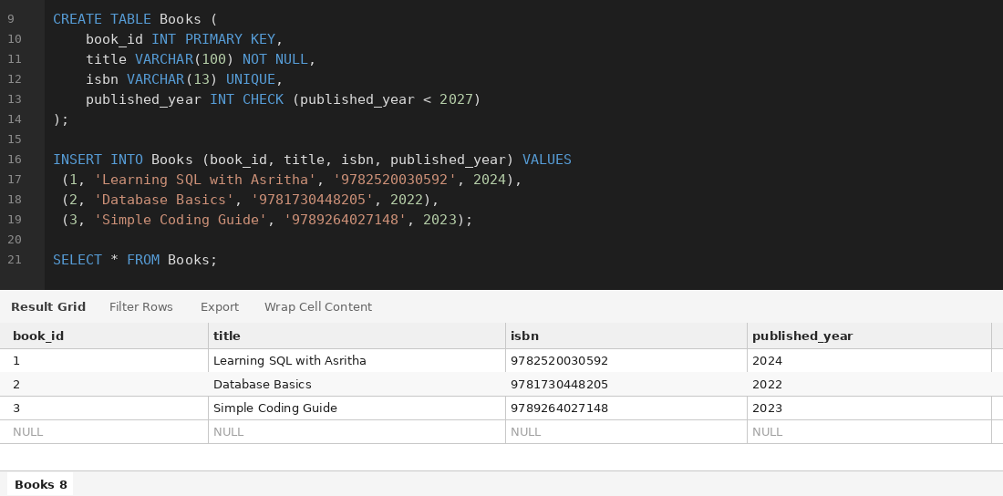
Step 2 — Create Members Table
Created the Members table with member_id, full_name and email. Inserted 3 members and verified the data using SELECT * FROM Members.
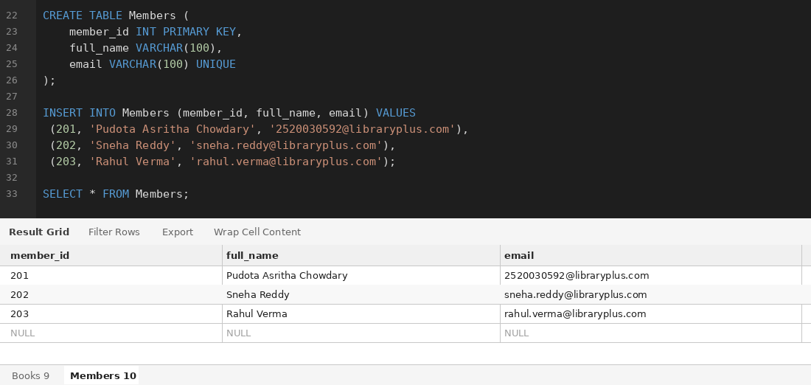
Step 3 — Create Loans Table
Created the Loans table to connect Members and Books. Then inserted 10 loan records and checked with SELECT * FROM Loans.
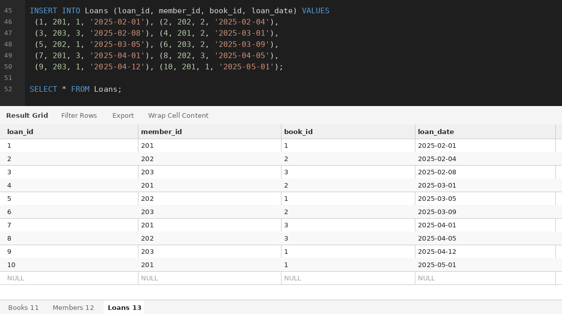
Step 4 — Join Query (Members & Books via Loans)
Used INNER JOIN on Loans, Members and Books to show which member borrowed which book.
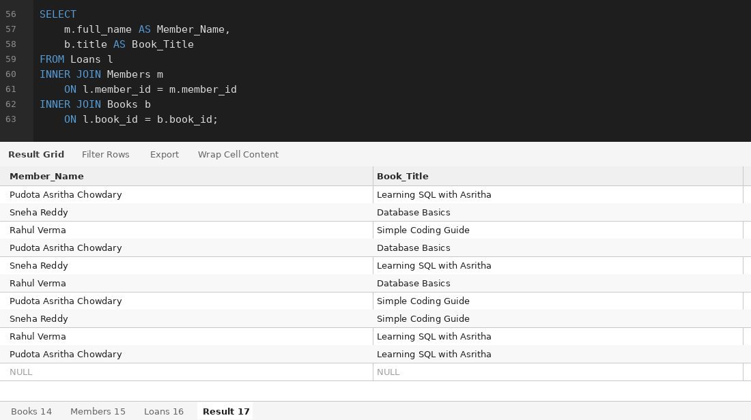
Step 5 — Aggregate Query (Books per Published Year)
Used GROUP BY and COUNT() to find how many books were published in each year.
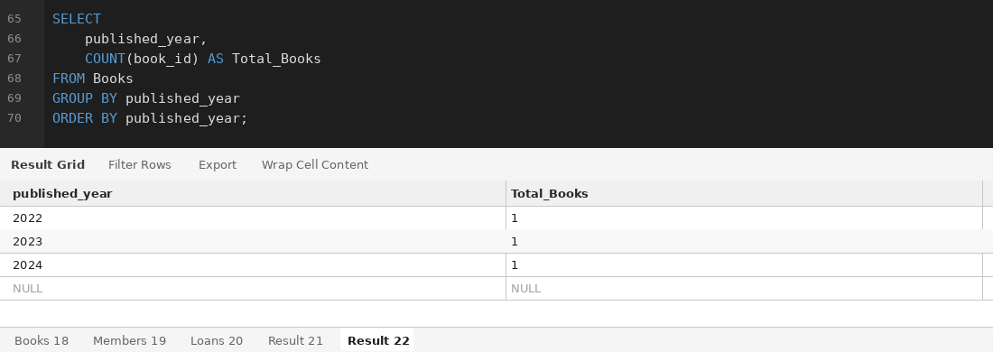
Step 6 — Donation_History Table & Transaction
Created Donation_History table. Then used START TRANSACTION and COMMIT to add a new book and also save the donation record together.
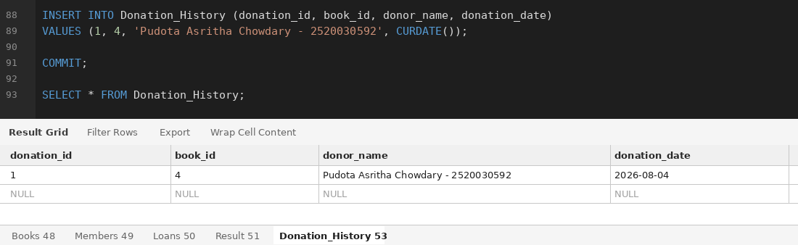
Step 7 — Index Creation & Indexed Search
Created an index on the isbn column of Books table to make searching faster. Then searched one book using its ISBN.
