SQL Practice — Student Marks Table

ASSIGNMENT
Name: Pudota Asritha Chowdary
Roll No: 2520030592

Step 1 — Create Database and Table
CREATE DATABASE marks_db; USE marks_db;
CREATE TABLE student_marks ( roll_no INT PRIMARY KEY, name VARCHAR(50),
subject VARCHAR(50), marks DECIMAL(5,2)
);

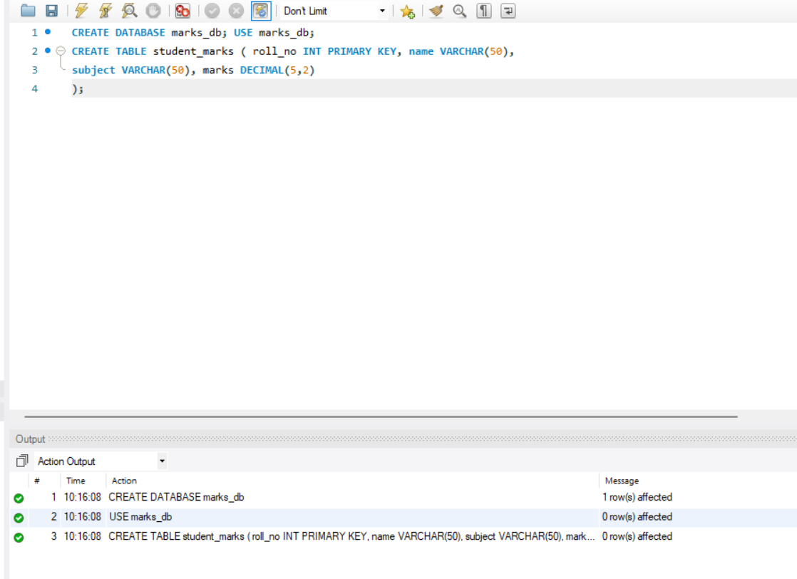

Step 2 — Insert Data

INSERT INTO student_marks (roll_no, name, subject, marks) VALUES
(1, 'Asritha', 'Math', 85.50),
(2, 'Sathwika', 'Math', 92.75),
(3, 'Akhila', 'Math', 78.40),
(4, 'Priya', 'Math', 88.90),
(5, 'Vasavi', 'Math', 80.25),
(6, 'Sahasra', 'AWS', 98.50),
(7, 'Manvitha', 'DBMS', 95.75),
(8, 'Meghana', 'English', 97.40),
(9, 'Maha', 'AWS', 99.90),
(10, 'Praharsha', 'Azure', 82.25);

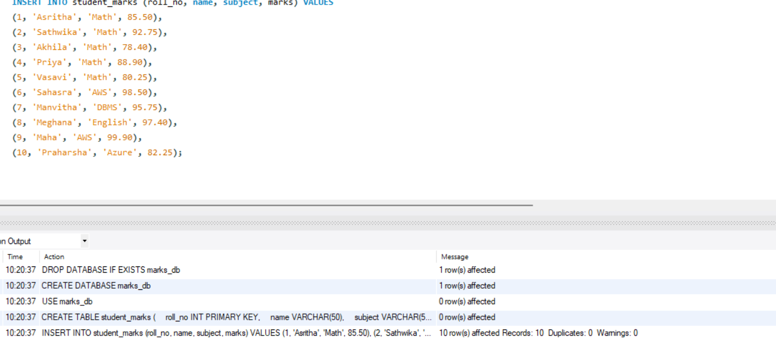

Step 3 — Simple Select
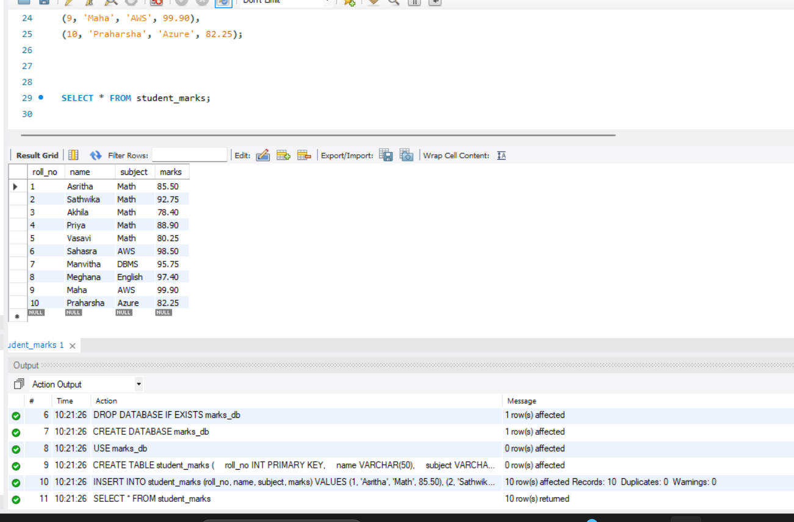
SELECT * FROM student_marks;

Step 4 — Aggregate Functions

SELECT COUNT(*) AS total_students FROM student_marks; SELECT SUM(marks) FROM student_marks;
SELECT AVG(marks) FROM student_marks; SELECT MAX(marks) FROM student_marks; SELECT MIN(marks) FROM student_marks;
LINE BY LINE OUTPUT —>
COUNT(*) -> 10
SUM(marks) -> 899.55
AVG(marks) -> 89.955
MAX(marks) -> 99.90
MIN(marks) -> 78.40
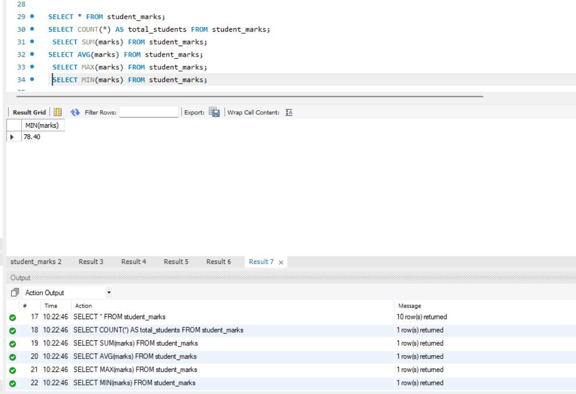

Step 5 — Filtering with WHERE

SELECT * FROM student_marks WHERE marks > 85; SELECT * FROM student_marks WHERE marks >= 90; SELECT * FROM student_marks WHERE marks < 80;
SELECT * FROM student_marks WHERE marks BETWEEN 80 AND 90; SELECT * FROM student_marks WHERE name LIKE 'P%';
SELECT * FROM student_marks WHERE name IN ('Praharsha', 'Asritha', 'Maha');
SELECT * FROM student_marks WHERE marks > 85 AND (subject = 'Math' OR name LIKE 'P%');

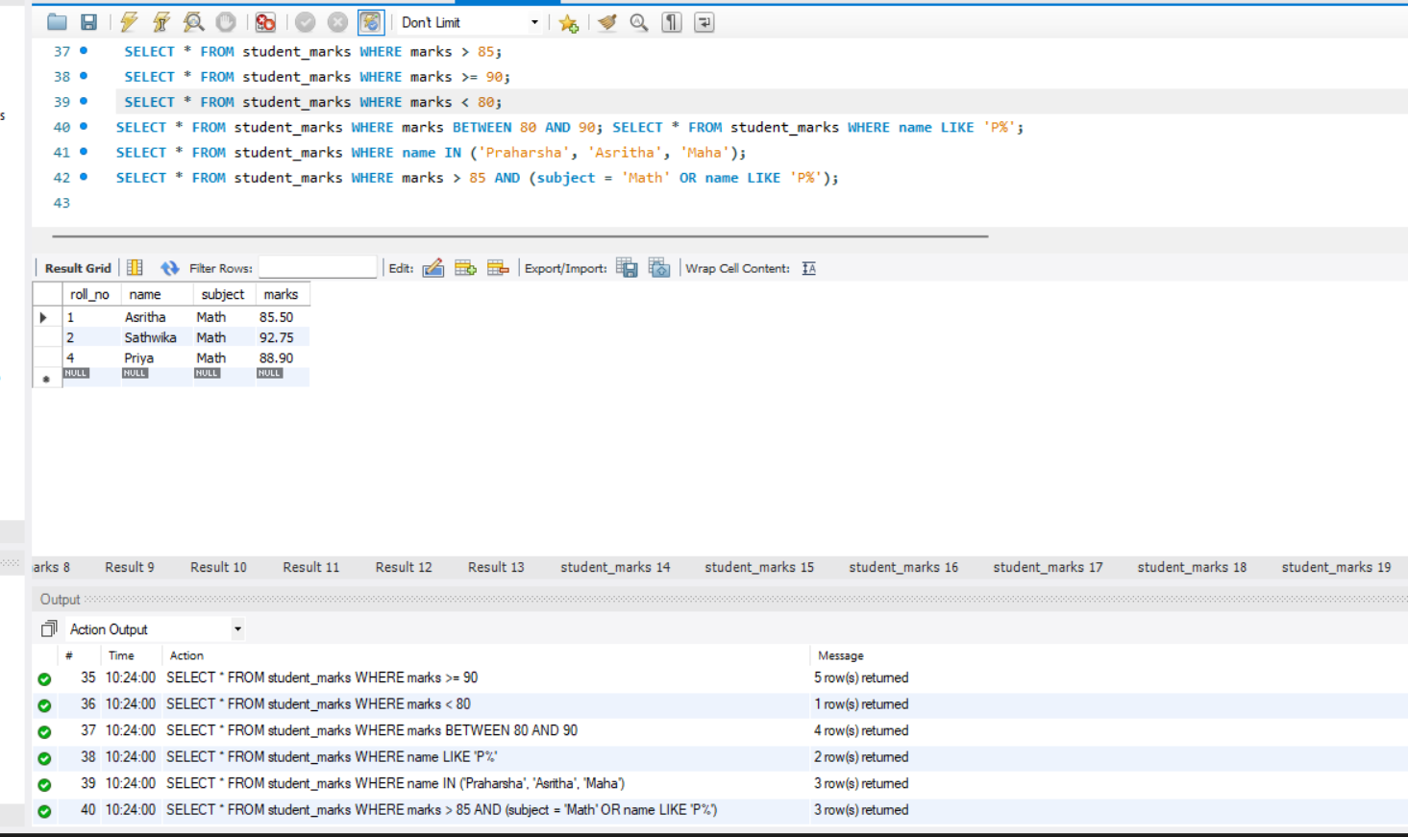

Step 6 — Update Queries
UPDATE student_marks SET marks = 90.00 WHERE roll_no = 3;
UPDATE student_marks SET subject = 'Remedial Math' WHERE marks < 80;
SELECT * FROM student_marks;
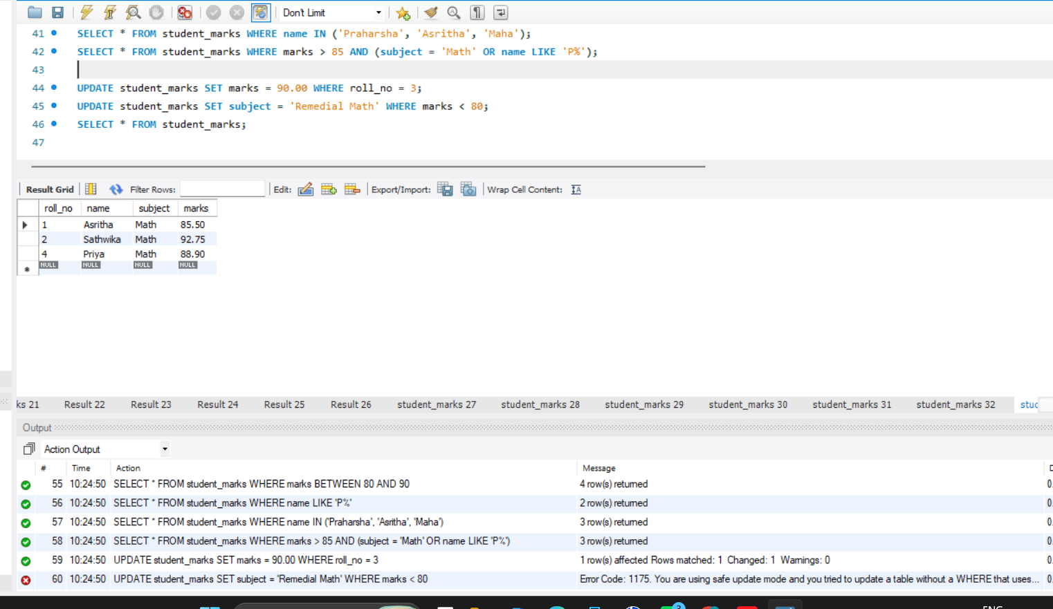

Step 7 — Delete Queries

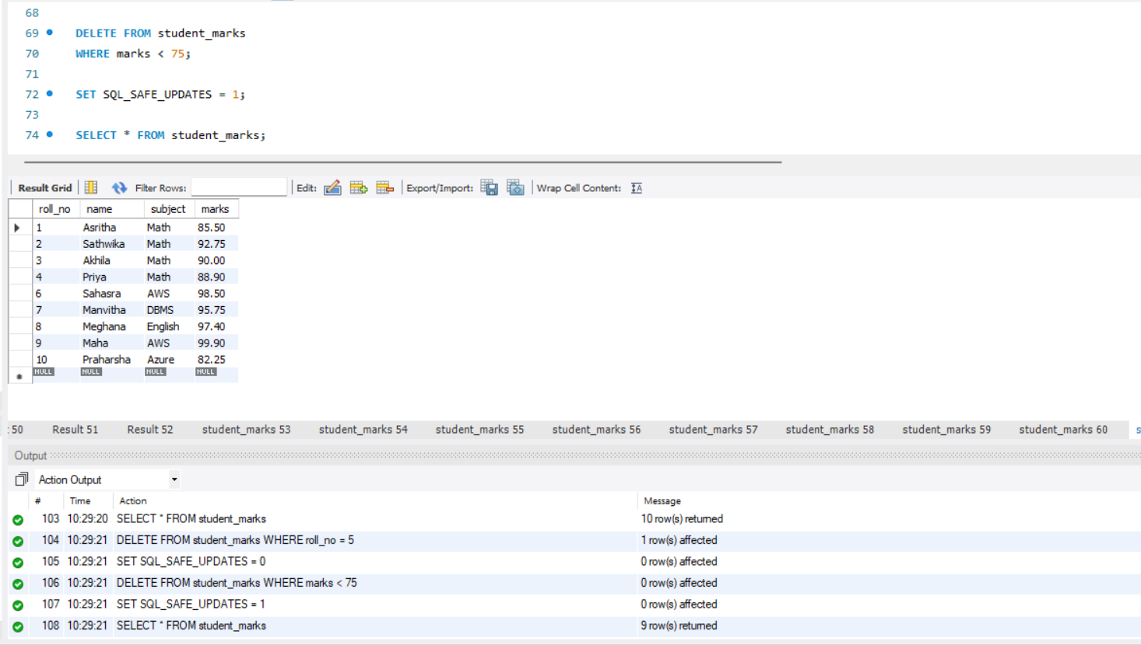
DELETE FROM student_marks WHERE roll_no = 5; DELETE FROM student_marks WHERE marks < 75;
SELECT * FROM student_marks;

Step 8 — Sorting

SELECT * FROM student_marks ORDER BY marks ASC; SELECT * FROM student_marks ORDER BY marks DESC; SELECT * FROM student_marks ORDER BY name ASC; SELECT * FROM student_marks ORDER BY name DESC;
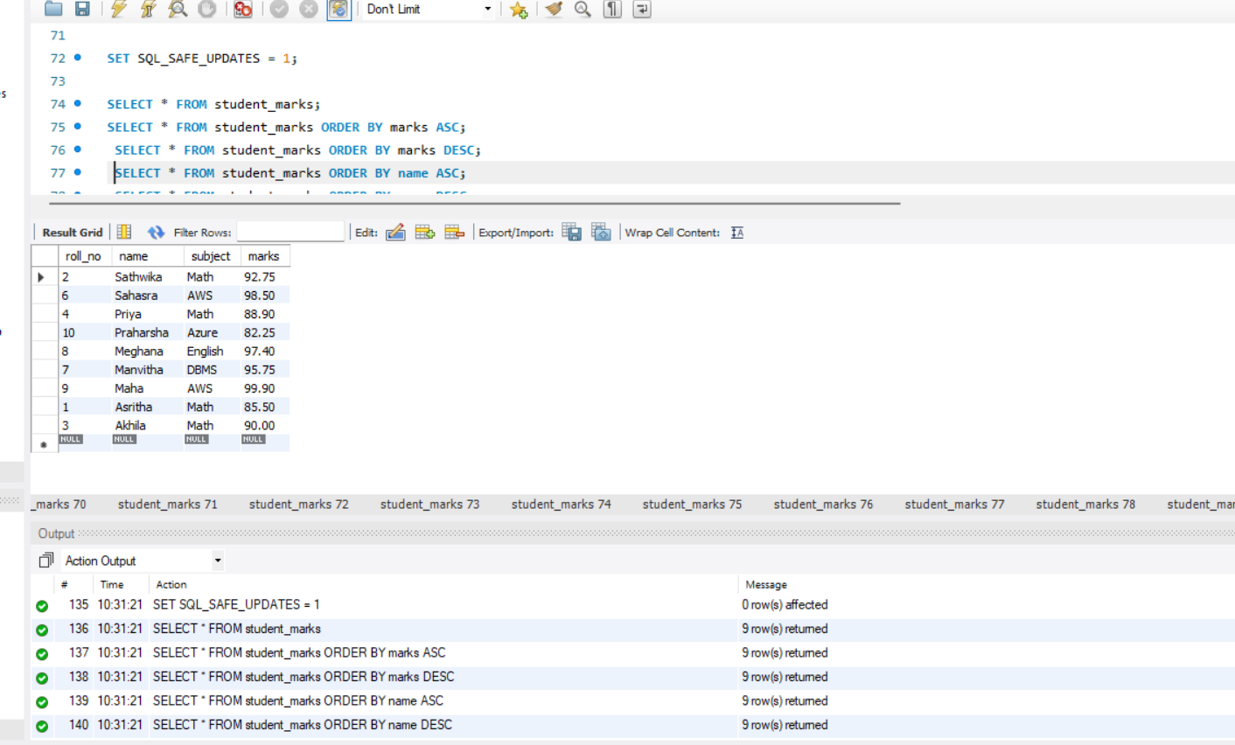

Step 9 — Group By

SELECT subject, SUM(marks) AS total_marks FROM student_marks GROUP BY subject; SELECT subject, AVG(marks) AS avg_marks FROM student_marks GROUP BY subject; SELECT subject, COUNT(*) AS num_students FROM student_marks GROUP BY subject;
LINE BY LINE OUTPUT —>
Math: SUM 357.15, AVG 89.29, COUNT 4
AWS: SUM 198.40, AVG 99.20, COUNT 2
DBMS: SUM 95.75, AVG 95.75, COUNT 1
English: SUM 97.40, AVG 97.40, COUNT 1
Azure: SUM 82.25, AVG 82.25, COUNT 1
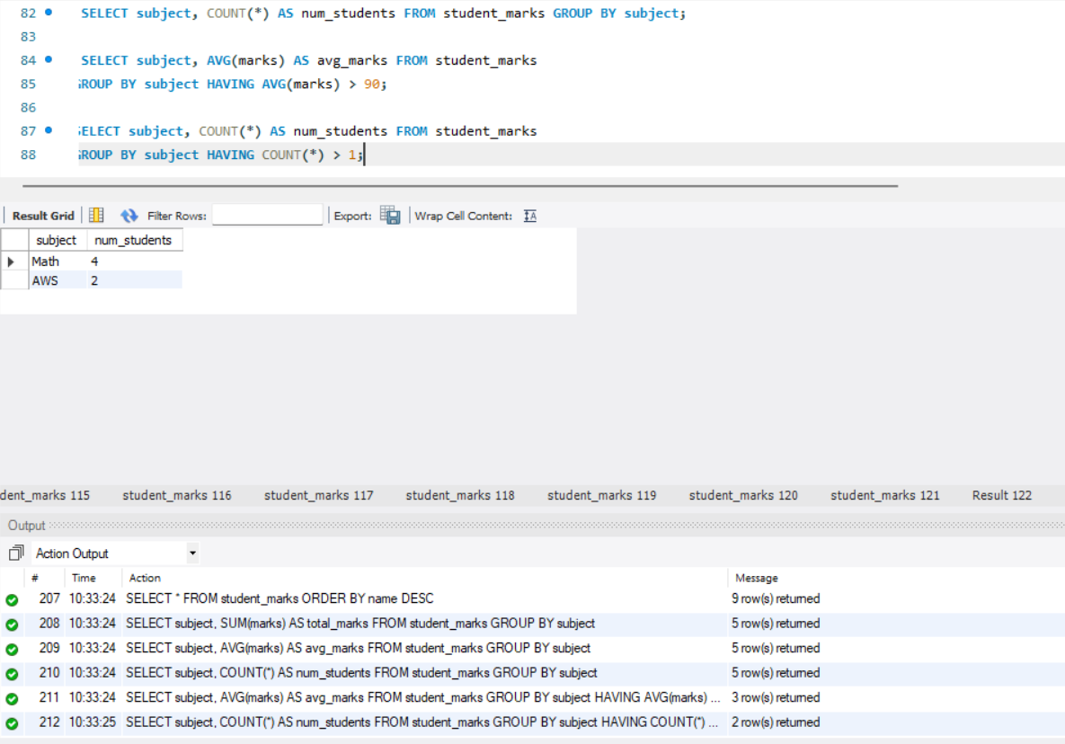

Step 10 — Having

SELECT subject, AVG(marks) AS avg_marks FROM student_marks
GROUP BY subject HAVING AVG(marks) > 90;

SELECT subject, COUNT(*) AS num_students FROM student_marks
GROUP BY subject HAVING COUNT(*) > 1;
LINE BY LINE OUTPUT —>
AVG > 90: AWS (99.20), DBMS (95.75), English (97.40)
COUNT > 1: Math (4), AWS (2)



