Laboratory Assignment AND Assessment Requirements Specification

Version 1.0

06 March, 2019

Developed by:

Crisan Gabriel

Todoran Ana-Corina

932

Version History

|  |  |  |  |
| --- | --- | --- | --- |
| Version | Description of Change | Author | Date |
| V01 | Initial configuration of the project | Crisan Gabriel  Todoran Corina | 22 February, 2019 |
|  |  |  |  |

**Contents**

Contents

1 Functional Requirements 3

2 Use cases – diagram 4

3.1 Use case number 1 (Description of the use case) 5

3 Analysis 6

3.1 Entities 6

3.2 Relations between entities 6

3.3 Attributes 6

3.4 System behavior 7

3.4.1 Use case 1-2-3 7

4 Design 7

**Analysis and design Document**

# Functional Requirements

List the functional requirements (FR) of the system.

|  |  |
| --- | --- |
| Section/ Requirement ID | Requirement Definition |
| FR0.1 | Adding a new student with the corresponding data: name, group, email, coordinating teacher |
| FR0.2 | Updating an existing student |
| FR0.3 | Deleting a student |
| FR0.4 | Display all students |
| FR1 | Adding a laboratory theme |
| FR2 | Extend deadline for a homework |
| FR3.0 | Notify students by email when lab theme or delivery date is modified |
| FR3.1 | Unsubscribe from notifications |
| FR4 | Add a grade to a lab topic |
| FR5 | Assign a grade to a student for a homework with corresponding data: theme number, number of the delivered week, deadline week, feedback |
| FR6 | Weekly report sent by email |
| FR7 | No delay option if the student has motivation |
| FR8 | Filtering entities based on different criteria |
| FR9.0 | Report: Laboratory grade for each student |
| FR9.1 | Report: The hardest the theme |
| FR9.2 | Students who can enter the exam |
| FR9.3 | Report: Students who have delivered all the themes on time |

**Actors**

The only actors from this application are the teacher (only they interact with the application).

# Use cases – diagram

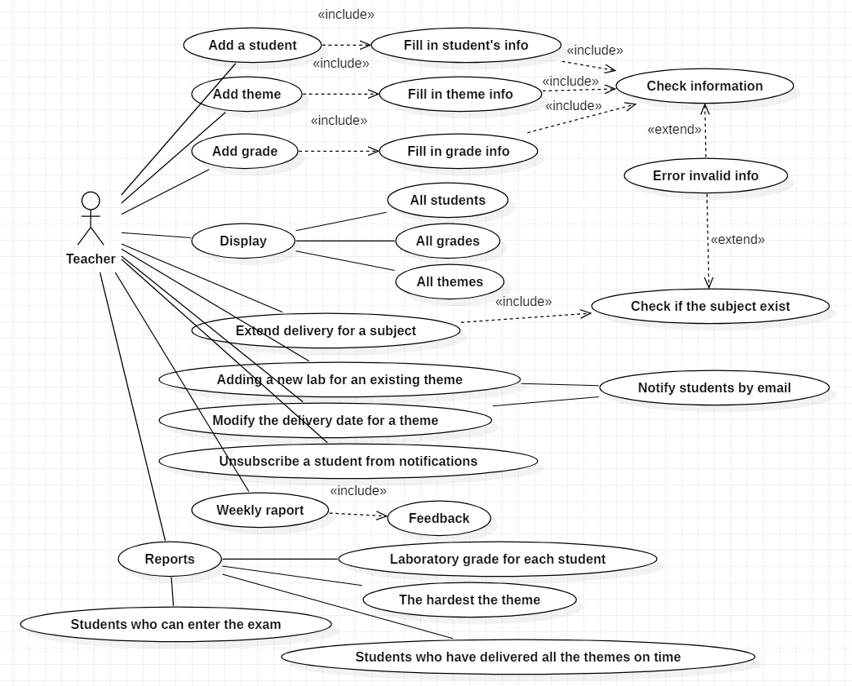

## Use case number 1 (Description of the use case)

Actors: Teacher

Description: Add student

Precondition: - valid student information (id, name, group)

Post condition: - repository size will increase with 1

Exceptions: When the fields aren’t filled.

|  |  |
| --- | --- |
| User action | Response |
| Complete the necessary fields | Check if everything is alright |
|  | Add student to repository |
|  | Display a corresponding message (success or failure) |

Actors: Teacher

Description: Add lab theme

Precondition: - valid lab theme information (lab number, description, deadline)

Post condition: - repository size will increase with 1

Exceptions: When the fields aren’t filled.

|  |  |
| --- | --- |
| User action | Response |
| Complete the necessary fields | Check if everything is alright |
|  | Add lab theme to repository |
|  | Display a corresponding message (success or failure) |

Actors: Teacher

Description: Add grade to a lab topic

Precondition: - valid grade information (theme number, number of the delivered week, number of the deadline week, feedback)

Post condition: - repository size will increase with 1

Exceptions: When the fields aren’t filled.

|  |  |
| --- | --- |
| User action | Response |
| Complete the necessary fields | Check if everything is alright |
|  | Add grade to repository |
|  | Display a corresponding message (success or failure) |

# Analysis

## Entities

Identify the entities: Grade, Student, LabTheme

## Relations between entities

Write the relations between the identified entities.

## Attributes

Write the attributes of the identified entities.

Grade:

1. idGrade
2. idStudent
3. idLabTheme
4. gradeValue
5. deliveredWeek
6. deadlineWeek
7. feedback

Student:

1. idStudent
2. name
3. group
4. email
5. coordinator

LabTheme:

1. numberTheme
2. numberOfTheDeliveredWeek
3. numberOfTheDeadline
4. description

## System behavior

## Use case 1-2-3

The system will probably act as a subsystem to a larger environment, in order to speed up a certain process in the company’s workflow.

# Design

* 1. **Class diagram**
     1. **Domain package**

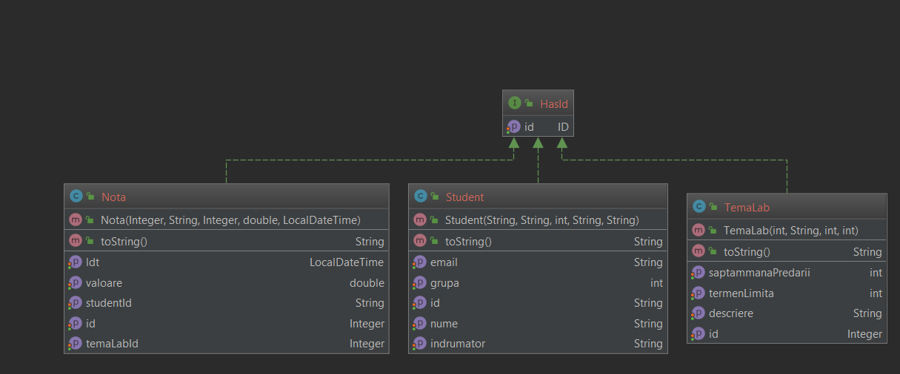

* + 1. **Exceptions package**

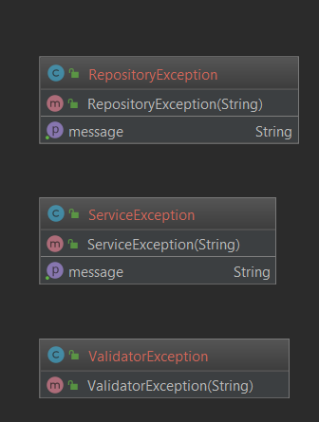

* + 1. **Repository package**
       1. **MemoryRepository**

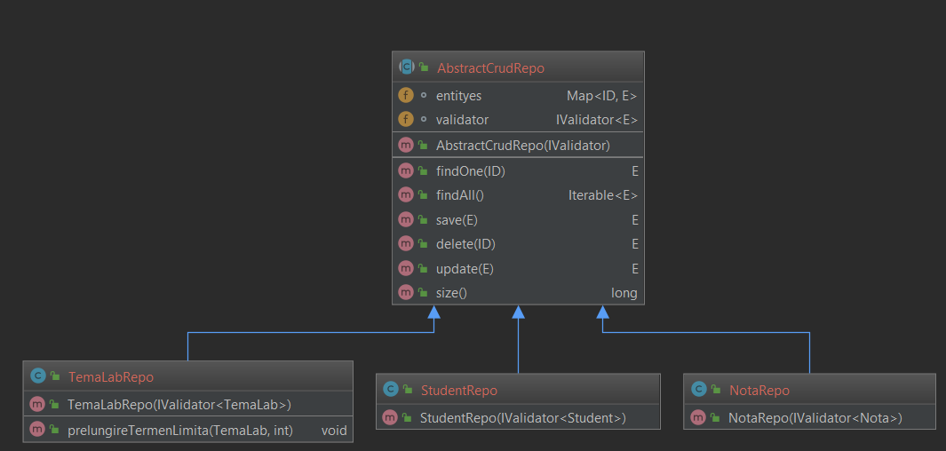

* + - 1. **TxtFileRepository**

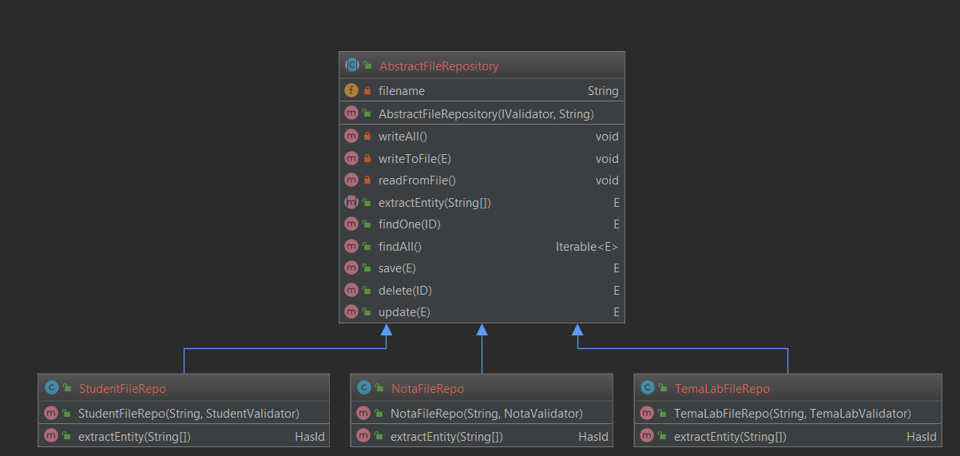

* + - 1. **XMLFileRepositoy**

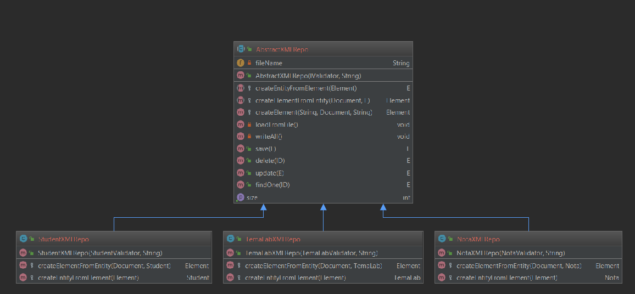

* + 1. **Service package**
       1. **TxtFileService**

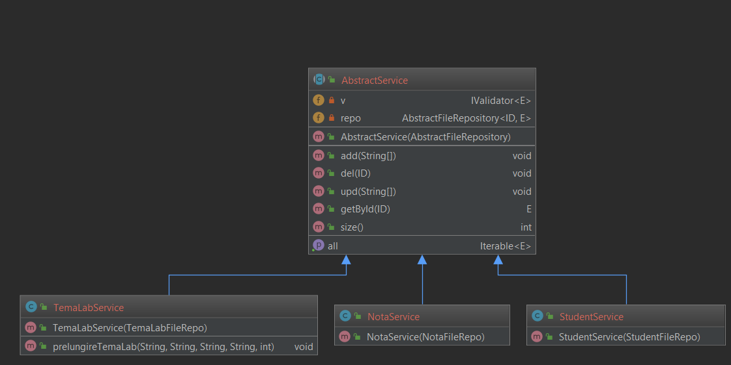

* + - 1. **XMLFileService**

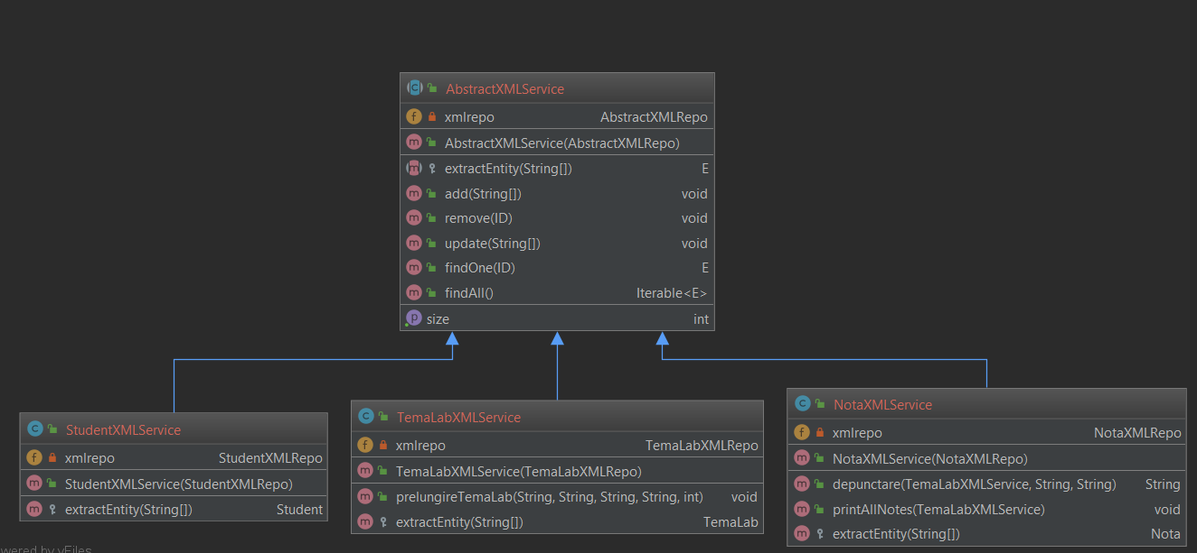

* + 1. **UI package**

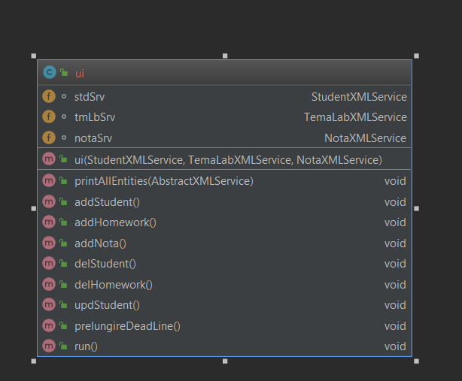

* + 1. **Validator package**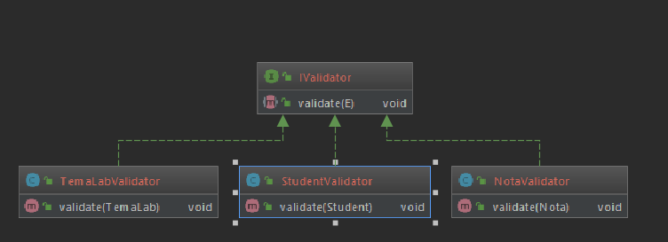
  1. **Sequence diagrams (for each use case)**



 

