Data 1.12.2016 Name Todoran Ana Corina

Problem statement:

A faculty stores information about: students, disciplines and grades.
Create an application which allows to:
- Manage the list of students and available disciplines. The application must allow the user to add, remove, update, and list both students and disciplines.
- Grade students at a given discipline. The program must allow only those students who are enrolled at a given discipline to receive any number of grades. Deleting a student also removes their list of grades. Deleting a discipline deletes all the grades at that discipline.
- Search for disciplines/students based on their ID or name/title. The search must work using case-insensitive, partial string matching, and must return all matching disciplines/students.
- Create statistics:
  - All students enrolled at a given discipline, sorted alphabetically or by descending order of average grade.
  - All students failing at one or more (students having an average <5 for a discipline are considered to be failing)
  - Students with the best school situation, sorted in descending order of their aggregated average (the average between their average grades per discipline).
  - All disciplines at which there is at least one grade, sorted in descending order of the average grade received by all students enrolled at that discipline.

- Unlimited undo/redo functionality. Each step will undo/redo the previous operation that modified the data structure.

Students register management - Feature list

F1. Add – a student to Student Repository
F2. Add – a discipline to Discipline Repository
F3. Add – a grade to Grade Repository
F4. List – students from Student Repository
F5. List – disciplines from Discipline Repository
F6. List – grades from Grade Repository
F7. Remove - an existing student from Student Repository (it also removes their list of grades)
F8. Remove - an existing discipline from Discipline Repository (it also remove all the grades at that discipline)
F9. Update – an existing student from Student Repository
F10. Update – an existing discipline from Discipline Repository
F11. Search – an existing student from Student Repository
F12. Search – an existent discipline from Discipline Repository
F13. Statistics - Sort students at a given discipline - Sort alphabetically all students
F14. Statistics - Sort students at a given discipline - Sort by descending order of average grade all students
F15. Statistics - All students failing at one or more disciplines
F16. Statistics - Students with the best school situation
F17. Statistics - Sort all disciplines by average
F18. Undo - the last operation that has modified program data will be reversed
F19. Redo - the last undo operation if there exists

Iteration plan
Iteration | Planned features
I1 | F1. Add – a student to Student Repository  F2. Add – a discipline to Discipline Repository  F3. Add – a grade to Grade Repository  F4. List – students from Student Repository  F5. List – disciplines from Discipline Repository  F6. List – grades from Grade Repository  F7. Remove - an existing student from Student Repository (it also removes their list of grades)  F8. Remove - an existing discipline from Discipline Repository (it also remove all the grades at that discipline)  F9. Update – an existing student from Student Repository  F10. Update – an existing discipline from Discipline Repository
I2 | F11. Search – an existing student from Student Repository  F12. Search – an existent discipline from Discipline Repository  F13. Statistics - Sort students at a given discipline - Sort alphabetically all students  F14. Statistics - Sort students at a given discipline - Sort by descending order of average grade all students  F15. Statistics - All students failing at one or more disciplines  F16. Statistics - Students with the best school situation  F17. Statistics - Sort all disciplines by average
I3 | F18. Undo - the last operation that has modified program data will be reversed  F19. Redo - the last undo operation if there exists

Iteration 1
Running scenario
 | User | Program | Description
a | 1 | studentID: | 1. Add student
b | 1 | studentID: 1  name: | studentID = 1
c | Maria | studentID: 1  name: Maria | name = Maria  Student with ID 1 and name Maria is now in student Repository
d | 2 | disciplineID: | 2. Add discipline
e | 3 | disciplineID: 3  name: | disciplineID = 3
f | FP | disciplineID: 3  name: FP | Name = FP  Discipline with ID 3 and name FP is now in discipline Repository
g | 3 | disciplineID: | 3. Add grade
h | 3 | disciplineID: 3  studentID: | disciplineID = 3
i | 1 | disciplineID: 3  studentID: 1  grade_value: | studentID = 1
j | 9 | disciplineID: 3  studentID: 1  grade_value: 9 | grade_value = 9  Maria has now a 9 at FP
k | 4 | ID: 1  Name: Maria | 4. List students
l | 5 | ID: 3  Name: FP | 5. List discipline
m | 6 | disciplineID: 3  studentID: 1  grade_value: 9 | 6. List grades
n | 9 | studentID: | 9. Update student
o | 1 | studentID: 1  name: | Update student with ID 1
p | Ana | studentID: 1  name: Ana | Now student with ID 1 has name = Ana
q | 10 | disciplineID: | 10. Update discipline
r | 3 | disciplineID: 3  name: | Update discipline with ID 3
s | OOP | disciplineID: 3  name: OOP | Now discipline with ID 3 has name = OOP
t | 8 | disciplineID: | 8. Remove discipline
u | 3 | disciplineID: 3 | Remove discipline with id 3 and also all his grades (OOP)
w | 7 | studentID: | 7. Remove student
x | 1 | studentID: 1 | Remove student with id 1 and also all his grades (Ana)
y | 8 | disciplineID: | 8. Remove discipline
z | 3 | disciplineID: 3 | Remove discipline with id 3 and also all his grades (FP)
Iteration 2
Running scenario
 | User | Program | Description
a | 1 | studentID: | 1. Add student
b | 1 | studentID: 1  name: | studentID = 1
c | Maria | studentID: 1  name: Maria | name = Maria  Student with ID 1 and name Maria is now in student Repository
d | 1 | studentID: | 1. Add student
e | 2 | studentID: 2  name: | studentID = 2
f | Corina | studentID: 2  name: Corina | name = Corina  Student with ID 2 and name Corina is now in student Repository
g | 2 | disciplineID: | 2. Add discipline
h | 3 | disciplineID: 3  name: | disciplineID = 3
i | FP | disciplineID: 3  name: FP | Name = FP  Discipline with ID 3 and name FP is now in discipline Repository
j | 11 | studentID/name: | 11. Search students
k | a | ID: 1  Name: Maria  ID: 2  Name: Corina | Search students which name contains the string ‘a’
l | 12 | disciplineID/title: | 12. Search disciplines
m | 3 | disciplineID/title: 3  ID: 3  Name: OOP | Search discipline with ID equal to 3
To show statistic functionalities I’ll use file repository and graphical user interface and some pictures:
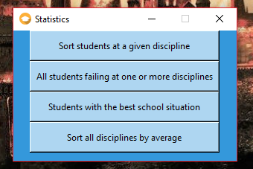

- Statistics - Sort students at a given discipline - Sort alphabetically all students:

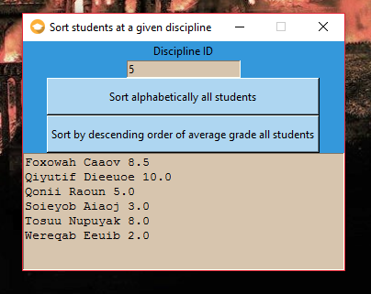
- Statistics - Sort students at a given discipline - Sort by descending order of average grade all students:

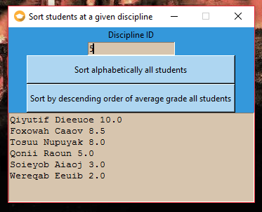

- Statistics - All students failing at one or more disciplines:

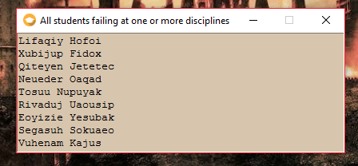

- Statistics - Students with the best school situation:

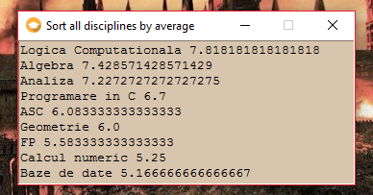

- Statistics - Sort all disciplines by average:

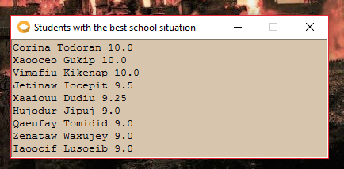

Iteration 3
Running scenario
 | User | Program | Description
a | 1 | studentID: | 1. Add student
b | 1 | studentID: 1  name: | studentID = 1
c | Maria | studentID: 1  name: Maria | name = Maria  Student with ID 1 and name Maria is now in student Repository
d | 1 | studentID: | 1. Add student
e | 2 | studentID: 2  name: | studentID = 2
f | Corina | studentID: 2  name: Corina | name = Corina  Student with ID 2 and name Corina is now in student Repository
g | 4 | ID: 1  Name: Maria  ID: 2  Name: Corina | 4. List students
h | 14 |  | 14. Undo last operation
i | 4 | ID: 1  Name: Maria | 4. List students (list before adding Corina)
j | 15 |  | 15. Redo last operation
k | 4 | ID: 1  Name: Maria  ID: 2  Name: Corina | 4. List students (list after adding Corina)

Work items/tasks
T1 | Interpret a command given by the user using an interface based on menu based
T2 | Check the validity of the arguments that were interpreted
T3 | Perform add/remove/update/ list operations on the repository based on the arguments
T4 | Perform statistics based on information from repositories
T5 | Unlimited undo/redo functionality.
T6 | Create a graphic user interface

