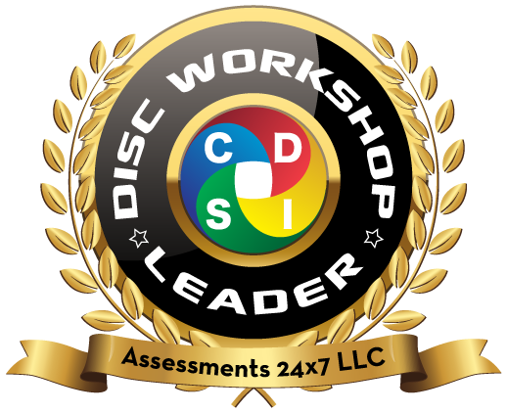
DISC Workshop Leader
Pre-Work for Orientation

Get Familiar:
Review the DISC WORKSHOP LEADER OVERVIEW
If you cannot click on the hyperlink, copy this link into your browser: https://www.assessments24x7.com/disc-workshop-leader.asp

Consider WHY:
Why are you completing this certification program?

Why are these training programs important to offer and what do you hope to accomplish in sharing these workshops with others?

Examine the Benefits:
What are 2 benefits you anticipate that each of these specialized workshops can offer, in your own words?

- Self-Awareness & Communication

- Transitioning from Peer to Leader

- Trust-Based Leadership

- Making Teams Work

- Sales Optimization

Incorporating DISC:
What do you know about each of the DISC styles that is important to consider when leading a workshop or training? How do they communicate and what might affect their learning?
D | I
S | C

Great Preparation:
What does great preparation for facilitating look like, in your opinion?

What are some elements of skillful preparation for facilitating that you know work for you?

Great Facilitation:
What makes a great facilitator, in your opinion?

What are a few of your best facilitation skills and training tricks that you know work well in a workshop?

Great Lessons/Workshops:
What makes a great lesson or workshop in your opinion?

What are a few ways you can ensure you make your lessons/workshops great?

