## CS/SE 2340 Computer Architecture

## Homework 2: MIPS Control Structures

Objective: Practice MIPS loops, conditionals, functions.

### Instructions

Create a MIPS program that fulfills the following specifications:

1. use the dialog syscall (#54) to input a string from the user
2. call a function which counts the number of characters and number of words in the string and returns these in $v0 and $v1; store these in memory
3. output (console) the string and counts to the user (see example below)
4. repeat from 1 until the user enters a blank string or hits “cancel”
5. additionally, use $s1 somewhere in your function so that you must save it on the stack at the top of your function and restore it before the function exits; Of course this function could be written without using an s register, but this is good practice in using the stack.
6. output a dialog message (syscall #59) to say goodbye before the program ends

Note: space is a character, so it should be counted

What to turn in:

* after you test your program, upload the .asm file to eLearning

Grading Rubric:

|  |  |
| --- | --- |
| **Points** | **Element** |
| 10 | input string from user using a dialog box |
| 15 | write a function, saving/restoring $s1 |
| 20 | count characters correctly |
| 20 | count words correctly |
| 15 | main program ends when user enters cancel or empty string |
| 10 | Display results: string, char count, word count; says goodbyte |
| 10 | Program contains meaningful comments as usual |

Sample Run:

Sample input dialog:

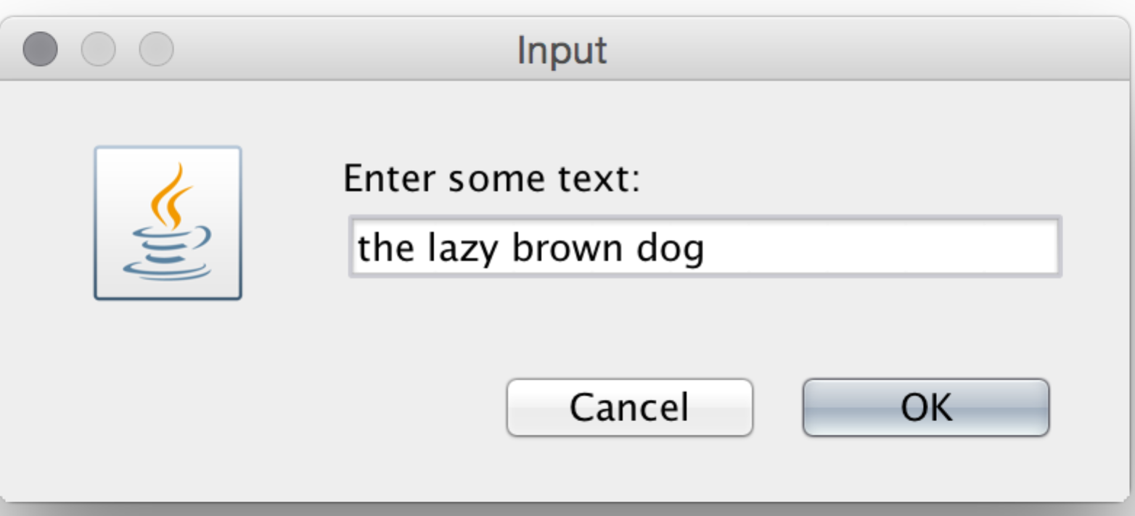

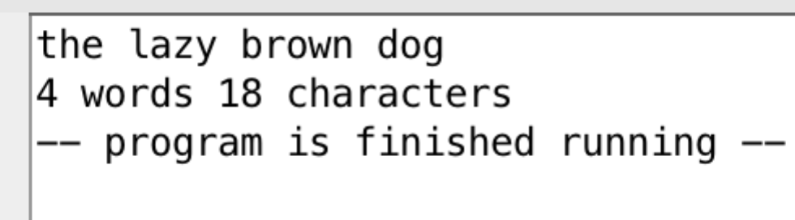Sample output:

Notes:

1. To find the number of words, you can simply count the spaces and add 1
2. This assumes the user does not have a space at the end, or have multiple spaces between words
3. Yes, we are pretending that users can follow instructions so that this assignment is easier
4. Remember that spaces count as characters