Table of Contents

1. Introduction 2

2. Understanding the Requirement 2

3. Proposed Solution 2

4. Platform Acquisition 2

5. Project Scope & Deliverables 3

6. Timeline & Milestones 3

7. Cost and Payment Schedule 3

1. Platform and framework cost 3

2. Cost of Development of Web pages 5

8. Team & Expertise 5

9. Ongoing Support 5

10. Terms & Conditions 6

11. Call to Action 6

Online Newspaper Website Proposal

## Introduction

This document presents a comprehensive proposal for the development of a sophisticated online newspaper website, tailored to align with industry-leading journalistic standards and contemporary audience expectations. The primary objective is to build a multilingual, dynamic, and responsive platform organized into main categories such as News, Entertainment, Lifestyle, and Special Sections.FirstreportProposal.docx

## Understanding the Requirement

The envisioned platform will:

* Deliver news, opinion, and multimedia features in a timely manner.
* Offer an accessible, intuitive interface for both readers and contributors.
* Support seamless access via mobile, desktop, and other devices, ensuring full accessibility.
* Allow non-technical editorial staff to efficiently manage content creation, editing, and publishing.FirstreportProposal.docx

## Proposed Solution

* Design and develop a scalable, visually compelling website.
* Implement a customized Content Management System (CMS) for straightforward publishing and editorial control.
* Employ mobile-optimized, responsive architecture for broad device compatibility.
* Integrate advanced search functions and personalized content recommendations.
* Enable multimedia content delivery, including video, audio, and images.
* Facilitate newsletters, real-time notifications, and social media sharing.
* Adhere strictly to data privacy and accessibility compliance standards.FirstreportProposal.docx

## Platform Acquisition

* The client will secure an appropriate domain name for the website.
* Acquisition and configuration of a modern, capable development platform—Wix is recommended for its rapid deployment capabilities and support for modules such as automatic linguistic conversion and third-party API integrations.FirstreportProposal.docx

## Project Scope & Deliverables

* Conduct project discovery and strategy workshops.
* Provide comprehensive UI/UX design proposals.
* Develop and set up both the frontend and backend (CMS setup).
* Build essential content modules (News, Features, Opinion, Editorial, Archive).
* Establish author and contributor dashboards for streamlined team operations.
* Integrate SEO best practices and analytics for performance tracking.
* Offer launch support and basic training for editorial staff.FirstreportProposal.docx

## Timeline & Milestones

| **Milestone** | **Estimated Timeframe** |
| --- | --- |
| Requirements & Discovery | Weeks 1–2 |
| Design & Prototyping | Weeks 3–5 |
| Development | Weeks 6–10 |
| Testing & QA | Weeks 11–12 |
| Launch & Training | Week 13 |

## Cost and Payment Schedule

* The proposal includes a transparent and itemized breakdown of costs for design, development, and optional additional features.FirstreportProposal.docx

### Platform and framework cost

* 1. Domain cost for 2 years : Rs. 3236.00
  2. Wix Framework for 2 years. Rs. 9770.40

(Rs. 450 Base plan + 100 GB space )

(or)

Wix Framework for 2 years. Rs. 4956.00

(Rs. 250 Base plan + 50 GB space )

* 1. Auto Translator tool : Rs. 441.00

Domain Cost

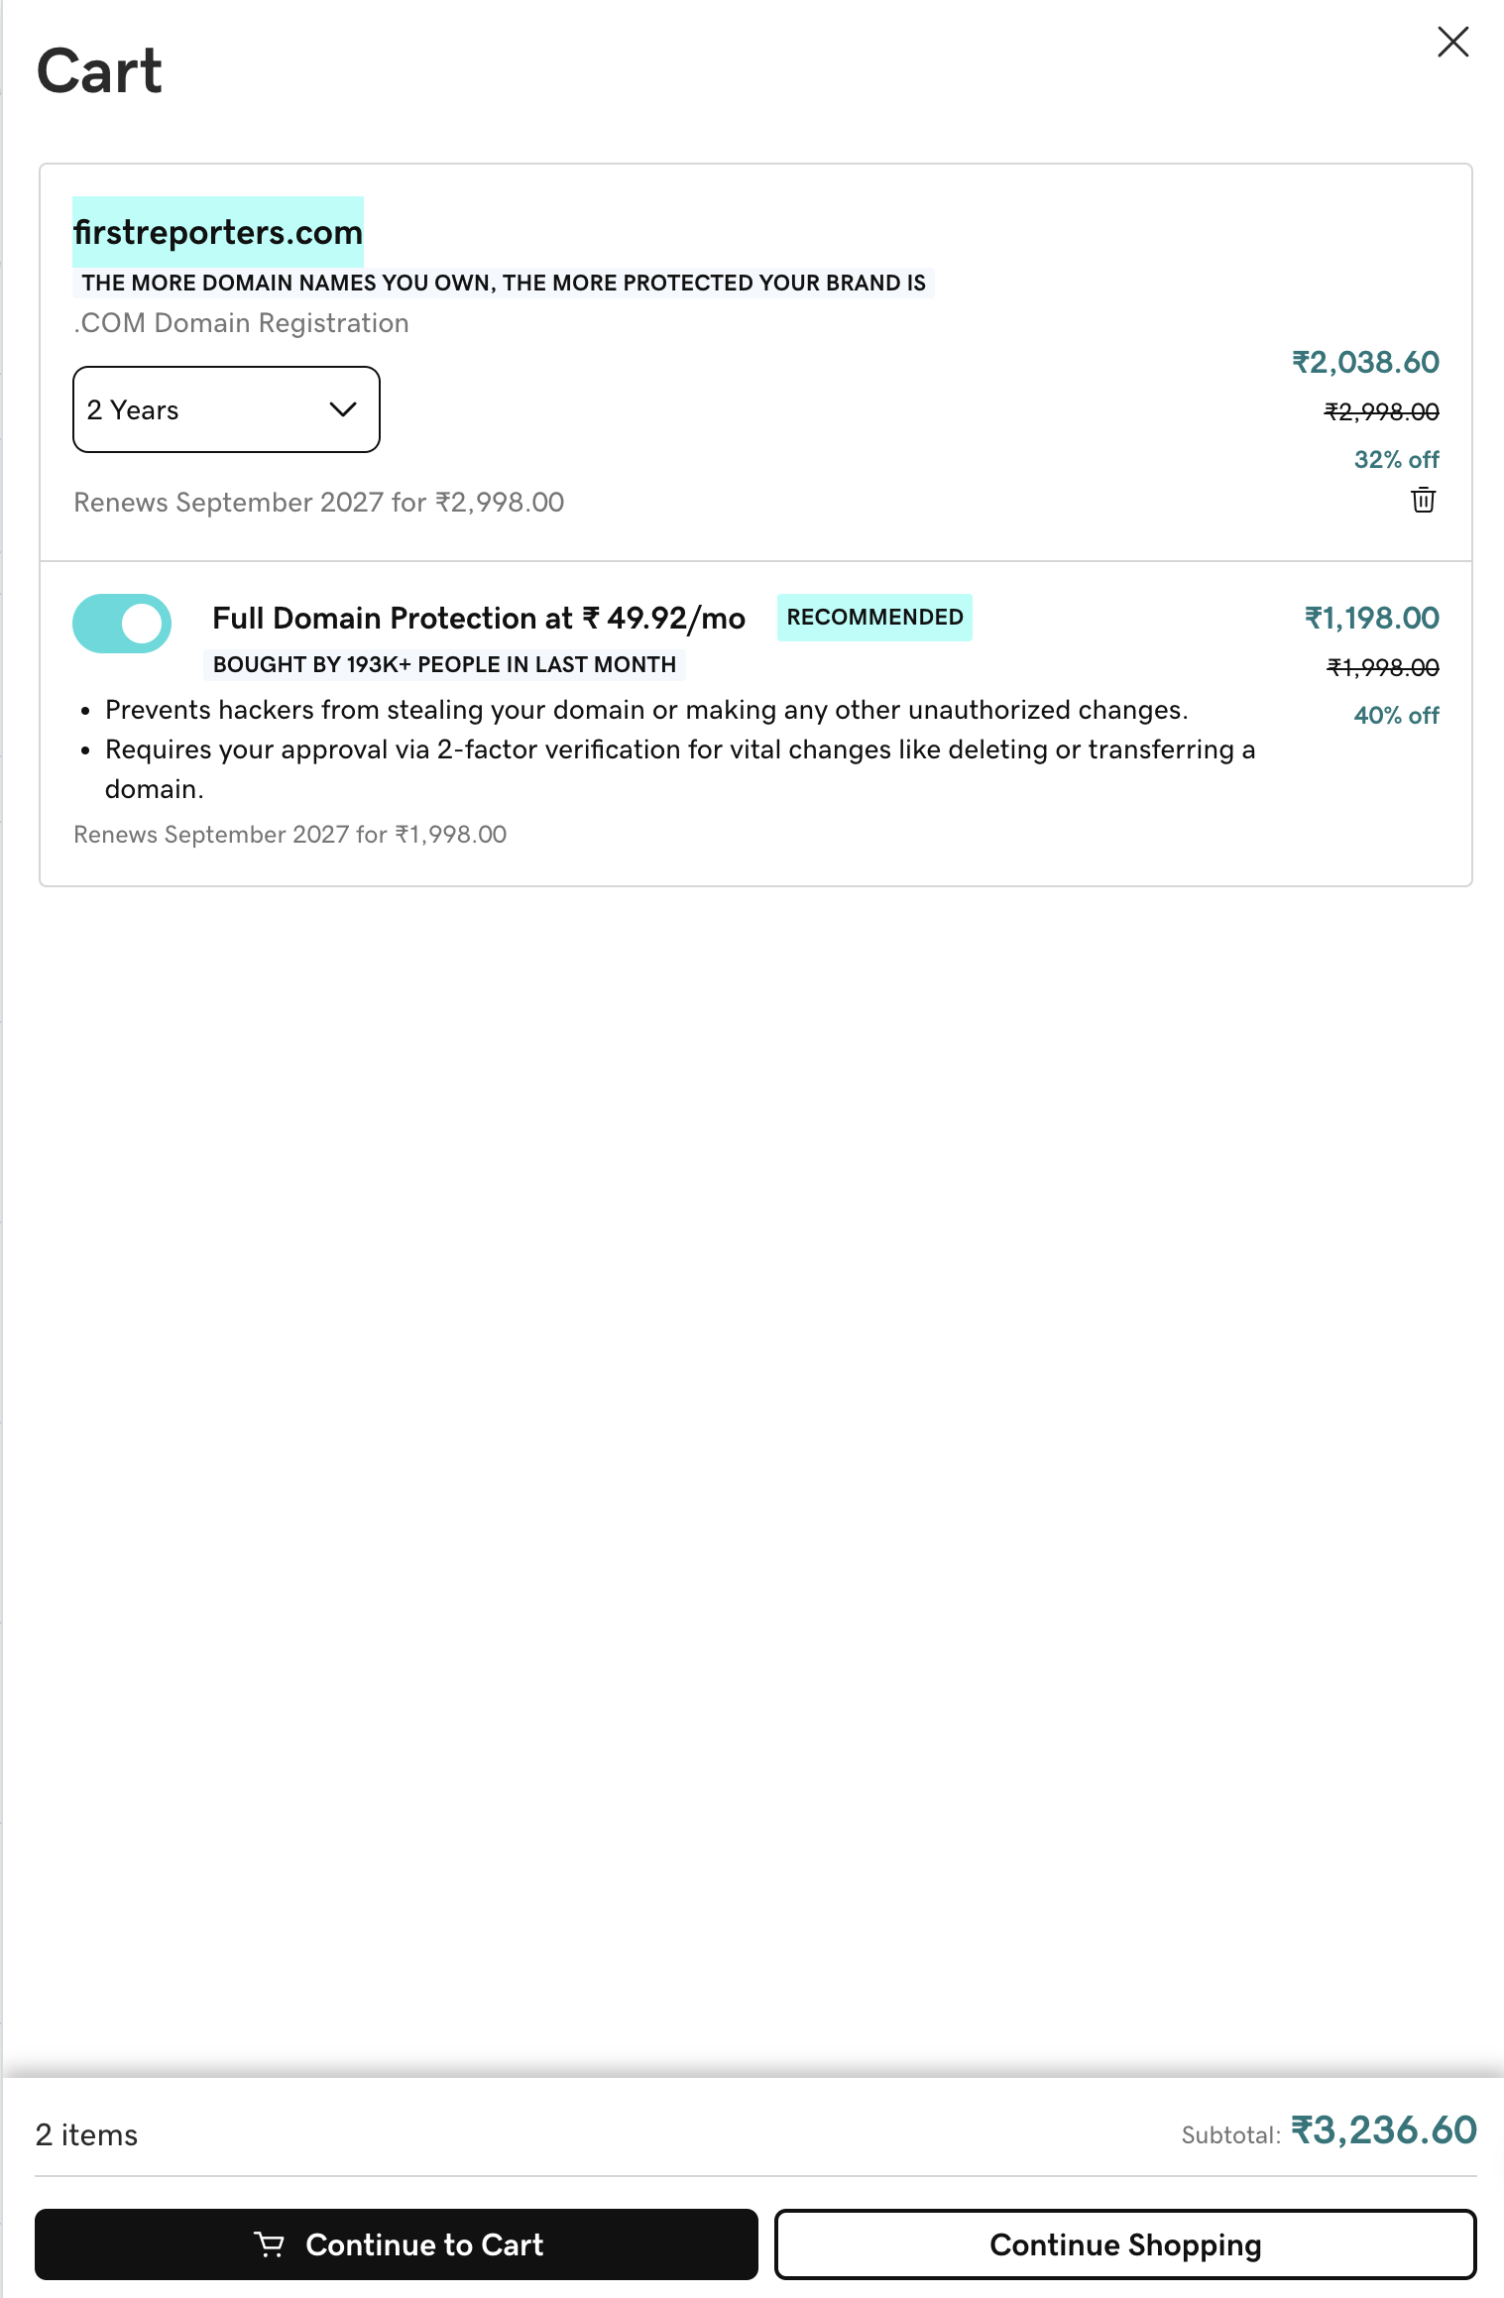

Wix Plans and cost

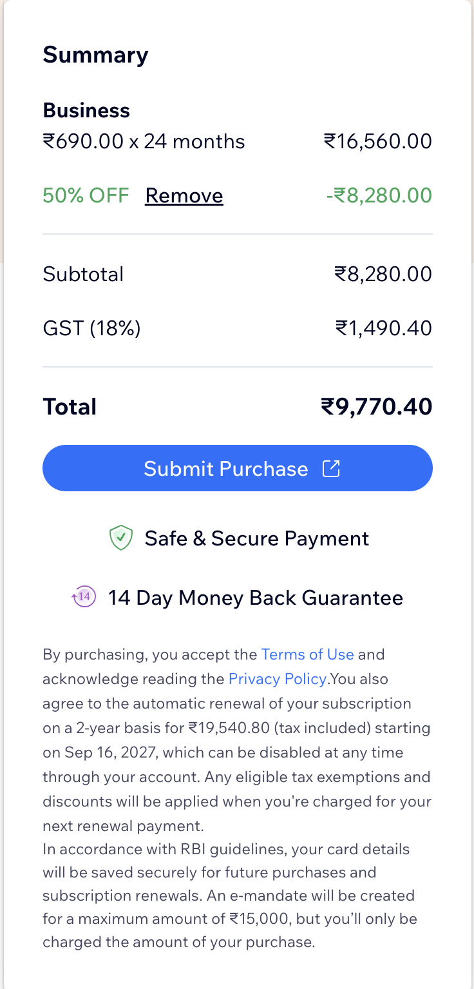 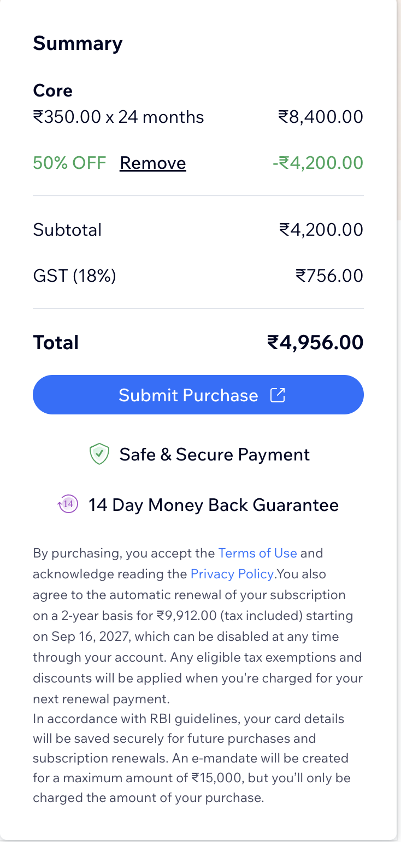

Auto translator module

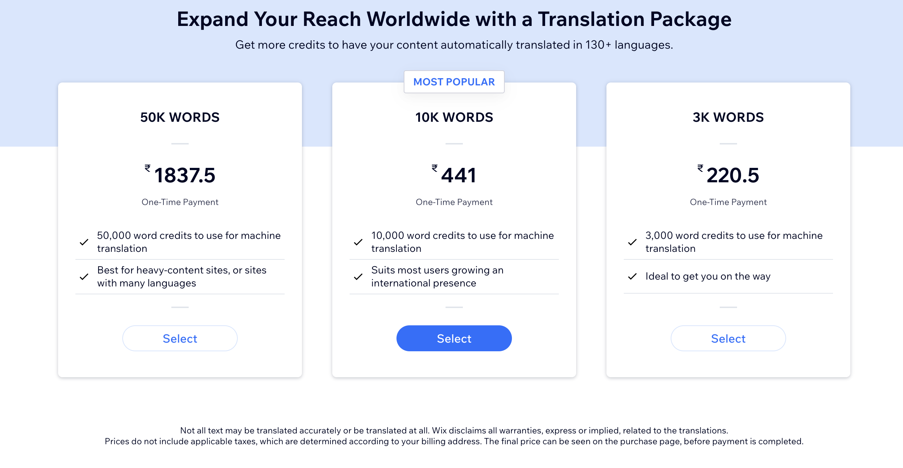

### Cost of Development of Web pages

* 1. Development of Database design, Database build (collections), Page layout design 5-10 Static pages, Development of approximately 60 Dynamic pages. Input screen to all 60 pages.
  2. Verification and Editor pages.
  3. Release to Actual Online News pages.

(To be decided)

## Team & Expertise

* Brief overview of the project team, highlighting previous experience and expertise in developing robust media and news publication websites.FirstreportProposal.docx

## Ongoing Support

* Maintenance options (monthly or yearly).
* Continued support and training for editorial staff to maximize platform utility and operational efficiency.FirstreportProposal.docx

## Terms & Conditions

* Agreed payment schedules.
* Full assurance of intellectual property rights.
* Clear confidentiality provisions.
* Policies addressing project timeline adjustments.FirstreportProposal.docx

## Call to Action

We eagerly anticipate the opportunity to collaborate on this digital transformation for your esteemed journalism initiative. Please feel free to reach out for any further clarifications or to discuss specific refinements to this proposal.FirstreportProposal.docx