1. 2023_SKCET_Cloud_CC1Time:

i.Create an EC2 Instance in the us-east-1 region with the following requirements.Give the Name tag of both EC2 instance & keypair as "ec2usecase1"(Name).

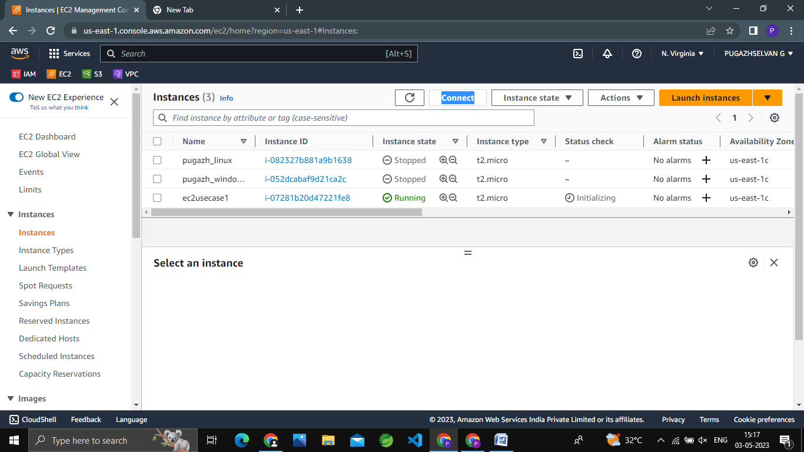

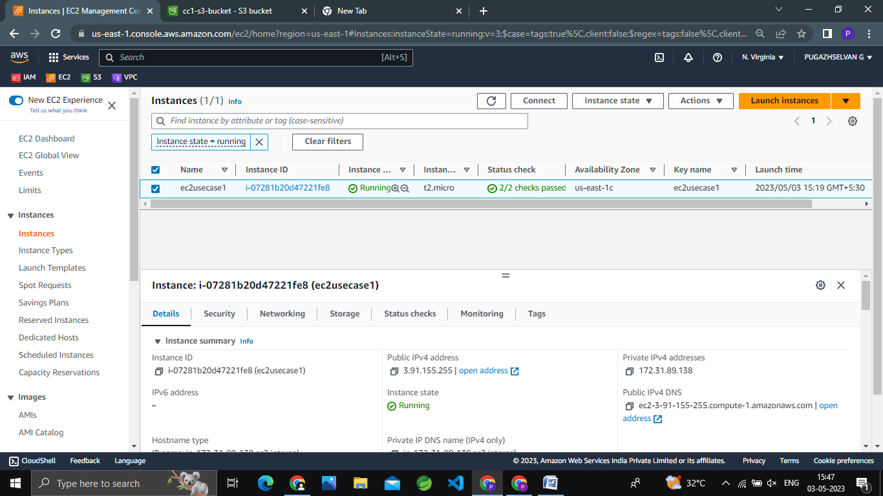

ii.EC2 instance AMI should be "Amazon Linux 2".

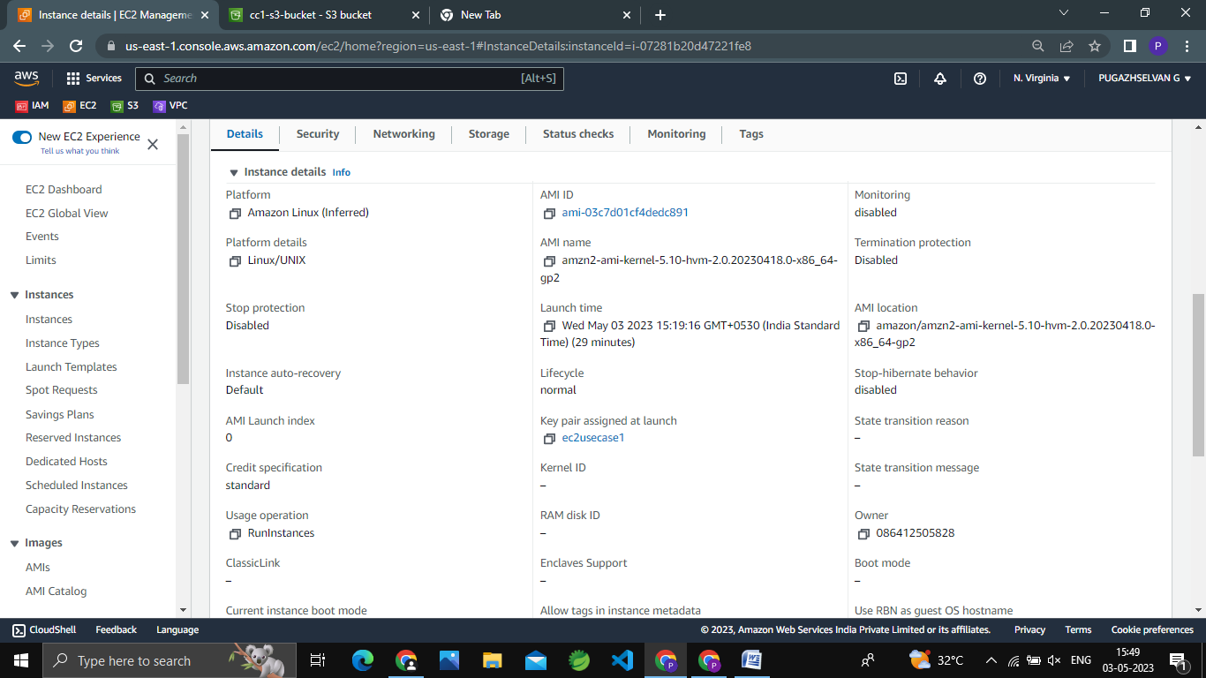

iii.Allow SSH traffic for taking putty remote connection.

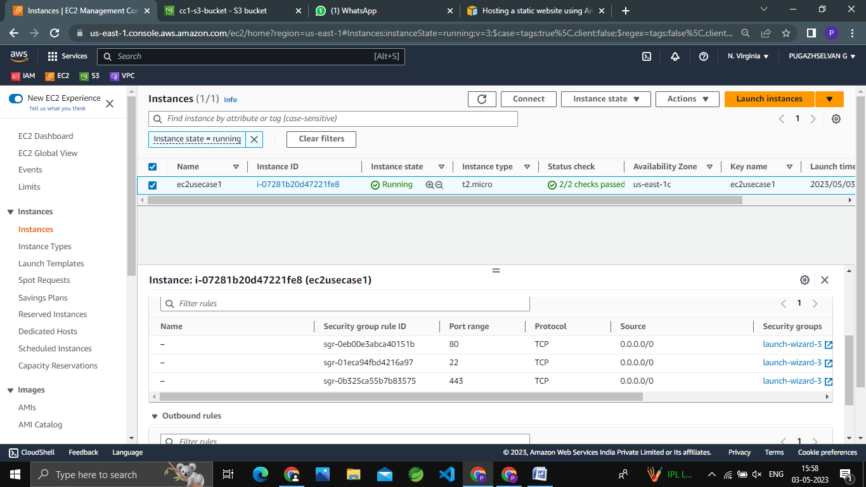

iv.Allow HTTP traffic from the internet for reaching website requests.(4 Marks)

