2)2023_SKCET_Cloud_CC1Time:30 minutesMarks: 17Q2.

Create an IAM group called 'Network-L1-Team' with'AmazonVPCReadOnlyAccess'and ‘AWSNetworkManagerReadOnlyAccess' policies, then add an IAM user called 'Network-L1-User1' to the group.

i.The name of the IAM group should be 'Network-L1-Team'.

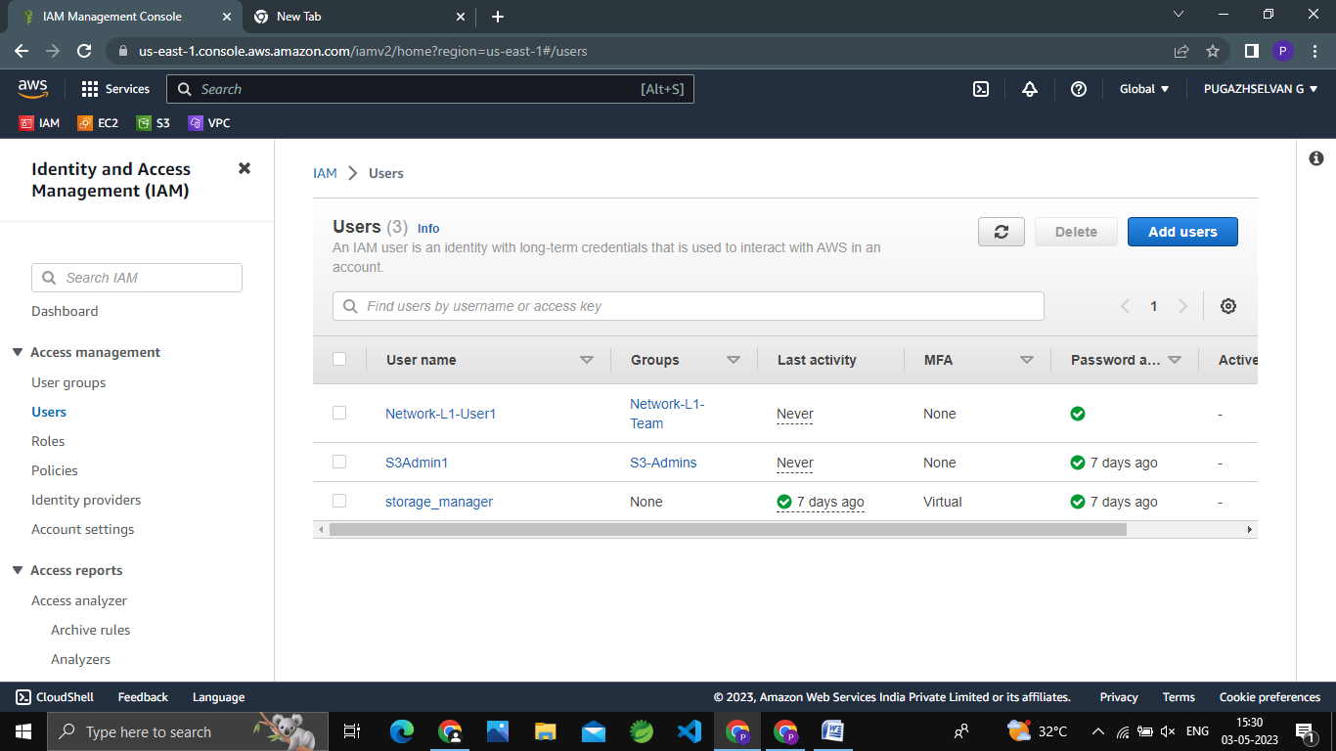

ii.The name of the IAM user should be 'Network-L1-User1'.



iii.The 'AmazonVPCReadOnlyAccess' policy should be attached.

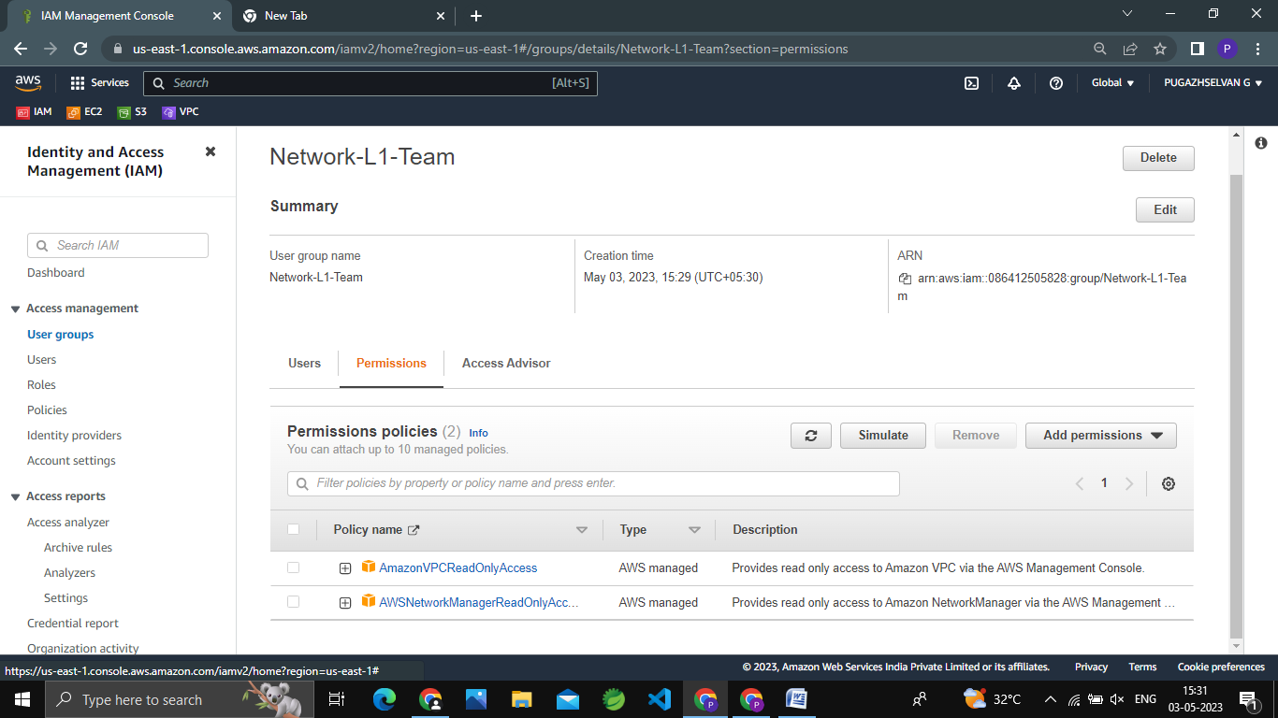

iv.The 'AWSNetworkManagerReadOnlyAccess' policy should be attached.

