3.023_SKCET_Cloud_CC1Time:30 minutesMarks: 17Q3.

i.Create a S3 bucket for the following requirementsCreate a new S3 bucket in the region of "Stockholm".

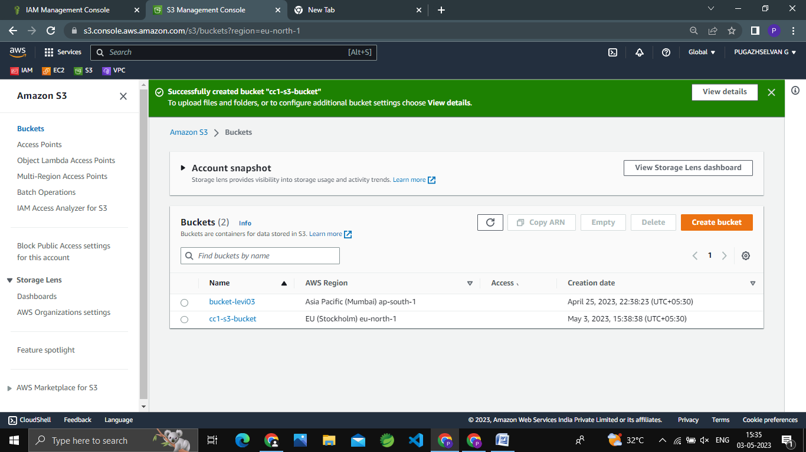

ii.Make the bucket accessible to everyone(publicly) via Bucket ACL.

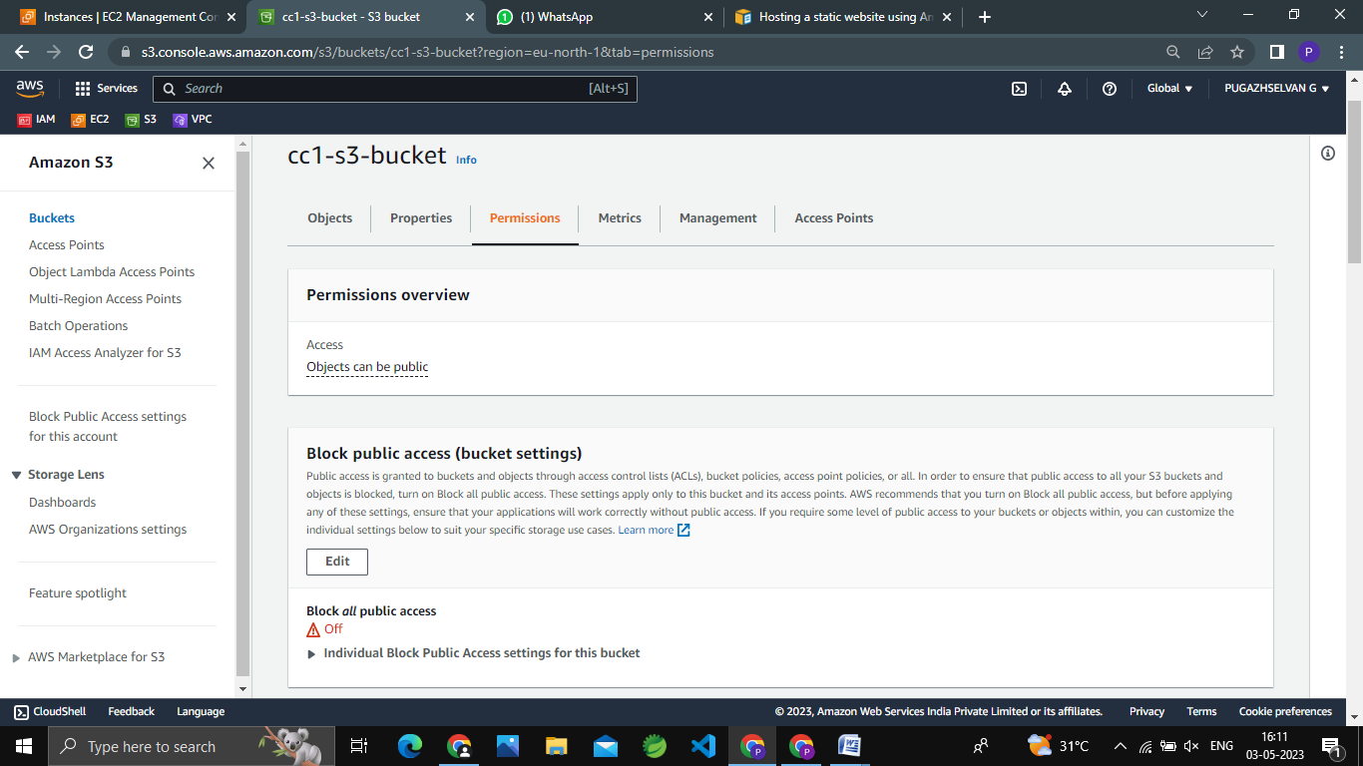

iii.Upload a text file in the name of 'accounts.txt'.

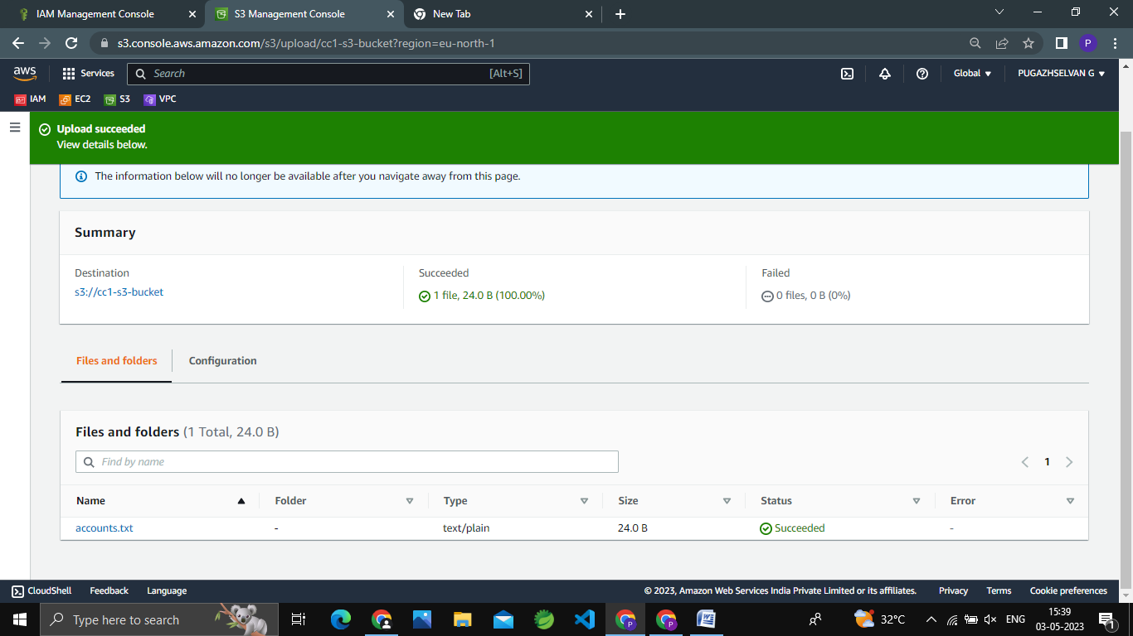

iv.Make the object 'accounts.txt' file accessible to everyone(publicly).

