**Exp. No.: 01 Name: B. PUGAZHENDHI**

**Date: 31/07/2024 Reg. No.: 2116231701042**

**Aim:**

To develop and design a mobile or web application and change background color and menus.

**Procedure:**

1. Open Figma.
2. Start a new design file.
3. Choose the size for your design or frame size.
4. Add and arrange text, images, and other elements.
5. Select the frame.
6. Find the “Fill” option.
7. Choose a new color or enter a hex code.
8. Save your design elements in the desired format.

**Screenshots:**

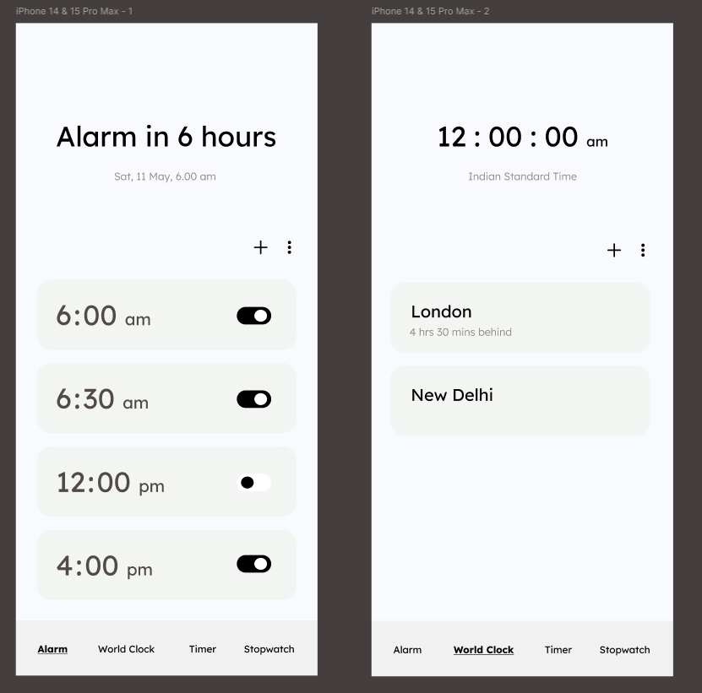

**Before:**

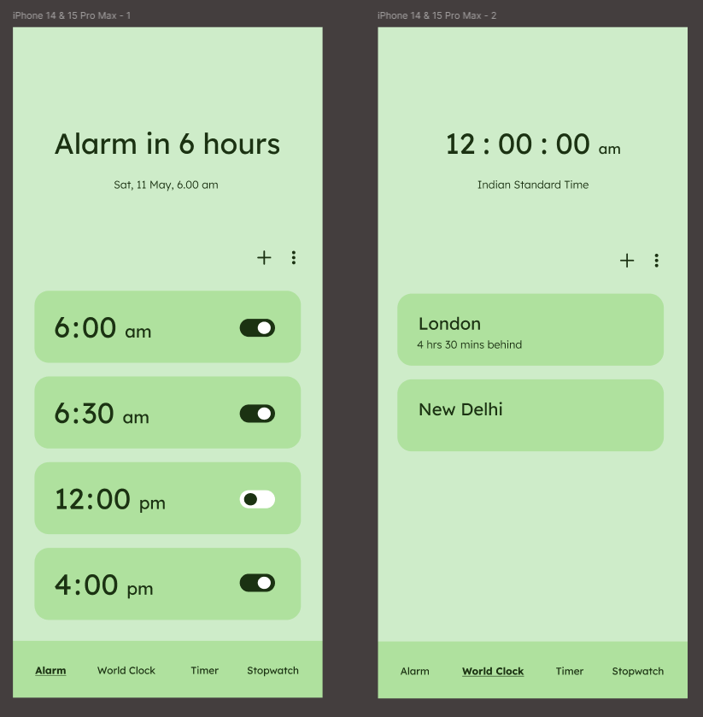

**After:**

**Result:**

Using Figma, a mobile application is designed and its background color is changed.