**Exp. No.: 02 Name: R.Priyanka**

**Date:1/8/24 reg no: 231701041**

**Aim: To Redesign canteen menu to increase the ease of use and ease of functionality (Grid and Menu Views).**

**Procedure:**

1. **Decide what needs to be improved and gather input from users.**
2. **Plan the project, set deadlines, and assign tasks.**
3. **Look at similar designs and gather feedback on the current menu.**
4. **Draw basic layout ideas on paper and create simple wireframes in Figma.**
5. **Start a new Figma project, set up pages, and create reusable design elements.**
6. **Design the grid with categories and item tiles, including images, names, descriptions, and prices.**
7. **Create a list view with sections, item names, descriptions, and prices, and add navigation features.**
8. **Show the designs to users and make changes based on their feedback.**
9. **Check for consistency and accessibility, and write design guidelines**

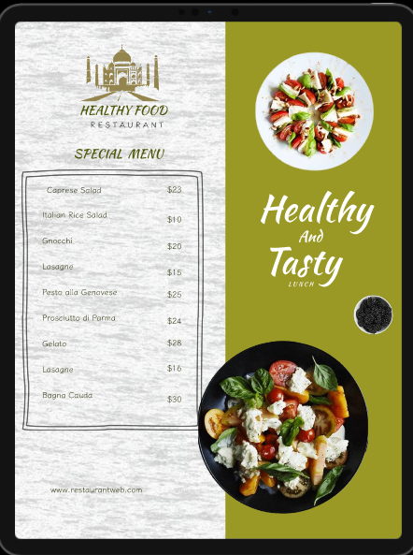

**Result:**

Using Figma, redesigned canteen menu to increase the ease of use and ease of functionality