**PREPARED BY**

S.GNANANIVIN

S.PUGAZHENTHI

K.GOKULKUMARAN

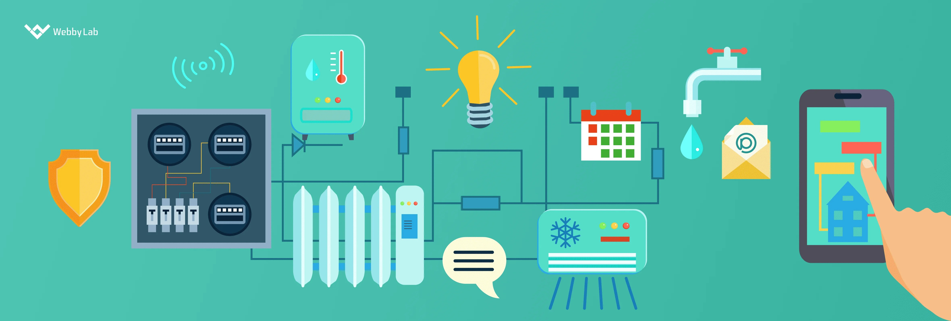

1. **PLANNING:**

Here I'll use the MQTT protocol to send data to a broker, but you can adapt it to other protocols if needed. I'll also assume you have some knowledge of IoT hardware, such as Raspberry Pi, Arduino, or ESP8266/ESP32, for sensor integration.

2. **SET UP THE IoT HARDWARE:**

You should have your IoT sensor (e.g., flow sensor) properly connected to your IoT device (e.g., Raspberry Pi, Arduino).

3.  **INSTALL REQUIRED LIBRARIES:**

You may need to install the **paho-mqtt** library if you haven't already. You can install it using pip.

pip install paho-mqtt

4. **WRITE THE PYTHON SCRIPT:**

import paho.mqtt.client as mqtt

import time

import random

# MQTT Broker Information

mqtt_broker_host = "your_mqtt_broker_host"

mqtt_broker_port = 1883

mqtt_topic = "water/consumption"

# Simulated Water Consumption Data

def get_water_consumption():

# Simulate a water consumption value (replace with actual sensor data)

return random.randint(1, 10)

# MQTT Callbacks

def on_connect(client, userdata, flags, rc):

if rc == 0:

print("Connected to MQTT broker")

else:

print("Connection failed")

def on_publish(client, userdata, mid):

print("Data sent to the broker")

# Initialize MQTT Client

mqtt_client = mqtt.Client("WaterConsumptionClient")

mqtt_client.on_connect = on_connect

mqtt_client.on_publish = on_publish

# Connect to the MQTT Broker

mqtt_client.connect(mqtt_broker_host, mqtt_broker_port)

mqtt_client.loop_start()

try:

while True:

# Get water consumption data

water_consumption = get_water_consumption()

# Publish data to the MQTT topic

mqtt_client.publish(mqtt_topic, water_consumption)

print(f"Sent water consumption data: {water_consumption}")

# Adjust the time interval according to your needs

time.sleep(60) # Send data every 60 seconds

except KeyboardInterrupt:

mqtt_client.disconnect()

Replace **your_mqtt_broker_host** with the actual host of your MQTT broker. This script connects to the MQTT broker, generates simulated water consumption data (replace it with real sensor data), and publishes the data to the specified MQTT topic at regular intervals.

Make sure you have an MQTT broker set up and configured to receive data from your sensors. Additionally, ensure your IoT device is connected to the internet or the local network to reach the MQTT broker.