  
**A NAAN MUDHALVAN**

**PROJECT**

***Submitted By***

S.GNANANIVIN

K.GOKULKUMARAN

S.PUGAZHENTHI

in partial fulfillment for the award of the degree

of

BACHELOR OF ENGINEERING

IN

***ELECTRONICS AND COMMUNICATION ENGINEERING***

SRI SHANMUGHA COLLEGE OF ENGINEERING AND

TECHNOLOGY, SALEM

**PROJECT OBJECTIVE:**

The objective of smart water management is to leverage cutting-edge technology and data-driven solutions to efficiently and sustainably manage our water resources. This entails optimizing water distribution systems, reducing water wastage, and ensuring the availability of clean and safe water for all. By integrating sensors, IoT devices, and advanced analytics, smart water management aims to monitor water quality, detect leaks, and predict water demand patterns, leading to improved resource allocation and reduced operational costs. Furthermore, it seeks to promote environmental conservation by minimizing water pollution and enhancing ecosystem preservation. Ultimately, the goal of smart water management is to create a more resilient and water-secure future, fostering economic growth and safeguarding the environment for generations to come.

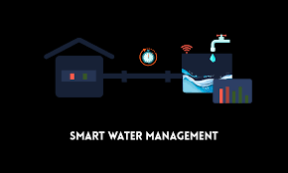

**IoT SENSOR SETUP**:

The goal is to monitor and manage water resources efficiently, reduce wastage, and ensure the availability of clean water. Here's a general overview of how you can set up such a system

* **Select Sensors:**

Choose the appropriate sensors for your water management system. These sensors will monitor various parameters, such as water level, quality, temperature, and flow rate. Common sensors include ultrasonic level sensors, pH sensors, temperature sensors, flow sensors, and turbidity sensors.

* **Data Connectivity:**

Ensure that you have reliable connectivity options. This can include Wi-Fi, LoRa (Long Range), NB-IoT (Narrowband IoT), or cellular networks. The choice depends on the location and range of your sensors.

* **Data Acquisition and Processing**:

Use a microcontroller or single-board computer like Arduino or Raspberry Pi to collect data from the sensors. Process the data locally to reduce the amount of data transmitted and save power.

* **Data Transmission:**

Transmit the processed data to a central server or cloud platform for analysis. Use secure communication protocols like MQTT or HTTPS to ensure data privacy and integrity. Consider using a gateway device if you have a large number of sensors over a wide area.

* **Data Storage and Analysis:**

Store the transmitted data in a database for historical analysis and future decision-making. Set up algorithms and rules for real-time analysis to identify anomalies, leaks, or other issues.

* **User Interface:**

Develop a user interface, such as a web or mobile application, that allows users to monitor the water data, receive alerts, and control water management devices remotely.

* **Control Mechanisms**:

Implement actuators and control devices, such as solenoid valves, pumps, or alarms, to enable remote control of water resources based on the data and user commands.

* **Energy Supply:**

Ensure a stable power source for your sensors and controllers. Depending on the deployment location, this can include solar panels, batteries, or a combination of power sources.

* **Security:**

Implement robust security measures to protect your IoT system from unauthorized access and data breaches. Use encryption, strong authentication, and regular updates to maintain security.

* **Maintenance and Monitoring**:

Regularly maintain and monitor the sensors and the overall system to ensure they function correctly. Replace batteries as needed, calibrate sensors, and update software to fix vulnerabilities and add new features.

* **Scale and Expand**:

As your smart water management system grows, consider adding more sensors and devices to cover larger areas or include additional functionalities like predictive maintenance or demand forecasting.

* **Compliance and Regulations**:

Ensure that your system complies with local and national regulations related to water management and data privacy.

**BLOCK DIAGRAM:**

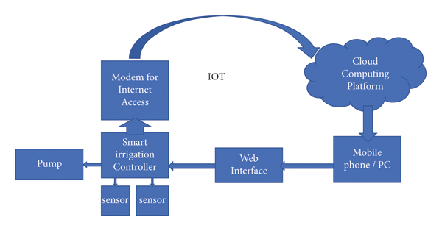

IoT SENSOR SETUP:

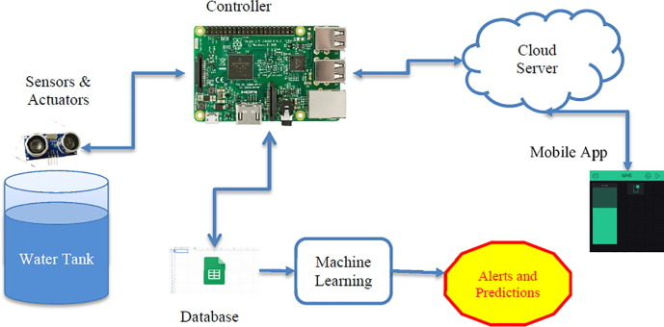

**MOBILE APP DEVELOPMENT:**

* **Define Objectives and Features**:

Clearly define the objectives of your smart water management app. What specific problems will it address? What features do you want to include?

* **IoT Sensors and Devices:**

Choose and deploy IoT sensors and devices to collect relevant data, such as water consumption, water quality, water pressure, and leak detection. These devices should be capable of sending data to a central server.

* **Data Collection and Storage:**

Develop a back-end system to collect, process, and store the data from IoT sensors. This system might involve databases, cloud platforms, and APIs.

* **User Registration and Authentication:**

Implement user registration and authentication to ensure data security and access control. Users should have their own accounts to monitor their water usage.

* **Real-Time Data Presentation:**

Create dashboards and real-time data visualization tools to present the collected data to users. This can include charts, graphs, and notifications to keep users informed.

* **Alerts and Notifications:**

Implement an alerting system to notify users of unusual water consumption, leaks, or water quality issues. Push notifications and email alerts can be useful.

* **Remote Control:**

Allow users to remotely control their water-related devices, such as turning off/on water supply, irrigation systems, or adjusting water heater settings.

* **Usage History and Analytics:**

Provide users with historical water usage data and analytics to help them make informed decisions about their water consumption habits.

* **Billing and Payment Integration:**

If applicable, integrate billing and payment features for users to manage and pay their water bills through the app.

* **Scalability and Security:**

Ensure that your app and backend infrastructure are scalable to handle a growing number of users and devices. Security is crucial to protect user data and the IoT network from potential threats.

* **Mobile App Development:**

Develop the mobile app for iOS and Android platforms. You can use native development (Swift for iOS, Java/Kotlin for Android) or cross-platform frameworks like React Native or Flutter for faster development.

* **Testing and Quality Assurance**:

Thoroughly test the app to ensure it functions as expected, is user-friendly, and that IoT data is accurate and reliable.

* **Deployment**:

Deploy your app to app stores (Apple App Store and Google Play Store) and ensure it meets their guidelines and requirements.

* **User Training and Support**:

Provide user documentation and support to help users set up and use the app effectively.

* **Continuous Improvement**:

Gather user feedback and analytics to make continuous improvements to the app, adding new features and optimizing existing ones.

* **Compliance and Regulations**:

Ensure your app complies with any relevant data privacy and security regulations, especially if you are collecting personal information.

**RASPBERRY PI INTEGRATION:**

Integrating a Raspberry Pi into a smart water management system using IoT (Internet of Things) can help you monitor and control water resources more efficiently. Here's a general outline of how you can set up such a system:

**Hardware Components:**

* Raspberry Pi (e.g., Raspberry Pi 3/4)
* Water level sensors (ultrasonic, capacitive, or float sensors)
* Solenoid valves or pumps (for water control)
* Internet connectivity (Wi-Fi or Ethernet)
* Power source (solar, battery, or AC)
* Enclosure to protect the Raspberry Pi from environmental conditions

**Software and Tools:**

* Raspberry Pi OS (Raspbian)
* Python for programming
* IoT platform (e.g., MQTT for communication)
* Database for storing data (e.g., MySQL, InfluxDB)
* Web development tools (HTML, CSS, JavaScript) for a dashboard
* Mobile app development tools (optional)

**Data Acquisition:**

* Connect water level sensors to the Raspberry Pi's GPIO pins.
* Use Python to read data from sensors and periodically send it to the IoT platform. You can use libraries like RPi.GPIO or Adafruit CircuitPython for sensor interfacing.

**Data Transmission:**

* Choose a communication protocol like MQTT to send data to an IoT platform or server.
* Set up an MQTT client **on** the Raspberry Pi to publish sensor data.

**IoT Platform:**

* Select an IoT platform (e.g., AWS IoT, Google Cloud IoT, or MQTT brokers like Mosquitto).
* Create a device in the platform and configure it to receive data from your Raspberry Pi.

**Data Storage:**

* Store incoming data in a database for historical analysis.
* You can use SQL or NoSQL databases based on your requirements.

**Remote Control:**

* Implement a control mechanism to remotely operate solenoid valves or pumps based on the water level data.
* Securely control these devices via your IoT platform.

**Data Visualization:**

* Create a web-based dashboard or a mobile app to visualize the water level data.
* Use HTML, CSS, and JavaScript for the frontend. You can use web frameworks like Flask or Django for building a web application

.

**Alerts and Notifications:**

* Set up alerts and notifications (email, SMS, or push notifications) to inform you of critical water level conditions or system faults.

**Power Management:**

* If your system is deployed remotely or in areas with unreliable power, consider using solar panels and batteries for power management.

**Security:**

* Ensure the security of your IoT system by following best practices, including strong authentication and encryption.

**Maintenance and Monitoring:**

* Regularly monitor the system's health and ensure it's running without issues. Implement error handling and fail-safes to prevent catastrophic failures.

**Scaling and Optimization:**

* Depending on your project's needs, you can scale and optimize the system by adding more sensors, devices, or data analysis capabilities.

**CODE IMPLEMENTATION:**

Implementing a complete smart water management system using IoT requires a significant amount of code and resources. Below is a simplified Python-based example to get you started. This example will involve reading data from a water level sensor and publishing it to an MQTT broker. You can build upon this foundation for a more comprehensive system.

import RPi.GPIO as GPIO

import time

import paho.mqtt.client as mqtt

# GPIO pins for the ultrasonic sensor

TRIG_PIN = 23

ECHO_PIN = 24

# MQTT settings

MQTT_BROKER = "mqttbroker.example.com"

MQTT_PORT = 1883

MQTT_TOPIC = "smart_water_management/water_level"

# Initialize GPIO

GPIO.setmode(GPIO.BCM)

GPIO.setup(TRIG_PIN, GPIO.OUT)

GPIO.setup(ECHO_PIN, GPIO.IN)

# Initialize MQTT client

client = mqtt.Client()

def get_distance():

# Trigger ultrasonic sensor

GPIO.output(TRIG_PIN, True)

time.sleep(0.00001)

GPIO.output(TRIG_PIN, False)

start_time = time.time()

end_time = time.time()

# Measure the time it takes for the sound wave to return

while GPIO.input(ECHO_PIN) == 0:

start_time = time.time()

while GPIO.input(ECHO_PIN) == 1:

end_time = time.time()

# Calculate distance

duration = end_time - start_time

distance = (duration * 34300) / 2 # Speed of sound is 343 m/s

return distance

def publish_water_level():

try:

while True:

distance = get_distance()

print(f"Water level: {distance} cm")

# Publish data to MQTT broker

client.connect(MQTT_BROKER, MQTT_PORT, 60)

client.publish(MQTT_TOPIC, f"{distance:.2f} cm")

time.sleep(10) # Publish data every 10 seconds

except KeyboardInterrupt:

print("Exiting...")

finally:

GPIO.cleanup()

client.disconnect()

if __name__ == "__main__":

try:

publish_water_level()

except Exception as e:

print(f"An error occurred: {str(e)}")

In this code:

* We use the HC-SR04 ultrasonic sensor to measure the water level.
* We set up an MQTT client to connect to an MQTT broker and publish water level data.
* The **get_distance()** function measures the distance using the ultrasonic sensor and calculates the water level based on the time it takes for the sound wave to return.
* The **publish_water_level()** function continuously measures the water level and publishes it to the MQTT topic.
* The program can be stopped using a keyboard interrupt (Ctrl+C).

**CONCLUSION:**

In conclusion, smart water management systems empowered by the Internet of Things (IoT) offer a promising solution to address the growing challenges of water resource sustainability, efficiency, and conservation. These systems enable real-time monitoring and control of water resources, allowing for precise data-driven decision-making and optimization of water usage. By incorporating various sensors, data analytics, and remote control mechanisms, IoT-driven water management enhances our ability to detect and respond to leaks, monitor water quality, and manage irrigation, all while promoting sustainable practices and minimizing wastage. As we continue to grapple with water scarcity and environmental concerns, IoT-based smart water management systems represent a crucial step towards a more sustainable and resilient water infrastructure, helping to safeguard this vital resource for future generations.