Today, we will look at Glynnsim3 transform by [eralex61](http://eralex61.deviantart.com): [GlynnSim plugin](http://eralex61.deviantart.com/art/GlynnSim-plugin-112621621)  
It can be used to create works like the ones below:  
  
[](http://pillemaster.deviantart.com/art/Wasting-Disc-Space-288754949)[](http://boxtail.deviantart.com/art/Shift-in-space-time-567172384)  
[](http://tatasz.deviantart.com/art/Rusty-596132442)[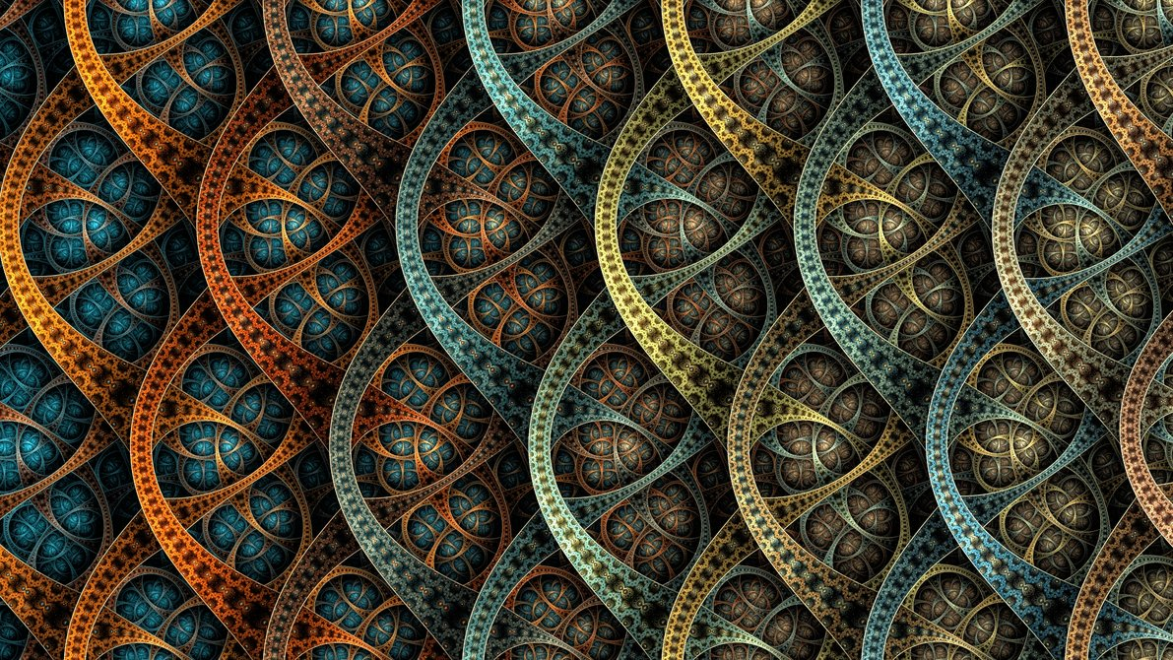](http://akurapare.deviantart.com/art/Container-Contest-1-367762660)  
  
Lets see what is it all about =D

**The basic shape**

Lets first figure out what glynnsim3 does. We will apply it as final transform to a checkboard pattern.  
  
Default checkboard (left), Glynnsim3 with thickness = 0.1 as final transform (middle) and Glynnsim with thickness = 0.5 (right):  
[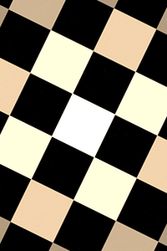](http://sta.sh/0222iv91gd66)[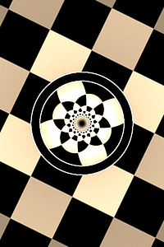](http://sta.sh/0j9tpasl67y)[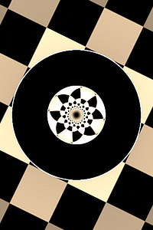](http://sta.sh/0amalbpusc6)  
  
The width of the ring is controlled by the thickness variable.  
  
Feel free to grab the starting params for the Glynnsim3 pattern below: [Glynnsim3 Starter Kit](http://sta.sh/0e0bav7rz27)  
[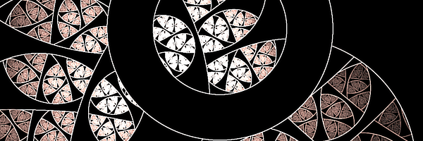](http://sta.sh/01p26suydtdc)  
  
You can see above that Glynnsim3 needs some sort of a ring battern to fill its empty areas.

**Classic way**

The [Circular Flame Tutorial or Unpolar+GlynnSim](http://pillemaster.deviantart.com/art/Circular-Flame-Tutorial-or-Unpolar-GlynnSim-271965226) fills Glynnsim3 by tiling a rectangle into a stripe, and then making this stripe into a ring that fills the gaps in the pattern.  
  
[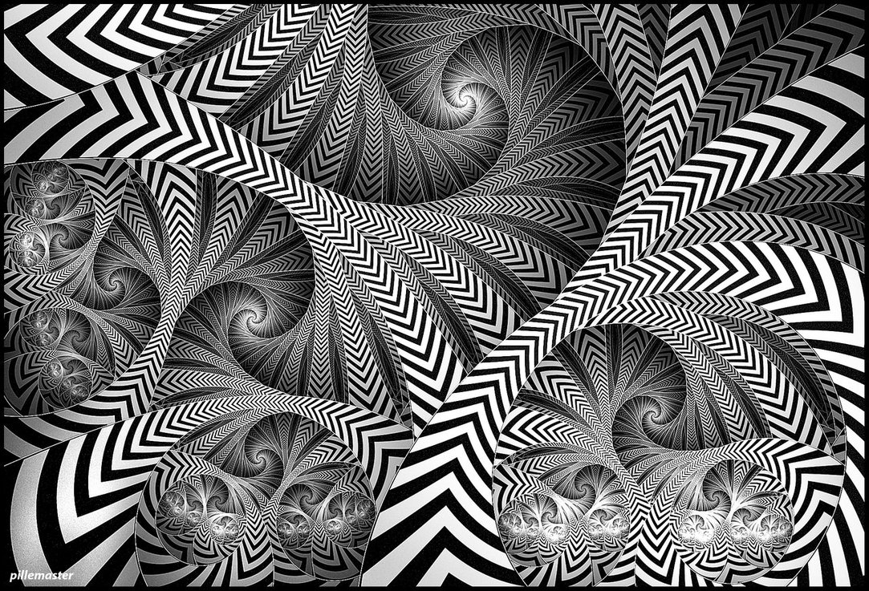](http://pillemaster.deviantart.com/art/Black-and-White-Tempest-281796132)  
  
Make sure you take a look at this tutorial, as it is pretty awesome.  
  
I also wrote a walkthrough to it on request, featuring step by step parameters, which you can check here: [Circular Flame Walk Through](http://sta.sh/0116s5yhxyin)

**No unpolar, No tiles**

But what can we do if we want to fill our Glynnsim3 with something that is not tiled?  
  
We can use crops (left) or use spherical + eyefish (right):  
[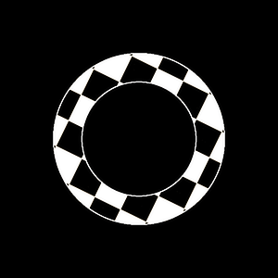](http://sta.sh/020f733ku4w7)[](http://sta.sh/011j9jhnp3yf)  
  
On the left example, I used 2 smartcrops to remove first the outer and then the inner parts of the plane, leaving just a ring.  
  
On the right example, I used the technique described in the tutorials below to make a hole in the plane, and then added a post linked hemisphere.  
  
[[http://st.deviantart.net/minish/main/defaulttag2.png](http://sta.sh/0171d0kb2tfi)**Shared linked transforms - Examples**Here we go, a collection of examples of shared linked transforms usage.  
Those are not all, just some exercises and examples of what can be done using weights.  
**Elliptic Splits**  
Lets start with a basic Elliptic Splits pattern:  
Tutorial - Splits ellipticBasic Elliptic Splits - starting parameters  
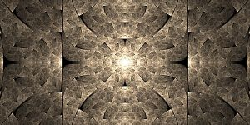  
Now, lets add a shared pre linked sphrical transform.  
Add a new transform (xform 3)  
Set its opacity to 0Set its color speed to 1 (optional, you need this so it does not affect the coloring)On xaos tab, set the weight of xform 3 to itself to 0On xaos tab, leave the weight from xform 1 to xform 3 as 1, and set everything else (to itself and to xform 2) to 0Repeat step 6 for xform 2At this point, your fractal should look the same as it was before you added xform 3. If yes, replace linear with spherical. Else, check previous s](http://sta.sh/0171d0kb2tfi) [[http://st.deviantart.net/minish/main/defaulttag2.png](http://sta.sh/0144k75f17ra)**Filling in with bubbles**Lets take a look at frameworks where you have a circular hole that needs to be filled to create a pattern.  
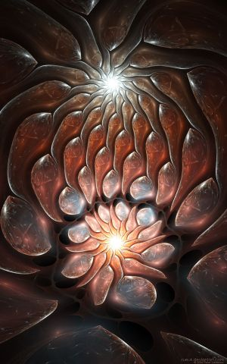  
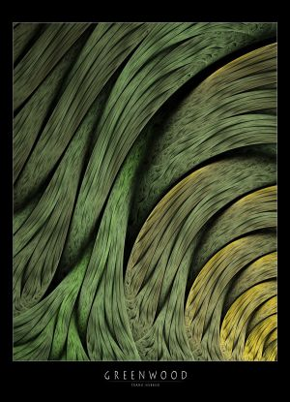  
**The basic idea**  
Here, you have a variation or a combination of variations that has a round hole, which you need to fill with something to create a round pattern:  
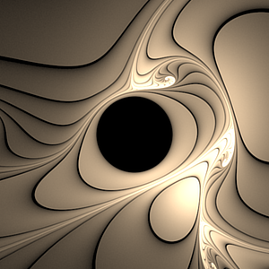  
We have basically two elements here - the framework itself and the filler. Lets take a look at some frameworks and fillers.  
**Plastics and Blooms**  
There are many tutorials on those structures (both frameworks and fillers):  
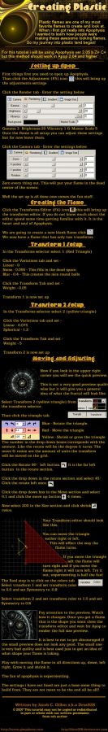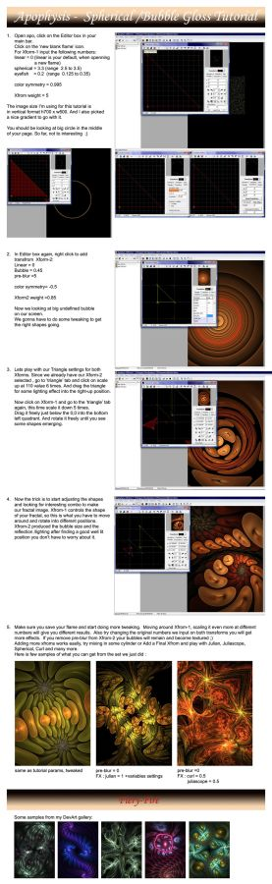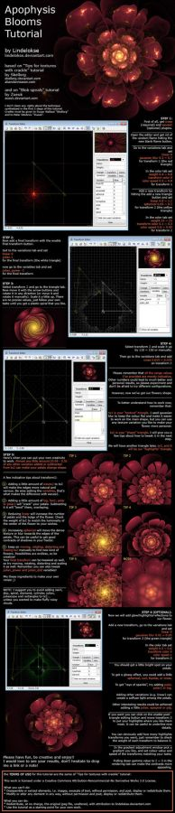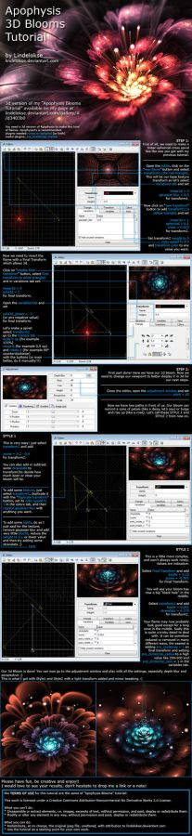  
And yeah, blooms are also plastics (just look at the transfor 2 of the 2D tutorial - linear + spherical) ;)  
Le](http://sta.sh/0144k75f17ra)  
  
We will take a closer look at the second method in the example below.

**Example**

Lets start with those base params: [Glynnsim3 Starter Kit](http://sta.sh/0e0bav7rz27).  
  
Do the following:

1. Add a new transform (transform 2), and replace linear with spherical.
2. Add a post linked transform to xform 2 (call it xform 3), and also replace linear with spherical.
3. Add a post linked transform to xfomr 3 (xform 4), and replace linear with hemisphere.
4. Set hemisphere amount to 1 + Glynnsim3 thickness (1.3 for the params above)

Steps 1 and 2 don't make much sense now, but will click later on.  
  
You should have something like this:  
[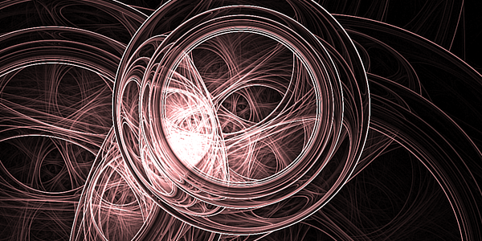](http://sta.sh/021s4uslh52)  
  
  
Notice that we got a hemisphere of correct size, and now we just need to make a hole in it to avoid overlaps. Go to xform 3 (the second spherical), and add eyefish until the pattern fits exactly the Glynnsim3:  
  
[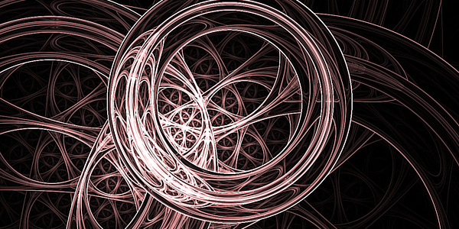](http://sta.sh/01loecn8deku)  
  
For some extra fun, replace the first spherical with julian. Julian power sets the number of times the pattern will be repeated. For example, if power is 3:  
[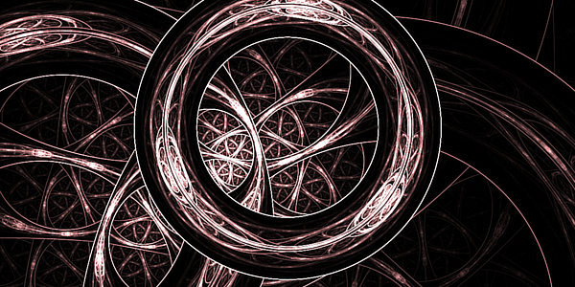](http://sta.sh/07l0fypy18e)  
  
Notice the pattern is a bit squished. We can fix it by increasing the distance parameter. For example, below, I set it to 3 also:  
[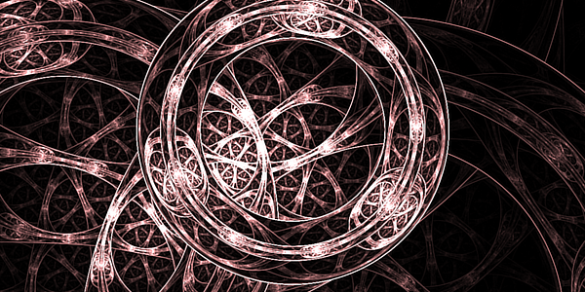](http://sta.sh/01yhe5xfpoqf)  
  
Feel free to check my final parameters: [Glynnsim3 final params](http://sta.sh/0f1ond0d3uq)  
  
This technique is also great to fill glynnsim3 with patterns, such as abstracts or gnarls:  
[](http://tatasz.deviantart.com/art/Rusty-596132442)[](http://tatasz.deviantart.com/art/Marble-596263224)