This tutorial will equip you with the skills to create a style of fractal known as tiles. The concept of a tile (think subway tile or kitchen backsplash) is ideal for a fractal application because of the repeating pattern of self-similarity. In this tutorial we will explore the power of post-transforms, learn how to apply a final transform, and explore different formulas known as variations within the Apophysis program.

**Explanation of Tiles**

The fractal tile style comes in a wide variety of shapes, from squares to hexagons and beyond. All of them follow the same basic ideas to create a pattern. Once you've conquered the structure for a tile, the possibilities are literally endless, with a whole plethora of fun formulas to be added and shapes to explore. Today we will focus our attention on the basic square tile.

**1. Basic Structure of a Square Tile**

**Step 1**

To begin creating the structure for our square-tiled fractal, open the **Editor** and click the button for a **New/blank flame**.

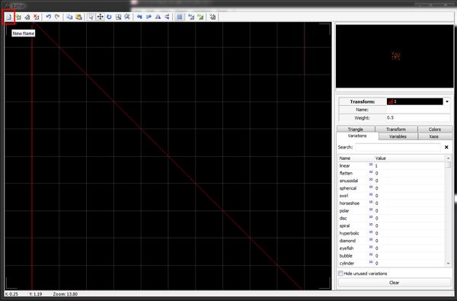

**Step 2**

The next step is to set up the first transform. We do this because it will serve as a template for the rest of the tile structure. Setting up this one transform and copying it saves us a lot of time and work, and is also good practice because it prevents us from making easy mistakes by forgetting steps or mistyping values.

We will leave the **Variation** set to **linear=1** as the linear formula is the backbone of this type of tile. Change the **Weight** of Transform 1 to **10**. On the **Colors**tab, set the **Color Speed** setting to **1**. The effect of this will not be apparent right now, but will become evident as we continue.

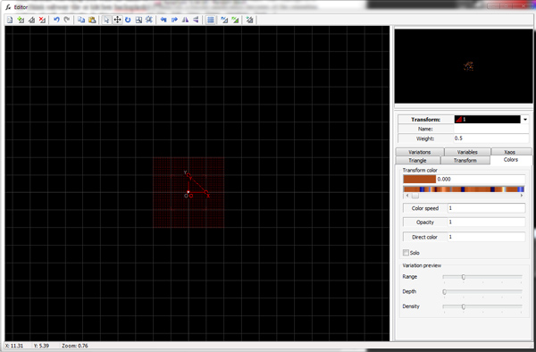

**Step 3**

Finally, we need to move this initial transform into place. Move Transform 1 left one unit. Move this same transform up one unit.

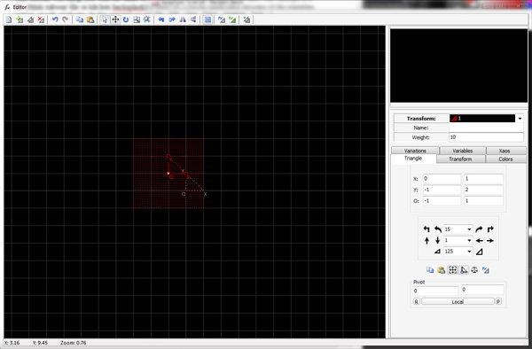

**Step 4**

Now that the first piece of our tile is in place, we can create the rest of the tile structure. Each of these transforms will be a duplicate of the first transform we setup.

Duplicate Transform 1 by clicking the **Duplicate Transform** button at the top of the editor. Move this transform to the right by two units.

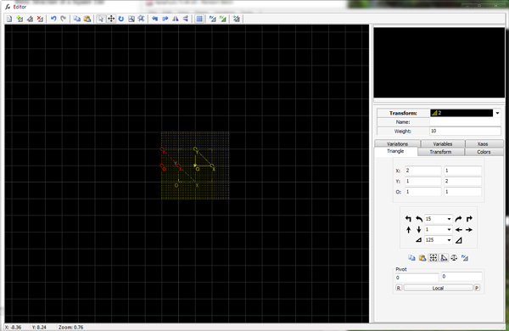

**Step 5**

Duplicate Transform 2 by clicking the **Duplicate Transform** button. MoveTransform 3 down by two units.

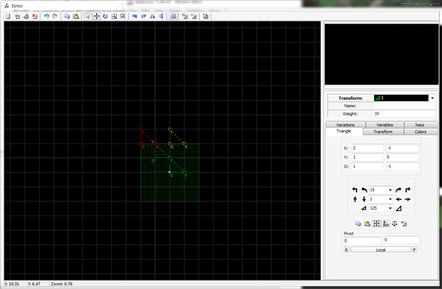

**Step 6**

Lastly, **Duplicate** Transform 3. Movethis transform to theleft by two units.

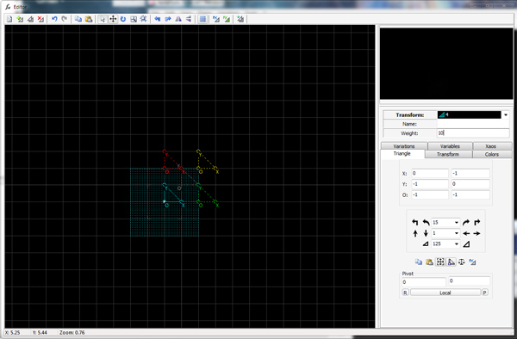

This completes the basic structure of a square tile.

**2. Add the First Shape**

The number of options for putting shapes into fractal tiles is staggering. For this tutorial, we'll look at a few different variations and how they can be used to create some amazing artwork.

**Step 1**

Create a **New Transform**.

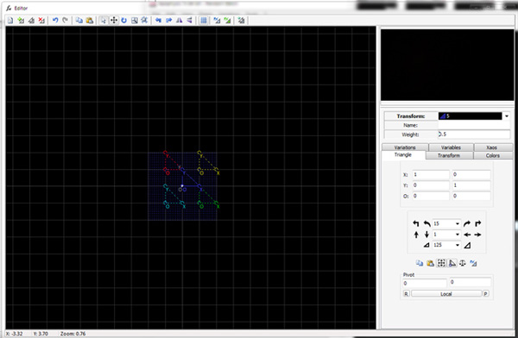

**Step 2**

At this point, it is good to have the variation preview turned on in the editor. This allows us to see what the particular variation is doing on the fractal plane. It also allows you to visualize what each transform's effect is on the fractal and can provide invaluable information as you design your own fractals.

Right-click in the grid-portion of the editor window and choose the option **Show variation preview**.

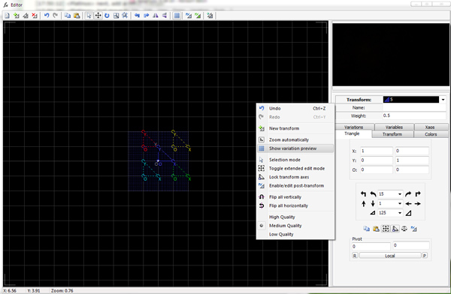

**Step 3**

For this transform, we need to use the **Variations** tab of the editor. Remove the **1** from **Linear** by changing it to a **0**. You should now see many small dots in the preview window. This shows you the structure of the tile we set up. To get an even clearer picture, scroll down to find the **Blur** variation and add **0.5** to Transform 5. You will see the dots become clearer. Change the **Blur** value back to **0** to continue.

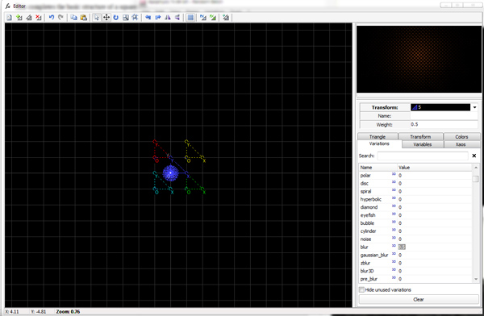

**Step 4**

To begin adding some shape to our tile structure, find the variation **Bubble** and change the **0** to **1**.

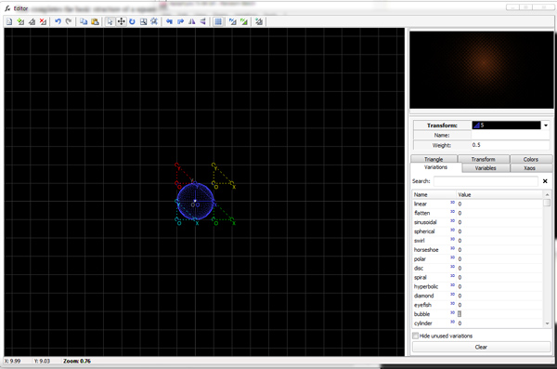

**Step 5**

At this point, the Bubble variation is too big to be useful in our tile. We could reduce the amount of the variation to 0.25 or perhaps even smaller. However, by doing so, we reduce the affect of the variation, which is not what we're aiming for as it will affect the shape.

Instead we are going to force the transform to become smaller and at the same time retain the round shape of the Bubble variation when set to 1. This is an incredibly powerful technique that will allow you to retain the shape of a variation known as post-transform. This is an over-simplified explanation, but use it to your advantage: when you activate the post-transform, you keep the original shape and can move it at will.

To activate the post-transform mode, look for the button in the top menu bar of the editor that has a **Px and a triangle**. Click this button to enter the post-transform editing mode.

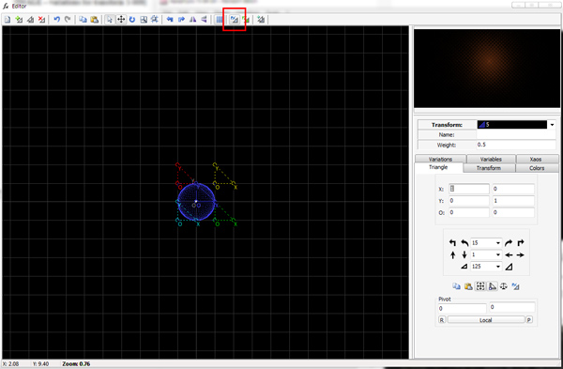

**Step 6**

With the post-transform mode active, switch to the **Triangle** tab. We want to shrink the size of Transform 5. Change the value in the **Scale Box** (the one with a triangle on either side) to **200**. Click the **Scale Down Triangle** twice.

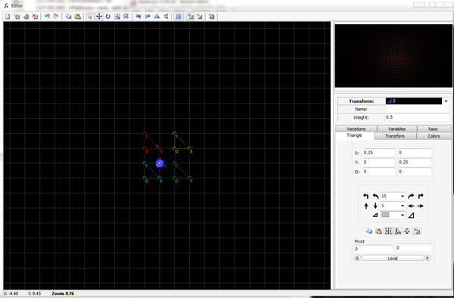

**Step 7**

We can edit the shape of this transform more by deactivating the post-transform mode and then scaling down the transform two more times by 200.

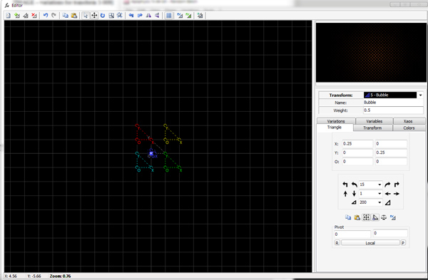

**Step 8**

The next step is to add more structure. Create a **New Transform**. Remove the **Linear** variation by changing it to **0**. Add **Cylinder** to this transform by changing its value to **1**. The cylinder variation will give a long bar or tube shape.

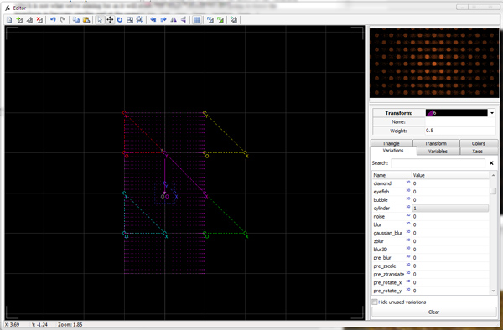

**Step 8**

Once again, at a value of 1, the cylinder transform is too large to fit nicely into our tile. It needs to be scaled down just as the bubble transform was. Enable post-transformmode, and scale down Transform 6 by the value of 200 three times. In the preview window, you'll now see the circles from the bubble transform appear connected by a long bar which is our cylinder transform.

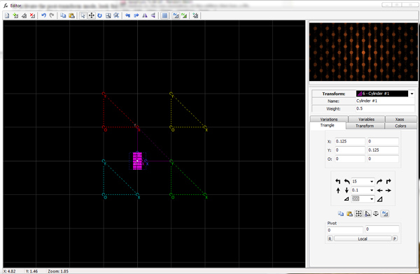

**Step 9**

Let's modify this transform some more. With post-transform mode still active, moveTransform 6 to the left 0.5 units and up 0.5 units. **Rotate** this transform 45 degrees counter-clockwise. Notice that each time we modify the position of this transform, the shape does not change, only the position. This is the power behind the post-transform mode. If we were to perform these same actions with post-transform turned off, the entire shape of the fractal would change drastically.

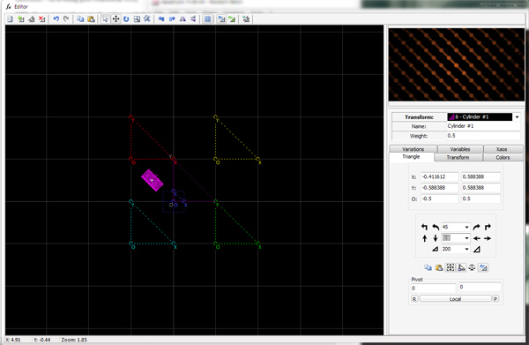

**Step 10**

We can get more shape out of this transform by one more trick. Turn post-transform mode off, andscale down this transform by 200 once. This technique will put more texture into the transform and give us a more 3D appearance.

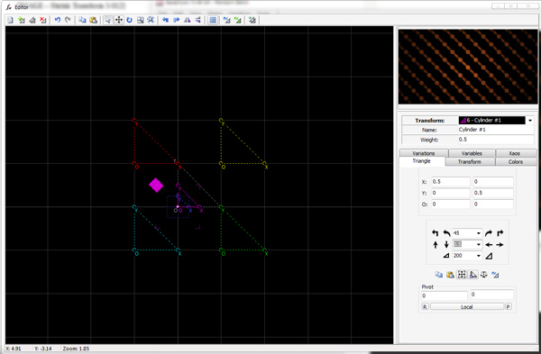

**Step 11**

To frame out the rest of our shapes, duplicate Transform 6. Enable post-transform mode once again. This time, rotateTransform 7 90 degrees clockwise and moveit one unit to the right.

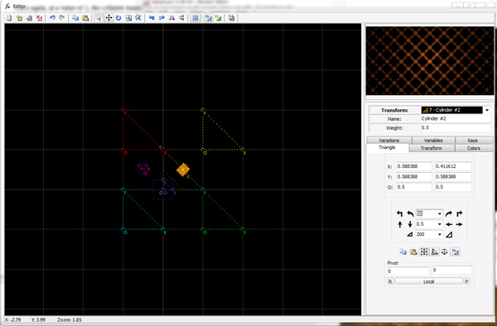

**3. Creating a More Complex Structure**

**Step 1**

We've now completed a very basic tile structure and shape. Add a **New Transform** and remove the linear variation from this transform by changing **Linear** from **1** to **0**. Change the values of **Juliascope** in the **Variations** tab from **0** to **1**. Enable the post-transform mode and scale down by 200 and then again by 125. Movethis transform up one unit. Finally, switch to the **Variables** tab and change the **juliascope_power** to **2** and **juliascope_dist** to **1**. These modifications really fill in the rest of the fractal and give it a solid and powerful appearance.

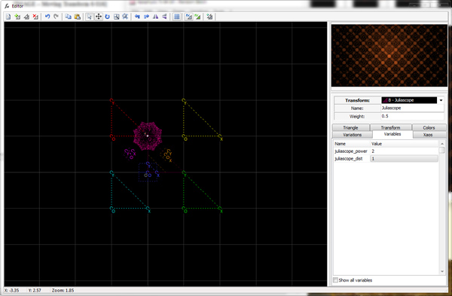

**Step 2**

Now is a good time to adjust the weights of transforms. Originally we set the weight of the first four transforms to 10. This allows the structure of the tile to hold despite how many more additional transforms we add, allowing us to continue to see what the tile looks like while we design it.

Change the weightof the transforms to the following:

* Transform 5: Bubble: 2
* Transforms 6 and 7: Cylinder: 3
* Transform 8: Juliascope: 3

Notice how changing these weights affects the overall appearance of the fractal. You may also notice a few annoying bright spots near the middle of the fractal. (This will depend on your current gradient). Let's fix those now.

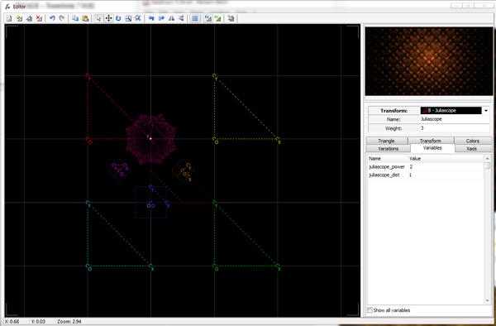

**Step 3**

Switch to the **Colors** tab. For each of the transforms 5 through 8, change the **Opacity** value from **1** to **0**. Pay careful attention to the preview window as you make each change and notice how the bright spot changes to conform to the same color values as the rest of the fractal.

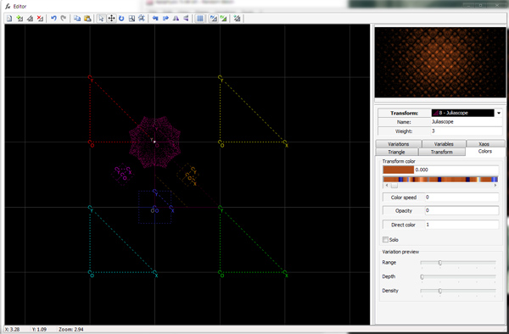

**Step 4**

This is a good time for us to pick a color palette for the finished fractal. Close the **Editor** and open the **Gradient** selection window. Choose gradient **558_Explosion**.

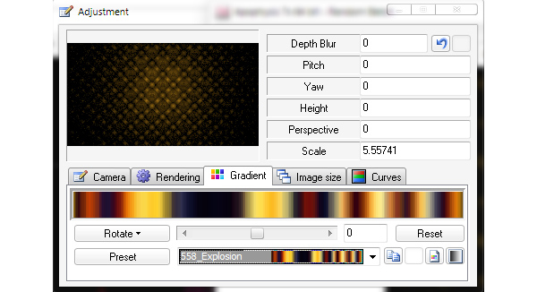

**Step 5**

Close out of the gradient selection and open the **Editor** window. Open the **Colors** tab**.** Remember when we set each of the linear transforms to a color speed of 1? We did this so that all of the color changes we make now will be consistent across the entire fractal.

Make the following changes to each of the transforms:

* Transform 5: **Transform Color**: 0.150 and **Color Speed**: -1
* Transform 6 and 7: **Transform Color**: 0.708 and **Color Speed**: -1
* Transform 8: **Transform Color**: 0.608

To give more prominence to the Juliascope transform (Transform 8), change the **Weight** from **3** to **4**.

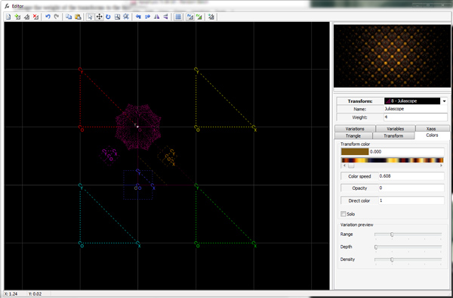

**4. Adding a Final Transform**

**Step 1**

To give our fractal more punch, we can add a final transform. The final transform will affect the entire fractal shape by influencing it with any formula or combination of formulas we choose.

Enable the final transform by clicking the Fx button with the little triangleat the top of the editor menu bar. You will see a grey triangle appear in the editor.

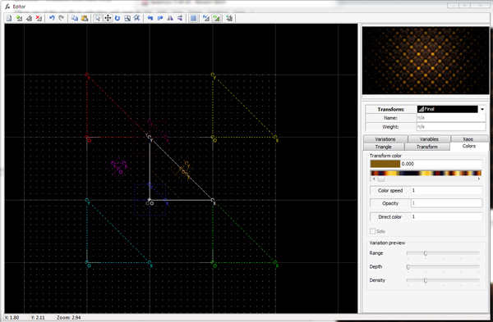

**Step 2**

This final transform begins just like any other new transform we add, with the linear variation set to 1. Remove this by switching to the variations tab and changing the value of **Linear** to **0**.

**Step 3**

Add to the final transform **0.5** of the **Foci** variation and notice the change of the overall shape. Additionally, add in **0.1** **Spherical**. There is a slight, but visually appealing change to the shape of the fractal. Combining variations like this, even positive and negative amounts, can create some incredible images.

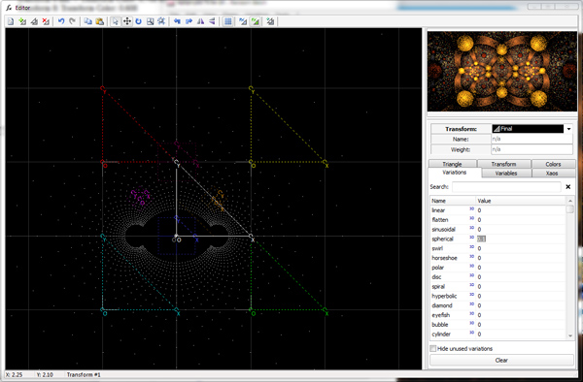

**5. Cleanup and Rendering**

The last few steps involve cleaning up the fractal and rendering.

**Step 1**

Close the editor and use the zoom and movetools in the main window to find a nice location on the fractal to render.

**Step 2**

Open the **Adjustment** panel and change to the **Rendering** tab. Change the **Gamma** setting to **3.5** for a slightly clearer render.

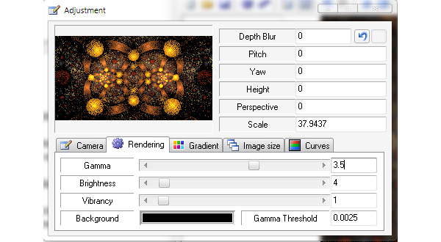

**Step 3**

The final step is to render the fractal. Open the **Render** dialog by clicking thepurple gear in the main window. From here, set the **Density** to **10,000**. The **Filter Radius** setting of **0.455** will work nicely for the detail in this fractal. An **Oversample** of **2** is ideal. Click **Start** to begin the render.

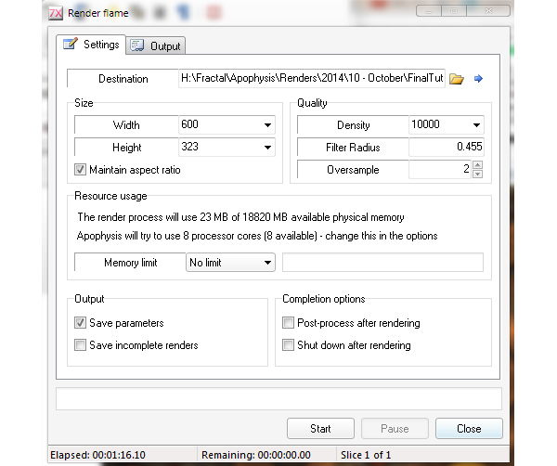

Explore the different final transforms first. Add several. Use negatives. Be bold! You will be amazed at the variety of images you can get just from changing these. Next, challenge yourself by removing the final transform and move some of the other transforms to new locations. Then, try changing the variations to create something new. If you would really like a challenge, start from scratch and try to create a hexagon or other type of tile.