Project1
Exploratory Data Analysis for a Banknote Authentication Dataset
COSC 6335 - Data Mining
Fall 2014
Dr. Eick

Group – A

Name | PeopleSoft Id | Email
Puja Anchlia
Dainis Boumber

- Mean and Standard Deviation

The mean and standard deviation of the 4 numerical attributes as produced by R code are given below:

Attribute Name | Mean | Standard Deviation
Variance | 0.4337353 | 2.842763
Skewness | 1.922353 | 5.869047
Kurtosis | 1.397627 | 4.31003
Entropy | -1.191657 | 2.101013

- Covariance and Correlation Matrix

The covariance matrix for the 4 numerical attributes:

Attribute Name | Variance | Skewness | Kurtosis | Entropy
Variance | 8.081299 | 4.405083 | -4.666323 | 1.653338
Skewness | 4.405083 | 34.445710 | -19.905119 | -6.490033
Kurtosis | -4.666323 | -19.905119 | 18.576359 | 2.887241
Entropy | 1.653338 | -6.490033 | 2.887241 | 4.414256

And the correlation matrix is given below:

Attribute Name | Variance | Skewness | Kurtosis | Entropy
Variance | 1.0000000 | 0.2640255 | -0.3808500 | 0.2768167
Skewness | 0.2640255 | 1.0000000 | -0.7868952 | -0.5263208
Kurtosis | -0.3808500 | -0.7868952 | 1.0000000 | 0.3188409
Entropy | 0.2768167 | -0.5263208 | 0.3188409 | 1.0000000

Statistical findings:
- All the attributes are somewhat related linearly. The degree of linear relationships among them is described in the below table:

Attribute Name |  | Variance | Skewness | Kurtosis | Entropy
Variance |  |  | +ve Weak linear  relationship | -ve Weak linear relationship | +ve Weak linear  relationship
Skewness |  |  |  | -ve Strong linear relationship | -ve Moderate  linear relationship
Kurtosis |  |  |  |  | +ve Poor linear  relationship
Entropy

- From the table above it can be inferred that the attributes Skewness and Kurtosis have somewhat strong negative linear correlation ( -0.8). That implies that larger values of Skewness are associated with lower values of Kurtosis and vice versa.

- Also, Skewness and Entropy ( - 0.52) have moderate negative linear relationship.
- Classification Scatter plots

Below are the six classification scatter plots:

- Variance, Skewness
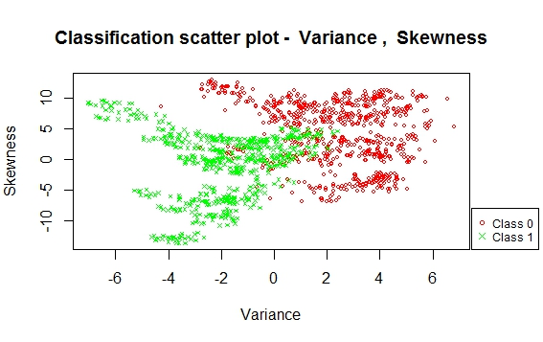
From the plot it can be said that the two classes are separated but with some overlap in between. These can be used to predict classes but with some error due to the presence of the overlapping region.

- Variance, Kurtosis
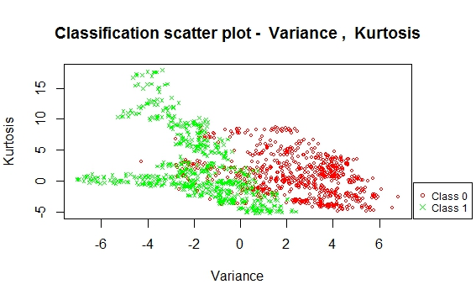
From the plot it can be said that the two classes are separated but with some overlap in between. These can be used to predict classes but with some error due to the presence of the overlapping region.
- Variance, Entropy

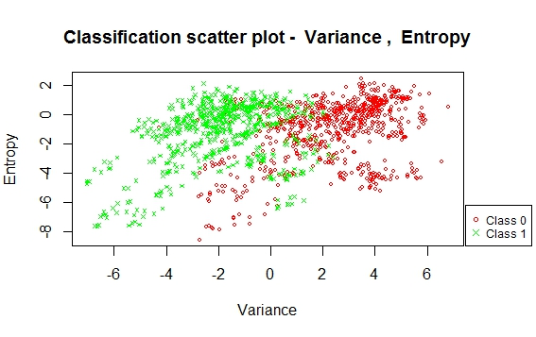
From the plot it can be said that the two classes are separated but with some overlap in between. These can be used to predict classes but with some error due to the presence of the overlapping region.

- Skewness, Kurtosis

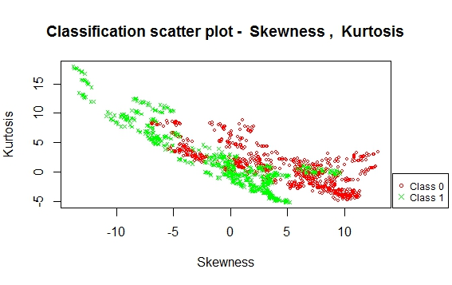
From the plot it can be said that the two classes are not quite separated, there is significant overlap between them. These are not that appropriate to predict classes.

- Skewness, Entropy

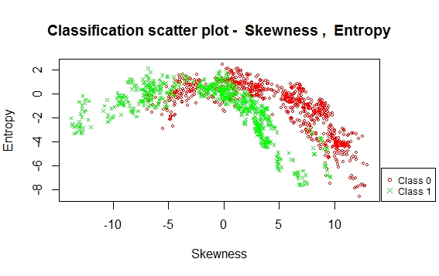
From the plot it can be said that the two classes are separated but not linearly and with some overlap in between. These can be used to predict classes but will not be that accurate.

- Kurtosis, Entropy
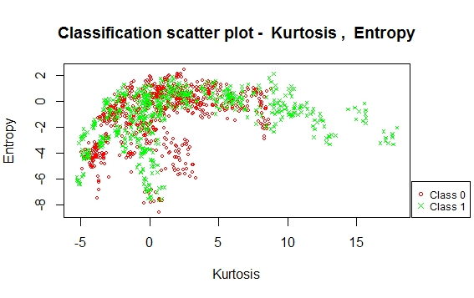
From the plot it can be said that the two classes are very much overlapped. So, it is very difficult to predict the class attribute using these two attributes.

- Scatter Plots

Below are the scatter plots of the first two attributes and third, fourth attribute:

- Variance, Skewness

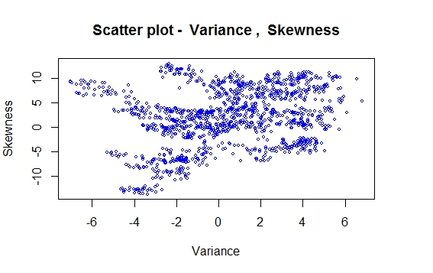
From the plot it seems that the two attributes are very poorly related.

- Kurtosis, Entropy

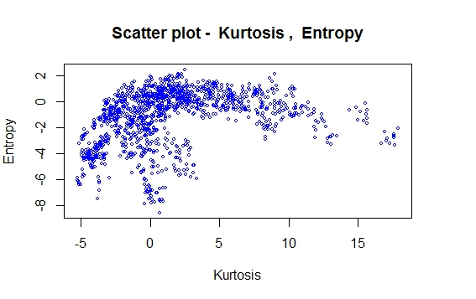
From the plot it seems that the two attributes are somewhat related but non-linearly with positive slope. Initially the value of entropy is steeply increasing with Kurtosis and then it is becoming stable later on. Also there are some gaps present indicating possible presence of outliers.

- Histogram

The histogram of the third attribute Kurtosis is shown below:
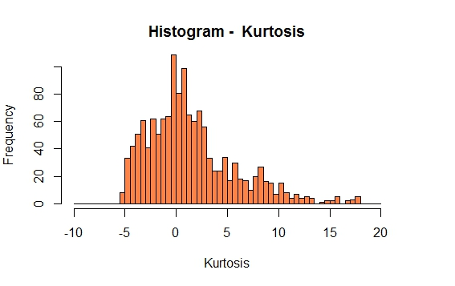
Statistical findings
- The data for this attribute is skewed right.
- There are two gaps present, possible outliers.

This histogram is chosen because with this bin size the gaps can be seen clearly.

- Box Plots

Below are the box plots for the Skewness and Kurtosis:

- Skewness
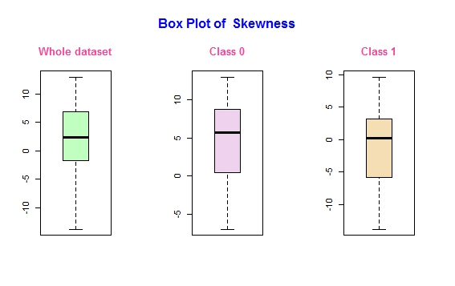
The class level location or median differs. For class 0 it is around 5.5 and for class 1 it is around 0.
The variance of the two classes are almost same with class 0 variance slightly larger.
There are no outliers.
The boxplot of the whole dataset is quite symmetric, but for the specific classes they are left skewed.

- Kurtosis
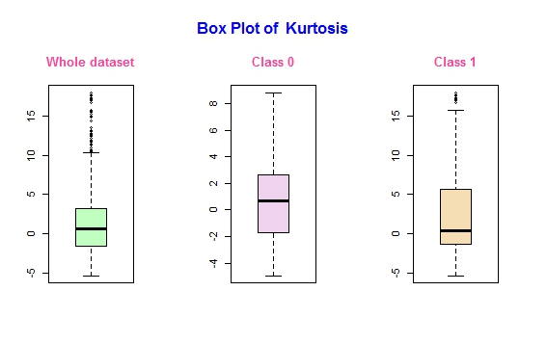
The class level location or median are slightly different, around 0.5 for class 0 and 0 for class 1.
The variance of the two classes are almost same. There are no outliers in Class 0, but outliers present for Class 1 and the whole dataset.
The boxplot of the whole dataset and class 0 is quite symmetric, but for class 1 it is right skewed.

- Star Plots

Below are the star plots of the first 20 instances of class 1 and class 0:

- Class 1

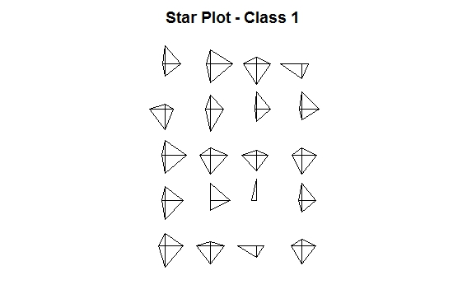

- Class 0

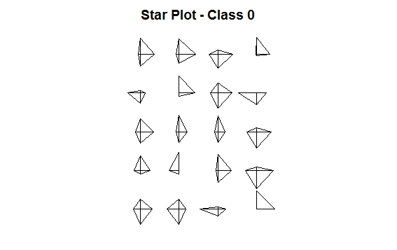

- Linear model

Before generating the linear model, the dataset is normalized that is z-scored.

The R² of the linear model is given below:

Multiple R-squared : 0.8649
Adjusted R-squared: 0.8645

The coefficients of each attribute is mentioned below:

Attribute Name | Coefficient Value
Variance | -0.405322
Skewness | -0.459553
Kurtosis | -0.437963
Entropy | -0.001676

According to the coefficient values it can be inferred that the “Entropy” attribute is not that important for the model. But all the other attributes are important.

