//Assignment 10.4

Problem Statement

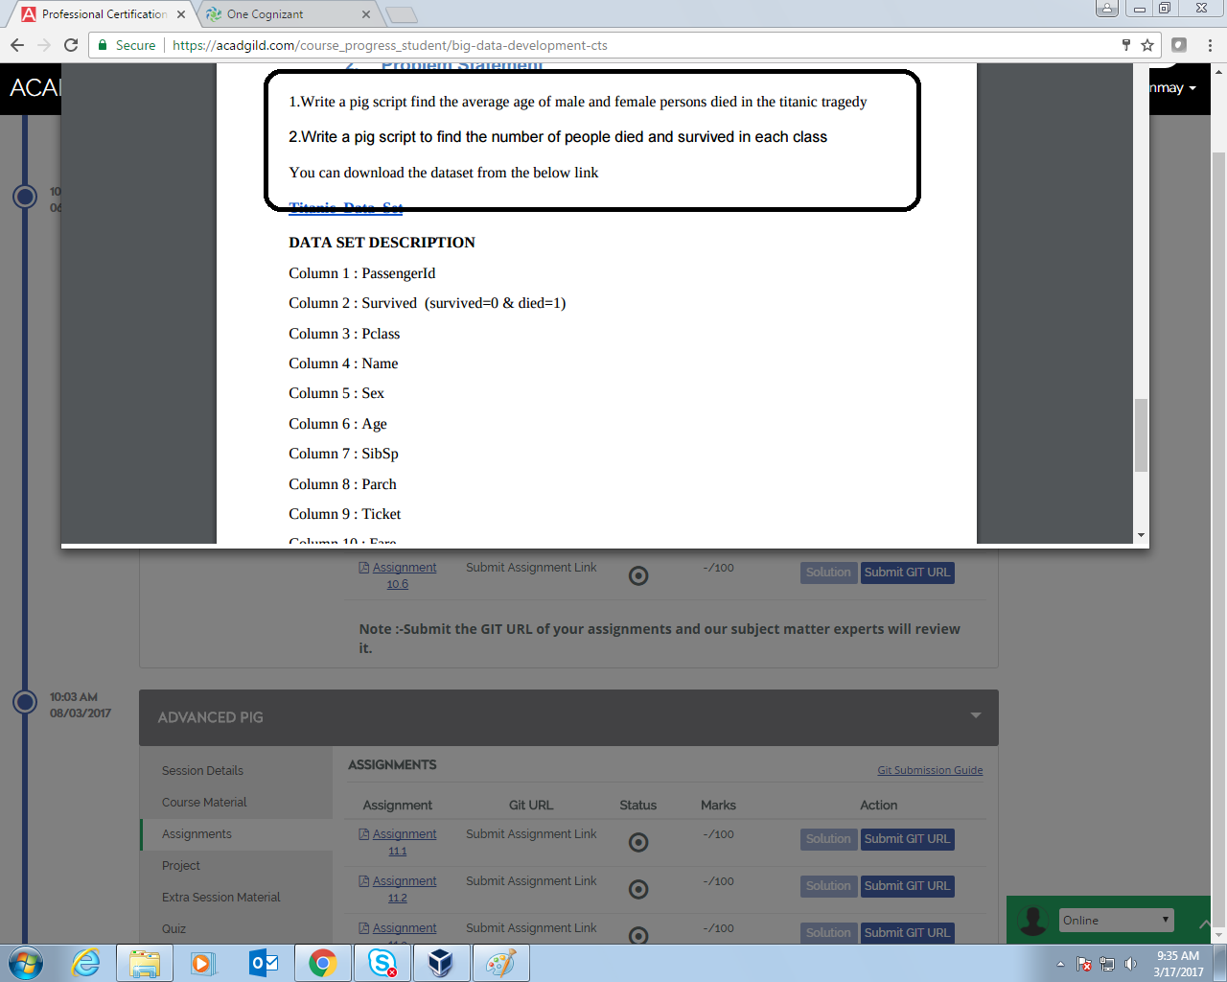

// 10.4a Query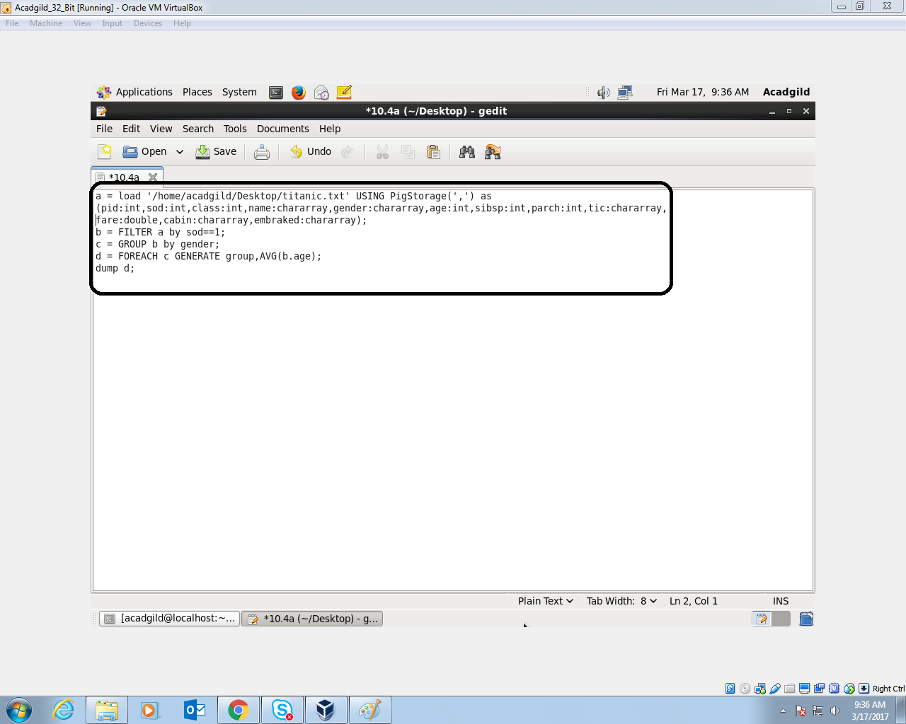

1. Filtered the file having Status died
2. Then grouped by Gender
3. Generate the average by using the function ‘AVG’

// 10.4a Output

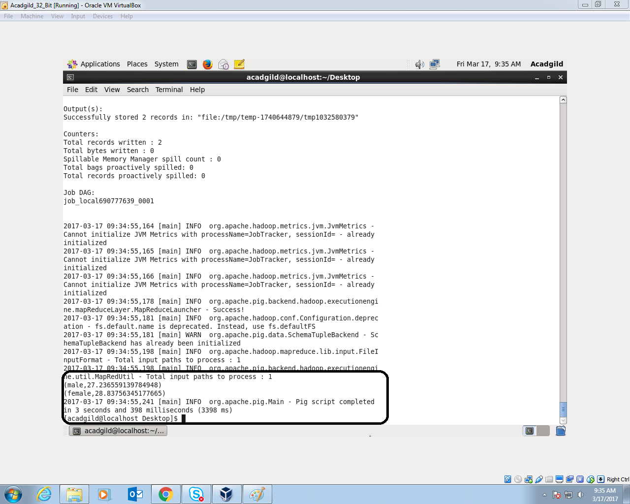

// 10.4b Query

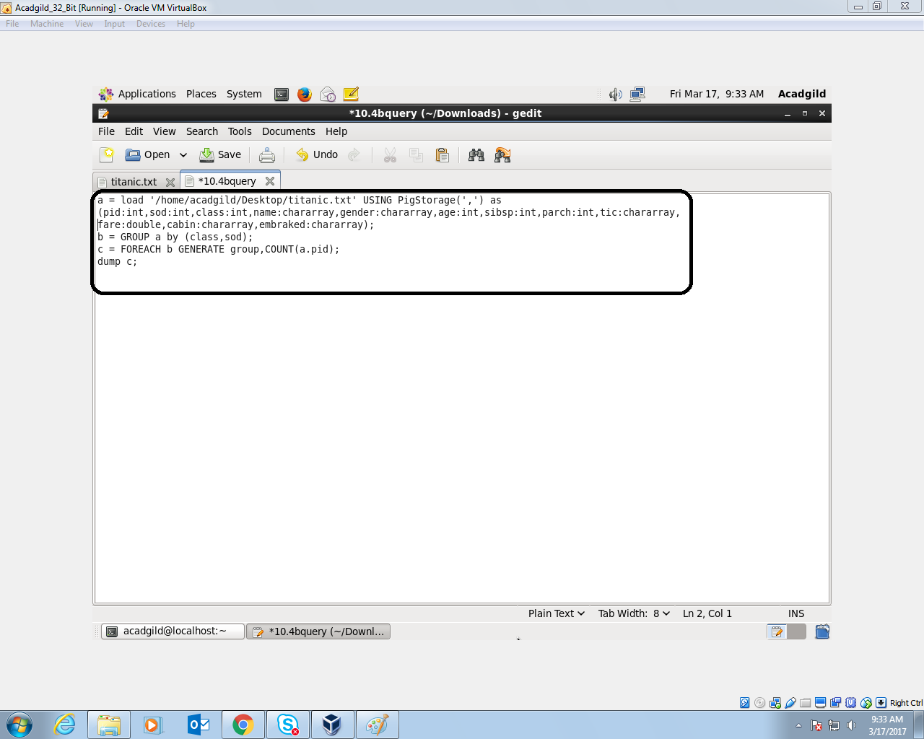

1) Grouped by Class and Status.

2) Found the count of ids in each group using ‘COUNT’

//10.4b Outptut

