// Assignment 10.5

// Problem Statement

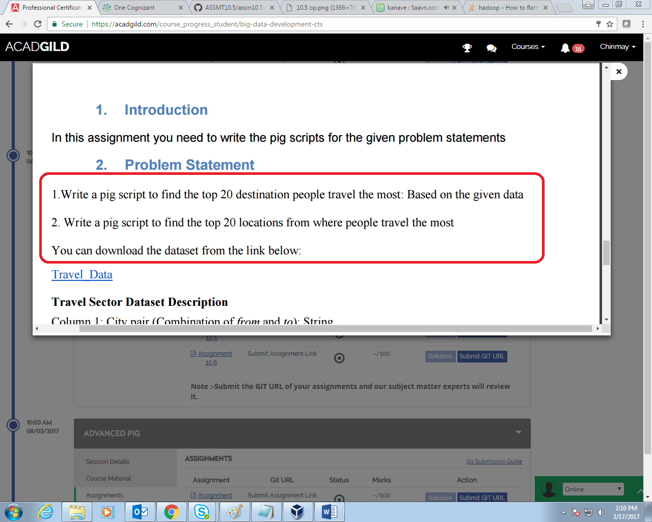

//10.5 a

// Query

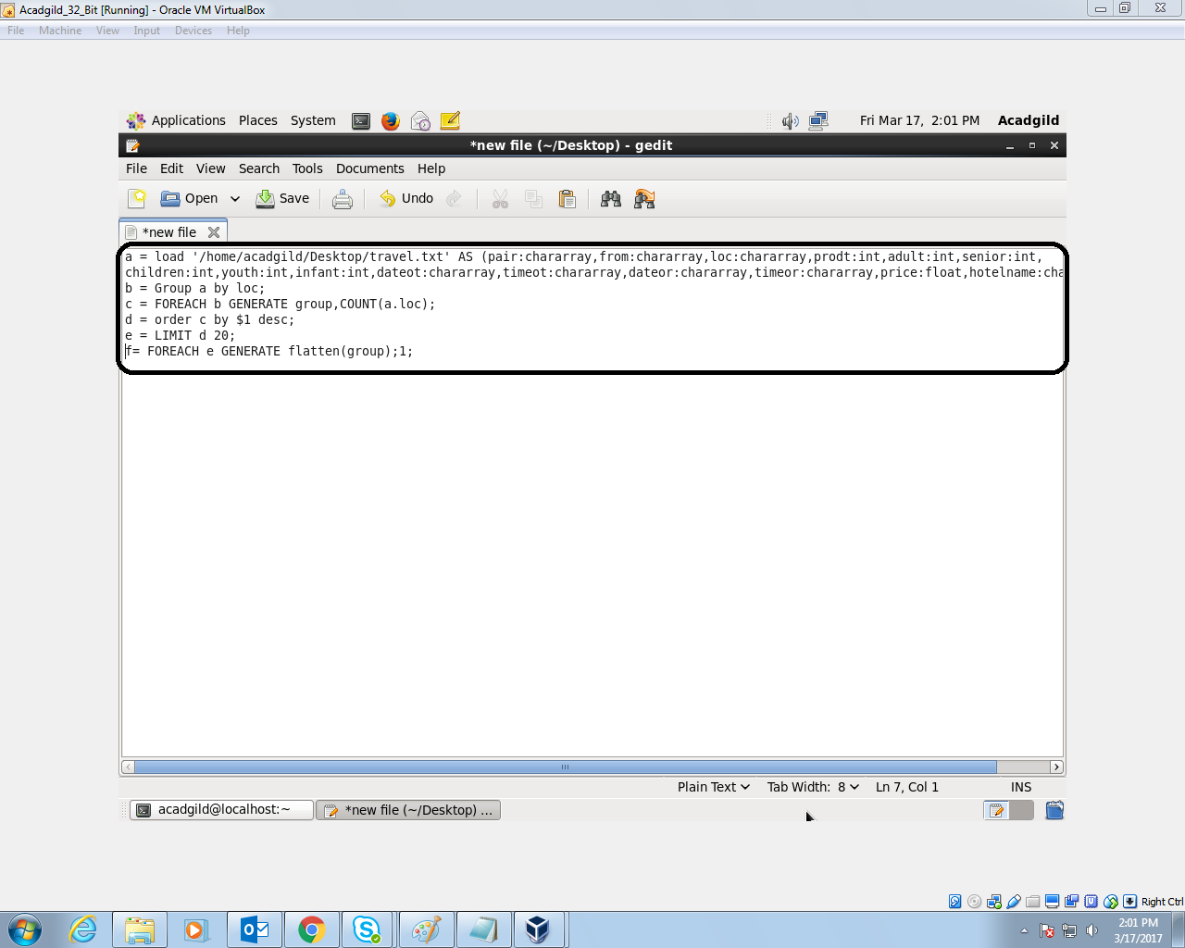

1. Group by location
2. Count the number of location in each group
3. Sort them in the descending order
4. Limit the output to first 20

// 10.5 a Output

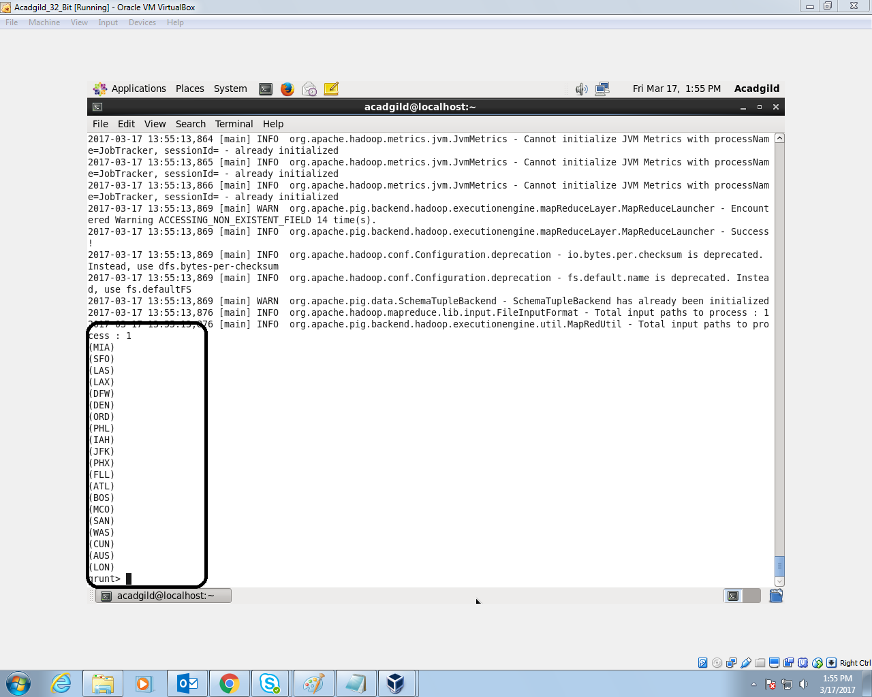

// 10.5 b

// Query

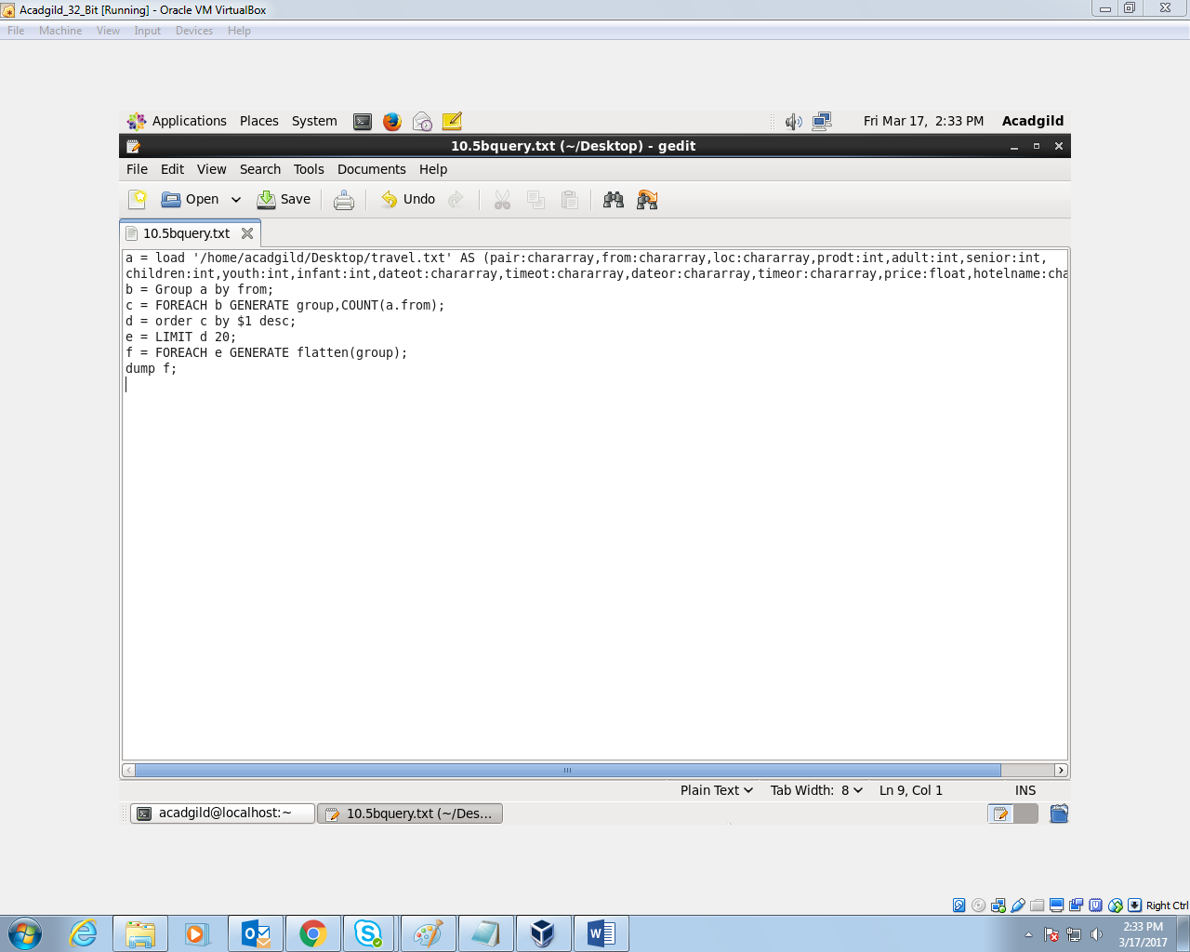

1. Group by starting point
2. Count the starting point in each group
3. Order in descending order.
4. Limit the output to top 20

//10.5 Output

