//Assignment 10.6

//Problem statement

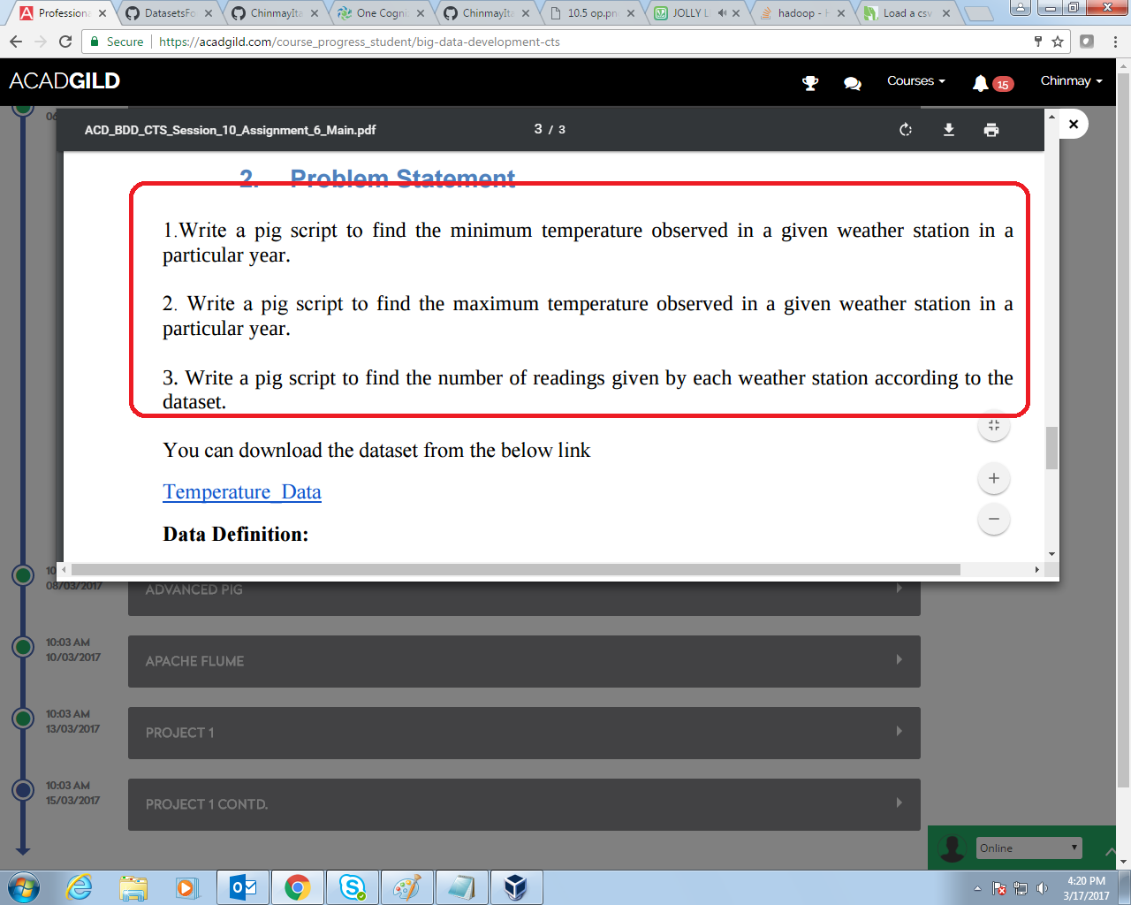

NOTE – The dataset provided contains only one year.

// 10.6a query

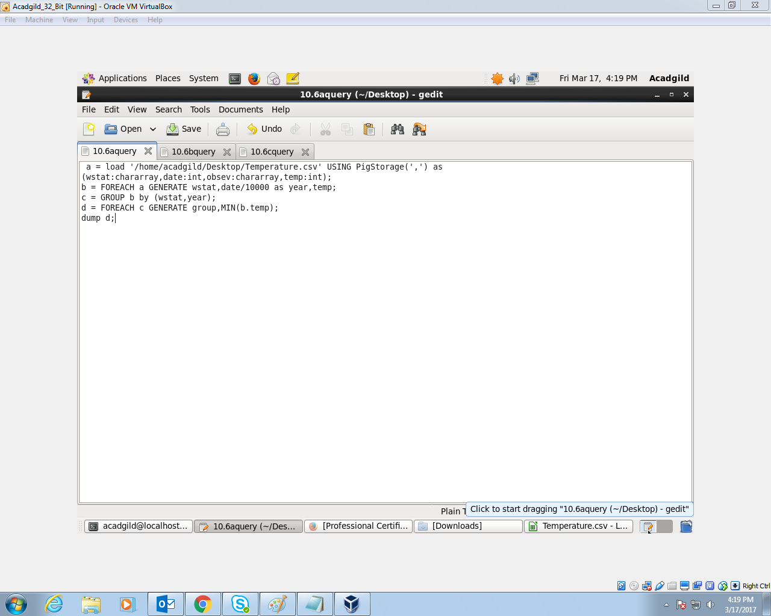

1. Get the year from the date
2. Group by year and weather station.
3. Get min in each group.

// 10.6a output

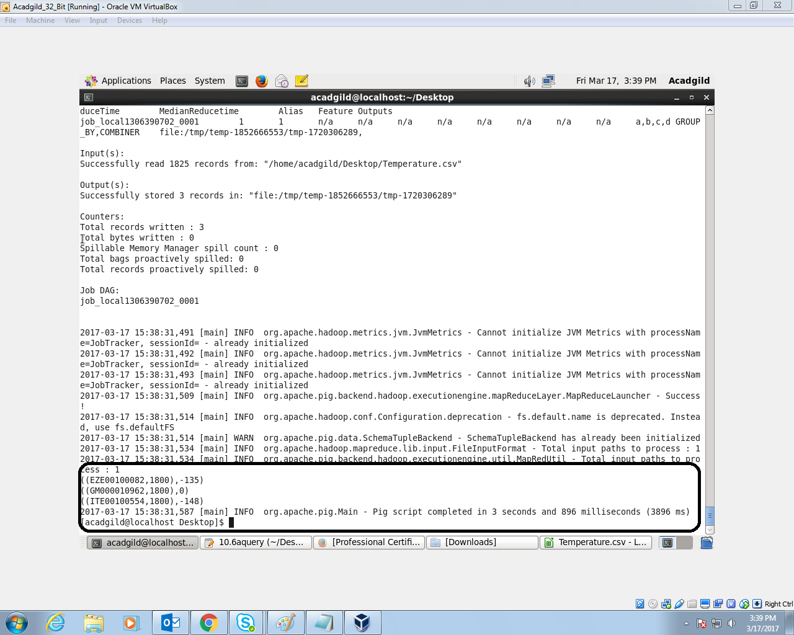

// 10.6b Query

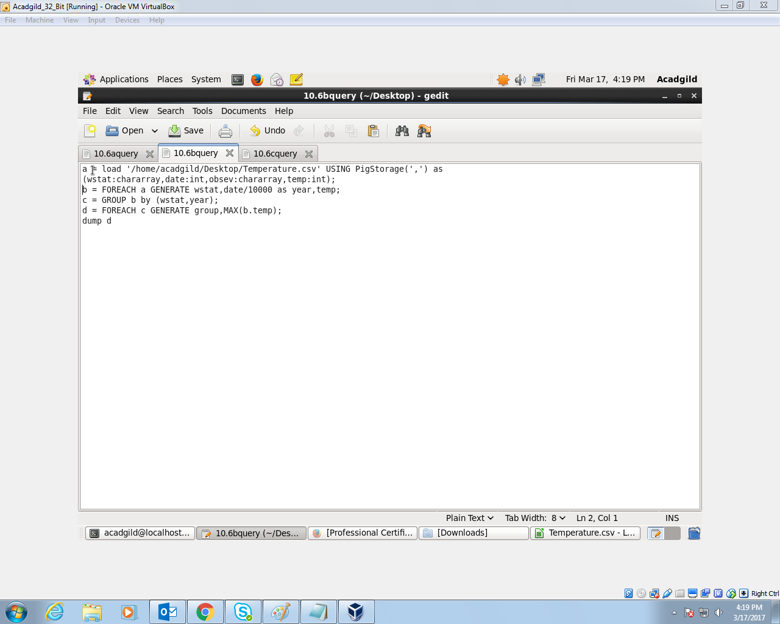

1. Get year from each date.
2. Group by station and year
3. Get max temperature in each.

//10.6b Output

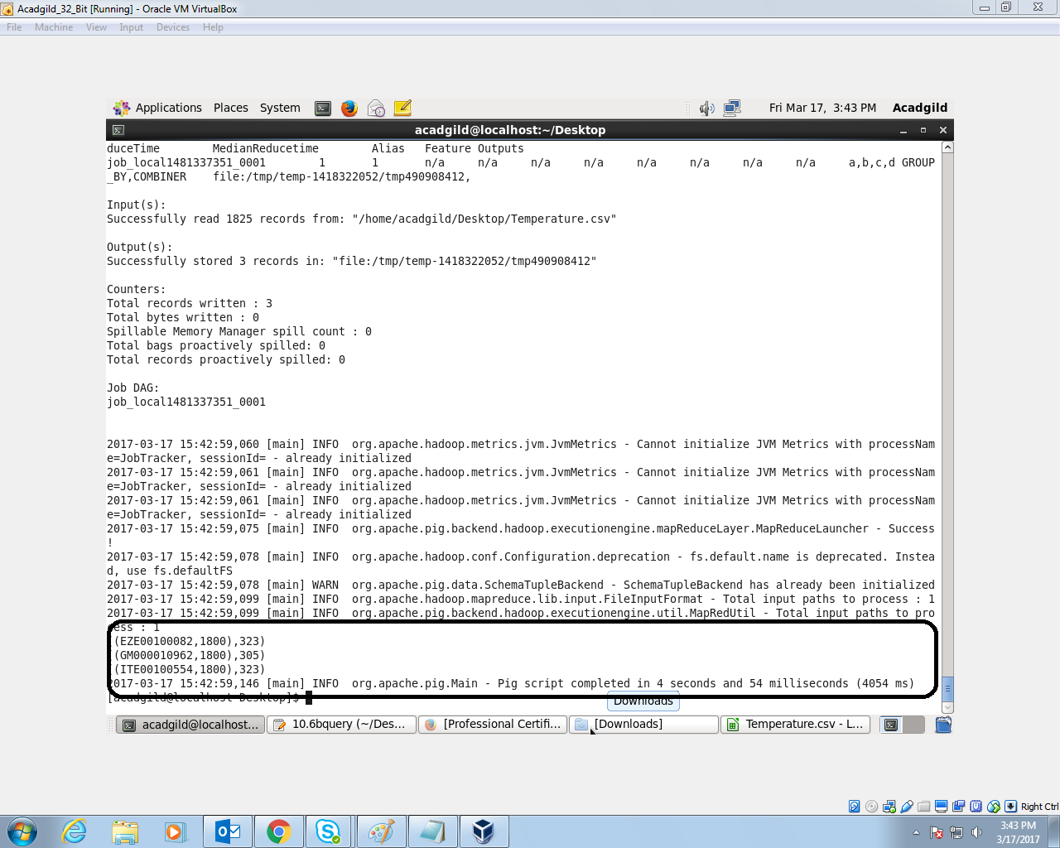

//10.6 c Query

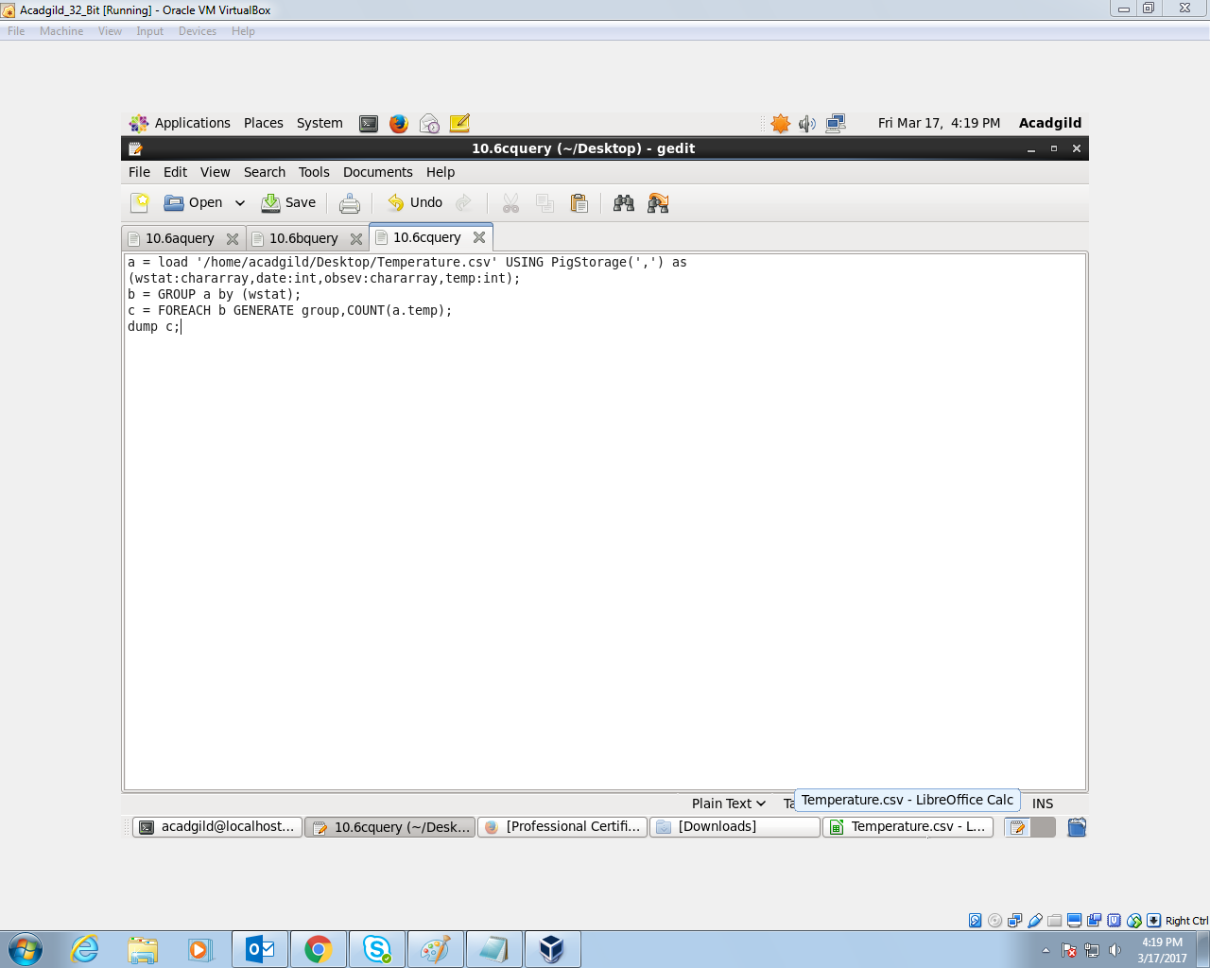

1. Group by station
2. Count the no. of temperatures in each group

// 10.6c Output

