**11.1**

**INPUT**

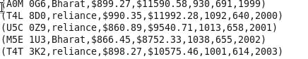

**LOAD**

**C:\Users\612834\Pictures\11\1.PNG**

1. **What is the total amount of petrol in volume sold by every distributor?**

**C:\Users\612834\Pictures\11\2.PNG**

**OUTPUT**

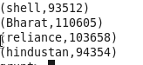

1. **Which are the top 10 distributors ID's for selling petrol? Also display the amount of petrol sold in volume.** 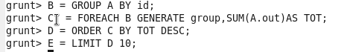

**OUTPUT**

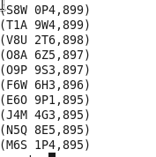

**3. List 10 years where consumption of petrol is more with the distributer id who sold it.**

**C:\Users\612834\Pictures\11\b.PNG**



**OUTPUT**

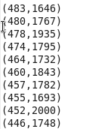

**4.Find the distributer name who sold petrol in least amount.**

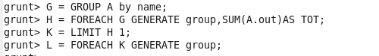

**OUTPUT**

Ooo

C:\Users\612834\Pictures\11\6.PNG