**ASSIGNMENT 24.6**

**Create database**

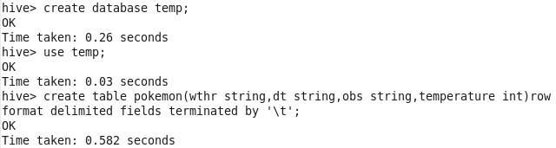

**DATASET:**

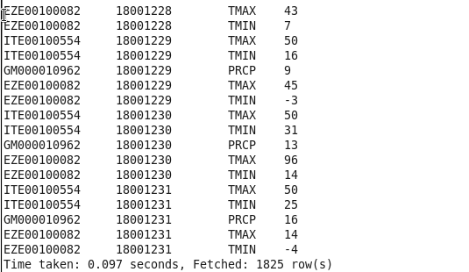

**1.Write a hive query to find the minimum temperature observed in a given weather station in a particular year.**

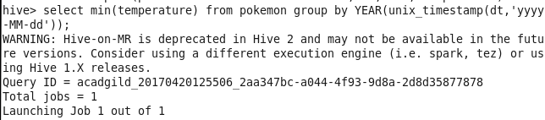



**2. Write a hive query to find the maximum temperature observed in a given weather station in a particular year.**

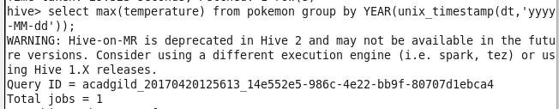

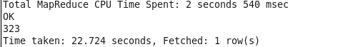

**3. Write a hive query to find the number of readings given by each weather station according to the dataset.**

