25.1

CREATE DATABASE ,TABLE AND LOAD

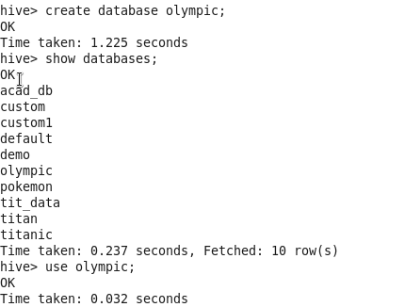

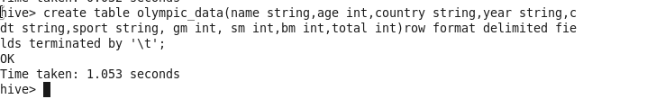

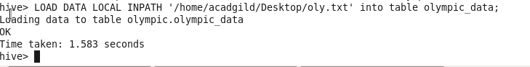

Problem Statement:

Write a Hive program to find the number of medals won by each country in swimming.

hive>select count(total) from Olympic_data where sport==”Swimming” group by country;

Output

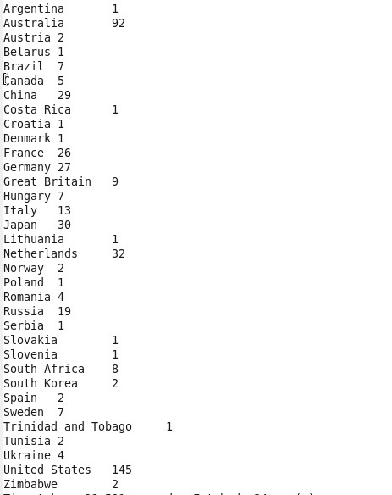

Problem Statement:

Write a Hive program to find the number of medals that India won year wise.

