25.2

Dataset is same as 25.1

Problem Statement:

Write a Hive Program to find the total number of medals each country won

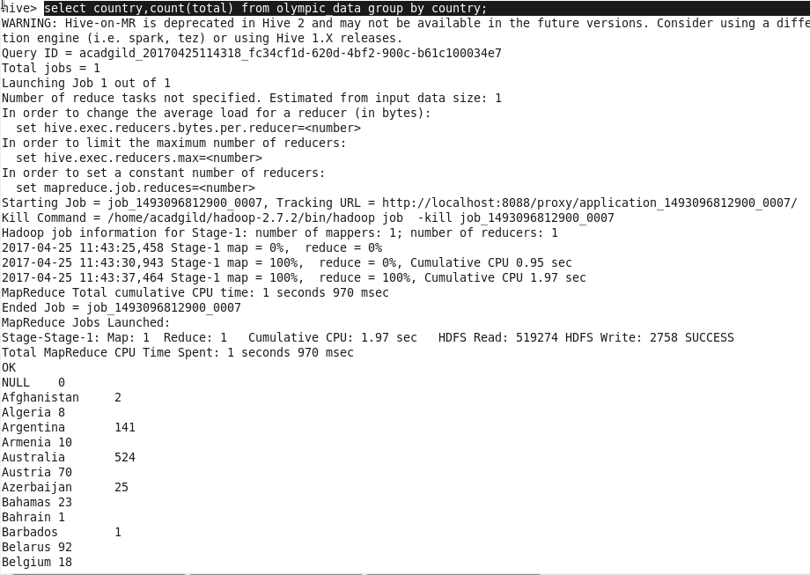

Problem Statement:

Write a Hive program to find the number of gold medals each country won

