**Assignment 35.1**

Create a employee table in Mysql and columns as Emp_id, Emp_name, Dept_name(Hadoop Developer), Emp_sal.

● Import the employee table contents into the HDFS directory using Sqoop.

● Create a employee2 table in Mysql and Export employee details file from HDFS directory to Mysql table employee2 using Sqoop.

● Explain the procedures performed, Share the screenshots of commands and results for the same.

**Start mysql**

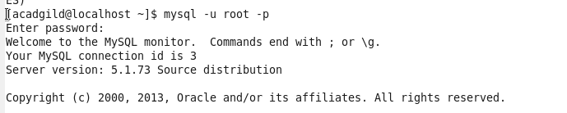

**Create database**

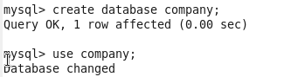

C:\Users\612834\Pictures\mproject\3.PNG



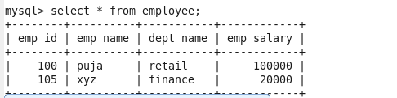

**Import data from mysql to hdfs**

C:\Users\612834\Pictures\mproject\6.PNG

**Output on hdfs**

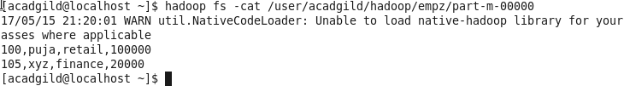

**Export data from hdfs to hdfs**

C:\Users\612834\Pictures\mproject\8.PNG

