**Problem Statement**

**We have a dataset of sales of different TV sets across different locations.**

**Company Name|Product Name|Size in inches|State|Pin Code|Price Sales_TV:**

**INPUT**

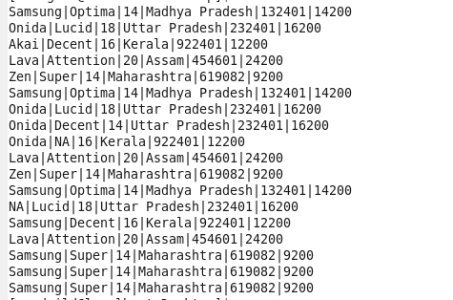

**Q1. Write a Mapreduce program to modify Sales of different TV Task 2 ( refer session 5 assignment 2 ) to use a custom partitioner with 4 reducers. Make sure that all records whose company name starts with A-F (upper or lower case) should go to 1st reducer, those starting with G-L to 2nd reducer, those starting with M-R to 3rd reducer and others to 4th reducer.**

**DRIVER** 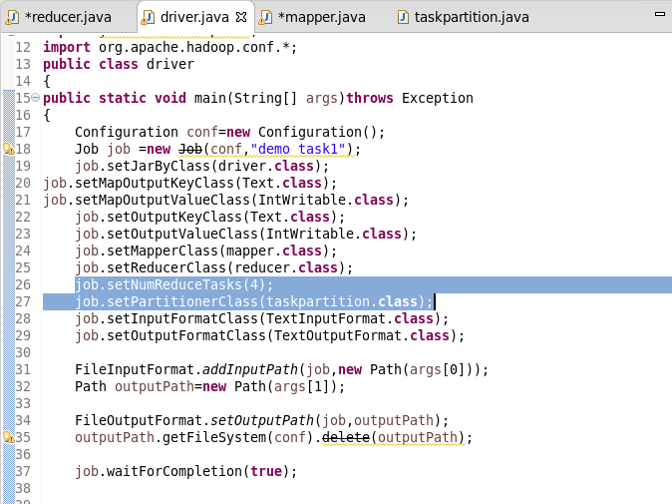

**MAPPER** 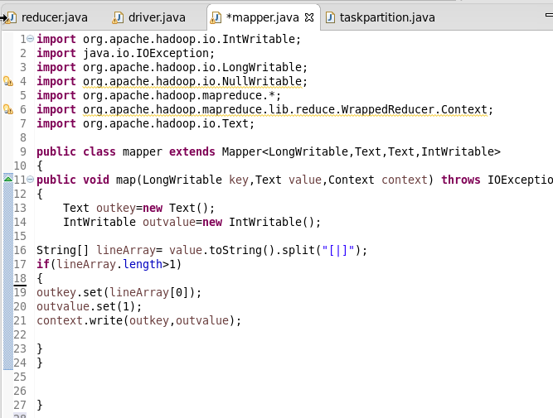

**PARTITIONER 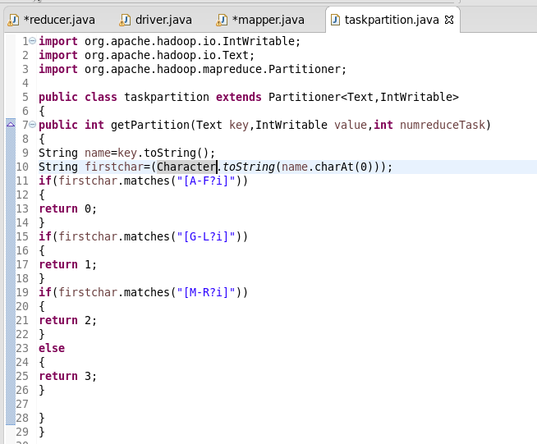  
REDUCER** 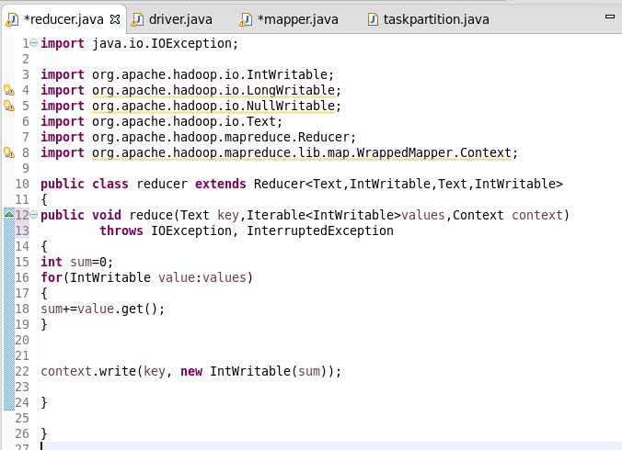

**RUN THE JAR**

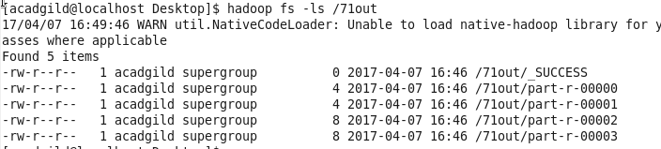

**OUTPUT** 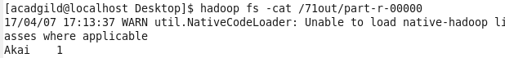 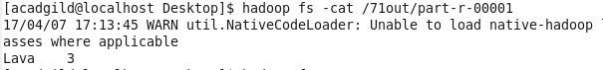 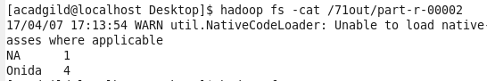

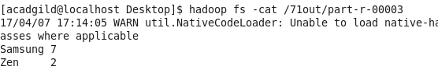

**Sales of different TV Task 5 : Modify Sales of different TV Task 2 (refer session 5, assignment 2) to take advantage of Combiner.**

**Same code as above only change in Driver**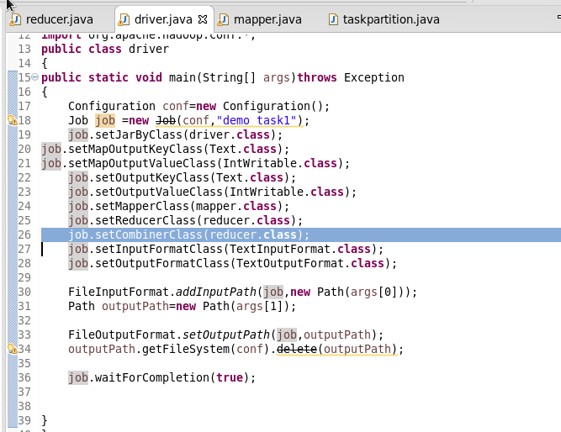

**OUTPUT** 