1. Explain the running modes of pig and integrate Tez with Hadoop and run a simple pig query using tez.

Local Mode - To run Pig in local mode, you need access to a single machine; all files are installed and run using your local host and file system. Specify local mode using the -x flag (pig -x local).
Tez Local Mode - To run Pig in tez local mode. It is similar to local mode, except internally Pig will invoke tez runtime engine. Specify Tez local mode using the -x flag (pig -x tez_local).
Mapreduce Mode - To run Pig in mapreduce mode, you need access to a Hadoop cluster and HDFS installation. Mapreduce mode is the default mode; you can, but don't need to, specify it using the -x flag (pig OR pig -x mapreduce).
Tez Mode - To run Pig in Tez mode, you need access to a Hadoop cluster and HDFS installation. Specify Tez mode using the -x flag (-x tez).

// pig installation Successfull
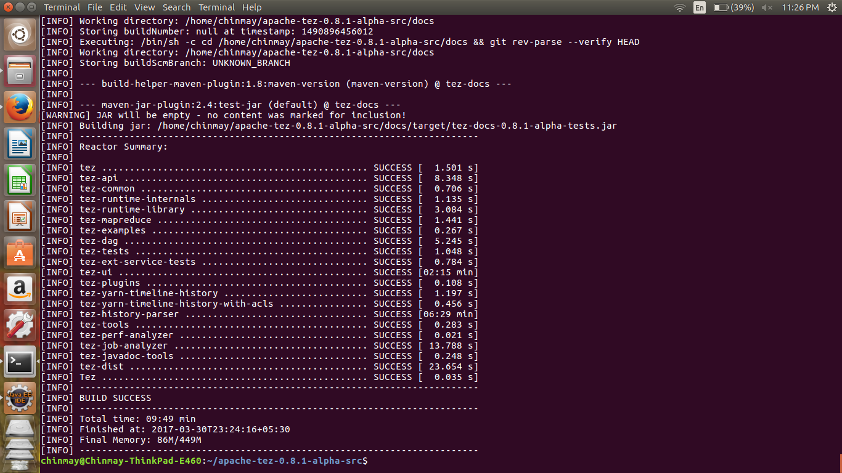

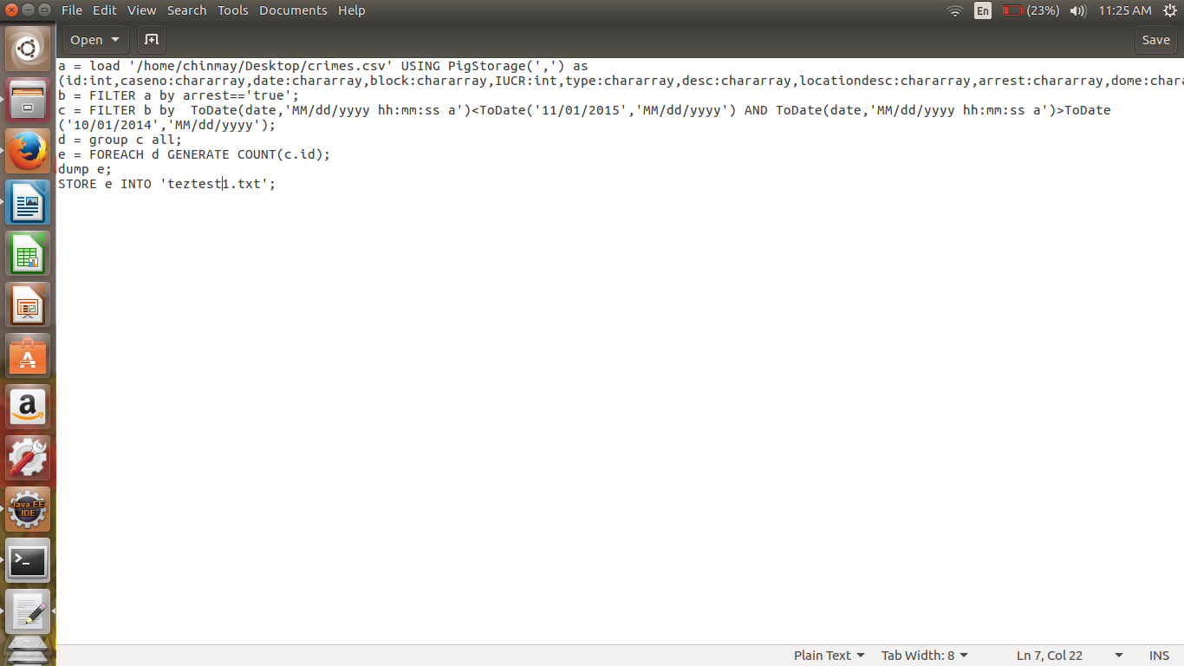
//Script
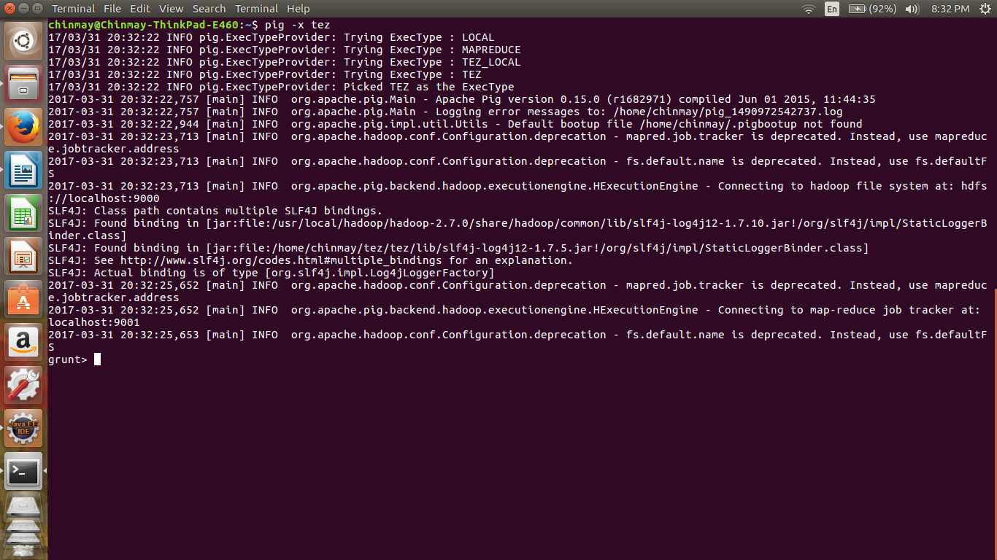

//implementation

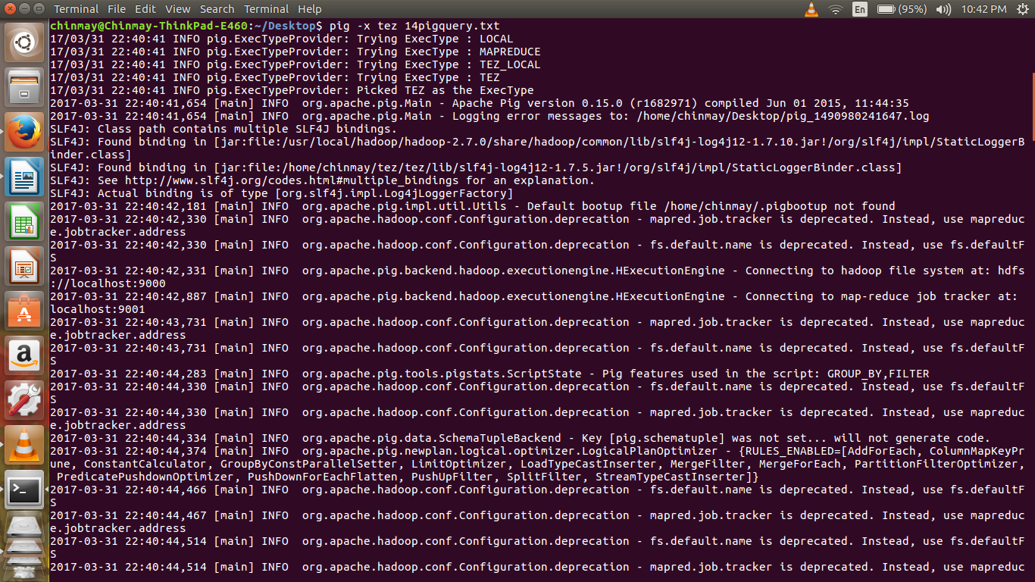
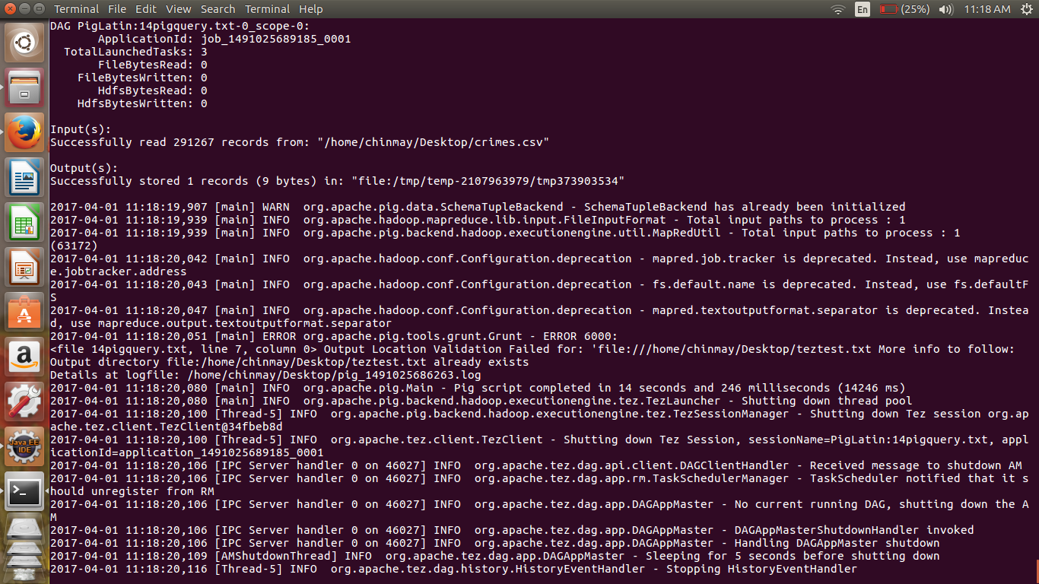

//pig local impletation
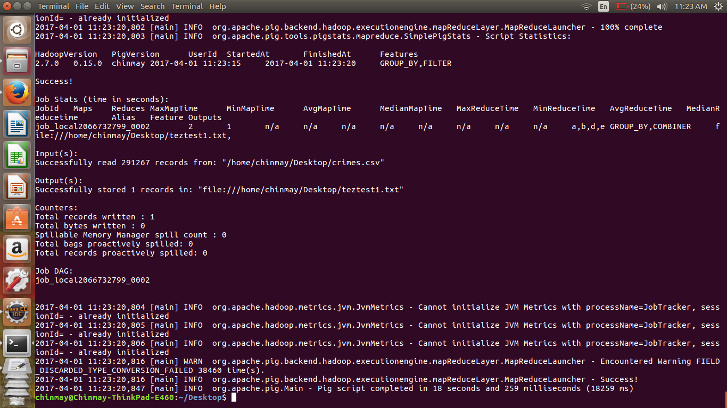

as we can same script takes less time in tez implementation .
For tez time taken was – 14 sec approxx
For pig local time taken was – 18 sec approx.

