1. **Find the number of students who scored less than 5(50%)C:\Users\612834\Pictures\11.2\1\21.PNG**

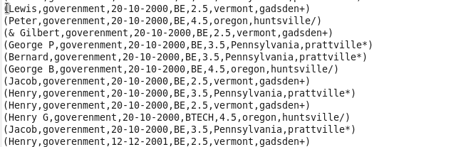

**C:\Users\612834\Pictures\11.2\1\24.PNG**

**C:\Users\612834\Pictures\11.2\1\23.PNG**

**OUTPUT**

**C:\Users\612834\Pictures\11.2\1\25.PNG**

1. **List the name of students who are from Alaska.** C:\Users\612834\Pictures\11.2\2\1.PNGC:\Users\612834\Pictures\11.2\2\2.PNG

**OUTPUT**

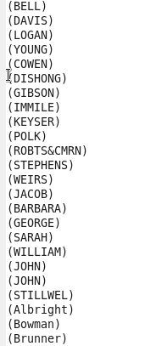

1. **How many government colleges are there in Alabama?**

C:\Users\612834\Pictures\11.2\3\1.PNG

C:\Users\612834\Pictures\11.2\3\3.PNG

**C:\Users\612834\Pictures\11.2\3\4.PNG**

C:\Users\612834\Pictures\11.2\3\5.PNG

**OUTPUT**

C:\Users\612834\Pictures\11.2\3\out.PNG

1. **List the name of students who are from Oregon and persuing BE.**

**C:\Users\612834\Pictures\11.2\4\2.PNGC:\Users\612834\Pictures\11.2\4\3.PNG**

**C:\Users\612834\Pictures\11.2\4\4.PNG**

**OUTPUT**

